Question 1: What is the output for Matrix M? Give the matrix.

Answer:

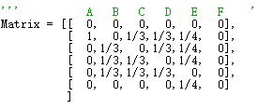

Question 2: What is the original rank vector(rj)?

We set e/n as the original vector. In this assignment, we set [1/6,1/6,1/6,1/6,1/6,1/6]. (Actually, I set 100\*e/n as the original vector, but it doesn’t affect the answer.)

Question 3: What is the Converged rank vector (R)?

`[2.5, 15.901917538356118, 14.246073382511964, 14.246073382511964, 15.078318219291013, 5.70414262159934]

Question 4: How many iterations did it take to get the convergence?

151

Git link: <https://github.com/jiayu2B/Pagerank/tree/master/pagerank>