**CS579 –Project Part 3**

**Jiayuan Shi**

4. Write following queries in SQL and issue them to your database. Then, capture the screen of the query results and include them in your submission. Make sure that each query returns at least one tuple (If necessary, you need to insert additional tuples).

(a). Show the list of all insurance companies with which <the name of a physician of your choice> has a contract.

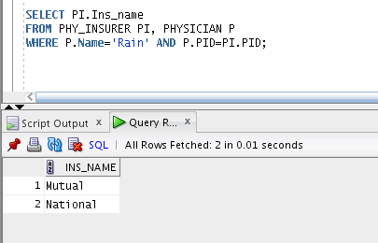

(b). Show the list of all visits by <the name of a person of your choice> between 1/1/2013 and 3/31/2013. For each visit, display the date, doctor’s name, PCP or not, and diagnosis.

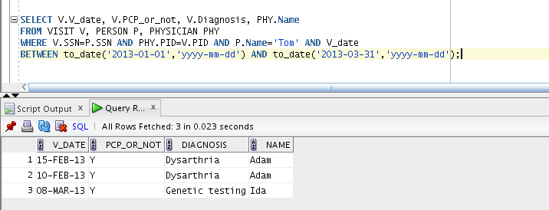

(c). Show the list of all insurance companies which have contract with <the name of a person of your choice>’s employer.

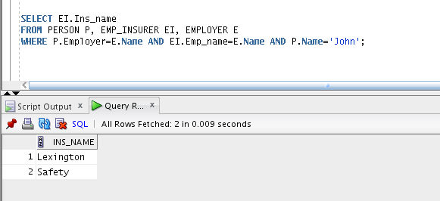

(d). Among the claims filed by <the name of a doctor of your choice>, show the list of those that were not paid yet. Here, we assume that all claims are filed by physicians. 