MA684 hw2

Jiayuan Shi

1.

> distance <- read.csv("stoppingdistance.csv", header=TRUE)

> attach(distance)

> plot(dist~speed)

> speed

[1] 15 15 15 20 20 20 25 25 25 30 30 30 35 35 35 40 40 40 45 45 45 50 50 50

[25] 55 55 55 60 60 60 65 65 65

> reg.results <- lm(dist~speed)

> summary(reg.results)

Call:

lm(formula = dist ~ speed)

Residuals:

Min 1Q Median 3Q Max

-48.73 -24.67 -3.98 32.63 84.97

Coefficients:

Estimate Std. Error t value Pr(>|t|)

(Intercept) -126.729 16.197 -7.82 7.9e-09 ***

speed 6.350 0.377 16.86 < 2e-16 ***

---

Signif. codes: 0 ‘***’ 0.001 ‘**’ 0.01 ‘*’ 0.05 ‘.’ 0.1 ‘ ’ 1

Residual standard error: 34.2 on 31 degrees of freedom

Multiple R-squared: 0.902, Adjusted R-squared: 0.899

F-statistic: 284 on 1 and 31 DF, p-value: <2e-16

> par(mfrow=c(2,2))

> plot(reg.results)

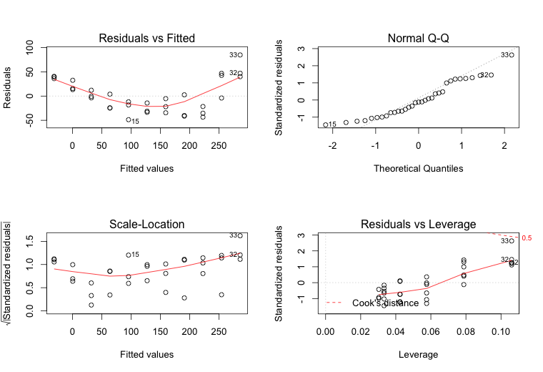

The assumptions of the linear regression model are,

i) Independent, random sample from underlying population:

Yes, each data in the sample is independent from the others, and they are randomly selected.

ii) Linearity, the means of Y|X fall on a straight line:

Yes, from the plot, we can see the straight line $μ_{Y/X}=β_{0}+β_{1}X$.

From R, we can get the estimate $\hat{Y}=-126.729+6.350X$, which is $\hat{distance}=-126.729+6.350*speed$

iii) Homoscedasticity, the variance of Y|X is the same for all X(variance of Ei is the same for all X):

Yes, from the above “Residuals vs Fitted” plot, variance of Ei is constant in the sample.

iv) Normality, the distribution of Y|X follows a normal distribution for all X:

Yes, we can see a straight line in the above “Normal Q-Q” plot, which means the distribution of Y|X follows a normal distribution for all X.

v) Existence, the model holds for valid values of X:

Yes, we can see the values of X through the command “speed” in R.

2.

> distance <- read.csv("stoppingdistance.csv", header=TRUE)

> attach(distance)

> plot(dist~speed)

> speed

[1] 15 15 15 20 20 20 25 25 25 30 30 30 35 35 35 40 40 40 45 45 45 50 50 50

[25] 55 55 55 60 60 60 65 65 65

> reg.results <- lm(dist~speed)

> summary(reg.results)

Call:

lm(formula = dist ~ speed)

Residuals:

Min 1Q Median 3Q Max

-48.73 -24.67 -3.98 32.63 84.97

Coefficients:

Estimate Std. Error t value Pr(>|t|)

(Intercept) -126.729 16.197 -7.82 7.9e-09 ***

speed 6.350 0.377 16.86 < 2e-16 ***

---

Signif. codes: 0 ‘***’ 0.001 ‘**’ 0.01 ‘*’ 0.05 ‘.’ 0.1 ‘ ’ 1

Residual standard error: 34.2 on 31 degrees of freedom

Multiple R-squared: 0.902, Adjusted R-squared: 0.899

F-statistic: 284 on 1 and 31 DF, p-value: <2e-16

$$\hat{distance}=b0+b1*speed$$

From the above results, we can get the estimate b0= -126.729, and b1=6.350.

$$\hat{distance}=-126.729+6.350*speed$$

2a. Yes, there is a significant association between speed and stopping distance. From the results of “summary(reg.results)”, we can see that the p-value is very small(< 2e-16), so we can reject the null hypothesis that $β=0$ (no association between speed and stopping distance), which means there is a significant association between speed and stopping distance.

2b.

$$∆speed=60-50=10$$

$$∆distance=10*6.35=63.5$$

s(y|x)= $\sqrt{s_{Y|X}^{2}}\text{=}\sqrt{\frac{\sum{({y_{i}-{\hat{y}}_{i})}^{2}}}{n-2}}$ = $34.2$

95% CI for this increase in distance $=63.5±2.04*34.2=$ (,)

So the stopping distance expected to increase from 0 to 98mph with 95% CI.

3a.

|  |  |  |  |  |  |
| --- | --- | --- | --- | --- | --- |
|  | Parameter  Estimate | Standard  Error | t-value  (df) | p-value | 95% CI |
| Intercept  Maternal Age | 115.44  -0.49 | 14.73  0.56 | ---  -0.875 | ---  0.389 | ---  (-1.64 , 0.658) |

${\text{t}}_{\text{obs}}\text{= }\frac{{\text{b}}_{\text{1}}}{{\text{se(b}}_{\text{1}}\text{)}}\text{=}$-0.49/0.56=-0.875, df=28, p-value=0.389

95% Confidence interval for the slope (t(crit) = 2.05)

-0.49+ 2.05 (0.56) or (-1.64 , 0.658)

H0: β1 = 0 (No association between maternal age and a child’s cognitive ability)

The p-value is 0.389 (>0.05), so we fail to reject the null hypothesis that $β=0$ (no association between speed and stopping distance), which means there is not a significant association between maternal age and a child’s cognitive ability.

With 95% confidence, we can say the slope for maternal age is between -1.64 and 0.658.

The slope is not big enough, which shows a weak association between maternal age and a child’s cognitive ability. In addition, the p-value is 0.389 (>0.05), also showing that there is not a significant association between the two.

3b.

Predicted IQ for a child born to a 20 year old mother:

${\hat{\text{y}}}_{\text{X0}}=$ 115.44-0.49*20=105.64

${\hat{\text{y}}}_{\text{X0}}\text{ ±}{\text{t}}_{\text{crit}}{\text{s}}_{\text{Y|X}}\sqrt{1+\frac{\text{1}}{\text{n}}\text{+}\frac{{\text{(x0-}\overline{\text{x}}\text{)}}^{\text{2}}}{\text{(n-1)}{\text{s}}_{\text{X}}^{\text{2}}}}$ =105.64 $\text{±}\text{2.05*13.5}\sqrt{1+\frac{\text{1}}{30}\text{+}\frac{{\text{(20-}\text{27}\text{)}}^{\text{2}}}{\text{(}\text{30}\text{-1)}\text{*4.5^2}}}$ =

(76.394, 134.89)

We are 95% confident that the IQ for a child born to a 20 year old mother is between 76.394 and 134.89.

3c.

Predicted mean IQ for children born of 30 year old mothers:

${\hat{\text{y}}}_{\text{X0}}=$ 115.44-0.49*30=100.74

${\hat{\text{y}}}_{\text{X0}}\text{ ±}{\text{t}}_{\text{crit}}{\text{s}}_{\text{Y|X}}\sqrt{\frac{\text{1}}{\text{n}}\text{+}\frac{{\text{(x0-}\overline{\text{x}}\text{)}}^{\text{2}}}{\text{(n-1)}{\text{s}}_{\text{X}}^{\text{2}}}}$ =100.74 $\text{±}\text{2.05*13.5}\sqrt{\frac{\text{1}}{30}\text{+}\frac{{\text{(30-}\text{27}\text{)}}^{\text{2}}}{\text{(}\text{30}\text{-1)}\text{*4.5^2}}}$ =

(94.635, 106.84)

We are 95% confident that the mean IQ for children born of 30 year old mothers is between 94.635 and 106.84.

4a.

> csi <- read.csv("CSI femur stature inches.csv", header=TRUE)

> attach(csi)

> plot(height~femurlength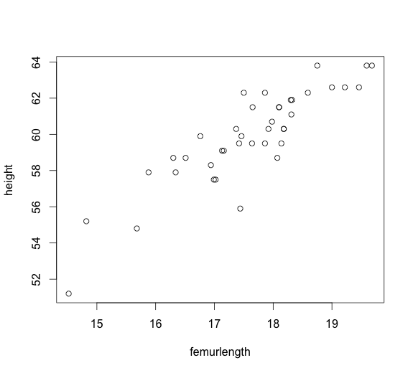

4b.

> mean(femurlength)

[1] 17.604

> sd(femurlength)

[1] 1.1652

Mean +/- sd for femur length: 17.604+/-1.1652

> mean(height)

[1] 59.892

> sd(height)

[1] 2.6374

Mean +/- sd for height: 59.892+/-2.6374

4c.

> reg.results <- lm(height~femurlength)

> summary(reg.results)

Call:

lm(formula = height ~ femurlength)

Residuals:

Min 1Q Median 3Q Max

-3.667 -0.740 0.015 0.678 2.614

Coefficients:

Estimate Std. Error t value Pr(>|t|)

(Intercept) 24.848 3.083 8.06 9.5e-10 ***

femurlength 1.991 0.175 11.39 8.1e-14 ***

---

Signif. codes: 0 ‘***’ 0.001 ‘**’ 0.01 ‘*’ 0.05 ‘.’ 0.1 ‘ ’ 1

Residual standard error: 1.27 on 38 degrees of freedom

Multiple R-squared: 0.773, Adjusted R-squared: 0.768

F-statistic: 130 on 1 and 38 DF, p-value: 8.1e-14

> confint(reg.results,"femurlength")

2.5 % 97.5 %

femurlength 1.637 2.3446

Linear regression predicting height (inches) from femur length (inches)

|  |  |  |  |  |  |
| --- | --- | --- | --- | --- | --- |
|  | Parameter  Estimate | Standard  Error | t-value  (df) | p-value | 95% CI |
| Intercept  Femur Length | 24.848 1.991 | ---  0.175 | ---  11.39 | ---  8.1e-14 | ---  (1.637, 2.3446) |

4d. $\hat{height }=24.848+1.991*femurlength$

For each inch increase in the femur length, on average, the height expected to increase 1.991 inch.

4e. s(y|x)= $\sqrt{s_{Y|X}^{2}}\text{=}\sqrt{\frac{\sum{({y_{i}-{\hat{y}}_{i})}^{2}}}{n-2}}$ = $1.27$

s(y|x) is called the ‘standard error of the estimate’, and is the standard deviation of femur length, for the sub-set of subjects with a particular height value.

4f.

Predicted height for a person with a femur of 19.00 inches:

> predict(reg.results,data.frame(femurlength=19),interval="predict")

fit lwr upr

1 62.673 60.02 65.325

We are 95% confident that the height for a person with a femur of 19.00 inches is between 60.02 and 65.325.

4g.

Predicted mean height for people with a femur of 19.00 inches:

> predict(reg.results,data.frame(femurlength=19),interval="confidence")

fit lwr upr

1 62.673 62.032 63.313

We are 95% confident that the mean height for people with a femur of 19.00 inches is between 62.032 and 63.313.