Nighty-night

An andriod app that makes people more aware of their sleeping habits while connecting better with their friends with the social features we emphasize on.

## Mobile App Design Brief Form

App Name:

Nighty-night (tmp)

App Logo:

Good night, friends

Industry:

Social; Health/sleep

App Description:

Combine people’s sleeping habits with their social life

Style/Theme:

Mostly blue with yellow to create simple and modern night view

Device to design for:

Android

Target User Age:

16+

Target User Requirement:

- People cares about health

- People want to get closer with friends/family members

- Pages description:

Screen Pages: 5+

1. Splash page - when a user click an icon this page should be seen

2. Log in page – next page after splash page

4. Sleeping status page – show the sleeping data (use’s score, rank in the community, sleeping hours graph)

5. Message box page – show messages with people (categories: good-night message, morning message, normal message)

6. Friend’s info page – show friend’s status and sleeping data(if allowed)

7. Friends list page – show all the friends

8. Setting page - set clock, set message notification (whether show on window), add friends, logout

Workflow description:

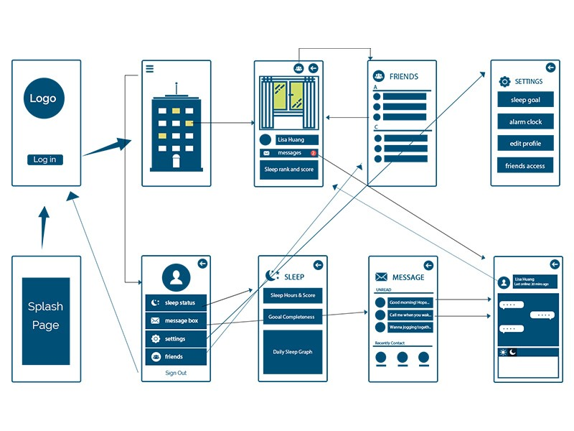

Proposal:

background:

Social media has been rapidly gaining its impacts on our culture, society and daily life ever since its birth in the late 1970s. Popular social networks, such as facebook and Twitter, are inflencing and reshaped by bilions of active users every second. The great intention of the original social media is to build more convient, stronger and wider connections among people. Unfortunately however, social media today is blamed for its negative impacts such as being a major distraction, which actually distances people in real life, decreases productivity and rest time. With a busy schedule that most of us have already, some even argues that insufficent sleep is at the level of a public health problem.

goal:

We want to create a social media app that makes people more aware of their sleeping habits while connecting to others at the same time. one hand, people can simply track and improve their sleeping habits; on the other hand, people can build a healthier sleep habit under their friends’/family’s impact.

(1) We will build a warm and friendly atmosphere for users while focusing on the connections between users and their friends.

(2) Although we are trying to promote healthier sleeping habit,

(3) people will not feel forced. They can still chat with their friends who are still awake, and even ask them to party together.

If the user indicates her/his desire for building a better sleep habit, we can help by getting warm notices from his/her friends and motivate her/him by encouraging her/him to rank higher among the community on the progress in fulfilling sleep habits goals set by herself/himself. We will use social interactions in our advantage to exert a subtle influence on people’s health.

basic idea:

We will invite users and their friends into a virtual building where everyone will own a window. When the person is sleeping, the curtain will be closed and will be open when the user is awake. All the people in the same building will be able to see each other’s status. We will place user with his friends in the same building.

functionalities:

- (1) track personal sleep habits

- hours of sleep

- rate sleep status of the day

- set goals such as sleeping 8 hours per day and getting rewards like get window decoration by fulfilling the goal in a strike

- (2) interact with friends (examples)

- wake friends up

- remind friends to sleep earlier

- message friend who is still awake to party together

- while pulling an all-nighter during final's week, friends can cheer each other up

- father leaves a bedtime story for his daughter／friends greet with ‘have a good dream’，which will be chosen to send out when they are about to sleep

- left a quiet message if the curtain is on and wait for his friend’s awake to see it

- rank hours of sleeps among the community (2)

- also the app will support the ‘group’ concept. So by moving some of your friends to another building(?), user can set different limitation on what they can be seen or what kind of message they are allow to send

- choose to be invisible

-statistic data such as median hours of sleeps, average, etc in a group/community