Graduate Thesis of Jinan University

Music Emotion Recognition with LSTM-RNN combining NLP techniques on classic Cantonese Songs

2014CST, International School
2014050693 HE JIAYUN

Abstract

- Brief intro of MER and efforts that has been made in this field
- Suggest creative new method
- Experimental Results

Introduction
- MER
- - General Intro (Categorical and Parametric MER)
- - Cantonese Songs
- - V-A Model (with 4 quadrants)
- LSTM-RNN
- NLP (TF*IDF Keyword Extraction, word2vec)
- Problems (copyright)

Related Works

Proposed Method
Combine acoustic features with contextual features, we train a LSTM-RNN model. When a new song is fed to the system, a series of keyword comments will be generated and we map those generated comments to the V-A model, create a 2-dimension emotional vector for the song.

Raw Data Processing
- NetEase 163
- spider163 (download songs, comments and lyrics)
- pyAudioAnalysis (extract acoustic features – mfccs, chroma vector……)
- jieba (Chinese NLP tools, use to preprocess the downloaded comments)
- snownlp (For sentimental analysis of comments and lyrics)
- word2vec (convert keywords to numpy vectors)

Modeling
Input x: acoustic features of a song (there are several of them in the
Output y:

Training
- environment setup (tensorflow)

Result

Acknowledgement
S北

Abstract

This paper presents an insight into music emotion recognition (MER) and offers a method of combining content features (MFCCs, hardness, Chroma features, etc.) and contextual features (song comments, lyrics) with neural networks (LSTM-RNN) and NLP techniques. In spite of many great efforts that has been made for MER, detecting emotion in music is still a tough task. Effort by Xia and Chen utilize support vector machine (SVM) classifiers scores above 73% in terms of precision, recall and F1 measure [1,2] (Contextual based), Cao and Li’s mood classification system achieve an accuracy of 65.7% (Content based). Currently there are few studies on combining both content features and contextual features and this is indeed a field that we can mine into. MY RESULT

1. Introduction

1.1 Music Emotion Recognition

1.1.1 General Introduction of MER

Music, an indispensible part of our daily lives, has been an important friend of us and help us manage our emotions. We need cheerful and exciting songs for winning moments, sad and peaceful music for departing and failure moments. It is quite simple for individuals like us to understand the bridge connecting music and emotions. Nevertheless, the situation can be quite different with machines, or computers. First of all, which is the most challenging one as well, emotions of songs is sometimes ‘individually independent’ - what a person feels from a song is deeply connected with his/her personal experiences, family background, educational background etc. Secondly, in the sight of music theory, songs with similar melodies can have totally different emotions. For instance, there are several versions of the famous Chinese song “MoLiHua” (Jasmine). They have almost identical melodies, however, they have total different emotions. The Turandot (opera) version presents mainly patriotic emotions and in stark contrast, the tradition version (from Jiangsu Province) expresses the emotion of love and fond for jasmine (much more quiet and peaceful). In addition, minor scales presents sad emotion in general but depends on songs, it can also represent other emotions. Finally, for classical music, various kinds of emotions can be present in one single music piece, and there are lots of rapid emotion changes. This can be a really tough task for precise labeling. To solve these problems, researchers name the task of MER and try to apply various techniques for the computer to understand what emotions that a song presents. Basically, MER tasks mainly focus on two fields – Contextual based MER and Content based MER. I will discuss this in the following sections.

1.1.2 Emotion Conceptualization

There are two different methods to conceptualize emotions: Categorical and Dimensional. Basically, categorical conceptualization of emotion uses categories and describe emotion precisely in one word. Essential to this approach is the concept of basic emotions,
that is, the idea that there is a limited number of universal and primary emotion
classes, such as happiness, sadness, anger, fear, disgust, and surprise, from which
all other secondary emotion classes can be derived [Ekman 1992; Picard et al. 2001]. However, categorical emotional conceptualization has its drawbacks especially when dealing with Chinese. The Chinese vocabulary for emotions is much more complex than in English world. Thus, I adopt the other method: Dimensional emotion conceptualization. Compared with the categorical method, the dimensional approach represents emotion in numerical values.

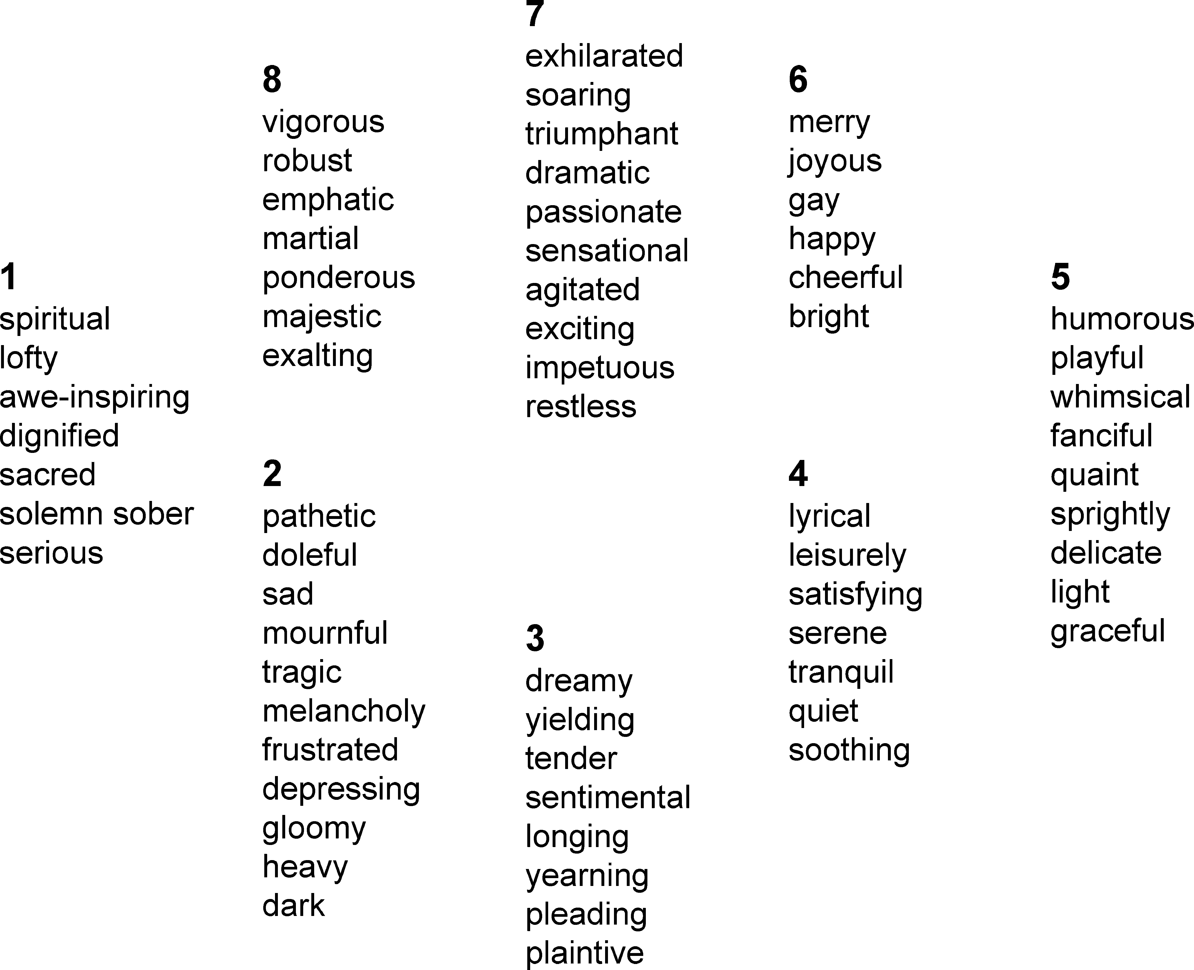

The Valence-Arousal model is one implementation of the dimensional approach. In the 2-D
V-A model, valence is related to degree of positive or negative while arousal is related to degree of excitement or peacefulness. This fuzzy representation of emotion overcomes the problem of vocabulary regarding to different cultures. In the seminal work of Russell [1980], the circumplex model of emotion is proposed. The model consists of a two-dimensional, circular structure involving the dimensions of valence and arousal. The circumplex model is also referred to as the two-dimensional emotion space (2DES).[4]

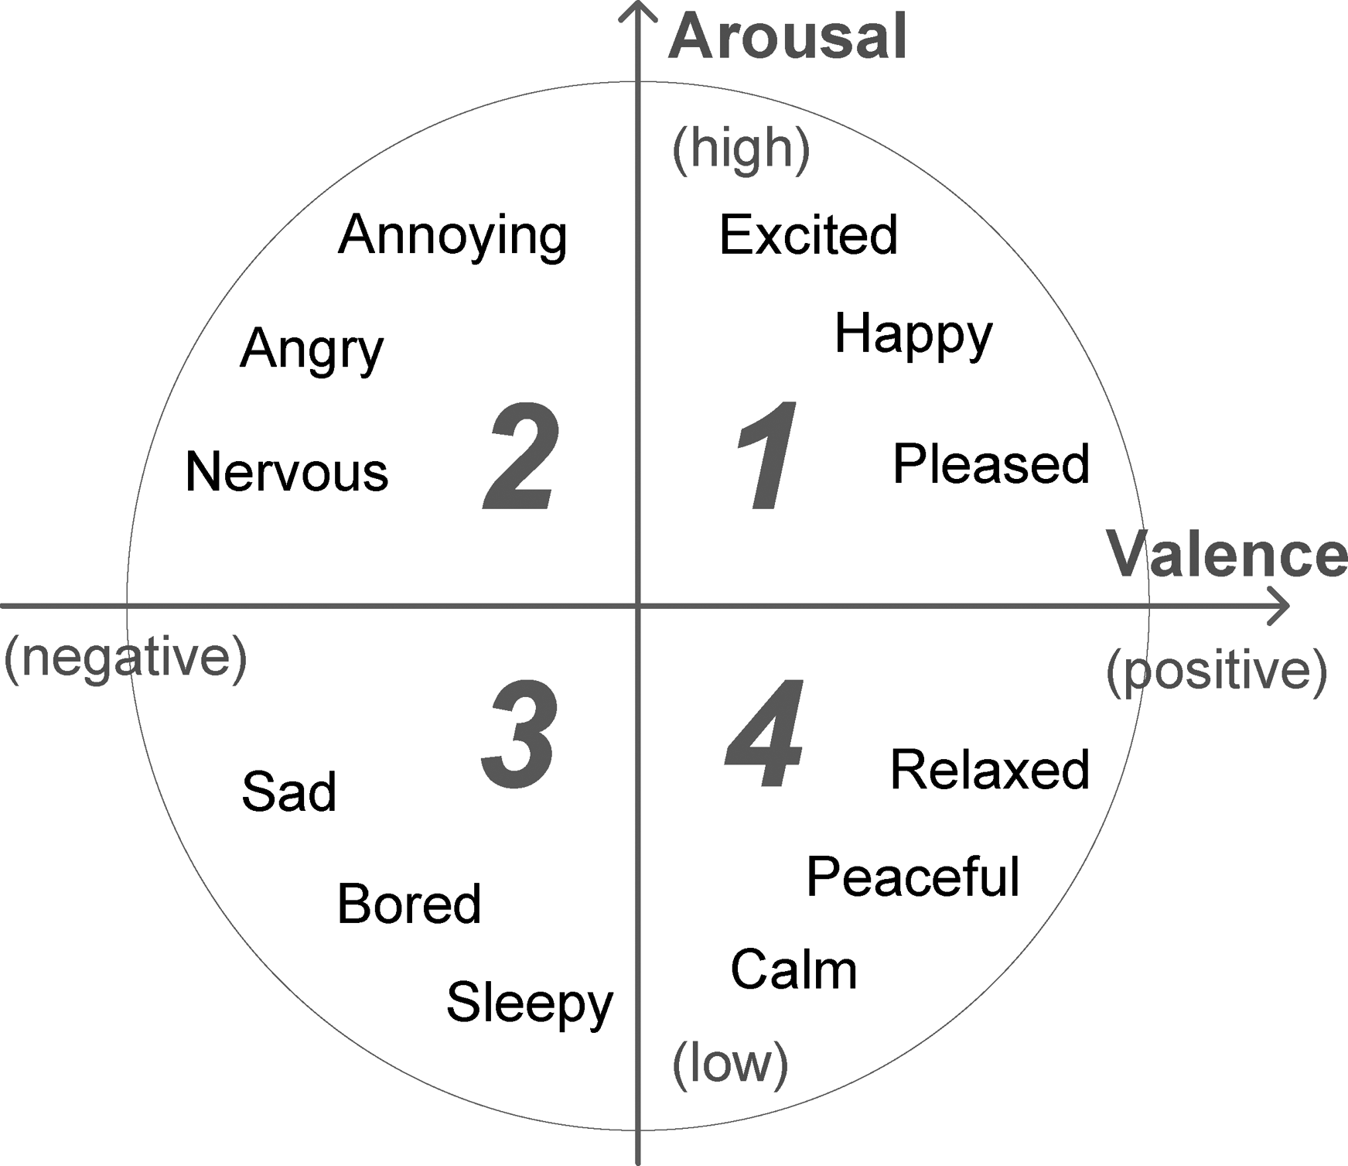

In spite of 2D implementation of dimensional approach, Eerola et al. [2009] build a regression- based computational model to predict the perceived emotion of movie soundtracks over the three-dimensional emotion space (3DES). However, they found that annotations in 3D is difficult to perform, and a two-dimensional model seems to offer a better parsimonious definition of emotion as well as limiting the calculation complexity of the task.

In this paper, emotion in music is annotated with the 2DES (V-A model), and those values for valence and arousal is obtain by performing NLP (Natural Language Processing) on song comments and lyrics. The NLP task will be discuss in Section 1.2

1.1.3 Content Based and Contextual Based MER

In general, MER tasks can be solved in two different perspectives: Music emotion recognition based on music content – all acoustic features of the music piece itself, and the other one is based on context, including lyrics, comments or reviews on the song. For content based MER, there are a diversified collection of acoustic features from which we can choose from. These acoustic features can be classified into four different groups: ENERGY (sonogram, related to Valence in V-A model, RHYTHM (tempo, related to Valence), MELODY (key
clarity, mode, harmonic change) and TIMBRE (MFCC). It is obvious that these acoustic features can be associate with valence and arousal values. We can map the acoustic features of a specific segment of song to a pair of valence and arousal values.

So, from where can we obtain valence and arousal values? Now we turn to contextual based MER. Song comments, song tags and lyrics as forms of textual information that can be analyzed in order to derive an emotional representation of music. Analysis of these data sources involves using techniques from both text-mining and natural language processing. Contextual based MER was proven to be effective by Xia and Chen, they utilized SVM (Support Vector Machine) classifier for training and testing data, and their sentiment-VSM set scores above 73% in terms of precision, recall and F-1 measures.

In this paper, a new approach of combing Content based MER and Contextual based MER is proposed. Acoustic features are treated as features while V-A values extracted from context are treated as labels in the neural network.

1.2 Natural Language Processing (NLP)

Natural Language Processing is an area of computer science and artificial intelligence concerned with the interactions between computers and human (natural) languages, in particular how to program computers to fruitfully process large amounts of natural language data. [5] Using NLP techniques, we can extract keywords and try to understand the emotions in the context. Emotion representation in song comments and song lyrics of Chinese songs can be complex and much more difficult than to understand song tags or genres. In addition, for DL (Deep-Learning) scenarios, loads of raw data will be needed and assigning keywords and emotional representation by human can be tiring and inefficient. Therefore, using NLP techniques to analyze song comments and extract labels from them can be very helpful.

In this paper, NLP techniques are utilized to extracting keywords from song comments, as well as extracting values in the 2DES from song comments and lyrics. When extracting keywords, TF*IDF, a numerical statistic technique is applied. The tf-idf value increases proportionally to the number of times a word appears in the document and is offset by the frequency of the word in the corpus, which helps to adjust for the fact that some words appear more frequently in general. [6]

1.3 Neural Networks

ANNs (Artificial Neural Networks) plays an increasingly important role in the modern world. Utilizing neural networks, raw data with considerably high dimensions that is difficult for human brains to process can be analyze properly and provide us with new ideas and thinking. One step further, as computational power getting stronger and stronger, we can do ‘Deep Learning’ with computers by nesting multiple ANNs together.

Reference
[1] R. H. Chen, Z. L. Xu, Z. X. Zhang, and F. Z. Luo, “Content
based music emotion analysis and recognition,” in Proc. of
the Intl. Workshop on Computer Music and Audio Technol-
ogy, 2006.

[2] Y. Xia, L. Wang, K. Wong, and M. Xu, “Sentiment vector
space model for lyric-based song sentiment classification,”
in Proc. of the Association for Computational Linguistics.
Columbus, Ohio, U.S.A: ACL-08, 2008, pp. 133–136.

[3] Yang and Chen “Machine Recognition of Music Emotion:A Review”

[4] [[Osgood et al. 1957; Plutchik 1980; Remington et al. 2000; Thayer 1989; Whissell et al. 1986].]
[5] https://en.wikipedia.org/wiki/Natural-language_processing

[6] https://en.wikipedia.org/wiki/Tf%E2%80%93idf

