Part 1
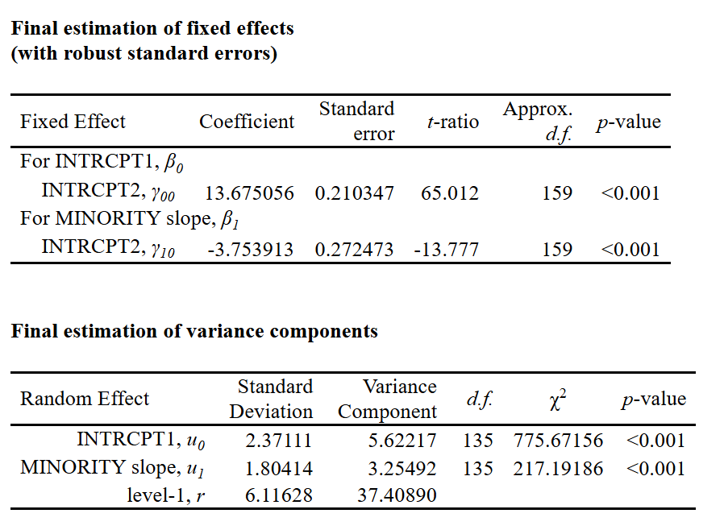
- Our “national gap” has a point estimate of -3.754, a standard error of 0.272, and a variance component of 3.25.
- We can observe that there is an estimated difference between the minority, black African and Hispanic students, and the white students when it comes to mathematical achievement.
- The intercept the mean math achievement for all schools.
- The minority slope the gap effect between the black Africans and Hispanics as minority, and white students.
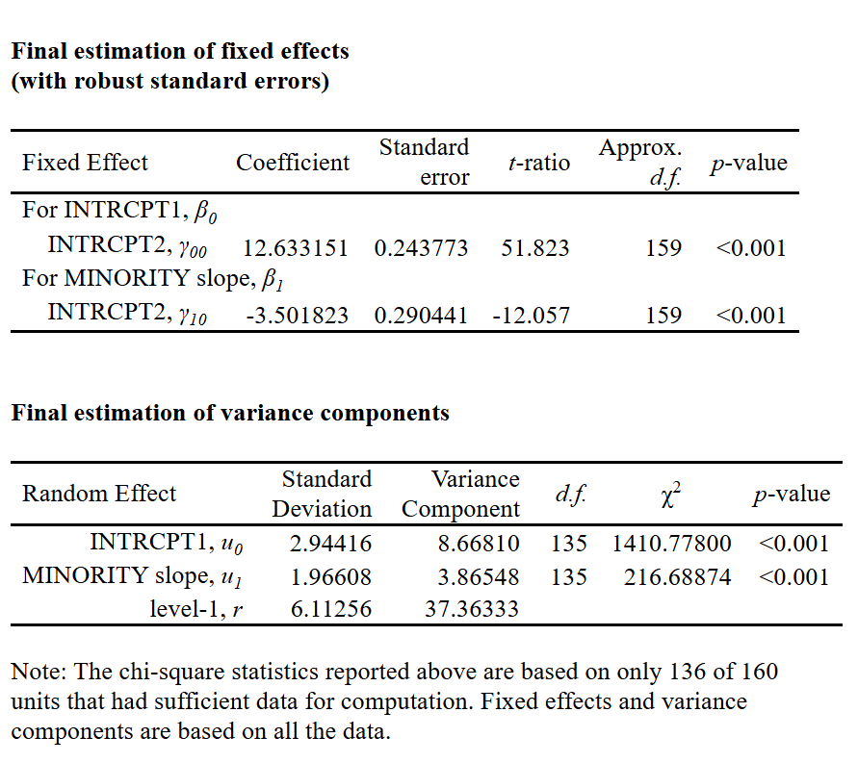
- Our Average within school gap is equal to -3.501 $(β_{w})$ with a standard error equal to 0.290
- We can see that the average within school gap decreased from the uncentered model by roughly 0.25

- First, when we notice a drop in the magnitude of the gap in the group-mean centered effect of having a minority, we can start by saying that the general model’s coefficient, the uncentered which represented the adjusted for population-level differences in effect of X, also combined between the both the adjusted (Y10) and unadjusted ($β_{w}$) effects of X, and thus when we group-mean center, the coefficient only reports the unadjusted effect. moreover, we can also note the existence of a compositional effect which is equal to the difference between the adjusted and unadjusted coefficients, which is 0.25. Overall, the group-mean centered model ignores the environmental differences, while focusing only on the individual-level gap.

- According to the estimated variance of the minority gap ($t$₁₁), it is equal to 1.966. according to the degree of freedom of 135, the X² of 216.688, and the estimated variance ($\hat{T}$₁₁) equal to 1.966, and a p-value < 0.001, we reject the null hypothesis that the variance is equal to zero. Therefore, we infer that the level of the gap within schools does indeed vary significantly across the population of schools.
- According to the unconditional covariance between the level-1 intercepts and slopes, which is equal to 1.70119, and taking into account the minority coefficient equals -3.50, then we can infer that schools with higher math scores, the minority-majority gaps’ magnitude tends to shrink. In other words, the higher the mathematical achievement, there tends to be lower minority-majority gap. 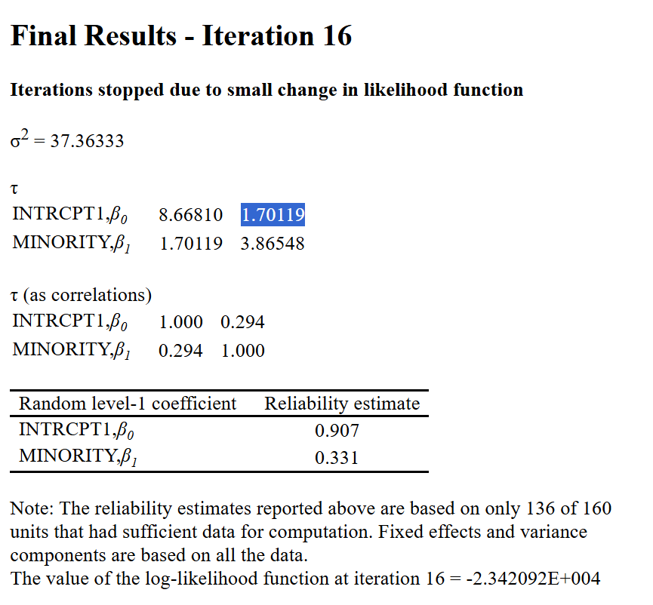
- According to the classification of the gap by sector, we notice that there is visual evidence that the right tail of the graph, which represents lower minority-majority gap levels, is occupied mainly with schools that are catholic, thus indicating that catholic schools exhibit lower levels of minority-majority gaps. Whereas the graph shows public schools occupying the left tail of the graph showing larger levels of minority-majority gaps. Thus, size of the gaps indeed varies by sector.
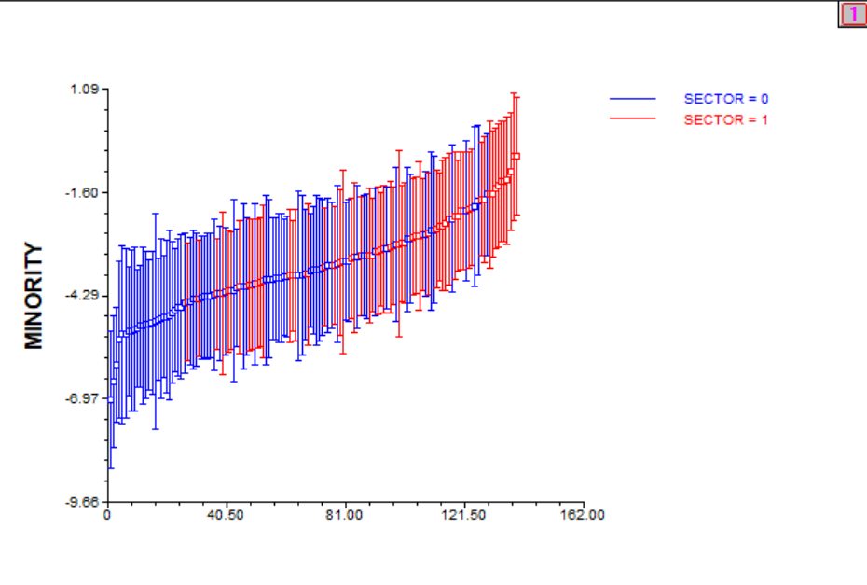

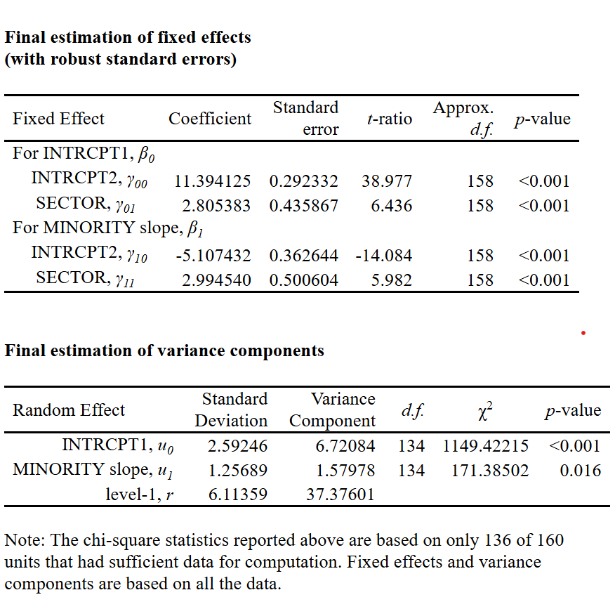
- The average minority gap in public schools equals to 5.11 units lower than majority students. While the average minority gap in catholic schools, -5.107432 + 2.994540, equals to -2.113. thus, the minority-majority gaps are expected to get reduced by 2.994 units when we move from a public to catholic school. A test directed to see whether the gaps are the same or not means that we test whether there is a difference if we moved from a public to catholic school, thus, the Y11 is the subject of the test.
- H₀: y11 = 0 ____ H_{a}: y11 != 0
- t-ratio is equal to 5.982, degrees of freedom equal to 158, and most importantly our p-vale < 0.001. thus, we reject H0 that the gaps are the same. We have statistical significant evidence to say that there is significant differences in the gaps between public and catholic schools.
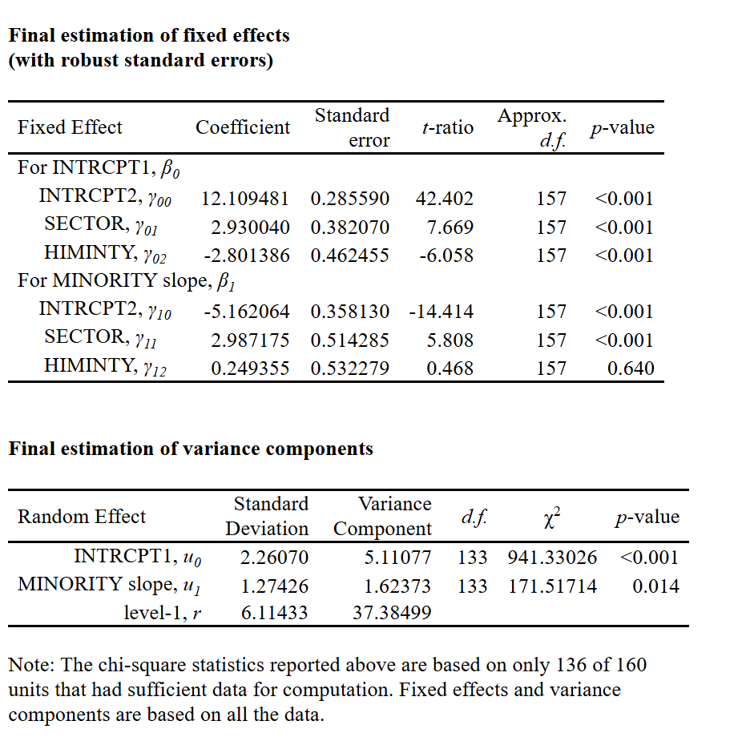

- HIMNITY (Y₀₂) refers to the mean difference in mathematical achievement between schools with more than 40% of the students being a minority, and the schools where that percentage is not exceeded by the minority, holding everything constant. Plainly, schools whose bodies of students exceed 40% of minority students are expected to attain math scores of 2.80 units lower than schools where the minority does not exceed that percentage. The HIMINTY (Y₁₂) refers to the minority effect in the mean difference between schools with more than 40% of the students being a minority, and the schools where that percentage is not exceeded by the minority, holding everything constant. In plain language, the schools whose bodies of students who are considered a minority exceeds 40% of the overall number of students tend to increase the minority-majority gap by 0.244 units. it must be mentioned that the HIMINTY (Y₁₂) is statistically insignificant and indistinguishable from zero.
- We can say that even after we account for the racial makeup for the school, the catholic schools’ math scores, the y01 coefficient, remains higher on average than public schools. The average indeed changes as it changed from 2.805 to 2.930 and therefore we can say that the racial makeup effect does not change the fact that school sector still has an independent positive association with achievement. On the other hand, the minority concentration effect of schools is not significant, which means it does not significantly change the slope. Thus, the racial makeup effect changes average achievement more than it changes the size of the minority-majority gap.

- First, we have learned that, on the population level of schools, there is a national math achievement minority-majority gap. On average, the minority students, the African Americans and Hispanics, are expected to achieve math scores than their white students counterpart. Moreover, when we modified the model as to center the majority gap with the school itself, we found that the gap decreased, which means that this is a compositional that reflects more accurately the differences of the schools themselves while isolating the noise, environmental and population-level additional effect. Moreover, according to our estimates, we have significant evidence proposing that the levels of gaps do vary from school to school as there might be schools with bigger or lower gap levels that others. For the covariance of the higher achievement and gaps, according to our tests, we can conclude that we have a covariance that indicates that the schools who has higher achievement are expected to have lower minority-majority gaps across schools. Moreover, we noticed that the gap levels tend to vary by school sector; public schools appear to have larger levels of gaps than catholic schools, perhaps the case in public school is determined by the socioeconomic status of the students, while in catholic schools they are more egalitarian in nature. Consequently, we also noticed that in 1980, the gap levels was expected to decrease by a relatively large magnitude when the school is a catholic school. As for the racial makeup of the school, we noticed that in 1980, the schools whose students concentration is more than 40% of minorities, the school is expected to achieve lower average math score, while also the same school’s gap level is expected to increase. Overall, the racial dynamics in the U.S. in 1980 had a major determining effect on the average math scores. Perhaps one major reason for that is the that the new laws of equality and support for the minorities were not fully realized yet.
Part 2
- VOCAB_{ti} = π_{0i} + π_{1i}*(AGE18_{ti}) + π_{2i}*(AGE18SQ_{ti}) + e_{ti}
- π_{0i}: this represents the intercept that is interpreted as the expected vocabulary size for individual i at the age of 18 months. It also represents the initial status of the study of the individual i at time t, 18 months.
- π_{1i}*(AGE18_{ti}): this coefficient refers to the instantaneous growth rate for person i at the age of 18 months.
- π_{2i}*(AGE18SQ_{ti}): this is the curvature term that captures the acceleration in each growth trajectory. It represents the non-linear or quadratic change in growth trajectory in the model.
- e_{ti}: this represents the error term in the model, where it is assumed independent and normally distributed with a mean of 0 and constant variance, $σ^{2}$.

- π_{0i} = β₀₀ + r_{0i}
- β₀₀: this represents the overall mean vocabulary sizes of the different individuals. This is the mean of individual means or the mean intercept.
- r_{0i}: this is the level-2 model’s error term for the intercept slopes. It is the random slopes that deviate from the overall fixed intercept for the individual i at 18 months
- π_{1i} = β₁₀ + r_{1i}
- β₁₀: this is the mean growth rate of the vocabulary sizes of the different individuals at 18 months age.
- r_{1i}: this represents the error term in the level-2 model for the slopes of the growth rates. This is the overall variance of the slope of the individual from the overall linear fixed slope at age 18 months.
- π_{2i} = β₂₀ + r_{2i}
- β₂₀: this is the mean acceleration of the slopes across the different individuals at age 18 months.
- r_{2i}: this is the error term in the level-2 model for the slopes of acceleration of individual vocabulary learning. Moreover, this is the overall variance from one slope of curvature to the other.
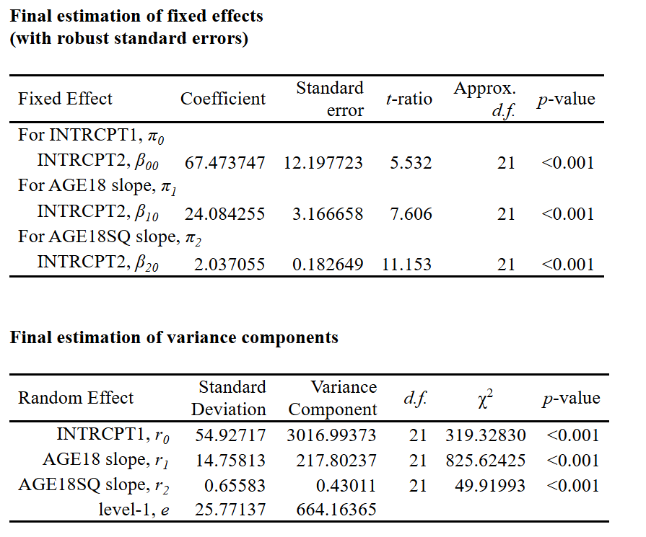

- β₀₀: This is the intercept in our model which represents which refers to the mean vocabulary size of individuals, which equals to 67.474 words, when the individuals are at the age of 18 month. As an initial point, this means that individuals at the age of 18, children, have already acquired an average of 67.474 words
- β₁₀: this is the instantaneous growth rate for the individuals at 18 months. On average, the individuals at the age of 18 months. Before the curvature is taken into account, a one month increase in the age of the individuals after a18 month age, there is an expected increase in the vocabulary size by 24.084 words. This is also the average slope at the specified age.
- Β₂₀: this is the quadratic term that represents the curvature or the acceleration rate in each growth trajectory, which is equal to 2.037. this means on average, children at the age of 18 months are acquiring new words at an increasing rate over time.

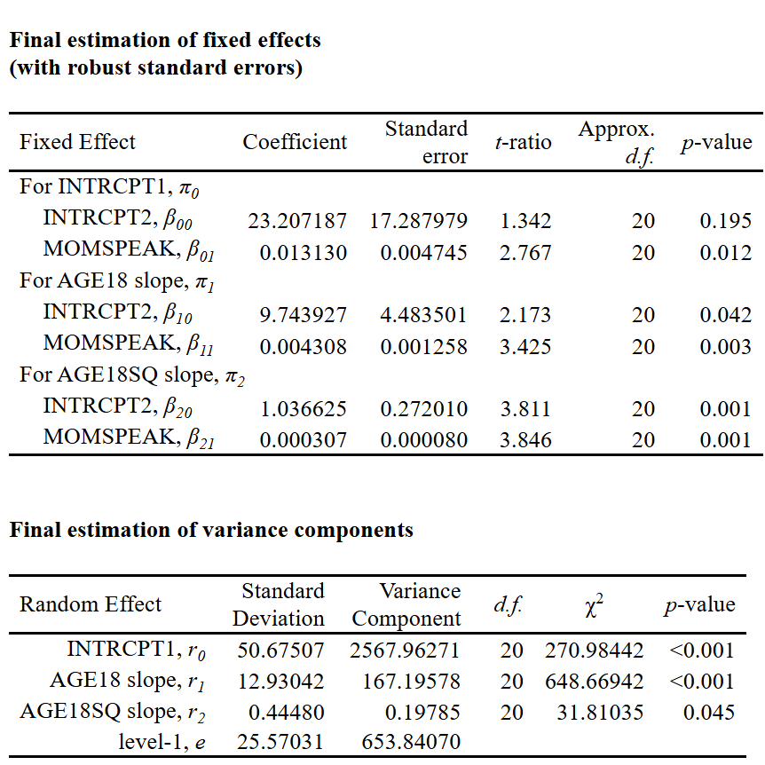
- –
- β₀₀: this is the intercept that refers to the mean vocabulary size for the different individuals at the age of 18 month, which is equal to 23.207 words/month.
- β₀₁: this is positive association between the average slopes of vocabulary sizes for the individuals at age 18 month and the average amount of mother’s speech which is equal to 0.013130 words/month.
- β₁₀: this is the instantaneous growth rate for the vocabulary size for the individuals with age of 18 months. It is now 9.744 words/month
- β₁₁: this coefficient represents the amount by which the vocabulary size increases or decreases for the individuals at the age of 18, with each 1 month increase. In this case it is positive which means the instantaneous growth rate of the vocabulary size increases by 0.004308 words/month
- After add the MOMSPEAK variable, we can notice several things. First, the p-values for all the coefficient became insignificant and indistinguishable from zero. The addition of the variable MOMSPEAK represents a suppression effect for the other variables, probably due to high multicollinearity since the coefficients decreased while the standard errors increased. Moreover, the magnitude average vocabulary sizes, instantaneous growth rate, and the curvature of the growth rate, all now have substantial reductions in the estimates, most likely this is due to the variable MOMSPEAK being a mediator.
