PartA

1. OLS estimate of the “national gap”
I estimated the minority-majority achievement gap using an ordinary least squares regression:
MATHACHᵢⱼ = β₀ + β₁MINORITYᵢⱼ + eᵢⱼ
The results:
• Intercept: 13.882
• Minority coefficient: -4.130
• Standard error: 0.175
Thus, the estimated national gap is -4.13.
Across the full national sample, minority students scored about 4.13 points lower in math achievement than majority students on average.

2. HLM estimate of the “within-school gap”
To estimate the minority-majority gap within the same school, the MINORITY variable was group-mean centered:
MINORITYCWCᵢⱼ = MINORITYᵢⱼ − M̄INORITY·ⱼ
The two-level model is:

Level 1
MATHACHᵢⱼ = β₀ⱼ + β₁ⱼ(MINORITYCWCᵢⱼ) + rᵢⱼ

Level 2
β₀ⱼ = γ₀₀ + γ₀₁(M̄INORITY·ⱼ) + u₀ⱼ
β₁ⱼ = γ₁₀
Estimated results:
Average within-school gap: -3.554
Standard error: 0.222
Thus, the within-school gap is -3.55.
When comparing students within the same school, minority students score about 3.55 points lower than majority students on average.

3. Comparison of the two gaps
National gap: -4.13
Within-school gap: -3.55
The national gap is larger by about 0.58 points.
Substantive explanation:
The national gap reflects differences within schools.
It also reflects differences between schools, because minority students are more likely to attend lower-achieving schools.
Because minority students are more likely to attend lower-achieving schools, the national gap includes both components. The within-school gap removes between-school differences, making it smaller.

4. Do minority-majority gaps vary across schools?
A random-slope model was estimated:
β₁ⱼ = γ₁₀ + u₁ⱼ
Results:
• Average gap: -3.577
• Variance of slope: 3.863
• Intercept–slope covariance: 1.992
• Likelihood ratio test: approximately 26.74

Statistical evidence
The nonzero slope variance and the likelihood ratio test indicate that the minority-majority gap varies significantly across schools.

Relationship with school achievement
The positive covariance (1.992) implies that higher-achieving schools tend to have less negative gaps, meaning smaller disparities.

Empirical Bayes plot interpretation
The empirical Bayes estimates range from approximately -6.8 to -0.7, indicating substantial between-school heterogeneity. Visually, Catholic schools tend to cluster toward smaller (less negative) gaps, whereas many of the largest gaps appear among public schools. However, confidence intervals overlap considerably, so the visual evidence is suggestive rather than conclusive.

Comparison between Figure 3 and the model results
Figure 3 provides descriptive evidence that gaps vary across schools and may differ by sector. However, the graph does not control for other school characteristics and does not itself provide a formal hypothesis test. The multilevel models below are therefore needed to determine whether sector differences are statistically meaningful.

Adding school sector
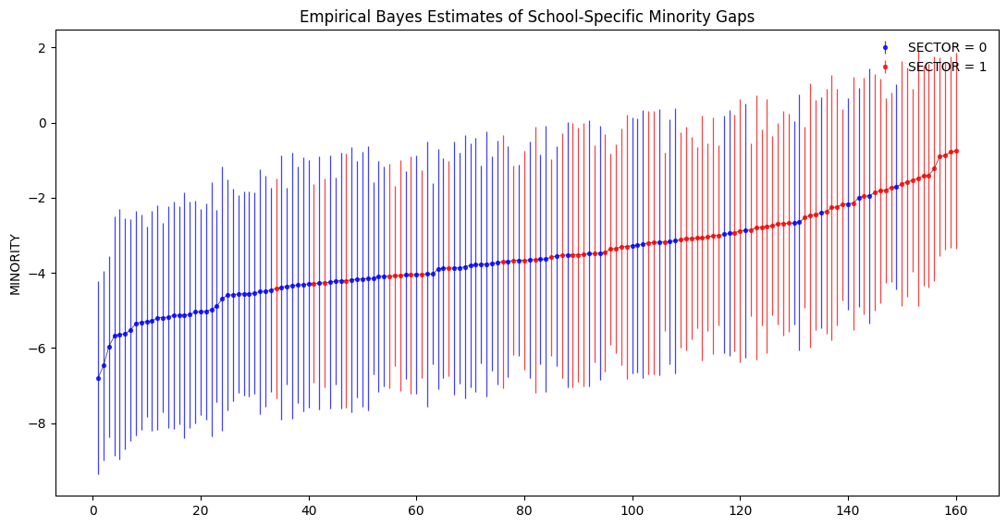
I added school sector as a level-2 predictor for both the intercept and the minority slope. In the data, SECTOR = 1 indicates a Catholic school.
coefficients:
Minority slope: -5.050
Minority × Sector: +2.990

Average minority gap in public schools
Gappublic = −5.050
Thus, the estimated average minority gap in public schools is -5.05.

Average minority gap in Catholic schools
GapCatholic = −5.050 + 2.990 = −2.060
Thus, the estimated average minority gap in Catholic schools is -2.06.

Hypothesis test
H₀: γ₁₁ = 0
Estimate: 2.990
p-value: < .001
I reject H₀ and conclude that the minority-majority gaps in public and Catholic schools are significantly different.

Interpretation
Public schools show an average minority-majority gap of about 5.05 points, while Catholic schools show an average gap of about 2.06 points. This indicates that Catholic schools have significantly smaller minority-majority achievement gaps.

6. Adding HIMINTY (school racial composition)
HIMINTY equals 1 if minority enrollment in a school exceeds 40 percent. I added HIMINTY to the model along with sector for both level-1 terms.
Main results:
• HIMINTY: 0.853 (not statistically significant)
• Minority × HIMINTY: 0.101 (not statistically significant)
• Sector effects remain statistically significant

Interpretation of the HIMINTY coefficients
The HIMINTY coefficient on the intercept suggests that majority students in high-minority schools are predicted to score about 0.85 points higher than those in low-minority schools, holding other variables constant. However, this estimate is not statistically significant, so there is no strong evidence of a meaningful difference in average achievement.
The minority × HIMINTY coefficient suggests that the minority-majority gap is about 0.10 points less negative in high-minority schools. This effect is extremely small and not statistically significant, so there is no evidence that school racial composition systematically changes the size of the gap.

How HIMINTY changes the interpretation of sector effects
After adding school racial composition, the sector effect remains strong and the interaction between sector and minority status remains significant. This means that the smaller minority-majority gap in Catholic schools cannot be explained simply by differences in racial composition across schools.

7. Summary
The analysis shows that there was a substantial minority-majority math achievement gap in the United States in 1980. Using OLS, the national gap was estimated at about 4.13 points, with minority students scoring lower on average. When comparing students within the same school using a hierarchical model, the gap was smaller, about 3.55 points, indicating that part of the national gap reflects differences between schools as well as differences within schools.
The results also show that the gap varies significantly across schools, with higher-achieving schools tending to have smaller gaps. The empirical Bayes plot provided descriptive evidence of this variation and suggested that Catholic schools may have smaller gaps, although this visual evidence was not conclusive.
The multilevel models confirmed that Catholic schools have significantly smaller minority-majority gaps than public schools, and this difference remains even after controlling for racial composition. In contrast, HIMINTY was not statistically significant, suggesting that differences in school racial composition do not explain variation in the gap.
Overall, the findings indicate that the achievement gap is real, varies across schools, and is systematically smaller in Catholic schools, highlighting the importance of school context beyond individual-level differences.

Part B
- Level-1 Model
$$AGE18_{ti}=AGE_{ti}−18$$
$$AGE18SQ_{ti}=(AGE_{ti}−18)^{2}$$

The level-1 model is:
$$VOCAB_{ti}=π_{0i}+π_{1i}AGE18_{ti}+π_{2i}AGE18SQ_{ti}+e_{ti}$$

π0i: Predicted vocabulary size for child i at 18 months (intercept)
π1i: Instantaneous linear growth rate at 18 months
π2i: Quadratic term capturing acceleration (curvature) in vocabulary growth
eti: Level-1 residual (within-child variability over time)

2. Level-2 Model (Random Effects for All Level-1 Terms)
π0i=β00+r0i
π1i=β10+r1i
π2i=β20+r2i​

Interpretation:
β00: Average vocabulary size at 18 months across all children
β10: Average linear growth rate at 18 months
β20: Average acceleration in vocabulary growth
r0i: Child-specific deviation in initial vocabulary
r1i: Child-specific deviation in growth rate
r2i: Child-specific deviation in acceleration
This specification allows children to differ in both their initial vocabulary levels and their growth trajectories.

3. Full Maximum Likelihood Results and Interpretation
Estimated fixed effects (approximate values):
- β00≈67.47
- β10≈24.08
- β20≈2.04

Substantive Interpretation:
The intercept (β00) indicates that, on average, children have a vocabulary of about 67 words at 18 months.
The linear term (β10) suggests that around 18 months, vocabulary increases by approximately 24 words per month, indicating rapid growth.
The positive quadratic term (β20) indicates that vocabulary growth is accelerating over time, meaning that children not only gain words, but do so at an increasing rate.

Conclusion on Growth Shape:
Vocabulary development follows a nonlinear, accelerating growth trajectory during the second year of life.

4. Adding MOMSPEAK at Level 2
The level-2 model becomes:
π0i=β00+β01(MOMSPEAKi)+r0i
π1i=β10+β11(MOMSPEAKi)+r1i
π2i=β20+β21(MOMSPEAKi)+r2i​
β01: Effect of maternal speech on vocabulary size at 18 months
β11: Effect of maternal speech on the linear growth rate
β21: Effect of maternal speech on acceleration (curvature)

Results with MOMSPEAK
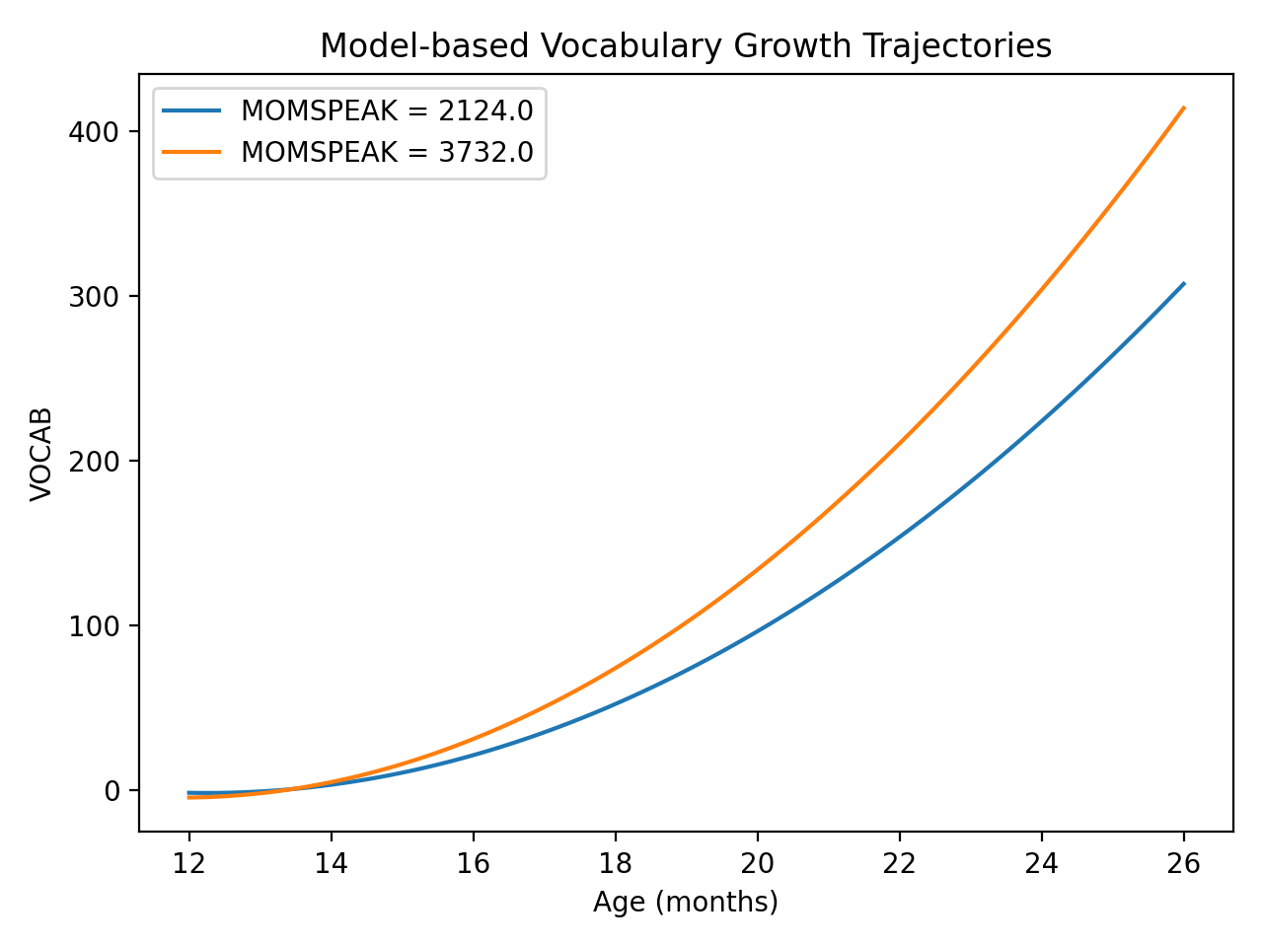
The estimates show that:
- β01>0 (significant)
- β11>0 (significant)
- β21>0 (significant)

Substantive Interpretation:
The number of words spoken by the mother at 16 months is positively associated with children’s vocabulary development. Children whose mothers speak more tend to:
Have larger vocabularies at 18 months
Exhibit faster vocabulary growth rates
Experience greater acceleration in vocabulary growth over time
Overall, maternal speech contributes both to higher initial vocabulary levels and to steeper and increasingly rapid growth trajectories.

6. Model-Based Trajectories (25th vs 75th Percentile of MOMSPEAK)
The model-based graph shows that children at the 75th percentile of MOMSPEAK have consistently higher vocabulary levels than those at the 25th percentile.The difference between the two groups widens over time
Maternal speech not only increases initial vocabulary but also accelerates vocabulary growth, leading to diverging developmental trajectories between children exposed to low and high levels of maternal speech.

Final Summary
The two-level growth model shows that vocabulary development during the second year of life follows a nonlinear, accelerating pattern. There is substantial variation across children in both initial vocabulary levels and growth trajectories. Maternal speech plays a significant role in shaping these outcomes, with higher levels of maternal input associated with higher vocabulary levels, faster growth rates, and greater acceleration. These results highlight the importance of early language exposure in influencing child development.

