Mermaid Flowcharts
This document demonstrates how to programmatically insert Mermaid diagram images into a Word document using python-docx.

Flowchart 1
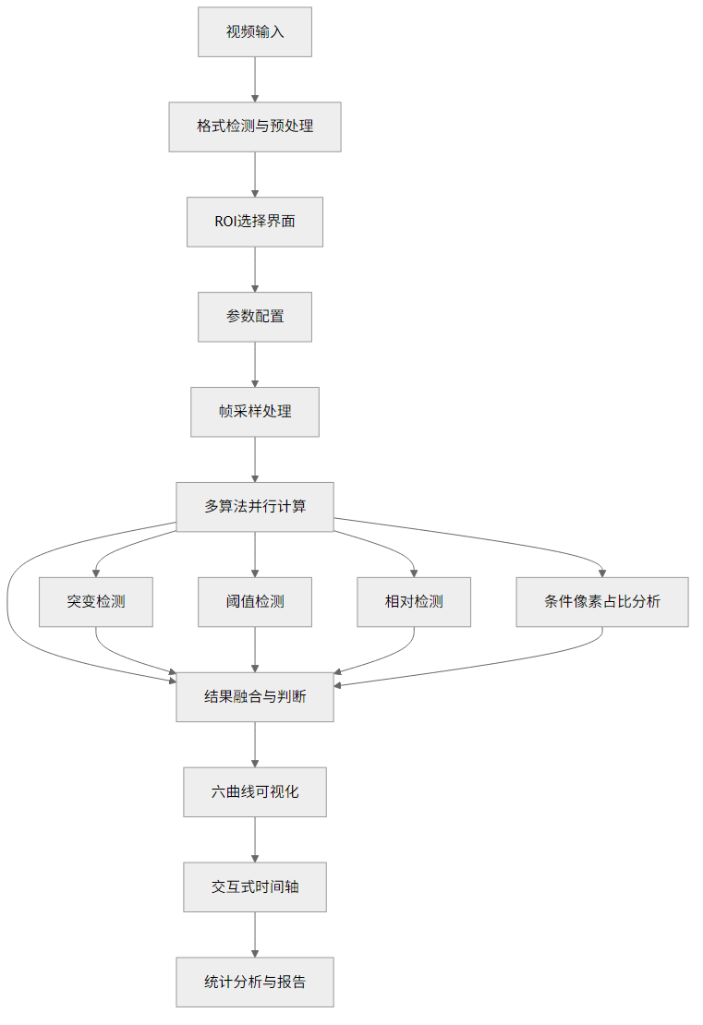
Figure 1: Diagram 1 E4598236

Flowchart 2
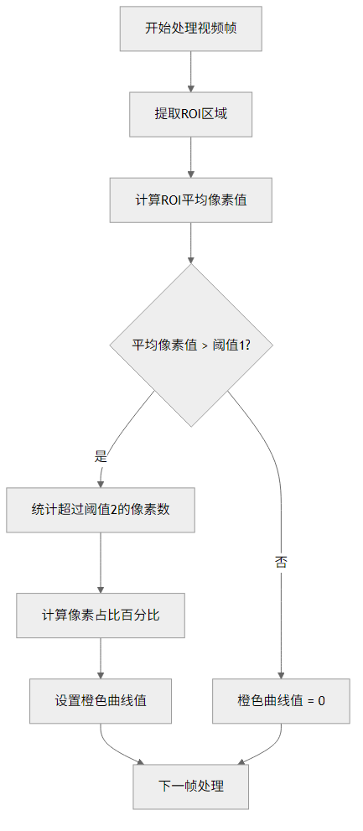
Figure 2: Diagram 2 55B6D503

Flowchart 3
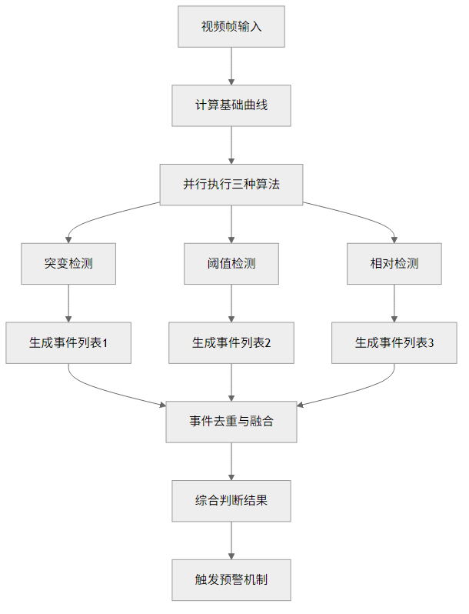
Figure 3: Diagram 3 Ec46Cfbd

Flowchart 4
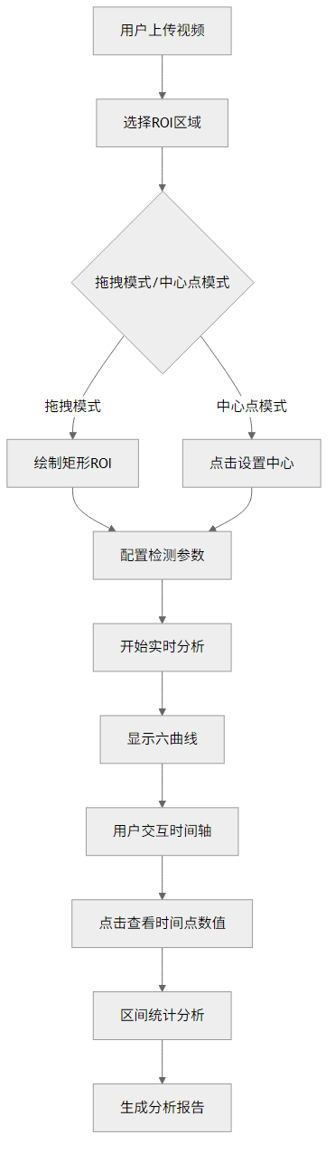
Figure 4: Diagram 4 41Baf30B

