Mermaid Diagram Test - New Configuration
This test will verify that images are saved to the project images directory.

Simple Flowchart
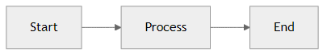
Mermaid图表

Decision Tree
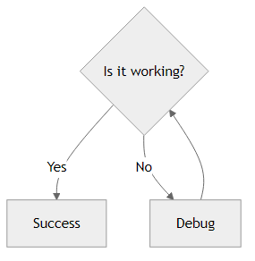
Mermaid图表

