(Cookie 1) After accessing /hello-servlet more than once, Welcome back shall be displayed. Try to delete the cookies of localhost in your browser, see what happens while visiting /hello-servlet again.

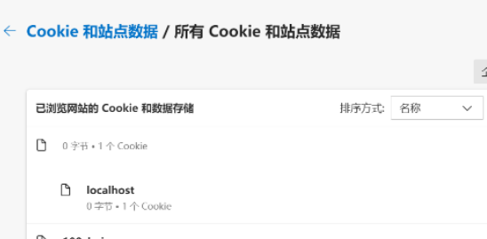

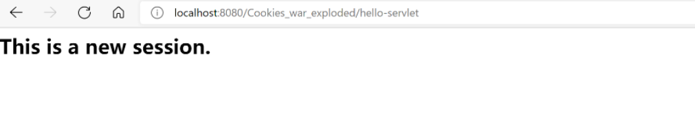

（Cookie 2) By default, your browser would accept cookies, so response.encodeURL does not necessarily fall back to URL rewriting. Try to disable the cookies for localhost in your browser.

