# 13. Figures

## 13.1 Figure 1

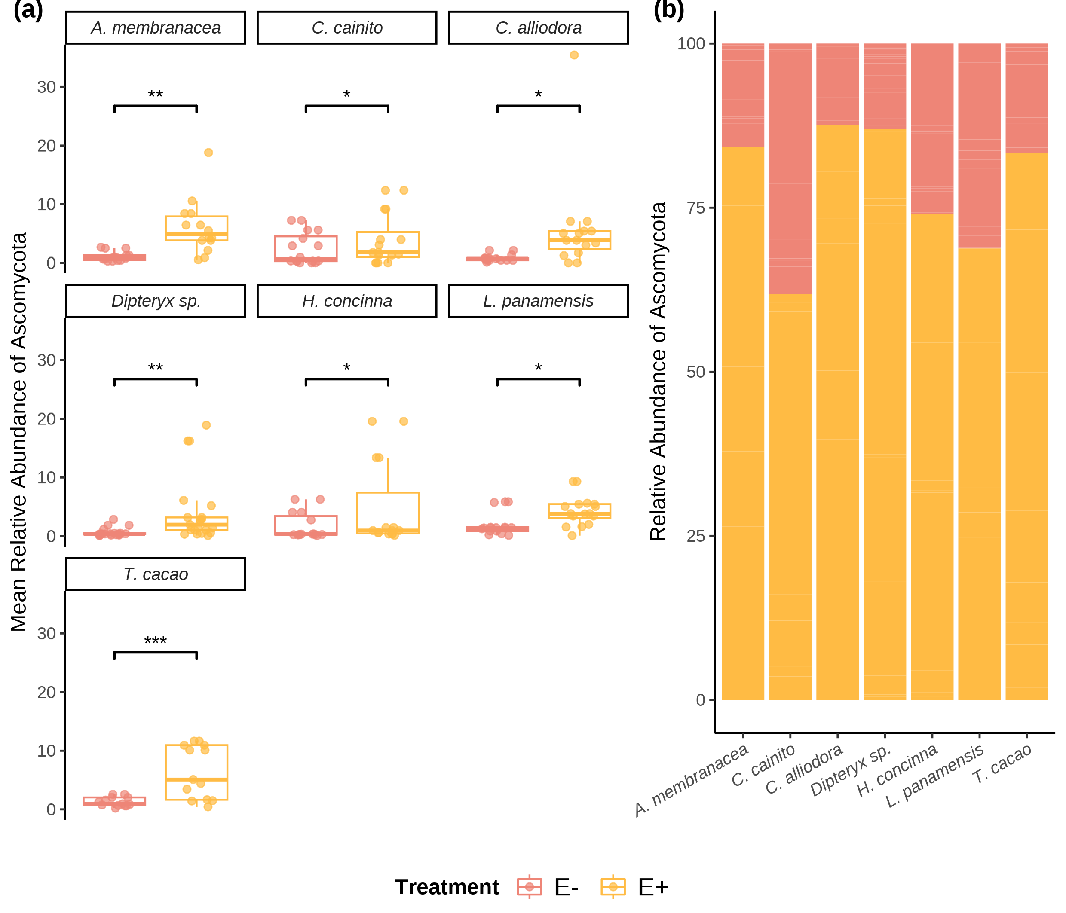

Relative abundance (RA) of Ascomycota OTUs of seven tree species used in the study. (a) Box plots show individuals’ RA and its distribution by species. (b) The RA of OTU’s by treatment withing each tree species. Pink outlined box plots represent low endophyte (*E-*) treatment and yellow filled represent high endophyte (*E+*) treatment. Relative abundance is the percentage of endophyte colonization within individuals of the same species. Statistical significance was calculated using a two-sided Student’s t-Test. Significance levels are represented by *ns* (not significant) and asterisks [*p* < 0.05 (*), *p* < 0.01 (\**\*),* p < 0.001 (***)*, p =* 0.001 (***),and *p* < 0.0001(****)].

## 13.2 Figure 2

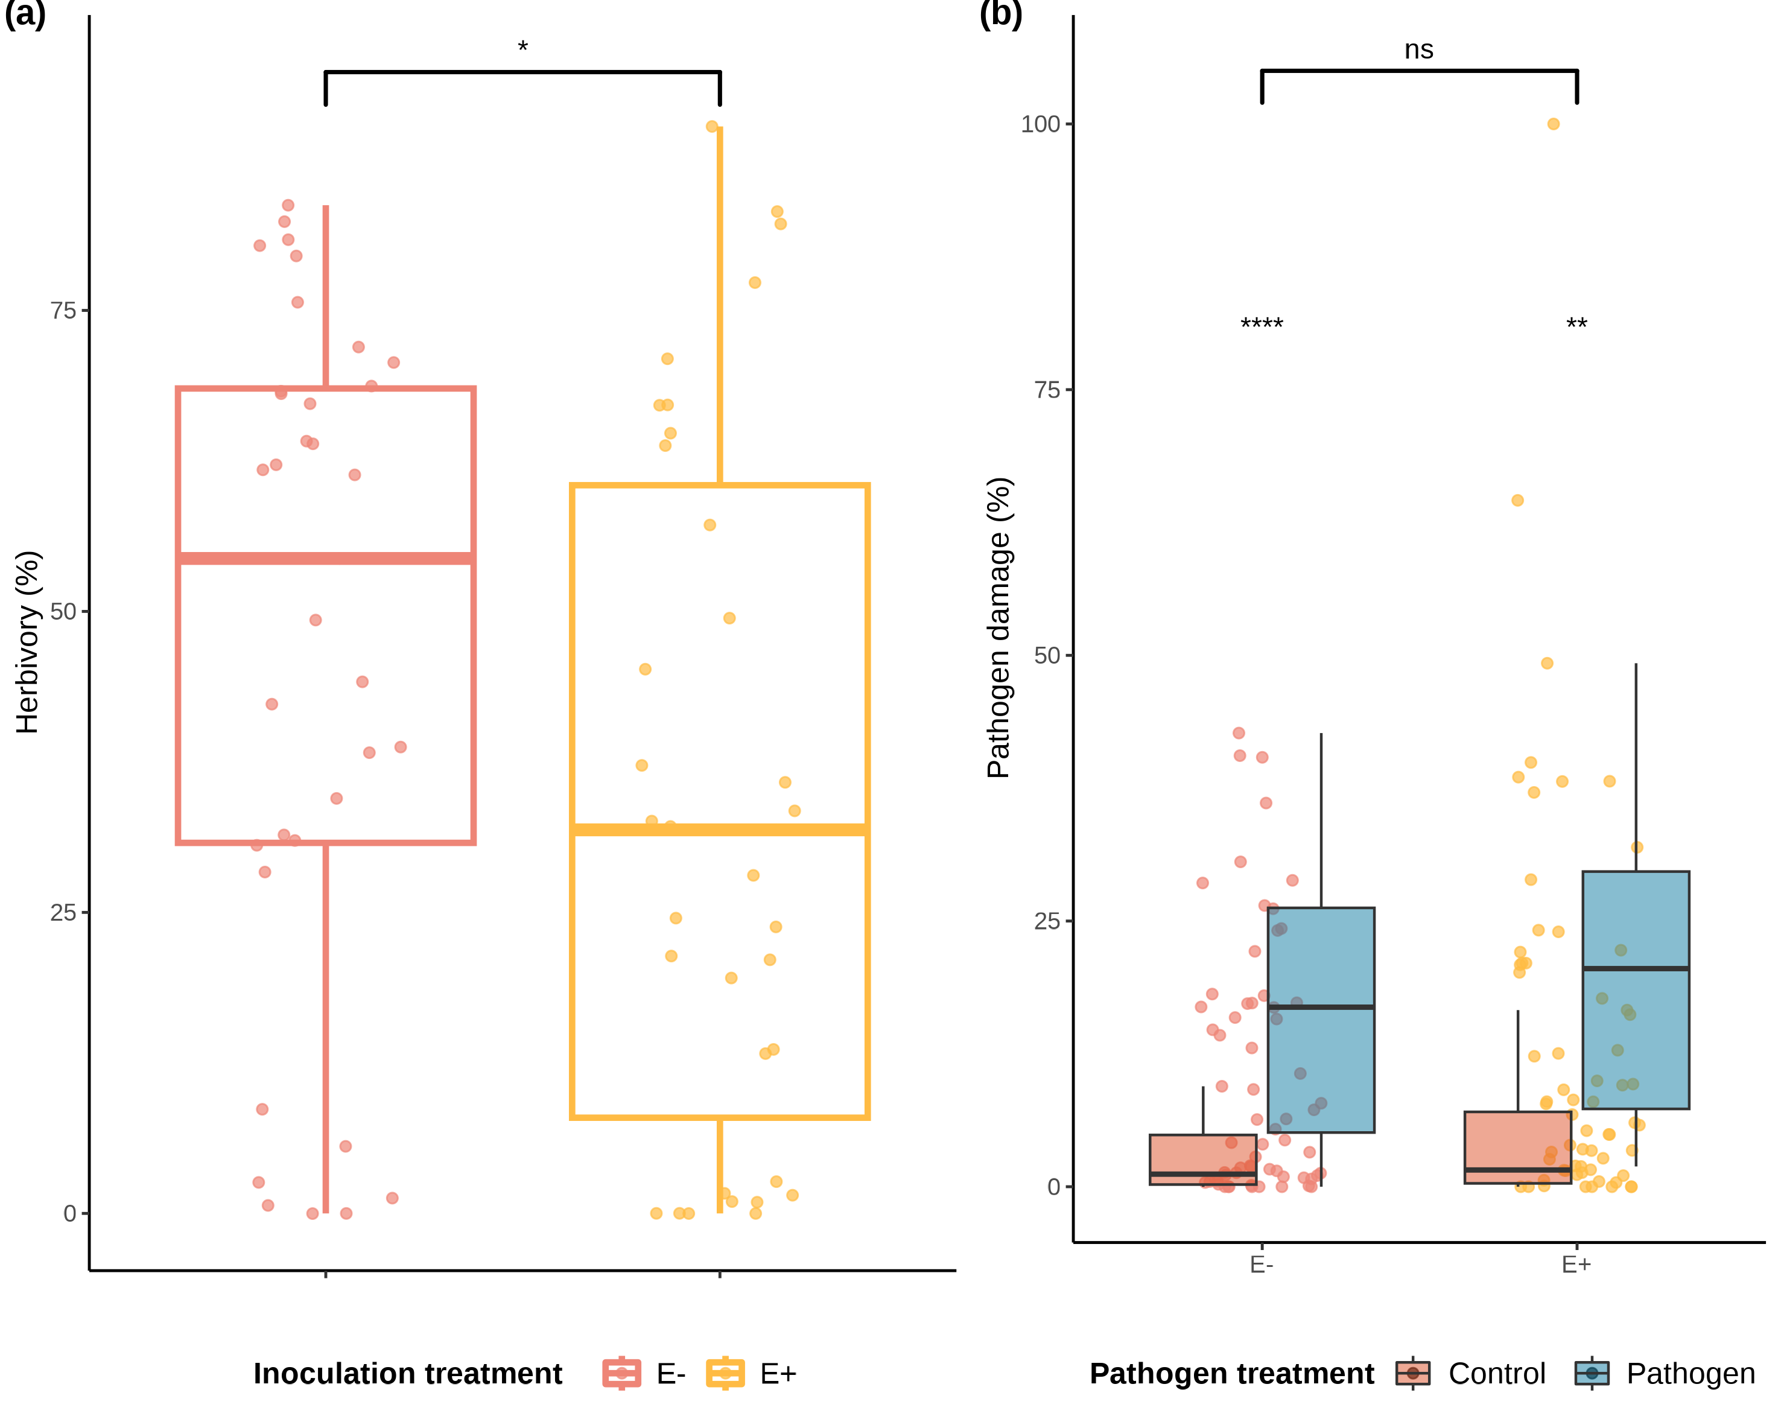

Distributions of values and means of herbivory (%) damage caused by *Atta colombica* in treatment groups (*E-* and *E+*) and tree species. a) Comparison of herbivory (%) means between treatment groups across individuals of all species. outlined box plots represent low FEF group (*E-*) and yellow outlined box plots represent high FEF group (*E+*). b) Comparison of pathogen (%) means between treatment groups across individuals of all species. Maroon filled violins represent control leaves and blue filled violins represent pathogen treated leaves. Statistical significance was calculated using a two-sided Student’s t-Test. Significance levels are represented by *ns* (not significant) and asterisks [*p* < 0.05 (*), *p* < 0.01 (\**\*),* p < 0.001 (***)*, p =* 0.001 (***),and *p* < 0.0001(****)].

## 13.3 Figure 3

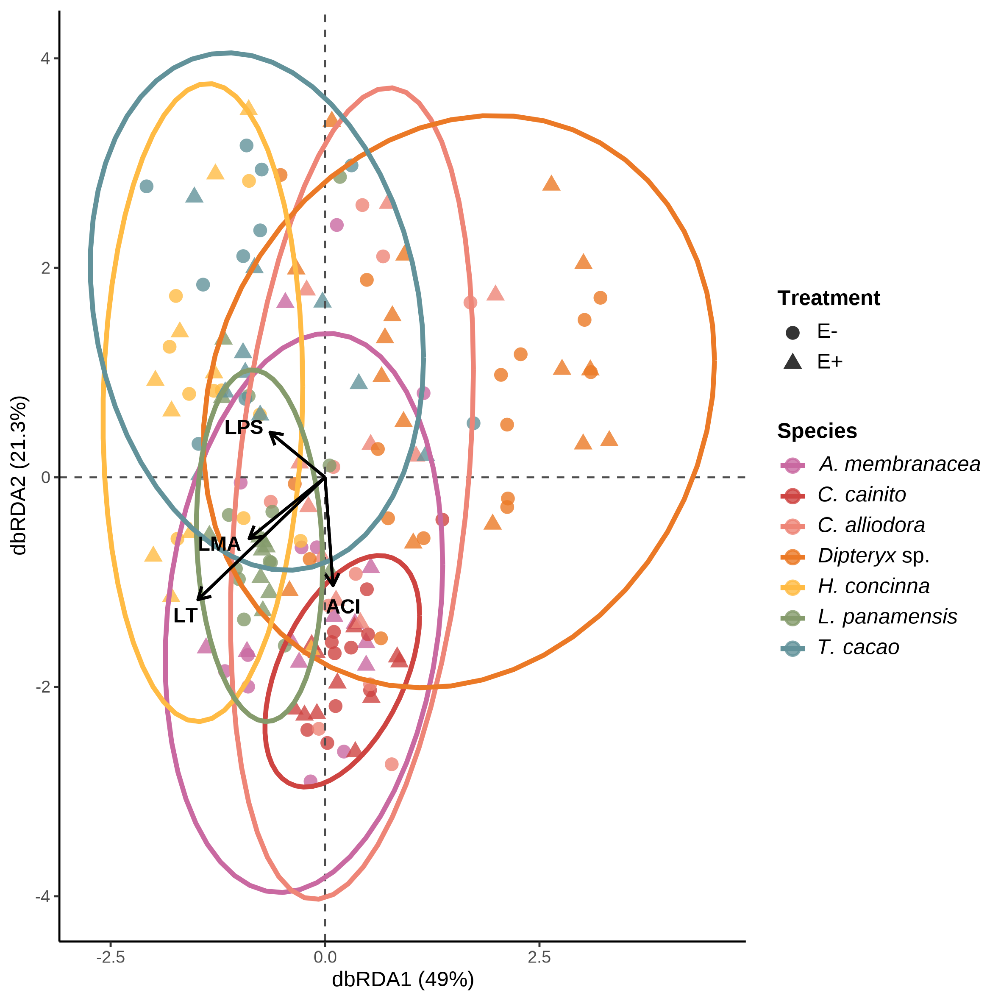

FEF community composition was associated with leaf functional traits from the leaf economic spectrum (genomic data set). variation in FEF community composition within and between host species (*n* = 7) and treatment groups (*E*-, *E*+) from distanmce-based redundancy analyses (dbRDA). Solid arrows represent statistically sisgnificant associations (*p* < .05). Each point represent a FEF community samples from one host tree species per treatment group; colors represent host tree species. Circles and filled triangles represent low (*E*-) and high (*E*+) FEF treatment groups, respectively.

## 13.4 Figure 4

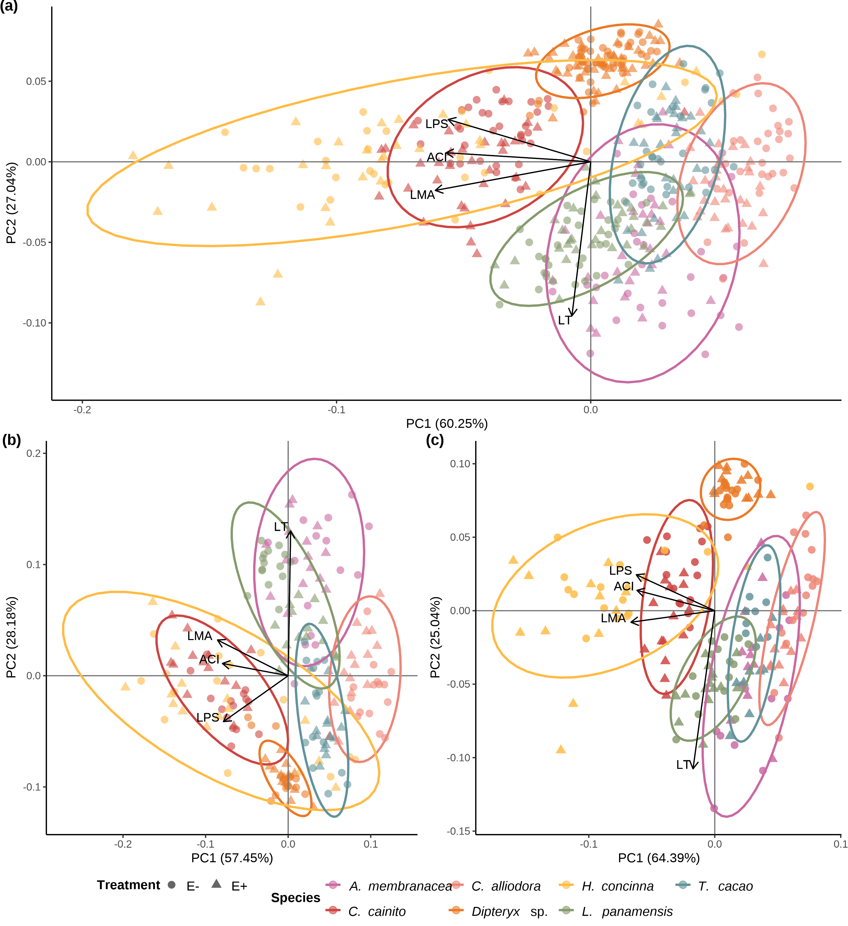

Leaf Functional traits are conserved within tree species regardless of endophyte load treatment. (a) Principal Component Analysis (PCA) of leaf functional traits from all tree species separated by *E-* and *E+* treatment. (b) PCA of leaf functional traits of plants solely used in ant herbivory assays. (c) PCA leaf functional traits of plants used solely in pathogen damage assays. Colors represent tree species. Circle and triangles represent low (*E-*) and high (*E+*) FEF treatment groups, respectively. Colored ellipses correspond to tree species and represent 95% confidence intervals.

## 13.5 Figure 5

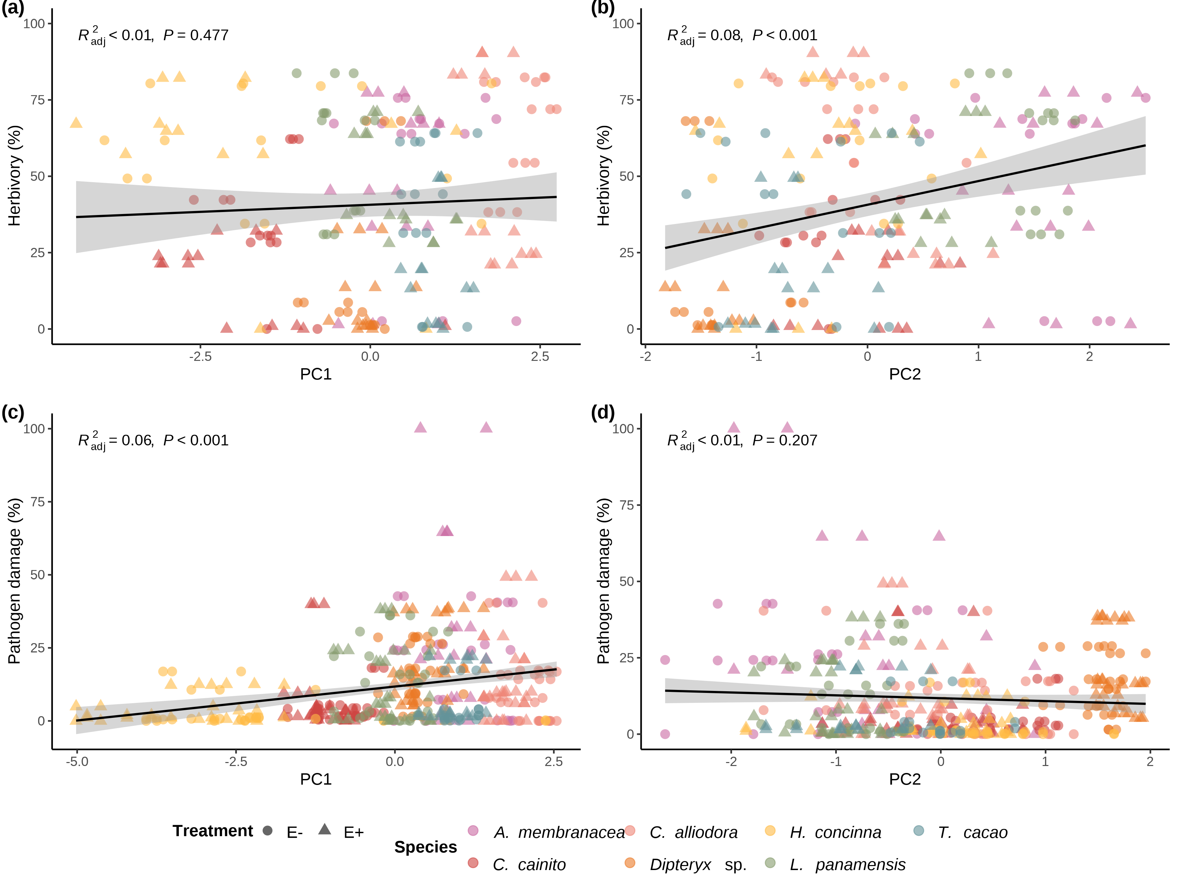

Simple linear regressions of herbivory and pathogen damage on PC1 and PC2 axes from PCAs of leaf traits for ant herbivory and pathogen damage assays. Linear regression of a) percent herbivory damage and PC1 axis (R2-adjusted= -0.0024, *p* = 0.447); b) percent herbivory damage and PC2 axis (R2-adjusted = 0.079, *p* = <0.001); c) percent pathogen damage and PC1 axis (R2-adjusted = 0.064, *p* = <0.001); and d) percent pathogen damage and PC2 axis (R2-adjusted = 0.0016, *p* = 0.207). Colors represent individual species. Circle and triangles represent *E-* and *E+* treatments, respectively.