Code description for ACCESS-Fire output analysis project

Contents
Project Layout 1
Folder structure 1
Github storage 1
Quick Start + example 2
Example 2: create figure sequence and video 2
Whole process with new model output 3
Converting new model output to netcdf 3
Scripted version of this 4
Reading into python (and plotting weather summary) 4

Project Layout

Folder structure
Base folder:
python scripts for plotting, testing, and analysing model output
data: netcdf model outputs, AWS and linescans, background tiff images for both sites
figures: script outputs organised as model_run/script_name/figure_name.png
outputs: posters or summaries created using project outputs
utilities: modules for use within the project, such as fio and plotting procedures

Github storage
For simplicity I've been using github to back up and version control the code, and most of it runs quite well on a small old laptop if a copy or subset of the data is available locally.
https://github.com/jibbals/accessfires

Quick Start + example
First you will need an appropriate python environment, on NCI these two lines will enable and load a predefined environment with everything already in it:
module use /g/data3/hh5/public/modules
module load conda/analysis3
Some scripts will require more RAM or CPU than is available on the user nodes, and you may need to send them to the queue, or run from a suitably configured interactive job. Running the scripts directly will run whatever code is within the script as well as anything in the __name__=='__main__' block at the end (see following example)
EXAMPLE (on NCI in GADI):
cd /g/data/en0/jwg574/accessfires/
module use /g/data3/hh5/public/modules
module load conda/analysis3
python vert_motion_slices.py
This runs the code in vert_motion_slices.py, including the "main" block (shown below)
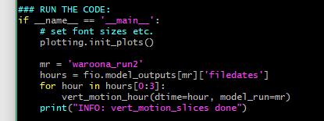
producing the following output:
INFO: Reading(iris) data/waroona_run2/umnsaa_2016010515_slv.nc
INFO: Reading(iris) data/waroona_run2/umnsaa_2016010515_mdl_ro1.nc
…
INFO: Saving figure: figures/waroona_run2/vert_motion_slices/fig_201601051750.png
INFO: Saving figure: figures/waroona_run2/vert_motion_slices/fig_201601051800.png
INFO: vert_motion_slices done

Example 2: create figure sequence and video
First step is to set up an interactive job, so you can run stuff without having the job killed for using too much cpu or ram. It's worth noting that any directories you want to see need to be specified in the job options

- First set up an interactive job (on express queue using en0 project quota, 32GB ram, job dies after 9 hours)
qsub -I -q express -P en0 -lmem=32GB,jobfs=20GB,walltime=9:00:00,storage=scratch/en0+gdata/en0+gdata/hh5
- Then change to our directory, load python environment[, and create the figures you want]
cd /g/data/en0/jwg574/accessfires/
module use /g/data3/hh5/public/modules
module load conda/analysis3
python weather_summary.py
Output from this (given weather_summary.py main block below):
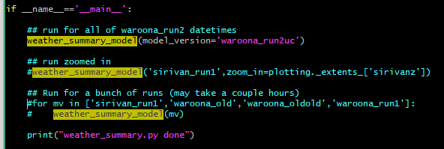INFO: Reading(iris) data/waroona_run2uc/umnsaa_2016010515_slv.nc
…
INFO: Saving figure: figures/waroona_run2uc/weather_summary/fig_201601061500.png
weather_summary.py done
- Then go to the figure directory, load and run ffmpeg to stitch the figures together into mp4:
module load ffmpeg
ffmpeg -pattern_type glob -framerate 2 -i '*.png' -pix_fmt yuv420p video.mp4

Whole process with new model output

Converting new model output to netcdf
- Go to iris_conversion directory, load required modules and set up environment
cd /g/data/en0/jwg574/iris_convert
module use ~access/modules
module load iris/1.12.0
module load nco/4.6.4
export VN=10.6
export STASHMASTER=/projects/access/umdir/vn$VN/ctldata/STASHmaster/STASHmaster_A
export STASHMASTER_META=/projects/access/umdir/vn$VN/ctldata/STASHmaster/STASHmaster-meta.conf
export UM2NC_PATH=/g/data/en0/jwg574/iris_convert
- Run conversion on model output
./um2nc_iris.py –addattr –outfile converted_data/umnsaa_2016010515_slv.nc –infile waroona_run2uc/umnsaa_2016010515_slv.nc
- Move the data to project folder
mkdir ../access_output/waroona_run2uc
mv converted_data/* ../access_output/waroona_run2uc/

Scripted version of this
The above three steps are scripted into convert_file.pbs, which is sent to the express queue to run as follows:
qsub -v INFILE=waroona_run2uc/umnsaa_2016010515_slv.nc convert_file.pbs
A whole folder can be sent to the queue at once using:
./convert_folder.sh waroona_run2uc

Reading into python (and plotting weather summary)
- Add model run to utilities/fio.py (waroona_run2 example shown here)
