ACCESS-Fire modelled weather case studies

Jesse Greenslade1, Mika Peace2,3, Harvey Ye2, Jeff Kepert2,3, Kevin Tory2

1 Centre for Atmospheric Chemistry, School of Chemistry, University of Wollongong  
2 Bureau of Meteorology, Australia  
3 Bushfire and Natural Hazards Cooperative Research Centre, Melbourne, Australia

corresponding author: Jesse Greenslade [jwg366@uowmail.edu.au]

Abstract

Body Text

Body Text First indent

Body Text First indent 2

Body Text 2

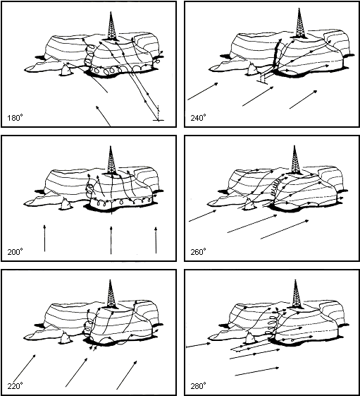

Sample Only

Figure 1. insert text

Table 1. insert text

|  |  |  |
| --- | --- | --- |
| Heading 1 | Heading 1 | Heading 1 |
| Table content | Table content | Table content |

References

Author1, A. A., B. B. Author2 and C. C. Author3, Title, *Publication,* Volume, xx-xx, doi:xxxxxxxxxx, year.