# OVERVIEW

1. Set up NCI and accessdev to run ACCESS set up NCI)
2. Figure out what region you want to simulate Determine extent of interest)
3. Download Harvey’s suite to your accessdev Download Harvey's suite)
4. Download required orography files Download orography)
5. Configure the suite to run your region Suite configuration)
6. Run the suite Start the run)

## 1) Access setup

**Need** an account with accessdev through NCI (groups: hh5, access, ...?)  
**Need** a met office UK account at <https://code.metoffice.gov.uk/>

Connecting to accessdev:

<https://accessdev.nci.org.au/trac/wiki/GettingConnected>   
need to ssh-keygen and ssh-copy-id between raijin and accessdev   
**check-access-setup** # run this to check connections

Store met office password in cached GPG agent thingy (WITHIN ACCESSDEV)

<https://code.metoffice.gov.uk/trac/home/wiki/AuthenticationCaching/GpgAgent>

mosrs-setup

mosrs-auth

mosrs-cache-password # caches access permission for 12 hours or so

Example downloading/running suites here: <https://accessdev.nci.org.au/trac/wiki/GettingConnected>

## 2) Determine extent of interest

Burn area and nearby topography should be covered in smallest high resolution nest

1. First look at burn area and nearby topography of interest to get an idea of where you want to simulate
2. Write down min and max latitude and longitude you want to cover, also the mid point of that area (I used QGIS)
3. Work out how many grid boxes will be simulated (for model configuration). Note that highest resolution nests have been .0028 and/or .0009 degrees (you could do something different). NOTE MODEL LIMITATIONS ON PROCESSOR COUNTS AND GRID BOX COUNTS: total processes should be multiple of 48, and grid boxes should be 24 * the number of processes (longitudinally and latitudinally)

EG for KI:

MIDDLE : -35.84, 137.00  
want left to right > 0.94 degrees (based on visual inspection of fire area and island)

left to right must be less than 2 degrees (to avoid missing SRTM area)  
want bottom to top > .4 degrees (and must be less than 1.68 degrees)

338 < npts_x < 714 (at .0028 resolution)  
143 < npts_y < 600 (at .0028)

npts needs to be nprocs * 24

14 < nprocs_x < 29

5 < nprocs_y < 25  
Procs inner product needs to be divisible by 48:

nprocs_y, nprocs_x = **10,24** (240 = 48*5)

grid points need to be nprocs * 24:

npts_y, npts_x = **240, 576**

## 3) Download Harvey's suite to your accessdev

1. Connect to accessdev (may require extra tools like bash/cygwin and putty and xming if using windows to connect)
2. Copy Harvey’s suite
3. It is copied into ~/roses/au-XXXX

## FOR LINUX (x11 forwarding needs to be set up)  
# (I have connections stored in ~/.ssh/config on both my laptop and in GADI)

ssh gadi

ssh access

mosrs-auth

## Downloading suite

# copy Harvey's suite:

rosie copy --prefix=au au-aa860

# vi editor will open here, can just type **:wq** to write and quite the file

# then answer yes to prompt

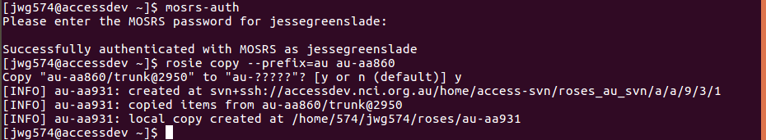

my .ssh/config file is as follows:

$ cat .ssh/config

Host access

HostName accessdev.nci.org.au

User jwg574

ForwardX11 true

ForwardAgent true

Host gadi

HostName gadi.nci.org.au

User jwg574

ForwardX11 true

ForwardAgent true

## 4) Download orography

30m data for kangaroo island

1) download 1 arc second (30m) resolution srtm topography info  
2) upload and convert to netcdf

Example:

# Harvey says to keep structure equivalent to how he's done it: /g/data/en0/hxy548/srtm/30m/  
1) get tiffs from <https://earthexplorer.usgs.gov/> - need to register to usgs

0) log in to usgs system  
a) open data tab (second tab)  
b) search for srtm data  
c) choose global 1-arc second srtm dataset  
d) back to first tab, then use the map do draw a polygon around the area you want for your smallest nest  
e) click results, then download individually as GEO tiff files

2) Upload to /g/data/en0/jwg574/srtm/30m/  
3) convert to netcdf: (Script available at /g/data/en0/jwg574/srtm/)

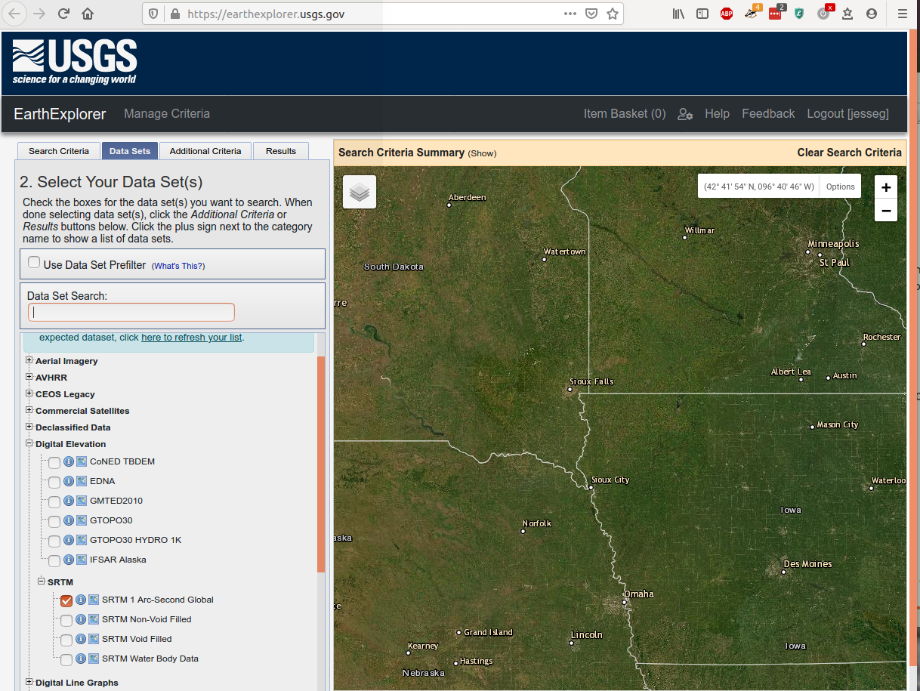

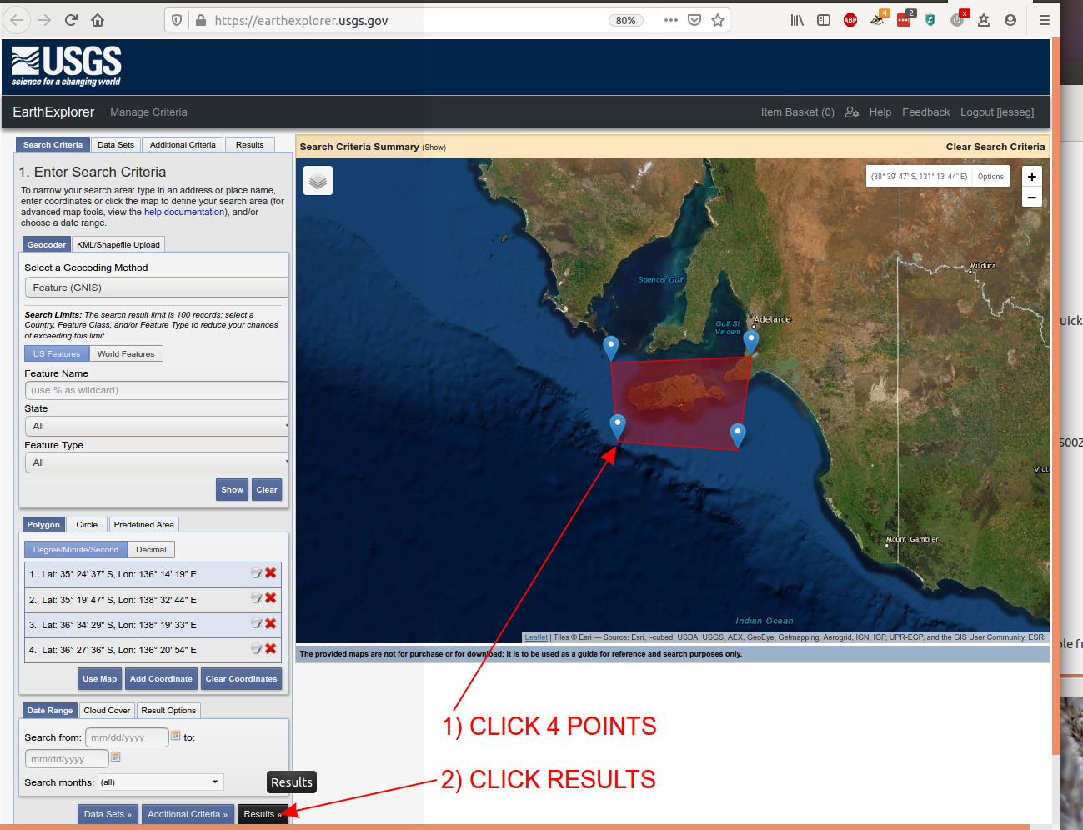

Example translating tif to nc:

module load gdal

gdal_translate -of NetCDF s31_e150_1arc_v3.tif s31_e150_1arc_v3.nc

## 5) Suite config

start dumps: ask Harvey to create start dump for case study – fire should start ~6 hours after simulation starts

1) Decide start time and ignition time for simulation

When harvey makes it, it will be in

/g/data/en0/hxy548/ics/start-dump.yyyymmddHHMM  
2) Create polygon(s), list of latlon points will go into fire.inp

1. I used QGIS to draw roughly matching fire areas to my starting simulation time
2. I then created nodes using Vector→Geometry Tools→ Extract Nodes
3. Then I saved the nodes layer as a CSV with GEOMETRY as_YX
4. They are stored in the order you draw them so it’s easiest to draw them counter clockwise for entry into fire.inp

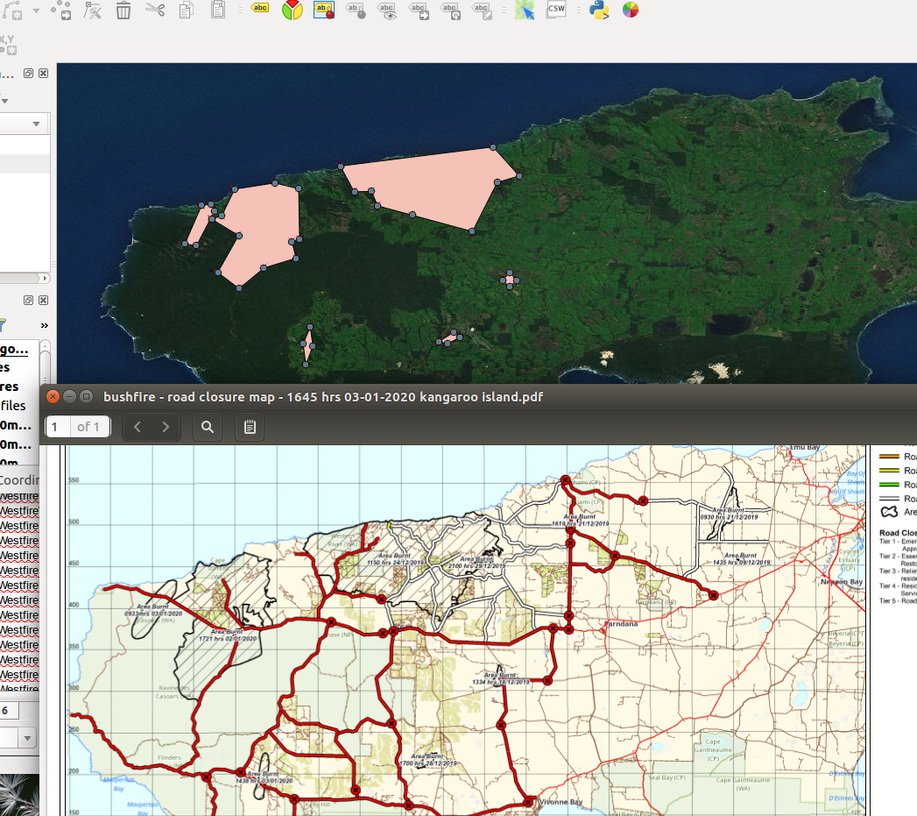

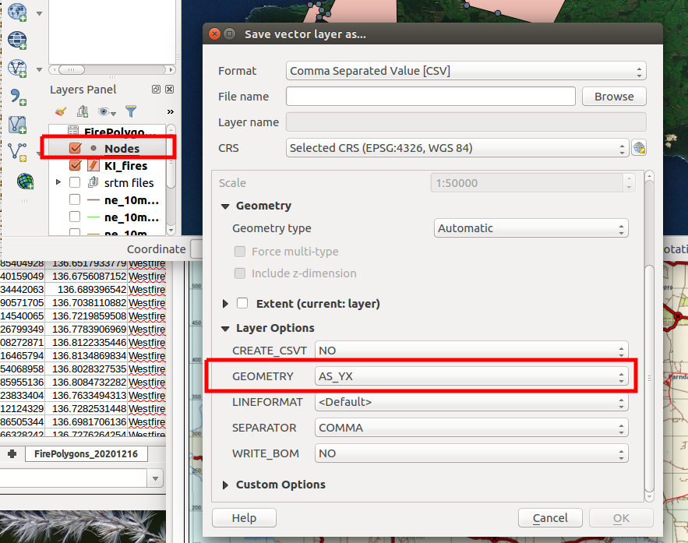

3) **fire.inp** (/roses/au-aa929/app/um/file/fire.inp -> found using "find ./ -name fire.inp")

1. Simulation start time
2. geopath (where you put srtm)
3. Constant Fuel flags   
   (until we have fuel files sorted out)
4. 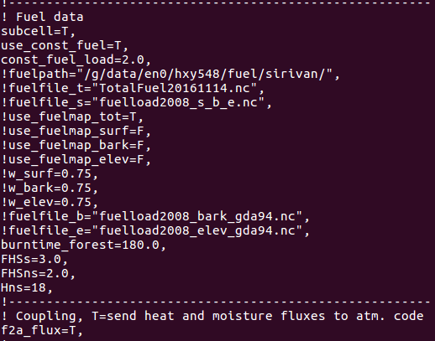Polygons for fire  
   I created the strings in excel based on lat,lon columns, then pasted into the fire.inp document fixing up the indices and spacing

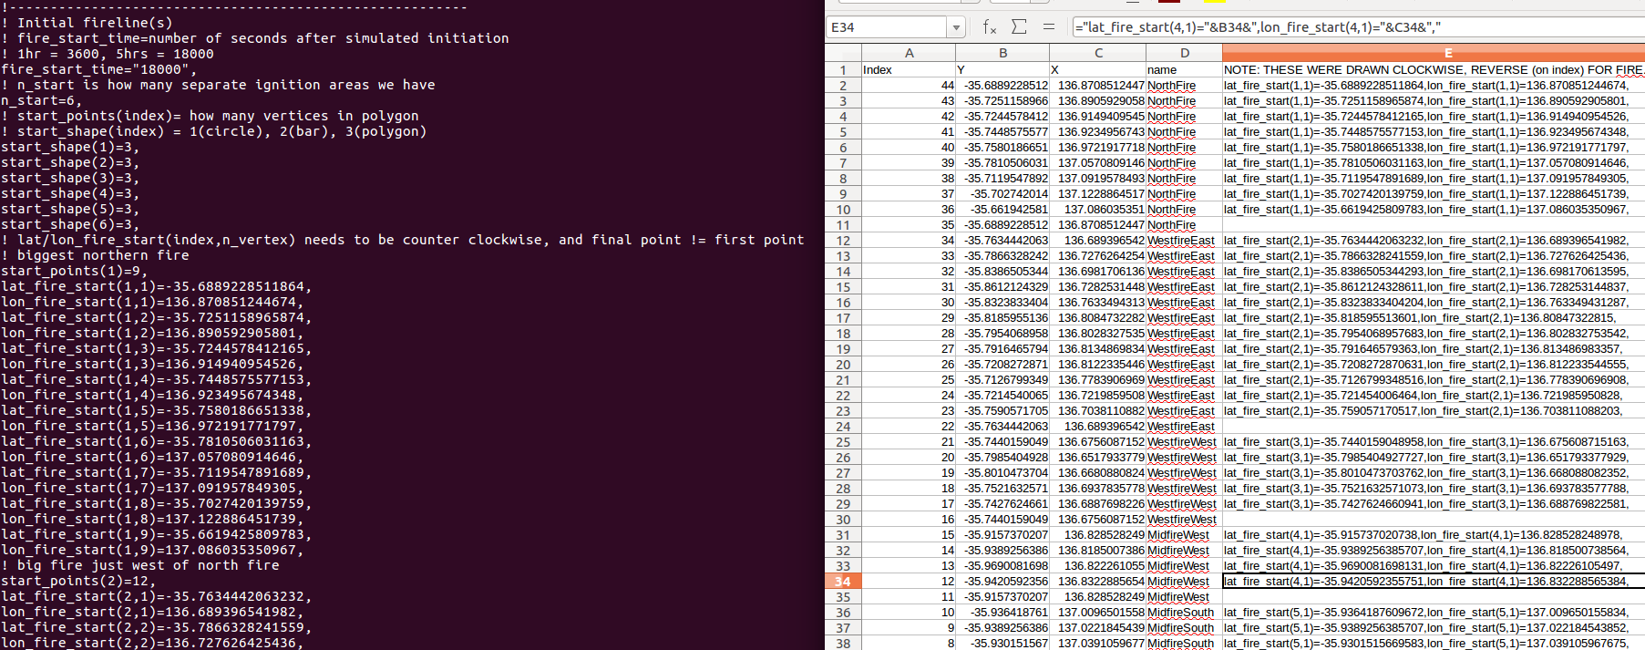

4) **Rose edit config**

cd roses/au-aa929

rose edit

* 1. Cycle points set to UTC start time matching Harvey's dumps
  2. 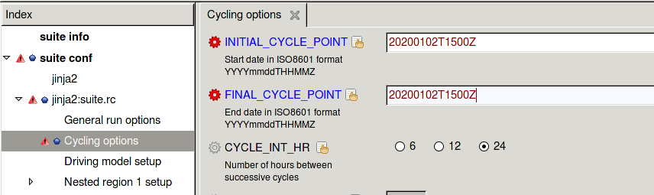Name the location
  3. Set resolution nests:  
     Use numbers determined in step 2 Determine extent of interest)

## 

## 6) Getting run started

1. Login to accessdev
2. authenticate with mosrs
3. go to suite directory
4. run suite
   * It’s running on GADI, showing info on accessdev through a GUI (takes a few seconds to appear)
   * You can close the GUI and it will keep on running
   * Pause and Stop buttons will pause or kill the run on GADI
   * rose sgc will bring back the GUI if you’ve closed it
   * rose suite-clean clears run files from GADI (may need if Harvey updates config code)
   * rose suite-restart restarts a run if it was killed because GADI went down

## log into accessdev  
ssh access  
## connect to mosrs  
mosrs-auth ## connect to mosrs to allow fcm_make to grab files from repository  
## go to where the suite is located  
cd roses/au-aa929  
## run suite  
rose suite-run ## start run

## checking output

Data pops out currently to GADI at /g/data/en0/jwg574/ACCESS-Fire/...

AWS may be available from <http://www.bom.gov.au/climate/data/index.shtml>