OVERVIEW
- Set up NCI and accessdev to run ACCESS
- Figure out what region you want to simulate
- Download Harvey’s suite to your accessdev
- Download required orography files
- Configure the suite to run your region
- Run the suite

1) Access setup
Need an account with accessdev through NCI (groups: hh5, access, ...?)
Need a met office UK account at https://code.metoffice.gov.uk/
Connecting to accessdev:
https://accessdev.nci.org.au/trac/wiki/GettingConnected
need to ssh-keygen and ssh-copy-id between raijin and accessdev
check-access-setup # run this to check connections
Store met office password in cached GPG agent thingy (WITHIN ACCESSDEV)
https://code.metoffice.gov.uk/trac/home/wiki/AuthenticationCaching/GpgAgent
mosrs-setup
mosrs-auth
mosrs-cache-password # caches access permission for 12 hours or so

Example downloading/running suites here: https://accessdev.nci.org.au/trac/wiki/GettingConnected

2) Determine extent of interest
Burn area and nearby topography should be covered in smallest high resolution nest
- First look at burn area and nearby topography of interest to get an idea of where you want to simulate
- Write down min and max latitude and longitude you want to cover, also the mid point of that area
- Work out how many grid boxes will be simulated (for model configuration). Note that highest resolution nests have been .0028 and/or .0009 degrees (you could do something different). NOTE MODEL LIMITATIONS ON PROCESSOR COUNTS AND GRID BOX COUNTS: total processes should be multiple of 48, and grid boxes should be 24 * the number of processes (longitudinally and latitudinally)

EG for KI:
MIDDLE : -35.84, 137.00
want left to right > 0.94 degrees (based on visual inspection of fire area and island)
left to right must be less than 2 degrees (to avoid missing SRTM area)
want bottom to top > .4 degrees (and must be less than 1.68 degrees)
338 < npts_x < 714 (at .0028 resolution)
143 < npts_y < 600 (at .0028)
npts needs to be nprocs * 24
14 < nprocs_x < 29
5 < nprocs_y < 25
Procs inner product needs to be divisible by 48:
nprocs_y, nprocs_x = 10,24 (240 = 48*5)
grid points need to be nprocs * 24:
npts_y, npts_x = 240, 576

3) Download Harvey's suite to your accessdev
- Connect to accessdev (may require extra tools like bash/cygwin and putty and xming if using windows to connect)
- Copy Harvey’s suite
## FOR LINUX (x11 forwarding needs to be set up)
# (I have connections stored in ~/.ssh/config on both my laptop and in GADI)
ssh gadi
ssh access
mosrs-auth
## Downloading suite
# copy Harvey's suite:
rosie copy --prefix=au au-aa860
# vi editor will open here, can just type :wq to write and quite the file
# then answer yes to prompt
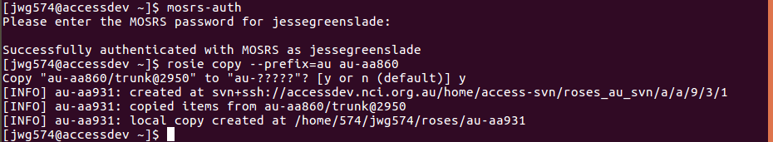
my .ssh/config file is as follows:
$ cat .ssh/config
Host access
HostName accessdev.nci.org.au
User jwg574
ForwardX11 true
ForwardAgent true
Host gadi
HostName gadi.nci.org.au
User jwg574
ForwardX11 true
ForwardAgent true

4) Download orography
30m data for kangaroo island
1) download 1 arc second (30m) resolution srtm topography info
2) upload and convert to netcdf
Example:
# Harvey says to keep structure equivalent to how he's done it: /g/data/en0/hxy548/srtm/30m/
1) get tiffs from https://earthexplorer.usgs.gov/ - need to register to usgs
0) log in to usgs system
a) open data tab (second tab)
b) search for srtm data
c) choose global 1-arc second srtm dataset
d) back to first tab, then use the map do draw a polygon around the area you want for your smallest nest
e) click results, then download individually as GEO tiff files
2) Upload to /g/data/en0/jwg574/srtm/30m/
3) convert to netcdf: (Script available at /g/data/en0/jwg574/srtm/)
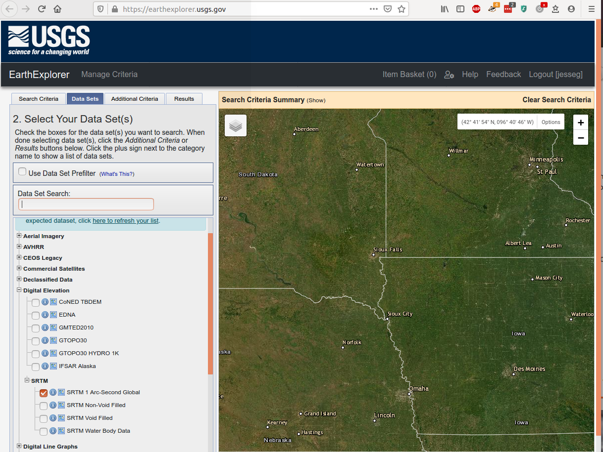

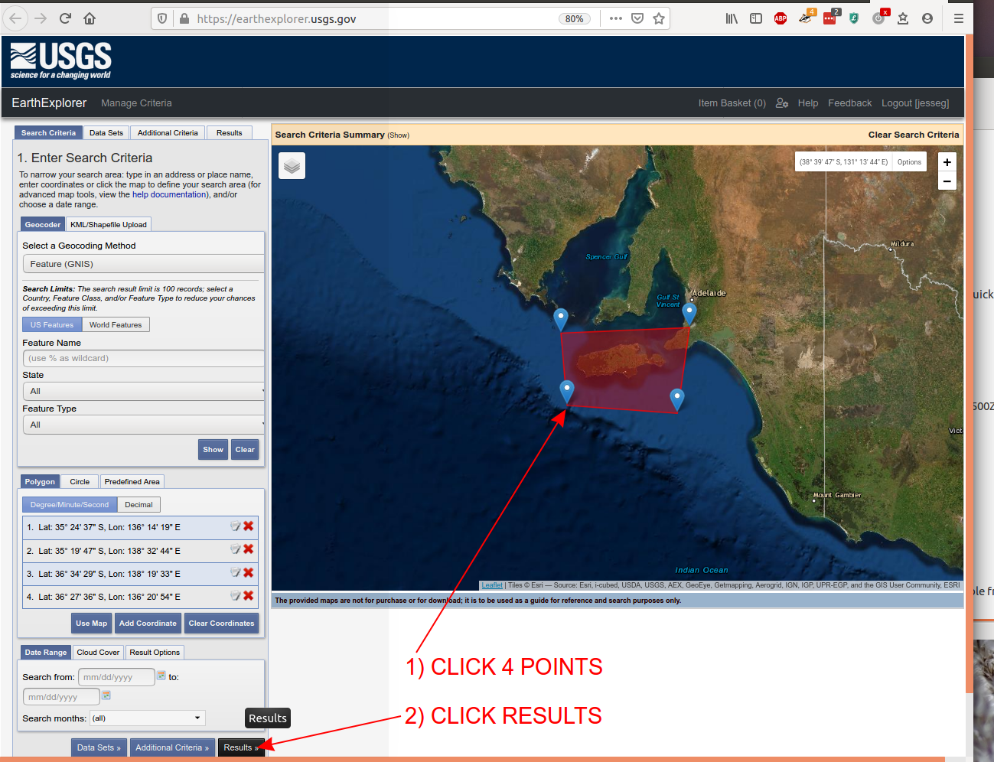
Example translating tif to nc:
module load gdal
gdal_translate -of NetCDF s31_e150_1arc_v3.tif s31_e150_1arc_v3.nc

5) Suite config
start dumps: ask Harvey to create start dump for case study – fire should start ~6 hours after simulation starts
1) Decide start time and ignition time for simulation
When harvey makes it will be in /g/data/en0/hxy548/ics/start-dump.yyyymmddHHMM (202001021500)
2) Decide extent of interest (West - East, South - North)
3) Create polygon(s), list of latlon points will go into fire.inp
4) fire.inp (/roses/au-aa929/app/um/file/fire.inp -> found using "find ./ -name fire.inp")
Harvey: "You only need to update the fire start time (seconds from the model start) in fire.inp. For the first runs, we'll be using fixed fuel. So there is no need to worry about the fuel data (yet). However, you do need to change the relevant flags in fire.inp for this to happen (we were using detailed fuel data for Sir Ivan)."
Starting fire polygon(s):
I'm starting with simple polygon until the model is definitely working
We are using constant fuel initially until we get data from DEW group
EXAMPLE:

5) Rose edit config
ssh access
cd roses/au-aa929
check-access-setup
rose edit
Go to Jinja2.suite.rc
Cycle points set to UTC start time matching Harvey's dumps
Name the location
3-4 nests: pick extent (West East North South) of interest using QGIS or equiv
Determine how many .0028 [and .0009] degree grid squares will be needed to cover space
Determine nprocs, npts will need to be nprocs*24 (see earlier example)

6) Getting run started
## log into accessdev
ssh access
## connect to mosrs
mosrs-auth ## connect to mosrs to allow fcm_make to grab files from repository
## go to where the suite is located
cd roses/au-aa929
## run suite
rose suite-run ## start run
## it's running on GADI, showing info on accessdev through a GUI
## Can close the GUI, stop and pause buttons will stop or pause the processes (so don't press)
## Can right click and check why failed things have failed (need to expand to failed child node)
rose sgc ## will bring back the GUI (only if the suite wasn't killed)
rosie go ## bring up rose config gui
## if changes have been made to run code you may need to run this
rose suite-clean
## to clear GADI of model run files
## if raijin goes down, all the runs are killed and you need to use
rose suite-restart

checking output
Data pops out currently to GADI at /g/data/en0/jwg574/ACCESS-Fire/...
AWS may be available from http://www.bom.gov.au/climate/data/index.shtml

