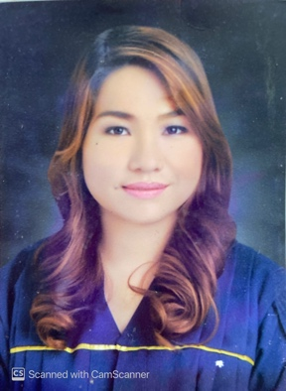
Princess Marie B. Silva,RDH
Sitio Pinagminahan, Barangay San Luis Antipolo City,Rizal
Mobile : +965 55420982 (whatsapp)
Email : princess.silva1005@gmail.com
License Number : 0000225
Objectives :
A Position as a Dental Hygienist , where I will be able to fully utilize my professional experience with Patients.

Educational Background:

College National University-Manila
F. Jhocson, Sampaloc, Manila, Metro Manila
Title in Dental Hygiene
Class 2012 - 2015

Secondary San Isidro National High School
C.Lawis Extension, Brgy. San Isidro Antipolo City
Class 2008 - 2012

Elementary St. James Community School
Antipolo Hills Subd. , Antipolo City
First Honorable Mention
Class 2002 - 2009

Registered Dental Hygienist, Republic of the Philippines, June 2016
Certificate of Registration from the Professional Regulation Commission
Professional Identification Card for Dental Hygienist
Licensed Dental Hygienist (Ministry of Health Kuwait)

EMPLOYMENT RECORD:

Dental Hygienist
THE LAPID DENTAL CENTER
July 2015 – February 2016

Dental Hygienist
Martinez Dental Clinic
July 04 ,2016 – October 02 ,2017

Dental Hygienist
Sunga Ortho Dental Care Clinic
February 12,2018 - July 20,2018

Dental Hygienist/Dental Assistant
Boubyan Dental Center,KUWAIT
August 15,2018 – October 30,2025

Dental Hygienist
Crown Dental
November 04,2025- Present

Areas of Expertise :

- Exceptional patient skills focused on oral hygiene treatment and care as well as preventive management.

- Chart conditions of decay and disease for diagnosis and treatment by Dentist.

- Examine gums, using probes, to locate periodontal recessed gums and signs of gum disease.

- Clean calcareous deposits, accretions, and stains from teeth and beneath margins of gums, using dental instruments.

- Educating patients on dental care and hygiene.

- Assisting the Dentist.

- Took Dental x-rays ( panoramic,cephalomeric.)
- Feel and visually examine gums and signs of disease.

- Doing Chairside Whitening and Home Bleaching.

- Expose and develop X-ray film.

PERSONAL INFORMATION:

Date of Birth: October 05, 1995
Age: 30 yrs. Old
Place of Birth: Quezon City
Gender: Female
Civil Status: Single
Height: 5”
Weight: 64 kg
Religion: Roman Catholic
Nationality: Filipino
Language Spoken: English, Tagalog

CHARACTER REFERENCES:

Christina Masigan Talal, RN
+965 60441975
Dental Nurse

Lean Ragragio, RN
+965 65865162
Dental Nurse

Maria Faith Trazo,RDH
+965 94980767
Dental Hygienist

