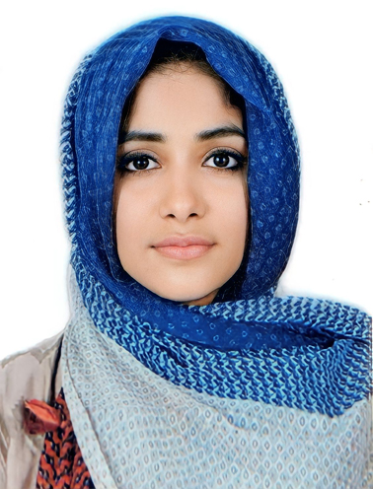 | Dr. Mariyam R. Iqbal  📍 Omariya, Kuwait  📞 +965 66916176  ✉️ mariyamriqbal4@gmail.com

Professional Summary
Dedicated and efficient dentist with strong clinical experience in restorative, endodontic, and pediatric procedures. Proficient in diagnosis, treatment planning, and patient communication. Skilled in advanced restorative techniques, esthetic procedures, and interdisciplinary care with a commitment to evidence-based dentistry.

Education
Bachelor of Dental Surgery (BDS)
Kerala University of Health Sciences
PSM College of Dental Science and Research
Year of Graduation: 2022

Professional Experience
Intern Dentist — PSM College of Dental Science and Research Institute (Dec 2022 – Jan 2024)
• Assisted senior practitioners in routine and specialized dental procedures.
• Gained experience across all dental departments with hands-on exposure to clinical cases.
Clinical Dentist — Dr. Shafiq’s Dental and Orthodontic Center, Perumbilavu, Thrissur (Feb 2024 – July 2025)
• Performed comprehensive dental care including root canal treatments, restorations, and extractions.
• Specialized in pediatric and cosmetic dental procedures.
• Managed patient communication, treatment planning, and follow-up care effectively.
Resident Dentist — IADPE General Dentistry Programme (July 2025 – October 2025)
• Engaged in advanced general dentistry training under multidisciplinary supervision.
• Enhanced skills in comprehensive treatment planning and execution of complex restorative and esthetic cases.

Core Skills
• Root Canal Treatment (Access Opening, BMP, and Obturation - Anteriors and Posteriors including Molars)
• Pediatric Dentistry – Pulpectomy, Apexification, Extractions, Stainless Steel Crowns, Restorations
• Extractions including Third Molars and Disimpaction Cases
• Tooth Preparation – Crown and Fixed Partial Dentures
• Anterior and Posterior Composite Restorations (Including IDS)
• Veneers and Aligners
• Periodontal Procedures – Flap Surgery, Frenectomy, Laser Curettage, Scaling and Polishing
• Orthodontic Procedures – Bonding, Debonding, Fixed Lingual Retainers
• Assisted in Implant Placements and Surgical Procedures

Certifications & Workshops
• Comprehensive Rotary Endodontics (3 Days)
• Comprehensive Oral Surgery
• Porcelain Laminate Veneers (2 Days)
• Master Class on Clear Aligners
• Skill Enhancement in Periodontics
• 2-Day (20 Hours) Clinical Workshop on Direct Composite
• Crown & Bridge Workshop
• Comprehensive Pedodontics Program

Professional Attributes
• Excellent communication and patient management skills
• Strong diagnostic and treatment planning abilities
• Committed to continuous learning and professional growth
• Efficient, empathetic, and detail-oriented approach

Languages
• English
• Malayalam
• Hindi
• Arabic (Basic)

