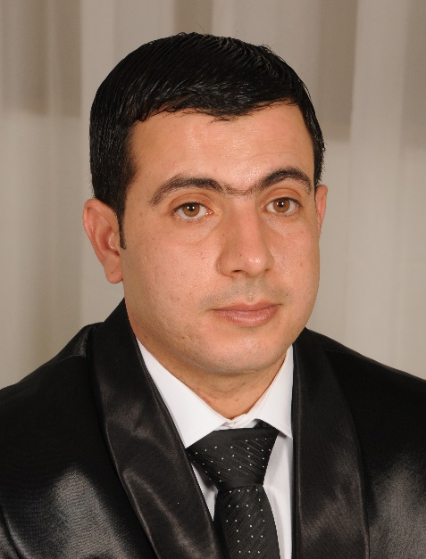
Circulum vitae
PROFESSIONAL EXPERIENCE
- From 2022 until today: general practicing dentist in Sekhira regional hospital, Sfax, Tunisia.
- From 2017 to 2022: general practicing dentist in private dental clinic in Hutat Sudair, Riyadh, Saudi Arabia.
- From 2015 to 2017: general practicing dentist in Foussena regional hospital, Kasserine, Tunisia.
- From 2007 to 2015: general practicing dentist possessing a private dental clinic in Sfax, Tunisia.

Name: BASSEM Surname: CHAARI
Birth date and place: September 25th 1980 in Sfax, Tunisia
Marital Status: Married since November 17, 2012
Address: Sfax 3021, Tunisia
Phone number +216 21 533 332
e-mail: chaari_bassem@live.fr

General practicing dentist with long experience in private clinic and public hospital in Tunisia and Saudi Arabia, ambitious and professional, I try always to update my knowledge and to master the new dental technics.
I hope to get a job in serious clinic where I can practice my hobby and contribute technically and materially in developing it.

COMPUTING
- Excellent Control of programs and internet.

SKILLS
- excellent experience in chirurgical extractions
- excellent experience in prosthodontic restoration
- excellent experience in clinic management and communication with patients
- good experience in implantology
- good experience in orthodontic treatment.
EDUCATION
- 2007: dentistry doctorate obtained from Monastir dental university, Tunisia (very honorable with jury`s congratulation).
- From 2005 to 2006: internal dentist in Rabta clinical univesitary hospital, Habib Bourguiba clinical univesitary hospital and of Monastir dental university.
- From 2003 to 2005: first aid instructor in Monastir dental university.
- 2002: First aid diploma obtained from Monastir dental university, Tunisia
- 1999: baccalaureate in mathematic sciences

LANGUAGES
- Arabic: excellently written and spoken
- French: excellently written and spoken
- English: moderately written and spoken

