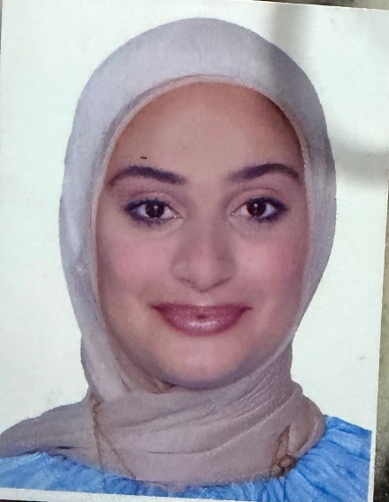
Nagham Neouchi
Receptionist | Administrative Support
Tripoli, Lebanon
July 8th, 1999
Phone: +961 70 184011
Email: Naghamnana952@gmail.com

Summary
Professional and organized Receptionist with over 2 years of experience in beauty and medical environments. Skilled in appointment coordination, customer service, cash handling, and administrative support. Experienced in promoting services, introducing packages, and supporting basic marketing activities to increase client bookings and retention.

Work Experience
Gharam Beauty Salon – Tripoli, Lebanon
Receptionist | 2022 – 2024
• Welcomed clients and ensured a high-quality customer experience
• Scheduled, confirmed, and organized appointments for beauty specialists
• Coordinated daily service bookings and managed walk-in clients
• Handled phone calls, WhatsApp inquiries, and booking messages
• Processed payments and managed daily cash transactions
• Maintained and updated client records
• Introduced service packages and special offers to clients
• Promoted seasonal promotions and loyalty programs to increase bookings
• Assisted in basic marketing activities through social media communication
• Coordinated smoothly between technicians and clients
• Ensured the reception area remained organized and presentable
Dental Clinic – Tripoli, Lebanon
Receptionist | 2024 – 2025
• Welcomed patients and managed daily appointment schedules
• Scheduled, confirmed, and rescheduled appointments
• Handled incoming calls and patient inquiries
• Maintained accurate patient records and documentation
• Assisted with billing, invoices, and daily cash handling
• Coordinated schedules with doctors and assistants
• Maintained a professional and organized environment

Skills
• Reception Management
• Appointment Scheduling
• Customer Service & Client Retention
• Package Promotion & Upselling
• Basic Marketing Support
• Call Handling
• Cash Handling & Billing Support
• Record Keeping
• Administrative Coordination
• Time Management
• Microsoft Word & Excel

Education
Bachelor’s Degree in English Literature – Lebanese University
Languages
Arabic – Native English – Advanced

