**Project Title: Deploying a Highly Available, Auto-Scaling WordPress Application for KicLabs Inc. on AWS**

**Laying the foundations**

**Lab 1: Configure the network.**

**Resource map:**

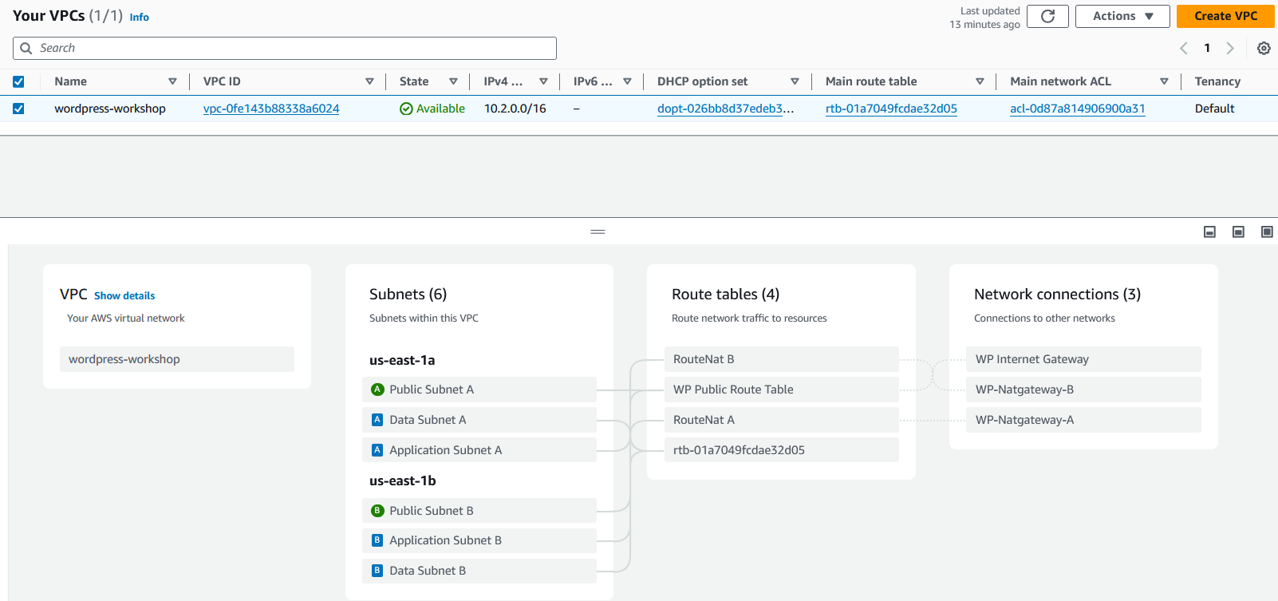

**Building the Data Tier**

**Lab 2: Set up the RDS database**

**Create database security groups:**

[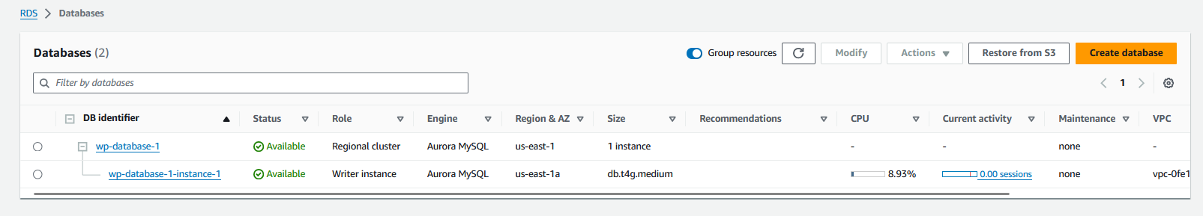](https://catalog.us-east-1.prod.workshops.aws/workshops/3de93ad5-ebbe-4258-b977-b45cdfe661f1/en-US/datatier/lab2" \l "create-database-security-groups)

# **[Lab 3: Create the shared file system](https://catalog.us-east-1.prod.workshops.aws/workshops/3de93ad5-ebbe-4258-b977-b45cdfe661f1/en-US/datatier/lab2" \l "create-database-security-groups)**

[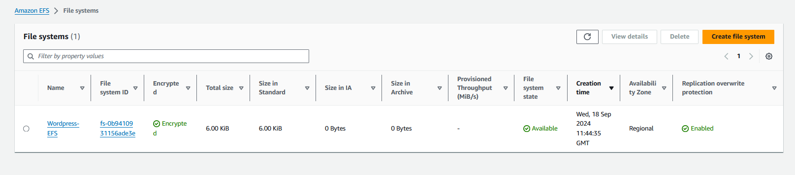](https://catalog.us-east-1.prod.workshops.aws/workshops/3de93ad5-ebbe-4258-b977-b45cdfe661f1/en-US/datatier/lab2" \l "create-database-security-groups)

**Build the Application Tier:**

**Lab 4: Create the load balancer**

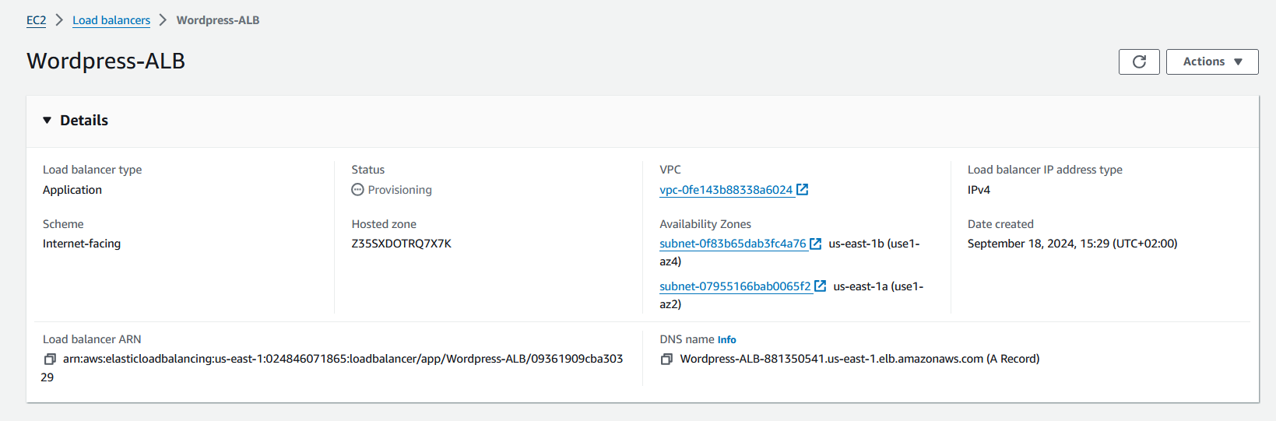

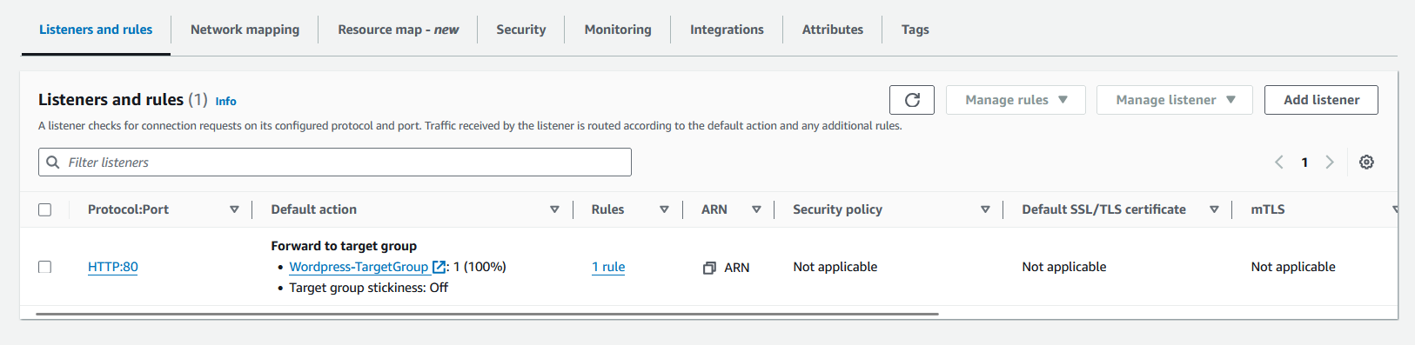

# **Lab 5: Create a launch Template**

**Launch an Instances:**

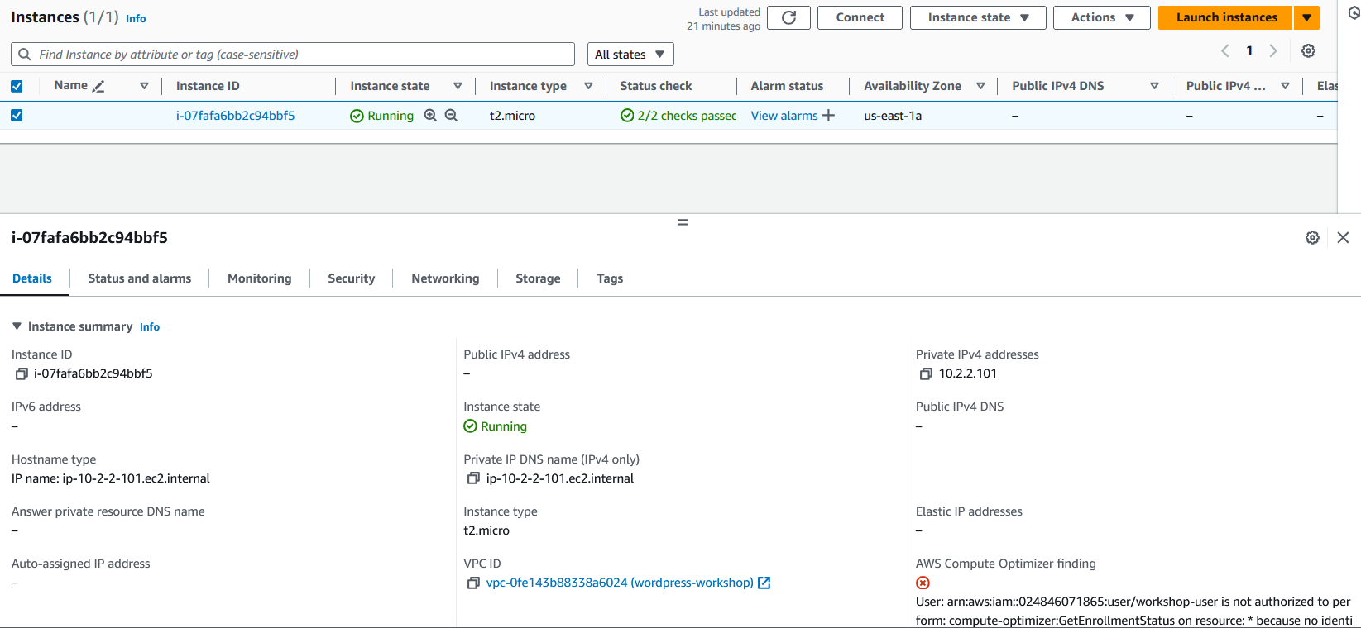:

**Launch Template:**

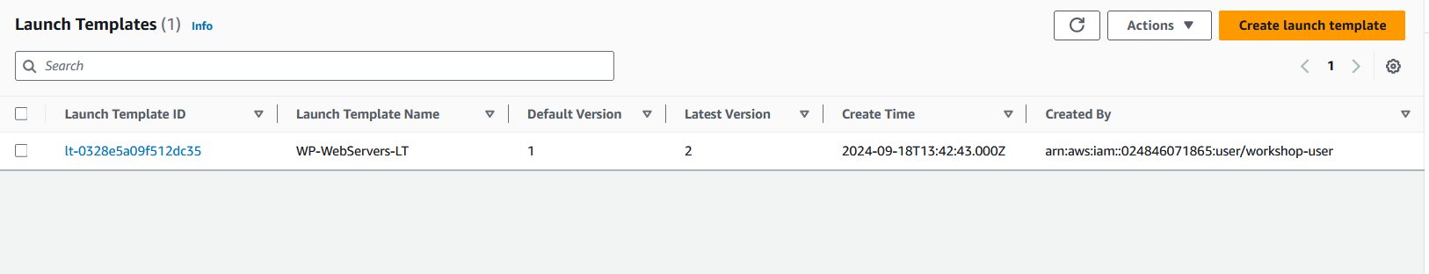

App Link: <http://wordpress-alb-881350541.us-east-1.elb.amazonaws.com/>

