SSH Brute-Force Detection Using Ubuntu Server and Kali Linux
Complete SOC Analyst Project Report

Introduction
SSH (Secure Shell) is a secure protocol used for secure remote administration. This project demonstrates how a SOC Analyst detects SSH brute-force attempts by monitoring authentication logs on an Ubuntu Server.

Objective
To configure Ubuntu Server and Kali Linux, simulate failed SSH login attempts, analyze SSH logs, and identify brute-force activity.

Tools Used
Ubuntu Server 26.04 LTS, Kali Linux 2025.3, Oracle VirtualBox, OpenSSH Server, journalctl logs.

Network Setup
Ubuntu Server (192.168.56.101) acted as the victim machine. Kali Linux (192.168.56.102) acted as the attacker machine. Both systems were connected using a VirtualBox Host-Only network.

Implementation Steps
1. Verified IP addresses.
2. Tested connectivity using ping.
3. Enabled SSH service.
4. Connected from Kali to Ubuntu.
5. Entered incorrect passwords multiple times.
6. Investigated logs using journalctl.

Architecture Diagram
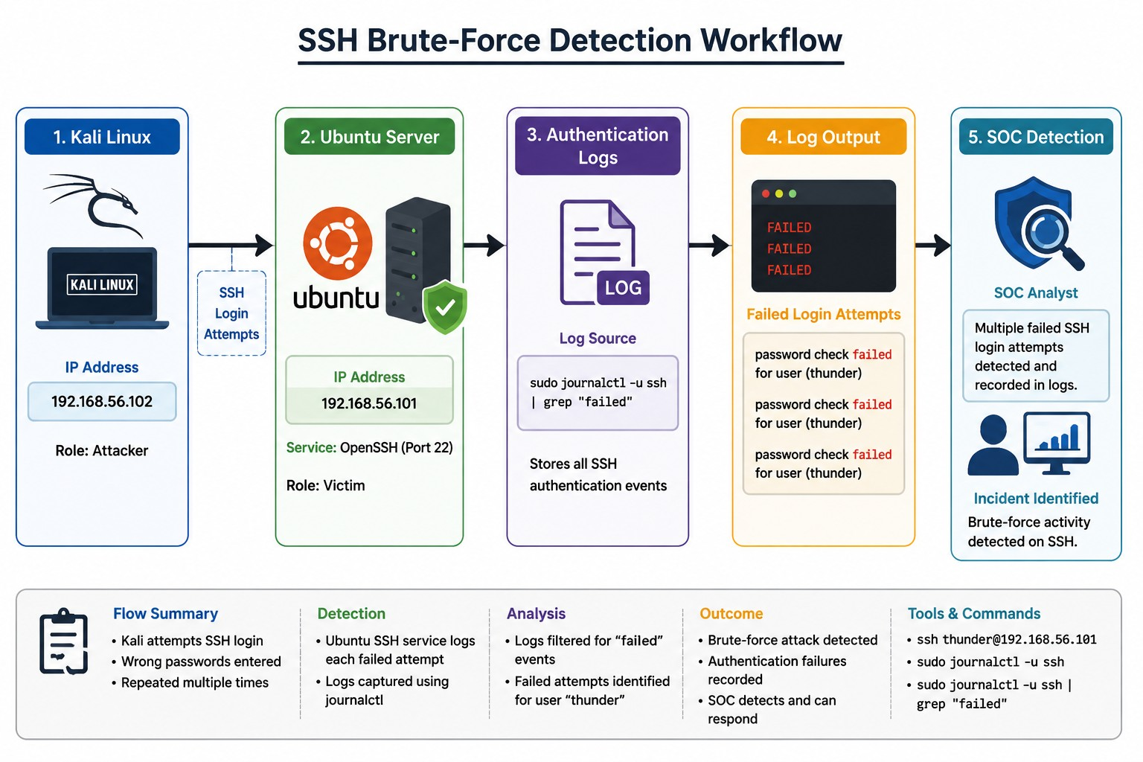

Screenshot 1 - Ubuntu Log Analysis
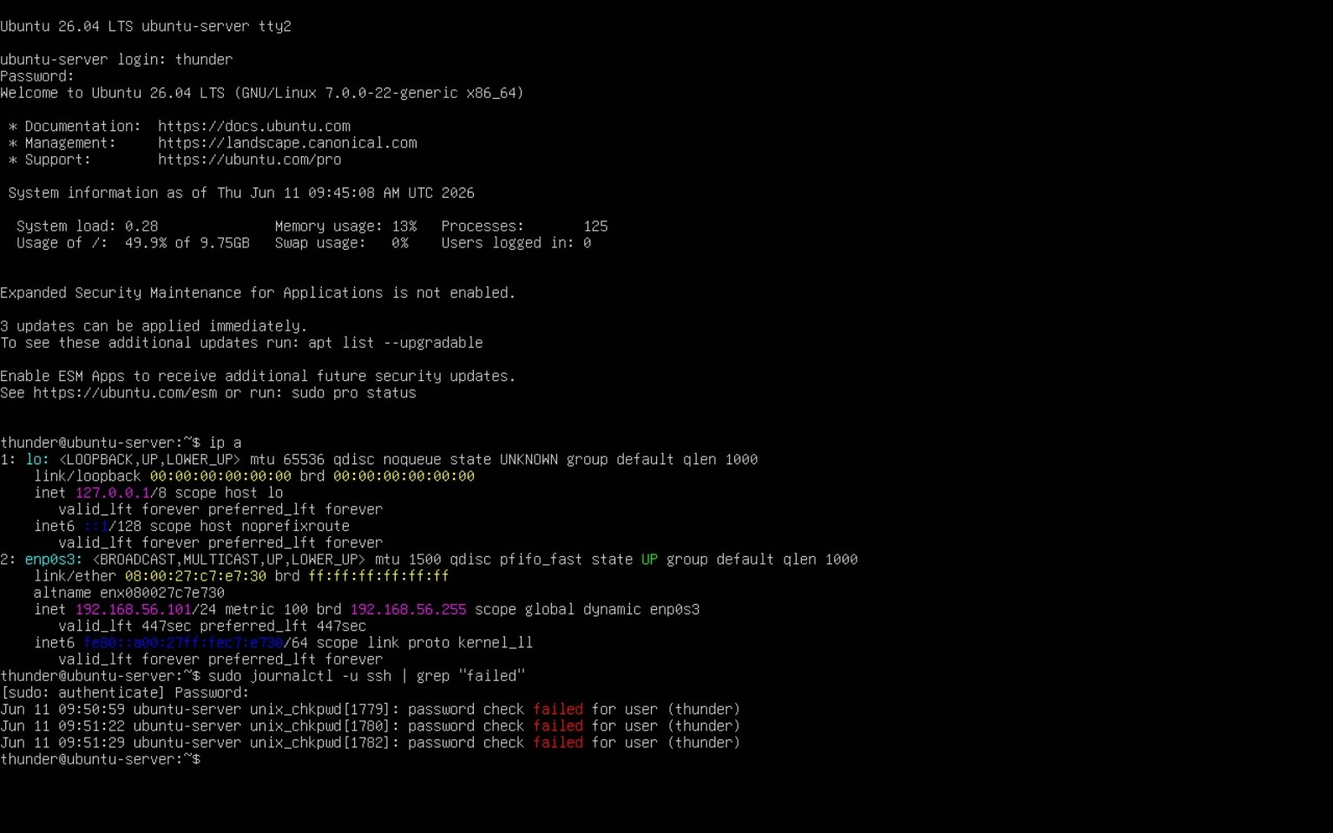

Screenshot 2 - Kali SSH Connection
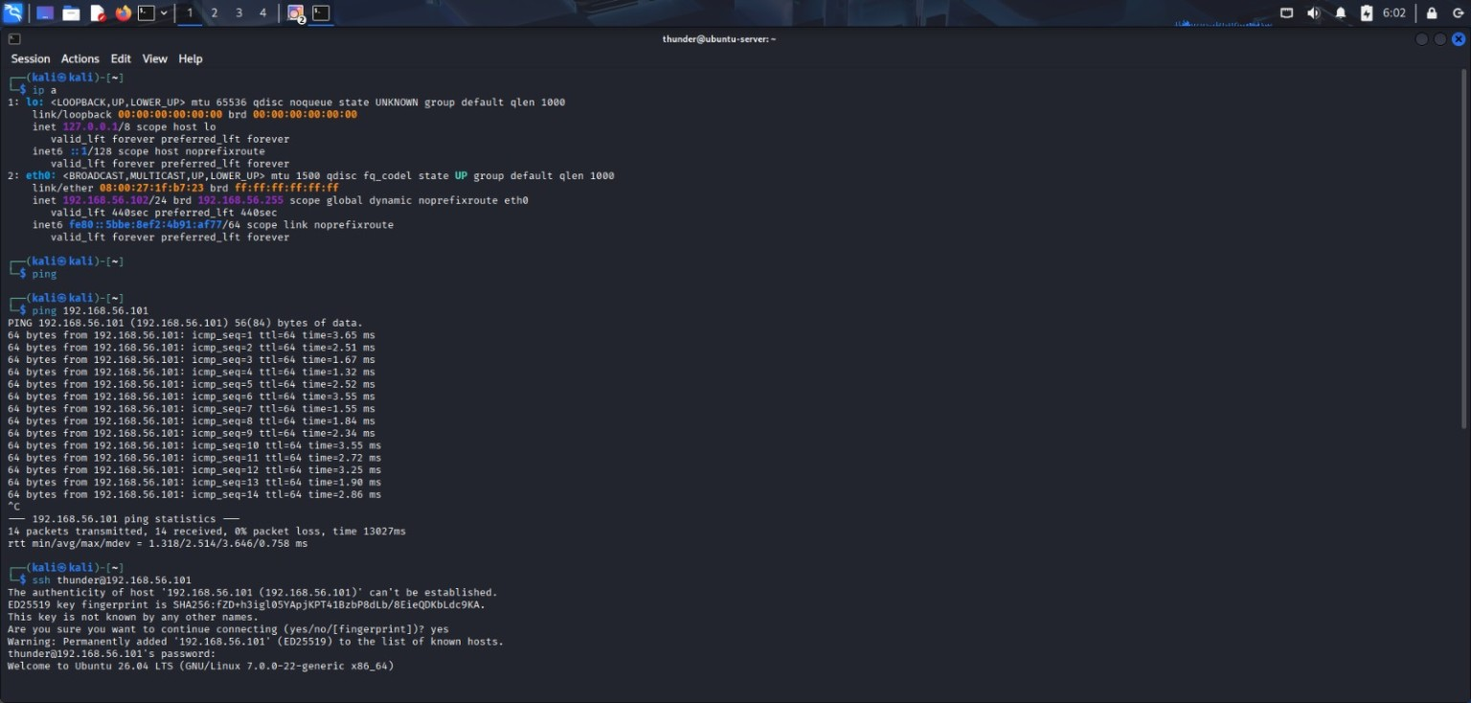

Screenshot 3 - Failed Login Attempts
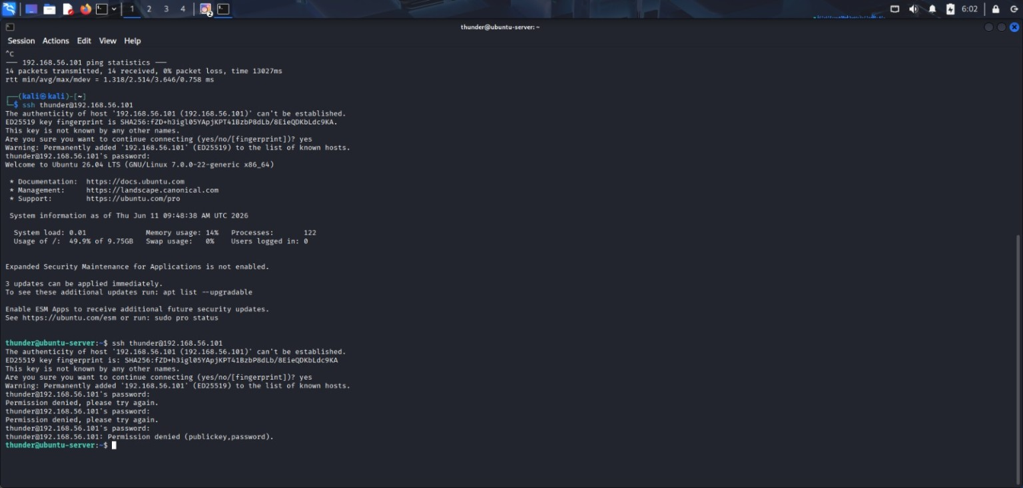

Findings
Multiple failed SSH authentication attempts were generated from Kali Linux and detected in Ubuntu logs. The user account thunder was targeted, and authentication failures were successfully recorded.

SOC Analyst Investigation
Detection Command:
sudo journalctl -u ssh | grep "failed"
Indicators:
- Repeated failed login attempts
- Authentication failures
- User account targeting
- Security events recorded in logs

Skills Demonstrated
Linux Administration, Ubuntu Server Management, Kali Linux, SSH Configuration, Network Troubleshooting, Log Analysis, Incident Detection, Threat Monitoring, SOC Operations.

Project Outcome
The SSH Brute-Force Detection Lab was successfully completed. Failed SSH login attempts were generated and detected through Ubuntu authentication logs, demonstrating practical SOC Analyst skills.

