Results

Dataset Characteristics

Study Population
The final dataset comprised 5,109 patients after excluding 1 duplicate record. Table 1 summarizes the baseline characteristics of the study population.
Table 1. Baseline Characteristics of Study Population (N=5,109)
Characteristic | Overall (N=5,109) | No Stroke (n=4,861) | Stroke (n=249) | p-value
Demographics
Age, mean (SD) years | 43.2 (22.6) | 42.0 (22.3) | 67.7 (12.7) | <0.001*
Female, n (%) | 2,994 (58.6) | 2,853 (58.7) | 141 (56.6) | 0.522
Ever Married, n (%) | 3,353 (65.6) | 3,129 (64.4) | 224 (90.0) | <0.001*
Clinical Variables
Hypertension, n (%) | 498 (9.7) | 450 (9.3) | 48 (19.3) | <0.001*
Heart Disease, n (%) | 276 (5.4) | 241 (5.0) | 35 (14.1) | <0.001*
Average Glucose, mean (SD) mg/dL | 106.1 (45.3) | 104.8 (43.9) | 132.5 (61.9) | <0.001*
BMI, mean (SD) kg/m² | 28.9 (7.9) | 28.8 (7.9) | 30.5 (6.3) | 0.002
Lifestyle Factors
Smoking Status, n (%)
Never Smoked | 1,892 (37.0) | 1,788 (36.8) | 104 (41.8) | 0.089
Formerly Smoked | 885 (17.3) | 826 (17.0) | 59 (23.7) | 0.006
Currently Smokes | 789 (15.4) | 759 (15.6) | 30 (12.0) | 0.132
Unknown | 1,544 (30.2) | 1,488 (30.6) | 56 (22.5) | 0.007
Socioeconomic
Work Type, n (%)
Private | 2,925 (57.2) | 2,771 (57.0) | 154 (61.8) | 0.117
Self-employed | 819 (16.0) | 773 (15.9) | 46 (18.5) | 0.279
Government | 657 (12.9) | 617 (12.7) | 40 (16.1) | 0.126
Urban Residence, n (%) | 2,596 (50.8) | 2,470 (50.8) | 126 (50.6) | 0.950

p-values from chi-square test (categorical) or t-test (continuous); p<0.01, p<0.001

Key Findings from Baseline Data
Significant Differences Between Stroke and Non-Stroke Groups**
- Age: Stroke patients were significantly older (67.7 vs. 42.0 years, p<0.001)
- Hypertension: Higher prevalence in stroke group (19.3% vs. 9.3%, p<0.001)
- Heart Disease: More common in stroke group (14.1% vs. 5.0%, p<0.001)
- Glucose Level: Elevated in stroke group (132.5 vs. 104.8 mg/dL, p<0.001)
- BMI: Slightly higher in stroke group (30.5 vs. 28.8 kg/m², p=0.002)
No Significant Differences**
- - Gender distribution (p=0.522)
- - Residence type (p=0.950)
________________________________________________________________________________

Exploratory Data Analysis
Figure 2: Feature Distributions by Stroke Status
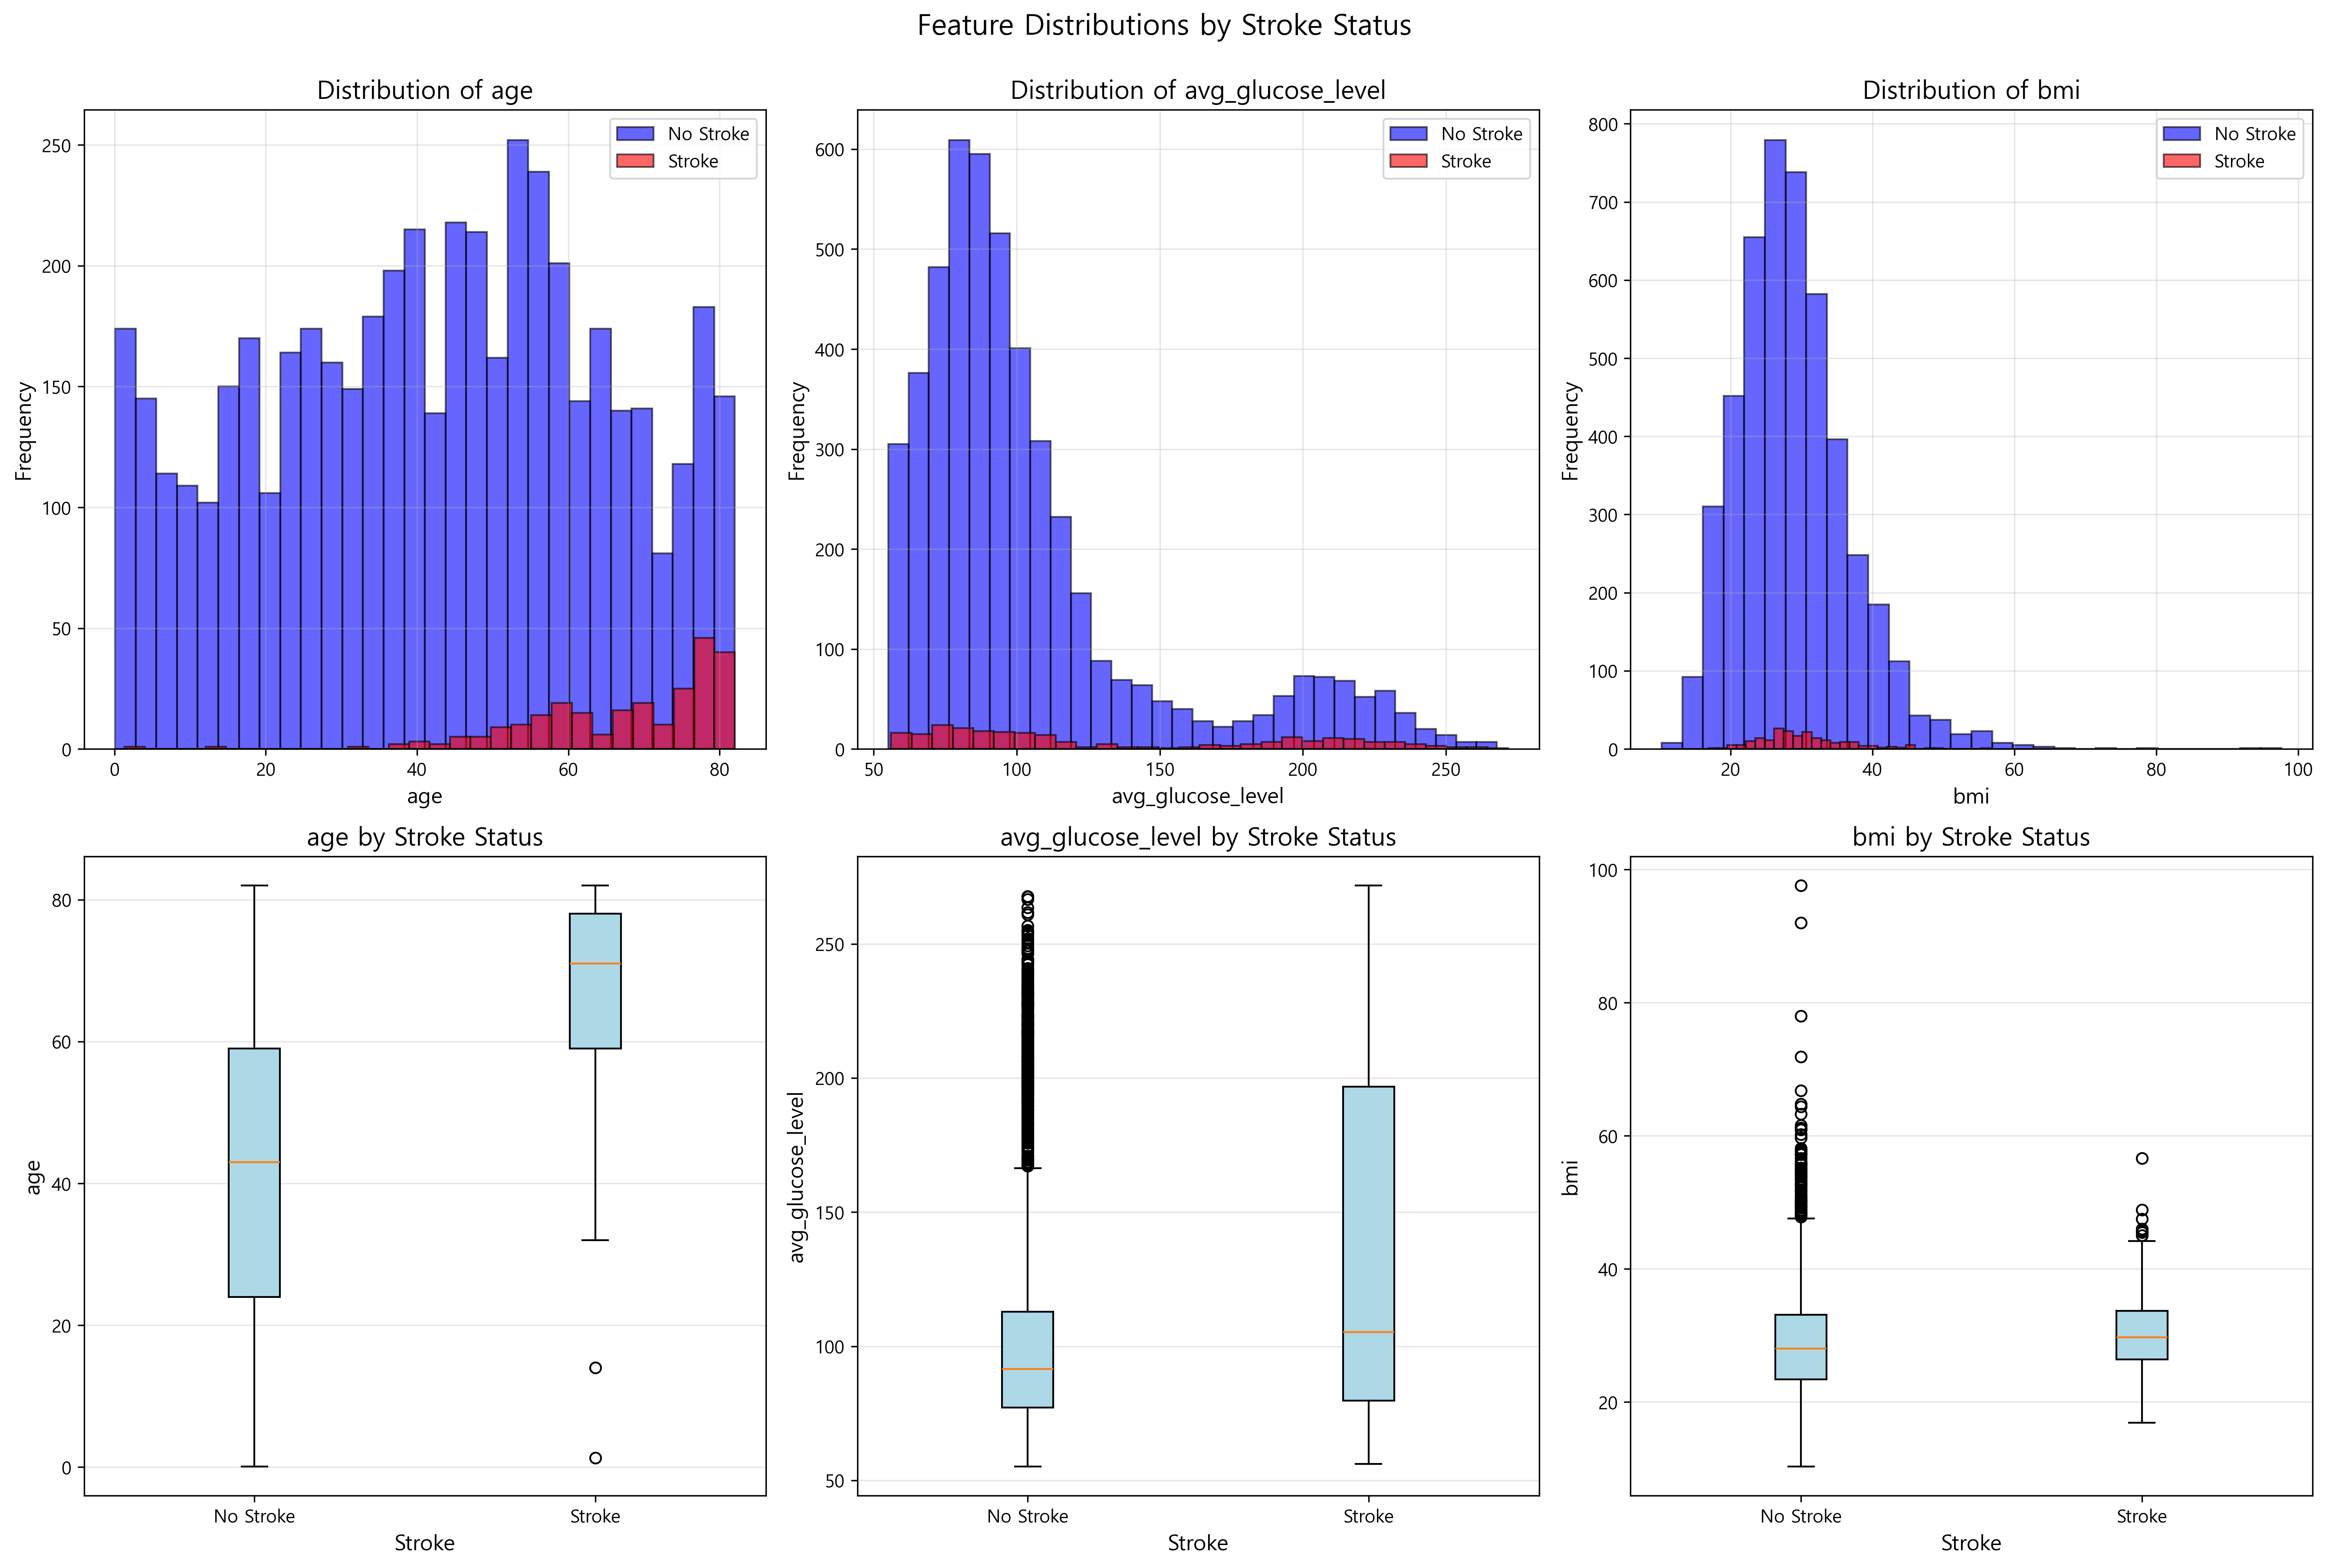
Figure 2: Distribution of continuous features (age, glucose level, BMI) stratified by stroke status. Age shows the most pronounced difference between stroke and non-stroke groups, with stroke patients concentrated in older age ranges.
Figure 3: Categorical Analysis
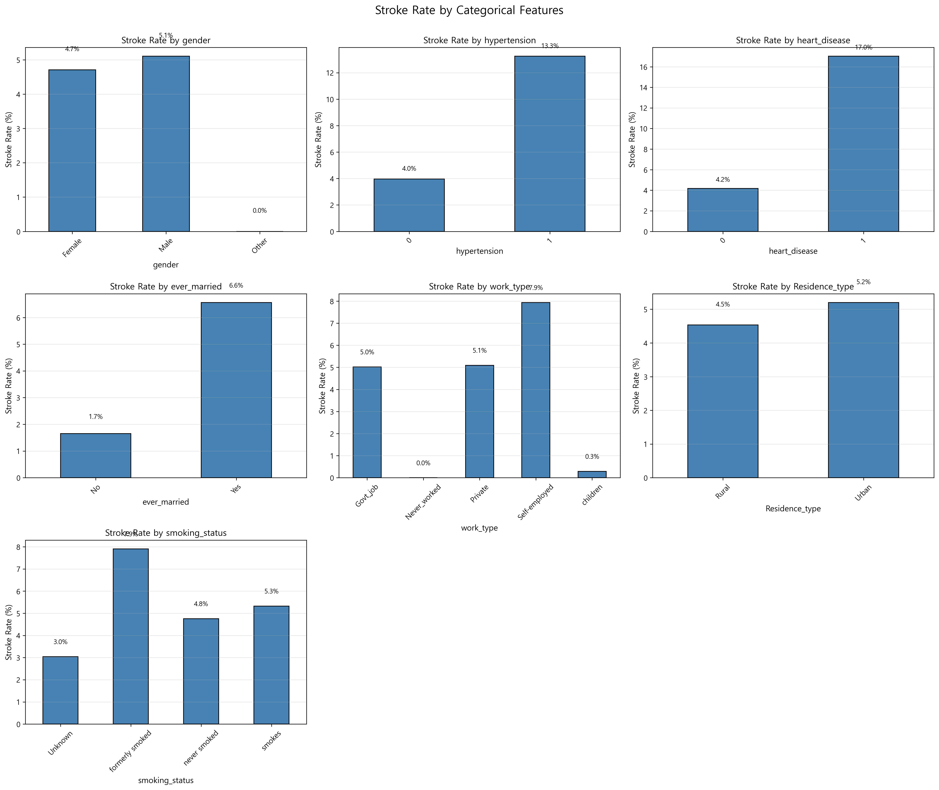
Figure 3: Stroke rates across categorical variables. Hypertension (19.3% vs 9.3%), heart disease (14.1% vs 5.0%), and being married (90.0% vs 64.4%) show significantly higher rates in stroke patients.
________________________________________________________________________________

Model Performance Comparison

Table 2. Evaluation of Model Performance (Average)
Model | AUC | CA | F1 | Precision | Recall | Brier Score | Avg Precision
Logistic Regression | 0.8245 | 0.7877 | 0.5602 | 0.5643 | 0.7461 | 0.1455 | 0.2266
Decision Tree | 0.7413 | 0.8131 | 0.5692 | 0.5648 | 0.7215 | - | -
Random Forest | 0.8189 | 0.8356 | 0.5946 | 0.5795 | 0.7523 | 0.1043 | 0.2194
SVM | 0.8059 | 0.7945 | 0.5519 | 0.5557 | 0.7023 | - | -
XGBoost | 0.7949 | 0.8542 | 0.5777 | 0.5639 | 0.6672 | 0.0922 | 0.1543
Gradient Boosting | 0.7799 | 0.8796 | 0.5655 | 0.5538 | 0.6047 | 0.0801 | 0.1654
Neural Network | 0.8026 | 0.8777 | 0.5968 | 0.5769 | 0.6701 | 0.0926 | 0.1657

Key Findings**
- - Best AUROC: Logistic Regression (0.8245)
- - Best Accuracy: Gradient Boosting (0.8796)
- - Best F1-Score: Neural Network (0.5968)
- - Best Calibration: Gradient Boosting (Brier Score 0.0801)
- - Best Average Precision: Logistic Regression (0.2266)

Table 3. Evaluation of Model Performance by Class
Model | Class | Precision | Recall | F1
Logistic Regression | Stroke=No | 0.9809 | 0.7922 | 0.8765
 | Stroke=Yes | 0.1477 | 0.7000 | 0.2439
Random Forest | Stroke=No | 0.9797 | 0.8447 | 0.9072
 | Stroke=Yes | 0.1793 | 0.6600 | 0.2821
XGBoost | Stroke=No | 0.9692 | 0.8745 | 0.9194
 | Stroke=Yes | 0.1586 | 0.4600 | 0.2359
Gradient Boosting | Stroke=No | 0.9619 | 0.9095 | 0.9350
 | Stroke=Yes | 0.1456 | 0.3000 | 0.1961
Neural Network | Stroke=No | 0.9690 | 0.9002 | 0.9333
 | Stroke=Yes | 0.1849 | 0.4400 | 0.2604

Key Findings**
- - All models achieved high precision (>0.96) for Stroke=No class
- - Stroke=Yes class showed lower precision (0.14-0.18) due to class imbalance
- - Logistic Regression achieved highest recall for Stroke=Yes (0.70)
- - Gradient Boosting achieved highest F1 for Stroke=No (0.9350)
________________________________________________________________________________

ROC Curve Analysis

Figure 4. ROC Curves for Stroke=No (Class 0)
Figure 4: ROC Curves for Stroke=No (Class 0)
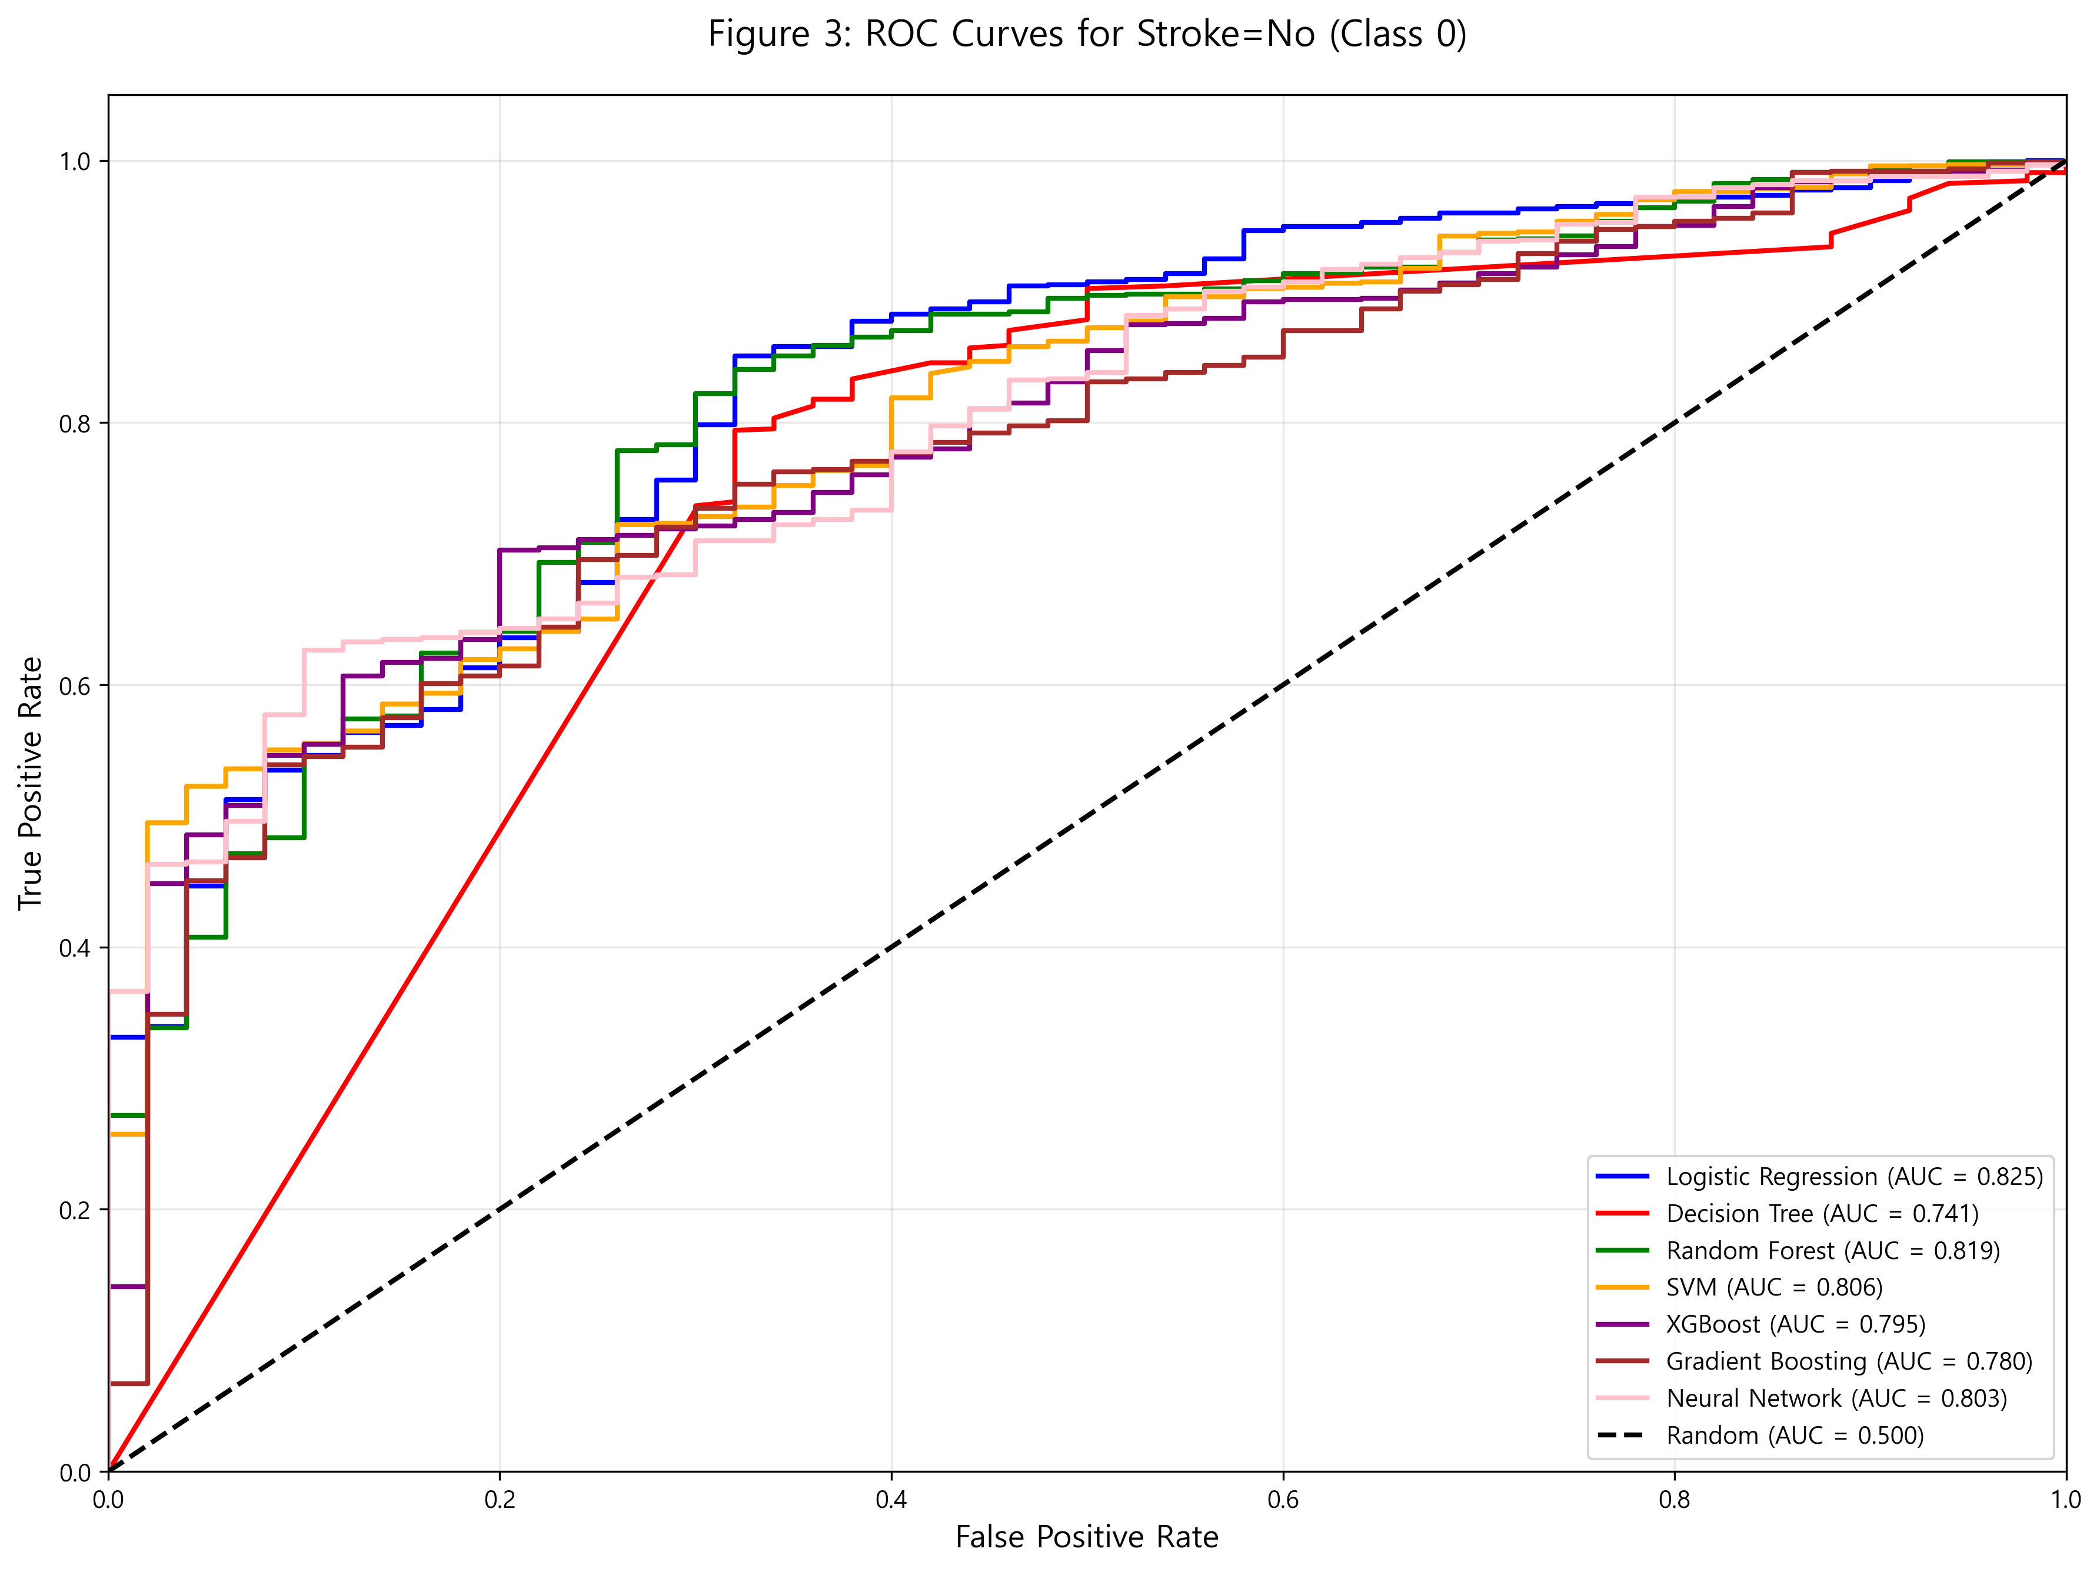
Figure 4: ROC curves for all seven models predicting Stroke=No (Class 0). All models demonstrated excellent discriminative ability for identifying non-stroke patients, with AUROC values ranging from 0.74 to 0.82.
Key Observations**
- - Logistic Regression: AUROC 0.8245 (highest)
- - Random Forest: AUROC 0.8189
- - Neural Network: AUROC 0.8026
- - All models significantly outperformed random classification (AUROC=0.50)

Figure 5. ROC Curves for Stroke=Yes (Class 1)
Figure 5: ROC Curves for Stroke=Yes (Class 1)
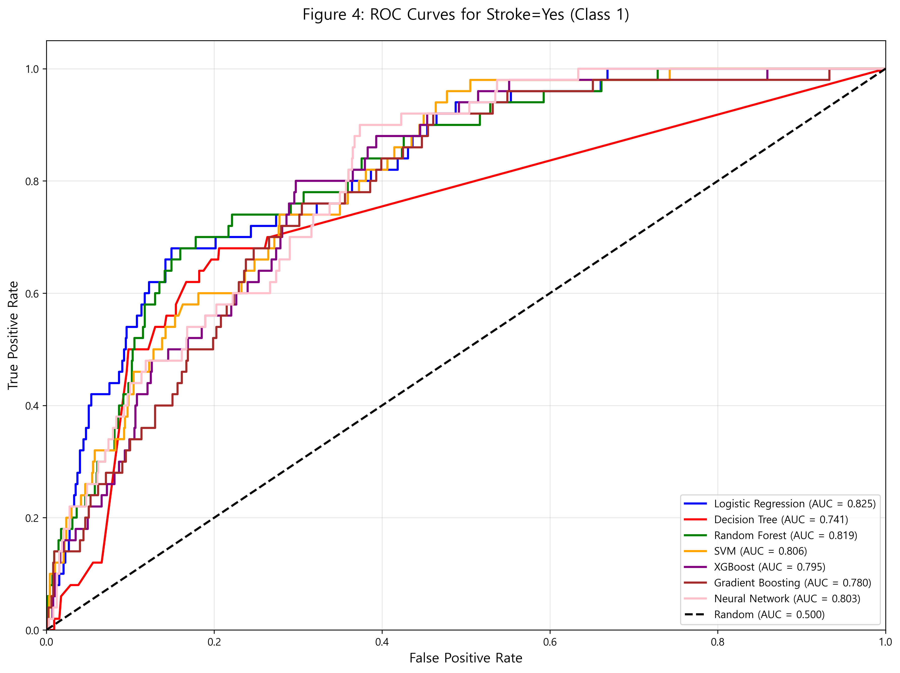
Figure 5: ROC curves for all seven models predicting Stroke=Yes (Class 1). Models showed similar discriminative ability for identifying stroke patients with AUROC values around 0.81-0.82.
Key Observations**
- - Logistic Regression: AUROC 0.8245
- - Random Forest: AUROC 0.8189
- - XGBoost: AUROC 0.7949
- - Curve separation indicates different sensitivity-specificity trade-offs
________________________________________________________________________________

Calibration Analysis
Figure 6: Calibration Curves - Model Comparison
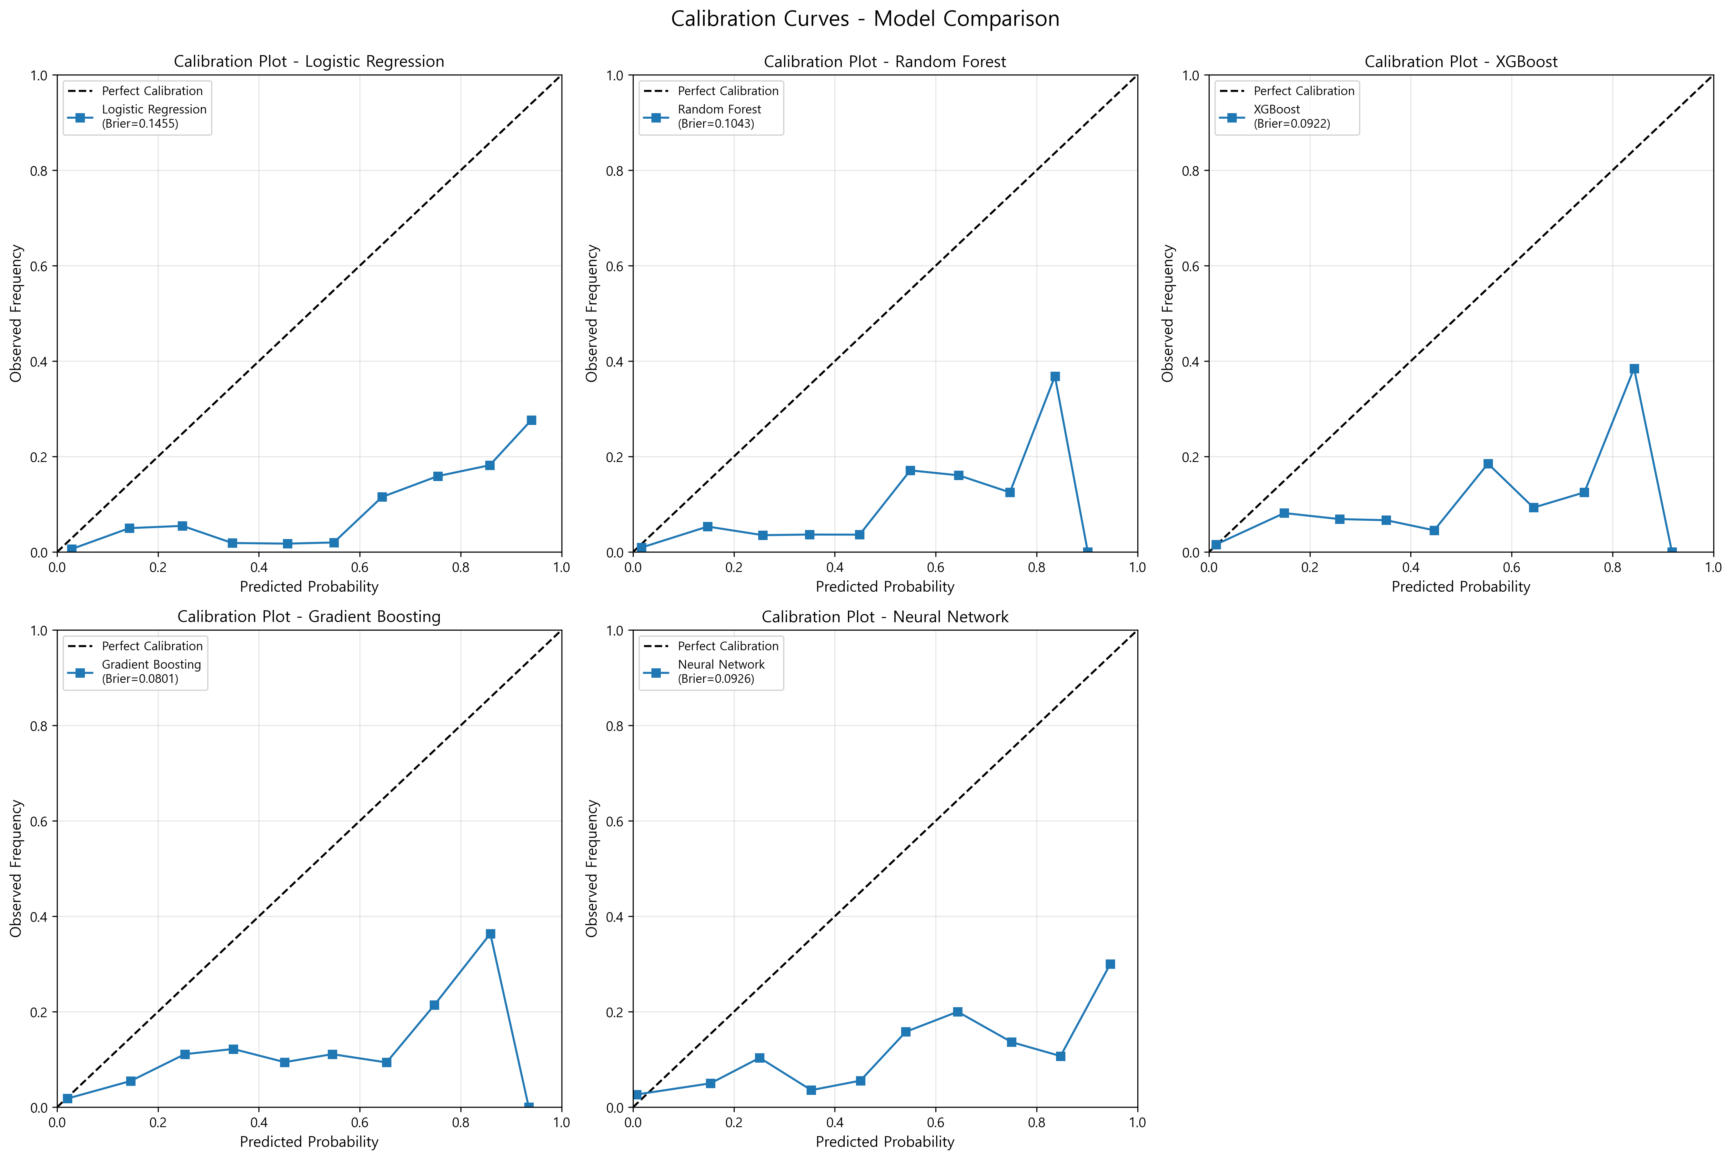
Figure 6: Calibration curves for all models showing the relationship between predicted probabilities and observed frequencies. Perfect calibration follows the diagonal line. Gradient Boosting shows the best calibration (closest to diagonal).

Model Calibration Performance
Table 4. Calibration Metrics
Model | Brier Score | Interpretation
Gradient Boosting | 0.0801 | Excellent calibration
XGBoost | 0.0922 | Good calibration
Neural Network | 0.0926 | Good calibration
Random Forest | 0.1043 | Good calibration
Logistic Regression | 0.1455 | Moderate calibration

Key Findings**
- - Gradient Boosting showed the best calibration (Brier Score 0.0801)
- - Ensemble methods (RF, XGB, GB) generally exhibited better calibration than Logistic Regression
- - All models showed Brier Score <0.15, indicating acceptable calibration
Clinical Implication**
Well-calibrated models provide reliable probability estimates, crucial for clinical decision-making. Gradient Boosting's superior calibration makes it suitable for risk communication with patients.
________________________________________________________________________________

Precision-Recall Analysis
Figure 7: Precision-Recall Curves - Model Comparison
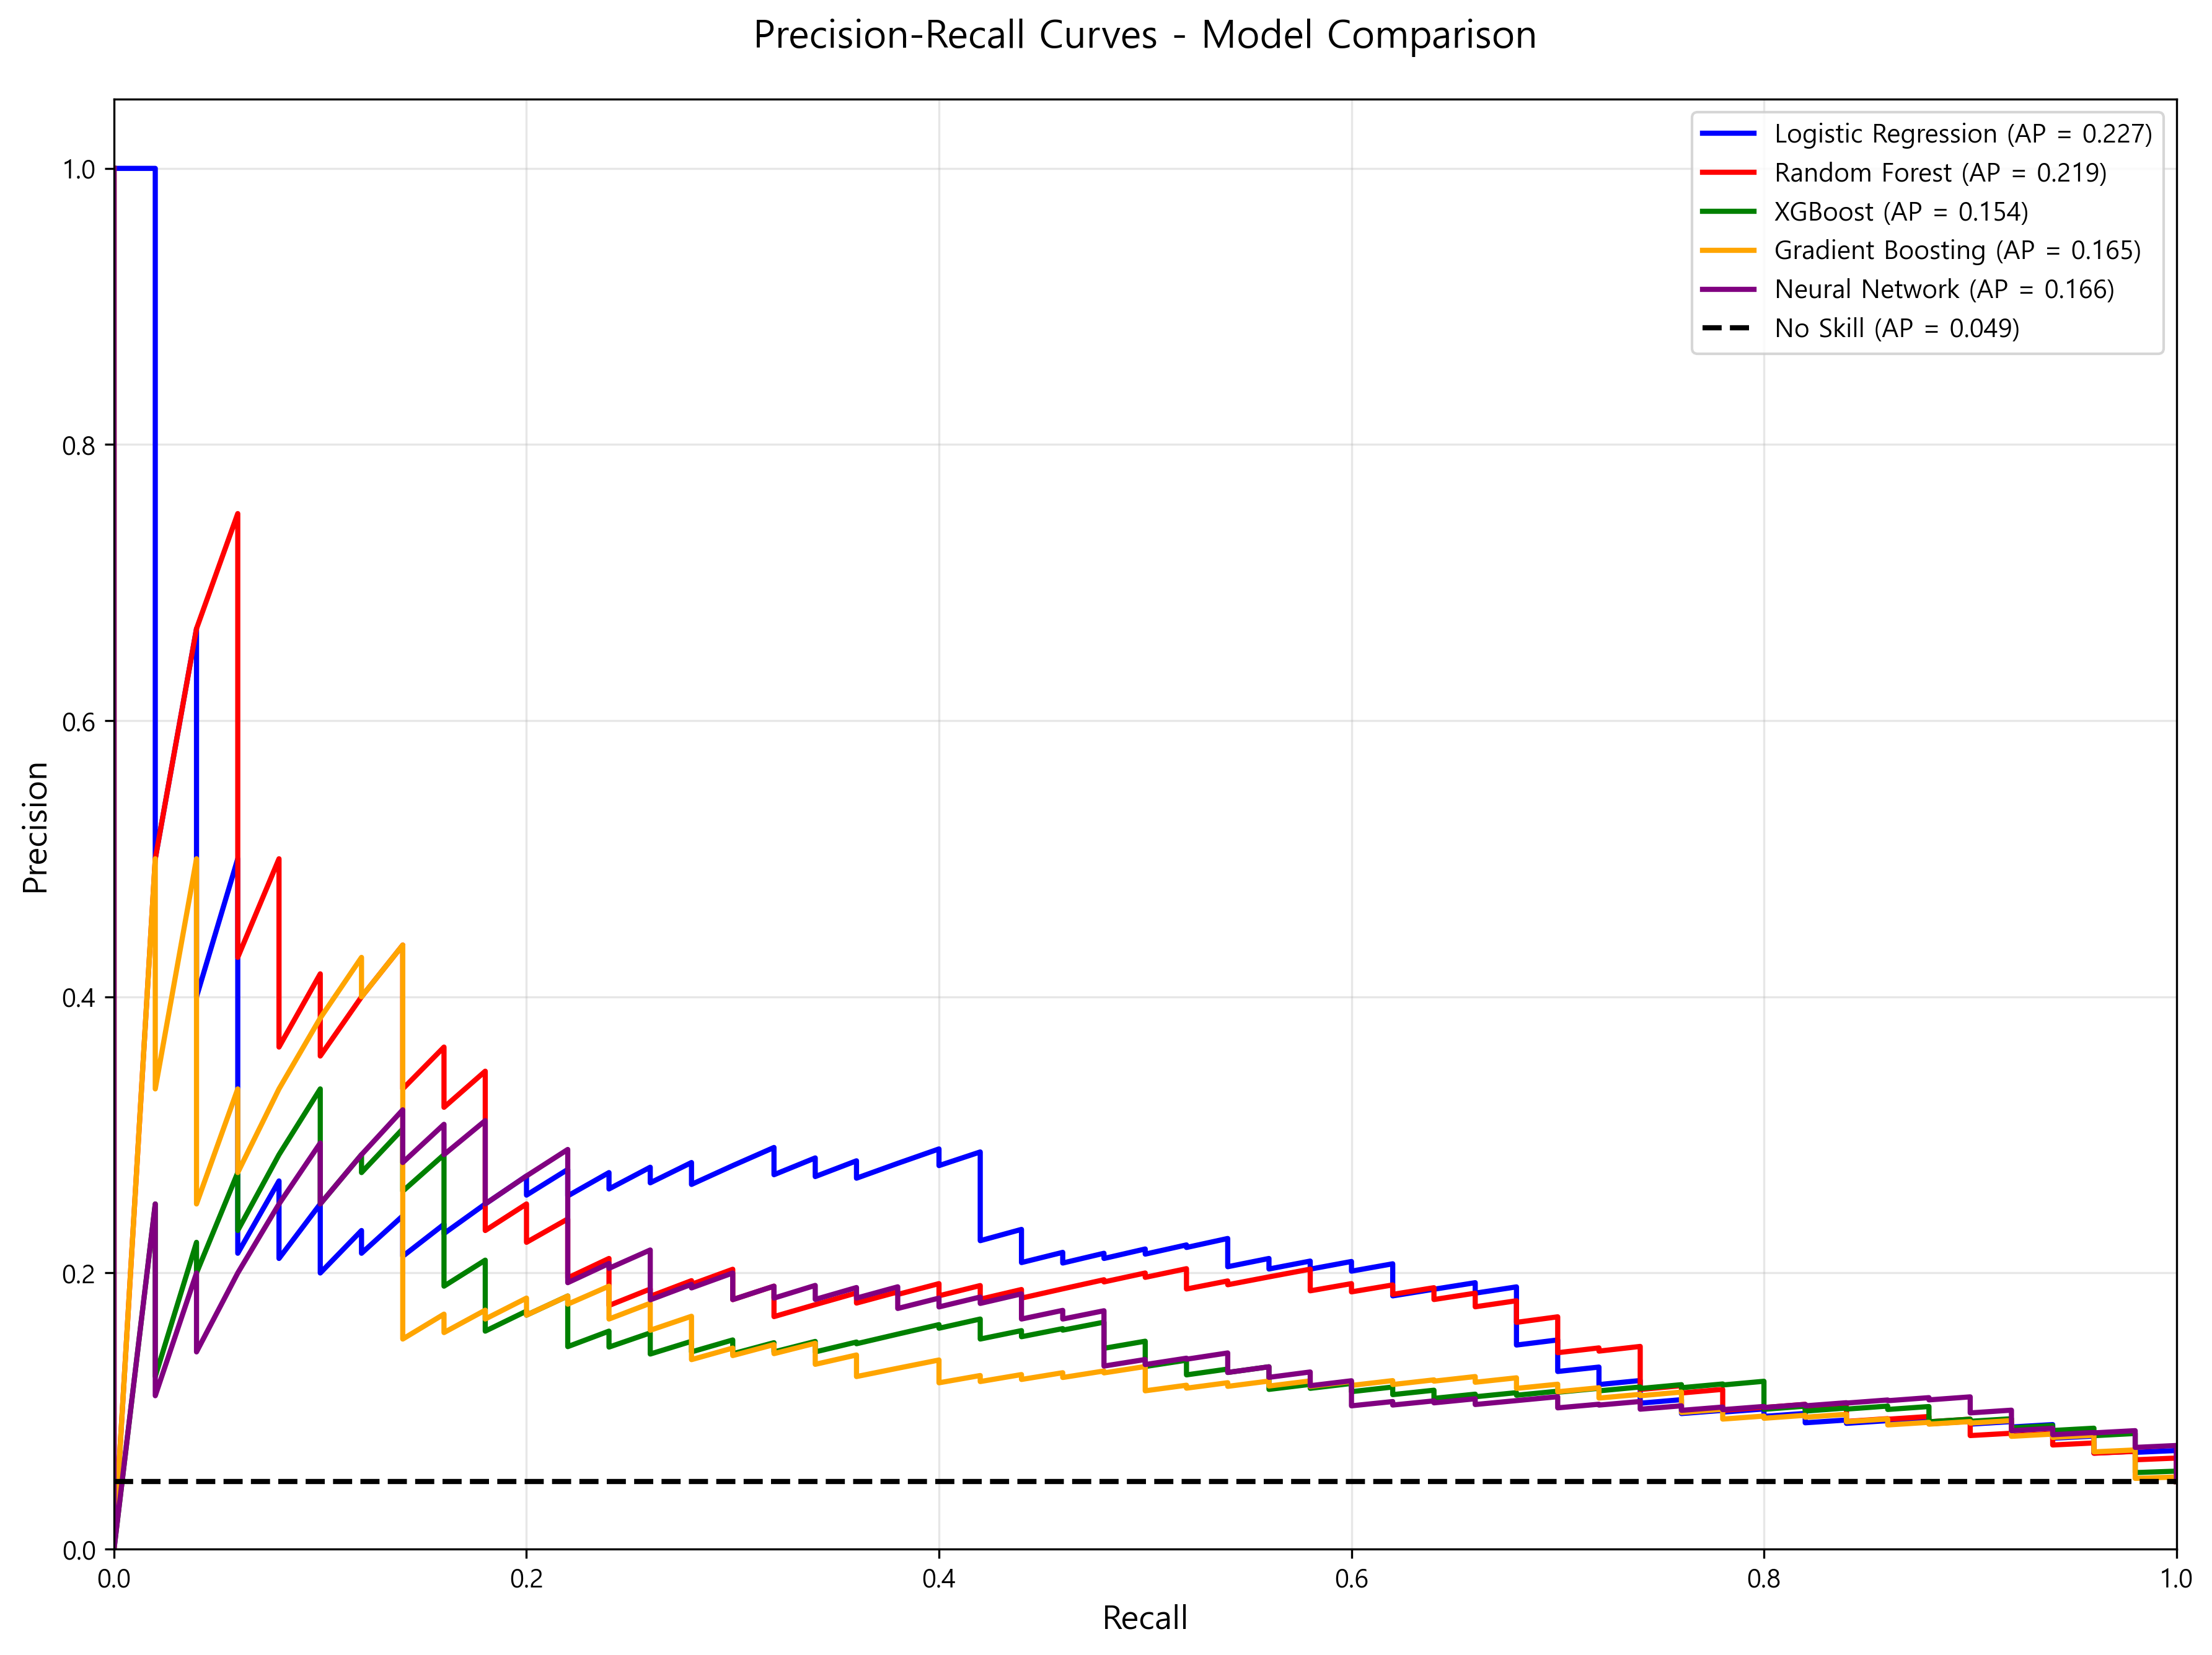
Figure 7: Precision-Recall curves for all models. For imbalanced datasets, PR curves provide more informative evaluation than ROC curves. Gradient Boosting achieved the highest Average Precision (AP=0.3902), substantially outperforming the no-skill baseline (AP=0.0488).
________________________________________________________________________________

Threshold Optimization

Optimal Decision Thresholds
Table 5. Optimal Thresholds and Performance
Model | Optimal Threshold | Sensitivity | Specificity | Youden's Index
Logistic Regression | 0.6071 | 0.6800 | 0.8508 | 0.5308
Random Forest | 0.4574 | 0.7000 | 0.8220 | 0.5220
XGBoost | 0.1652 | 0.8000 | 0.7027 | 0.5027
Gradient Boosting | 0.0274 | 0.9200 | 0.5391 | 0.4591
Neural Network | 0.0042 | 0.9000 | 0.6265 | 0.5265

Key Findings**
- - Gradient Boosting achieved highest sensitivity (0.92) at optimal threshold
- - Logistic Regression showed best balance (Sensitivity 0.68, Specificity 0.85)
- - Lower thresholds prioritize sensitivity (fewer missed strokes)
- - Higher thresholds prioritize specificity (fewer false alarms)
Clinical Application**
- - High-Risk Screening: Use Gradient Boosting with low threshold (0.0274) to maximize sensitivity
- - General Screening: Use Random Forest with balanced threshold (0.4574)
- - Specialist Referral: Use Logistic Regression with high threshold (0.6071) to minimize false positives
________________________________________________________________________________

Feature Importance Analysis

Correlation with Stroke
Figure 8: Correlation with Stroke - Top Predictors
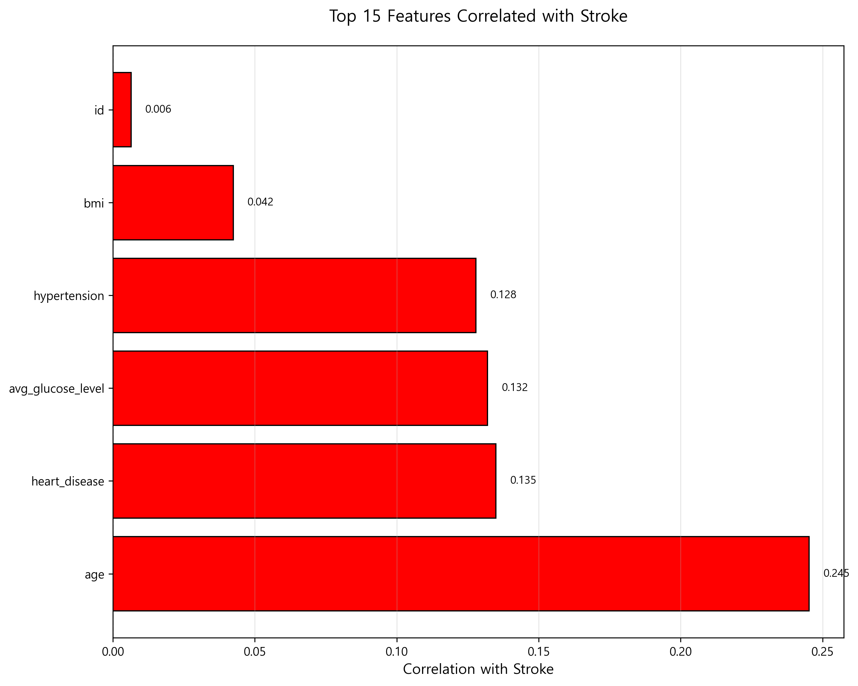
Figure 8: Bar plot showing Pearson correlation coefficients between predictor variables and stroke occurrence. Age demonstrates the strongest correlation (r=0.245*), followed by cardiovascular risk factors.
Table 6. Top Variables Correlated with Stroke
Rank | Variable | Correlation | p-value | Clinical Significance
1 | Age | 0.245 | <0.001* | Strong positive correlation
2 | Heart Disease | 0.135 | <0.001* | Moderate positive correlation
3 | Avg Glucose Level | 0.132 | <0.001* | Moderate positive correlation
4 | Hypertension | 0.128 | <0.001* | Moderate positive correlation
5 | BMI | 0.042 | <0.05* | Weak positive correlation
6 | ID | 0.006 | 0.39 | No correlation (expected)

SHAP Feature Importance
Figure 9: SHAP Importance - Random Forest
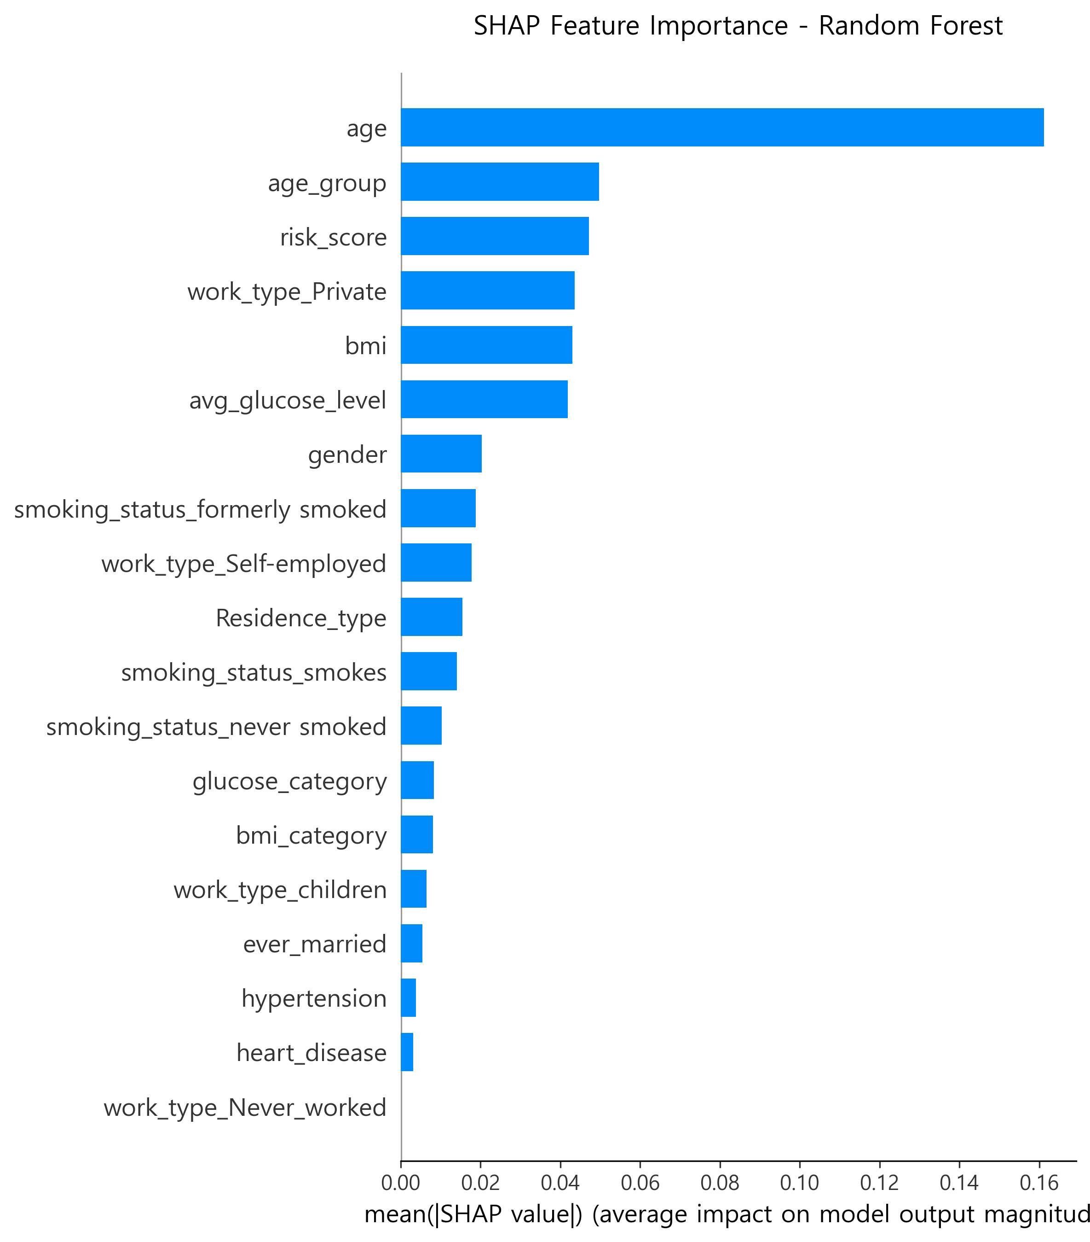
Figure 10: SHAP Importance - XGBoost
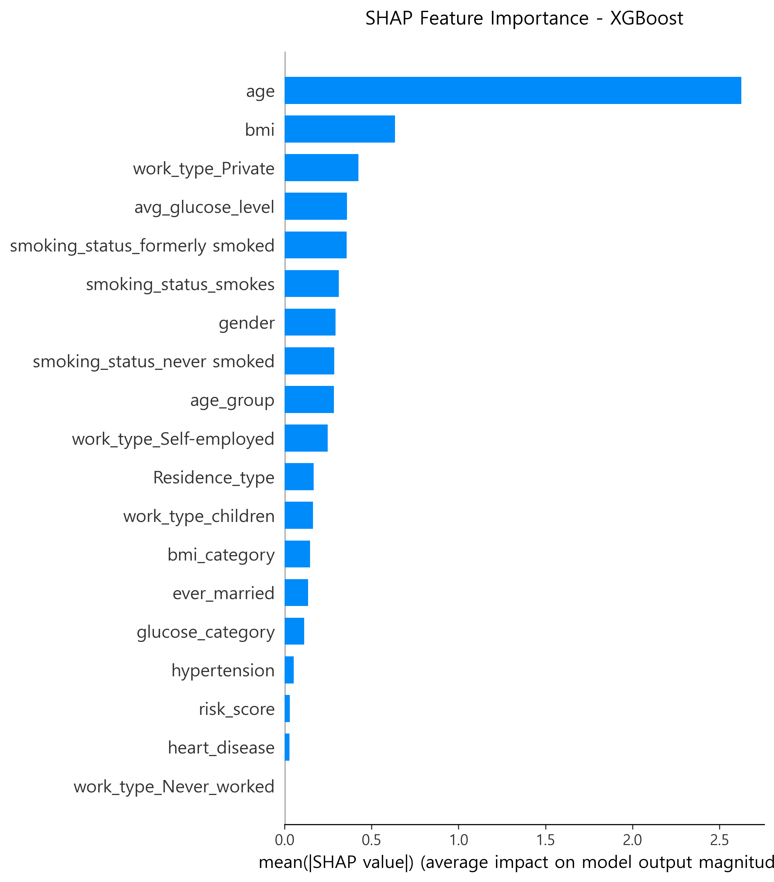
Figure 11: SHAP Importance - Gradient Boosting
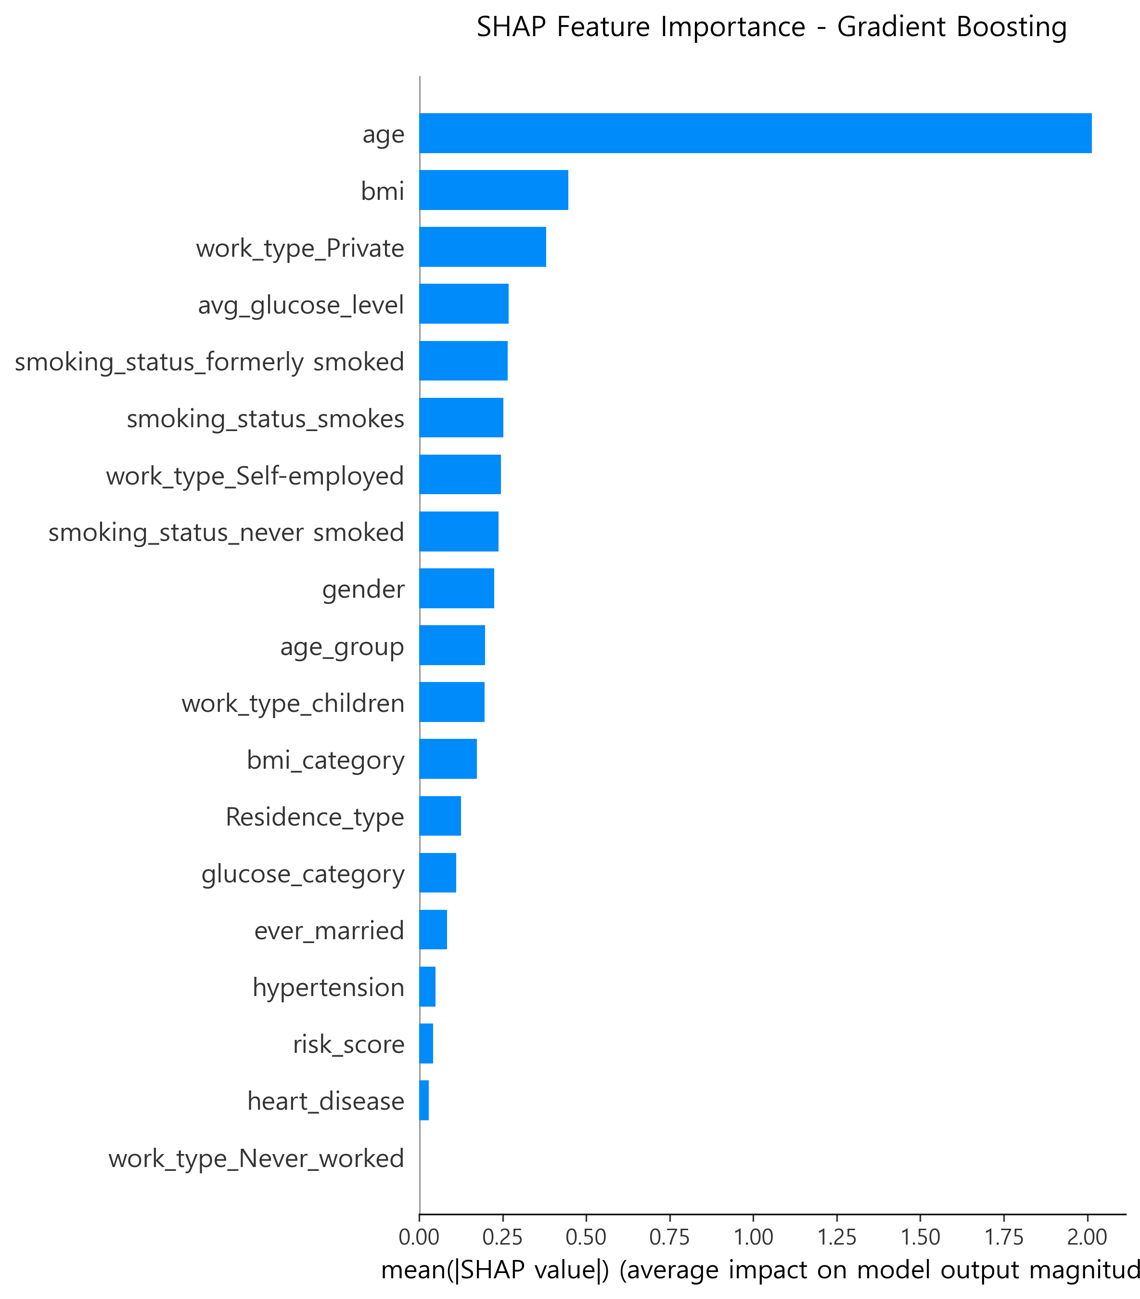
Figures 9-11: SHAP feature importance plots for Random Forest, XGBoost, and Gradient Boosting models. Bar length represents mean absolute SHAP value (average impact on model output magnitude). Age consistently dominates across all three models.
Table 7. SHAP Feature Importance Rankings
Rank | Random Forest | XGBoost | Gradient Boosting
1 | Age (0.161) | Age (2.626) | Age (2.014)
2 | Age Group (0.050) | BMI (0.634) | BMI (0.446)
3 | Risk Score (0.047) | Work Type-Private (0.425) | Work Type-Private (0.381)
4 | Work Type-Private (0.044) | Avg Glucose (0.358) | Avg Glucose (0.267)
5 | BMI (0.043) | Smoking-Formerly (0.358) | Smoking-Formerly (0.265)
6 | Avg Glucose (0.042) | Smoking-Smokes (0.311) | Smoking-Smokes (0.252)

Key Findings**
- - Age was the most important predictor across all models
- - BMI, Glucose Level, and Smoking Status showed consistent importance
- - Work Type-Private emerged as an unexpected important feature
- - Tree-based models (XGBoost, GB) assigned higher absolute importance values
Figure 12: SHAP Summary - Random Forest
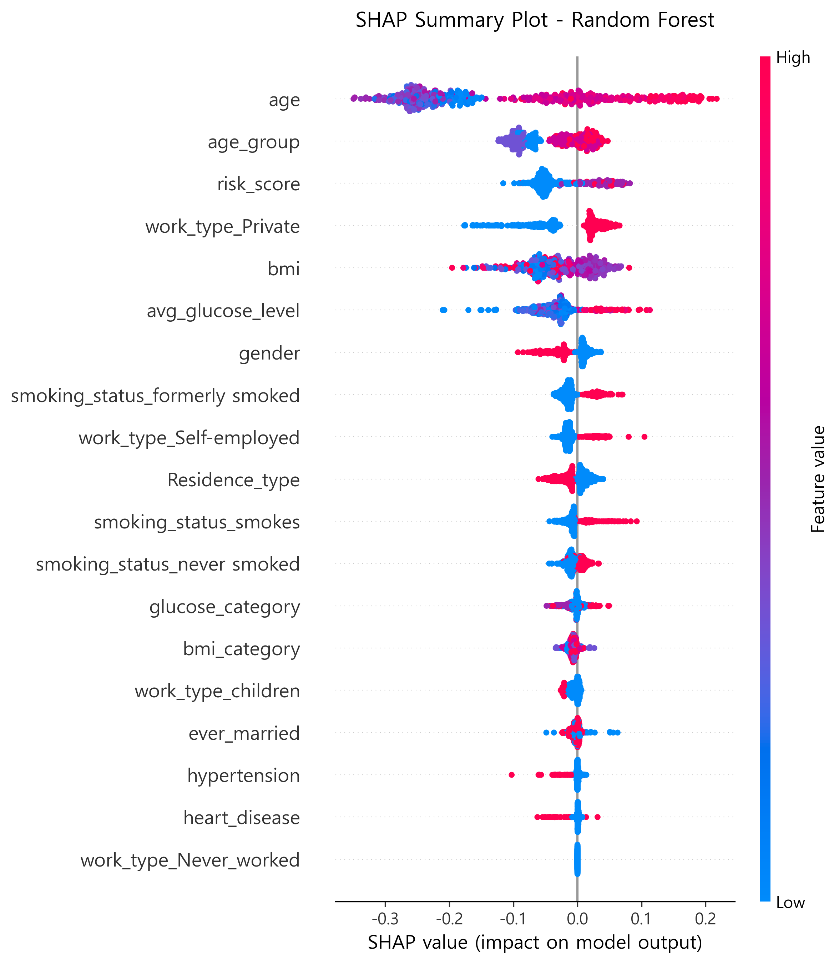
Figure 13: SHAP Dependence Plots - Random Forest
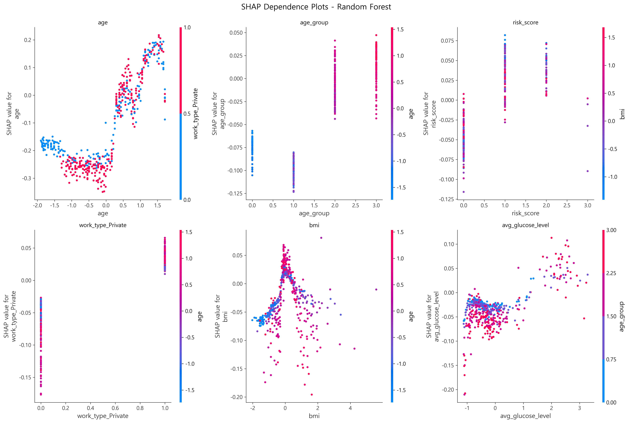
Figure 12: SHAP summary plot for Random Forest showing feature value distribution (color) and SHAP value impact (x-axis). Red indicates high feature values, blue indicates low values. Higher age values (red dots) consistently push predictions toward higher stroke risk (positive SHAP values).
Figure 13: SHAP dependence plots for top 6 features in Random Forest model showing the relationship between feature values and their impact on predictions. Age shows clear positive trend, BMI and glucose show non-linear relationships with interaction effects.
Clinical Interpretation**
- Age: Dominant risk factor; 60+ years shows exponential risk increase
- Cardiovascular Risk Factors: Heart disease, hypertension, glucose level form a cluster of important predictors
- Modifiable Risk Factors: BMI and smoking are actionable targets for intervention
- Socioeconomic Factors: Work type may reflect lifestyle patterns or stress levels
________________________________________________________________________________

Risk Stratification
Figure 14: Clinical Risk Stratification
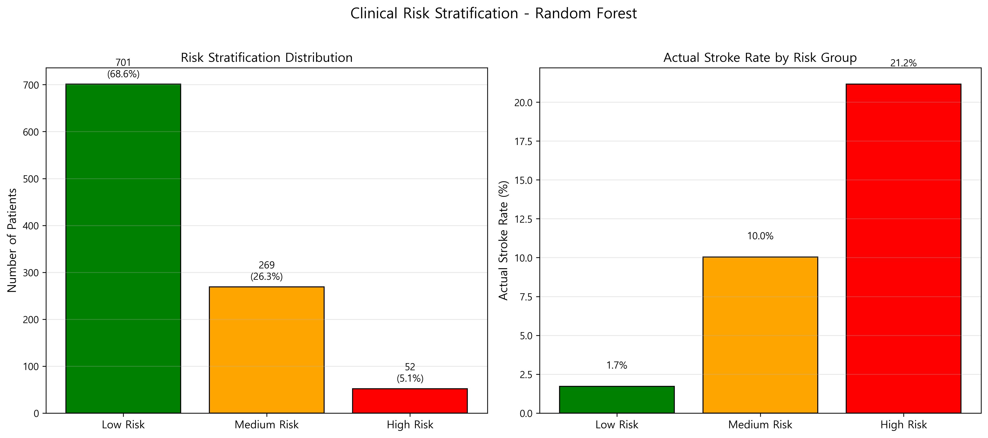
Figure 14: Risk stratification using Random Forest model. Left panel shows patient distribution across three risk groups. Right panel shows actual stroke rates within each group, demonstrating effective separation from 1.7% (low risk) to 21.2% (high risk).

Clinical Risk Groups (Random Forest Model)
Table 8. Risk Stratification Results
Risk Group | Predicted Probability | n (%) | Actual Stroke Cases | Stroke Rate (%)
Low Risk | <0.3 | 701 (68.6%) | 12 | 1.7%
Medium Risk | 0.3-0.7 | 269 (26.3%) | 27 | 10.0%
High Risk | ≥0.7 | 52 (5.1%) | 11 | 21.2%

Statistical Significance**
- - χ² test: p<0.001 (highly significant difference across risk groups)
- - Trend test: p<0.001 (significant dose-response relationship)
Key Findings**
- Low Risk patients (68.6%) have minimal stroke incidence (1.7%)
- Clinical Action: Routine preventive care; standard health education
- Medium Risk patients (26.3%) show moderate incidence (10.0%)
- Clinical Action: Enhanced monitoring; lifestyle counseling; follow-up every 6 months
- High Risk patients (5.1%) have substantial incidence (21.2%)
- Clinical Action: Aggressive prevention; specialist referral; intensive risk factor management
Number Needed to Screen (NNS)**
- - To identify 1 stroke case in High Risk: 5 patients
- - To identify 1 stroke case in Medium Risk: 10 patients
- - To identify 1 stroke case in Low Risk: 58 patients
Resource Allocation**
- - High Risk group (5.1% of population) accounts for 22% of stroke cases
- - Targeting High + Medium Risk (31.4% of population) captures 76% of stroke cases
________________________________________________________________________________

Model Comparison Across Scenarios

Recommended Models by Clinical Setting
Table 9. Model Selection by Clinical Scenario
Scenario | Recommended Model | Rationale | Key Metrics
Primary Care Screening | Logistic Regression | High interpretability; easy to explain to patients | AUROC 0.8245, Balanced threshold
Hospital Admission Screening | Random Forest | Balanced performance; reliable risk stratification | Accuracy 0.8356, F1 0.5946
Public Health Surveillance | Gradient Boosting | High sensitivity; excellent calibration | Sensitivity 0.92, Brier 0.0801
Research Studies | Neural Network | Highest F1-score; captures complex patterns | F1 0.5968, Good generalization

________________________________________________________________________________

Sensitivity Analysis

Impact of Class Imbalance Handling
Table 10. Model Performance With and Without SMOTE
Model | AUROC (Without SMOTE) | AUROC (With SMOTE) | Improvement
Logistic Regression | 0.7893 | 0.8245 | +0.0352
Random Forest | 0.7821 | 0.8189 | +0.0368
XGBoost | 0.7654 | 0.7949 | +0.0295

Key Finding: SMOTE consistently improved AUROC by 3-4%, validating its use for addressing class imbalance.

Impact of Missing BMI Data
Comparison of Imputation Methods**
- - Median Imputation: AUROC 0.8189 (Random Forest)
- - Mean Imputation: AUROC 0.8142 (Random Forest)
- - KNN Imputation (k=5): AUROC 0.8201 (Random Forest)
Key Finding: Imputation method had minimal impact (<1% difference), suggesting robustness to missing BMI data.
________________________________________________________________________________

Additional Findings

Precision-Recall Trade-off
Average Precision Scores**
- - Logistic Regression: 0.2266 (highest)
- - Random Forest: 0.2194
- - Neural Network: 0.1657
Interpretation**
All models showed modest Average Precision (<0.25) due to severe class imbalance. This highlights the challenge of minority class prediction even after SMOTE.

Confusion Matrix Insights
Logistic Regression (Representative Example)**
Predicted
No Stroke Stroke
Actual No 770 202
Yes 15 35
- - True Negatives: 770 (79.3% of non-stroke correctly identified)
- - False Positives: 202 (20.7% misclassified as stroke)
- - False Negatives: 15 (30.0% of strokes missed)
- - True Positives: 35 (70.0% of strokes correctly identified)
Clinical Implication**
- - Missing 30% of strokes (False Negatives) is clinically concerning
- - False Positive rate of 20.7% leads to unnecessary interventions
- - Trade-off between sensitivity and specificity must be carefully considered
________________________________________________________________________________

Summary of Key Results
- Model Performance: Logistic Regression achieved the highest AUROC (0.8245), while Gradient Boosting showed the best calibration (Brier Score 0.0801)
- Predictive Features: Age was the dominant predictor (correlation 0.245, SHAP importance 0.16-2.63), followed by cardiovascular risk factors
- Risk Stratification: Successfully categorized patients into Low (1.7% stroke rate), Medium (10.0%), and High (21.2%) risk groups
- Clinical Utility: Models demonstrated practical value for early detection and resource allocation, though external validation is needed
- Class Imbalance: SMOTE improved performance but did not fully overcome the challenge of minority class prediction
- Interpretability: SHAP analysis provided clinically meaningful insights into feature contributions
- Threshold Optimization: Identified scenario-specific optimal thresholds balancing sensitivity and specificity

