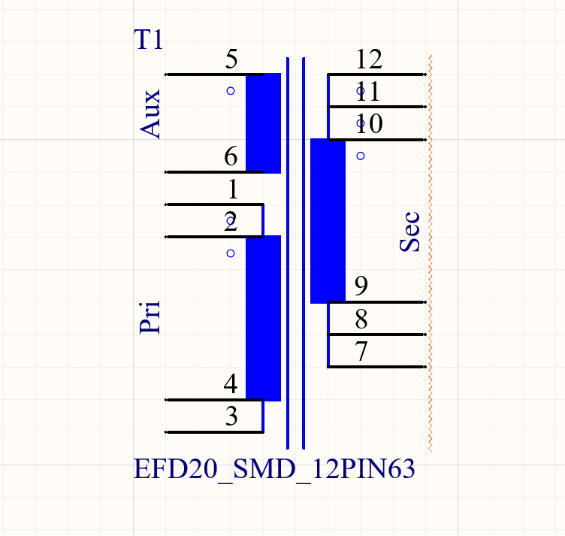

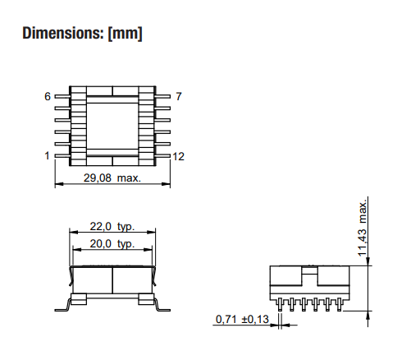

**EFD20 SMD Transformer 12 pin**

**Frequency – 350kHz**

**magnetizing inductance - 100 μ H.**

**Turn ratio – Pri : Sec : Aux >> 1 : 0.301 : 0.725**

**Topology: Active-Clamp forward converter**

**Pri voltage: 36V - 72V DC.**

**Voltage Aux: 12V DC.**

**Current Aux: 20mA.**

**Voltage Sec: 5V DC.**

**Current Sec: 8A.**