I set the trip current to 0.4A from the serial console :

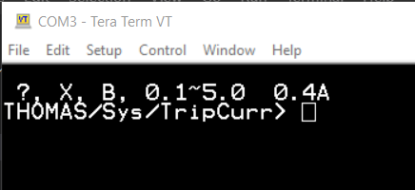

Then applied up to 3A to both the trip coils.

But in the event list only following appears as below:

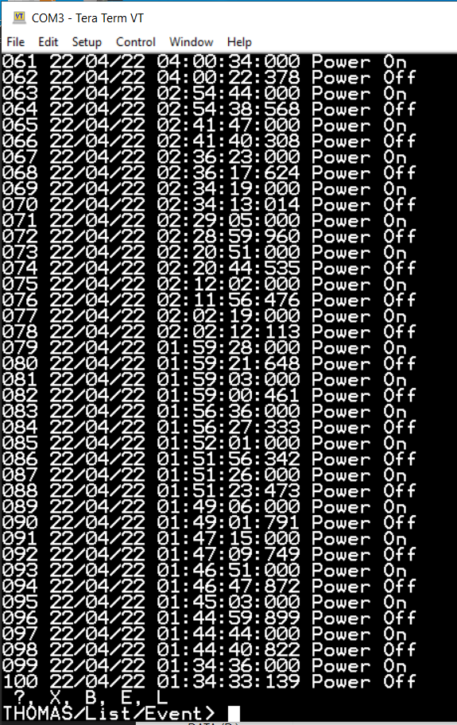

So I need help on how to trigger an event.