I have the newest Fault list in terraterm.

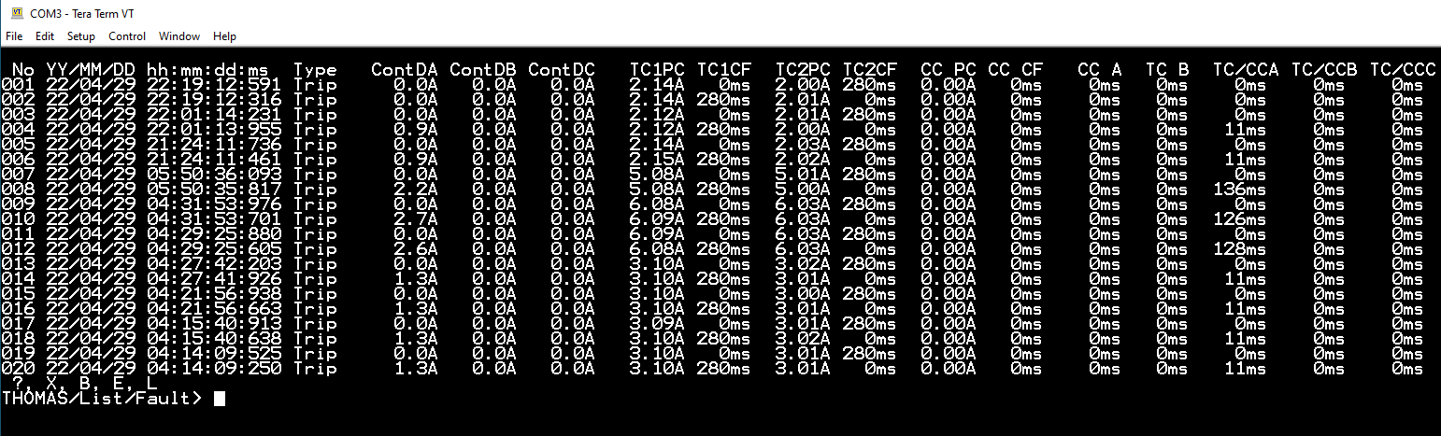

I set the threshold current to 0.4A for Trip Coils, then applied DC 2A to both trip coil and DC 10V to Voltage channel.

Then downloaded Modbus Tables trip1.csv, trip2.csv, PhaseA_Curr.csv and voltwave.csv

Here is my settings:

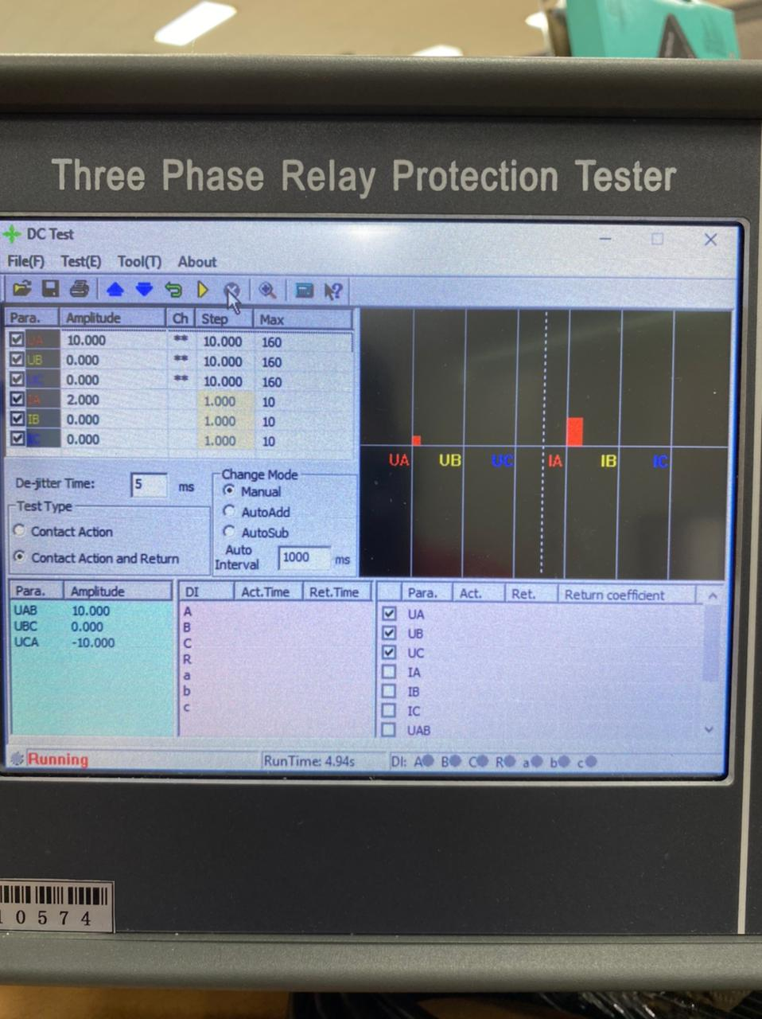

I also checked with clamp meter. The current was accurate on clamp meter.