

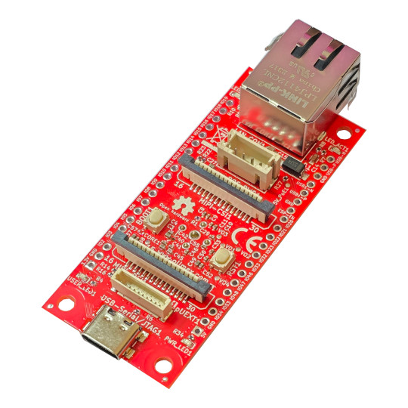

ESP32-P4-DevKit
User Manual
Rev.1.0 December 2024 olimex.com
Table of Contents
What is ESP32-P4-DevKit 3
Order codes for ESP32-P4-DevKit and accessories: 4
HARDWARE 5
ESP32-P4-DevKit layout: 6
ESP32-P4-DevKit POE connector: 8
ESP32-P4-DevKit CSI connector: 9
ESP32-P4-DevKit MIPI connector: 10
ESP32-P4-DevKit UEXT connector: 11
ESP32-P4-DevKit EXT1 and EXT2 connectors: 12
UEXT connector: 13
ESP32-P4-DevKit schematics: 14
SOFTWARE: 15
Revision History 16

What is ESP32-P4-DevKit

ESP32-P4-DevKit is development board with ESP32-P4 Dual Core RISC-V processor from Espressif.

The features of ESP32-P4-DevKit are:

- ESP32-P4 Dual core 400Mhz RISC-V processor, 768KB internal RAM
- USB JTAG for programming and debugging
- Ethernet PHY and connector with POE option
- Camera CSI interface
- Display DSI interface
- microSD card
- Boot and Reset buttons
- SPI Flash 16MB
- UEXT connector
- All GPIOs available on two 0.1″ 2.54 mm 20 pin DIL headers
- four mounting holes 3.3mm diameter
- Dimension 72x30mm

ESP32-P4-DevKit is Open Source Hardware, all CAD files and firmware and available, so people can study and modify.

Order codes for ESP32-P4-DevKit and accessories:

ESP32-P4-DevKit ESP32-P4 development board with Ethernet
UEXT-PQ pUEXT to UEXT adapter
pUEXT-CABLE 1mm step pUEXT cable with 50, 100 and 200mm lenght
POEv3 PoE add-on board allowing board to be powered by Ethernet POE
UEXT modules many UEXT modules which can connect to Neo6502 UEXT connector
USB-CABLE-AM-USB3-C High speed, High current cable for power supply and programming

HARDWARE

ESP32-P4-DevKit layout:

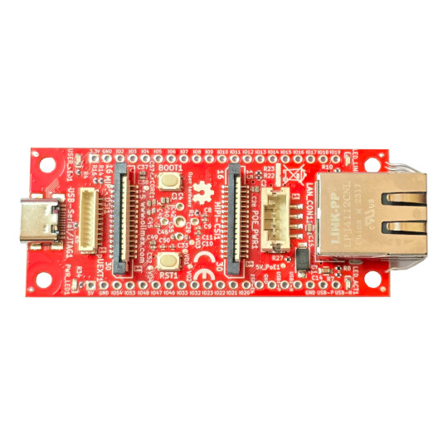
LED
USB-C JTAG
Power LED
MIPI-DSI
UEXT connector
BOOT button
RESET buttoon
MIPI-CSI
Ethernet
POE

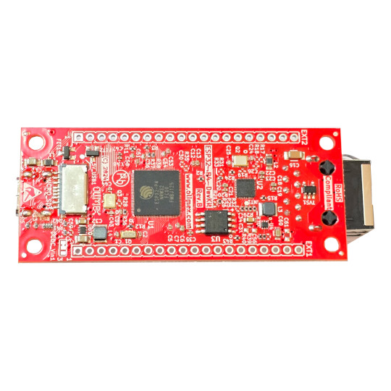
GPIO connector 2
Micro SD card
GPIO connector 1
SPI flash

ESP32-P4-DevKit POE connector:

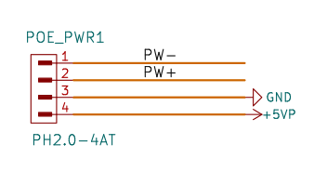
PW+ and PW- come from the LAN transformer. POEv3 external board have POE negotiator and DCDC step down circuit which produce 5V/3A which is feed back to the ESP32-P4-DevKit.

ESP32-P4-DevKit CSI connector:

MIPI-CSI connector is with standard Raspberry Pi 1,2,3 and 4 camera FPC layout. So you can connect standard Rpi camera to it.

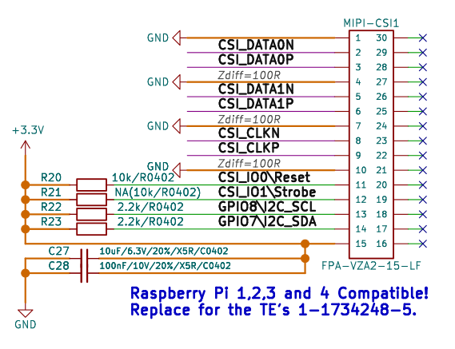

ESP32-P4-DevKit MIPI connector:

MIPI-DSI is Raspberry Pi DSI connector layout:

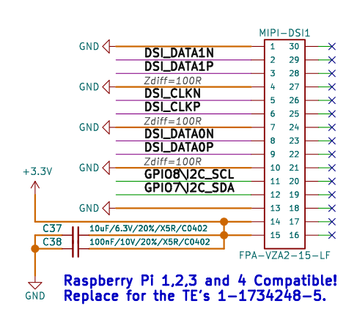

ESP32-P4-DevKit UEXT connector:

ESP32-P4-DevKit is very compact board so standard UEXT connector is impossible to be used, this is why pUEXT connector is used:

pUEXT is 1.0 mm step connector:
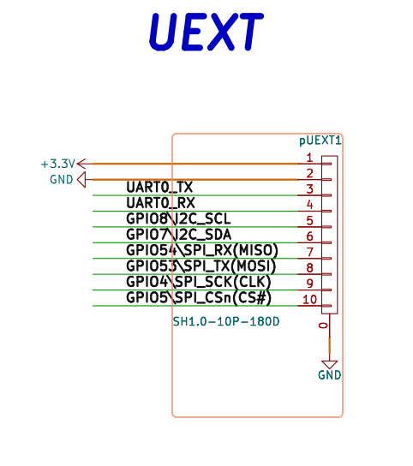
UEXT-PQ is adapter which allow pUEXT connector to be wired to standard UEXT.

ESP32-P4-DevKit EXT1 and EXT2 connectors:
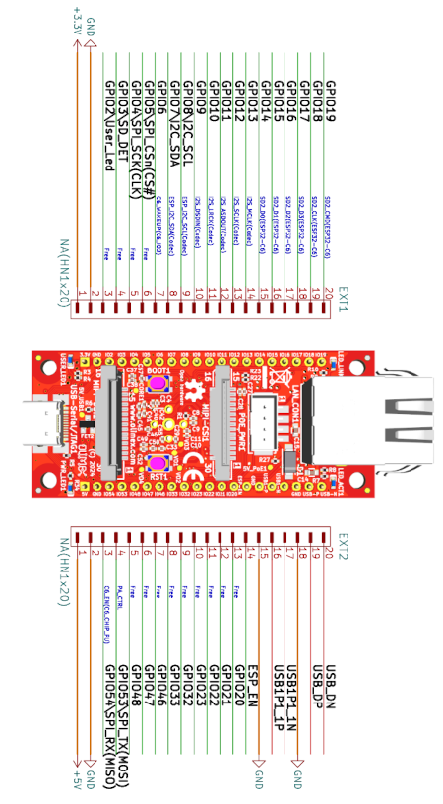

UEXT connector:

UEXT connector stands for Universal EXTension connector and contain +3.3V, GND, I2C, SPI, UART signals.
UEXT connector can be in different shapes.
The original UEXT connector is 0.1” 2.54mm step boxed plastic connector. All signals are with 3.3V levels.
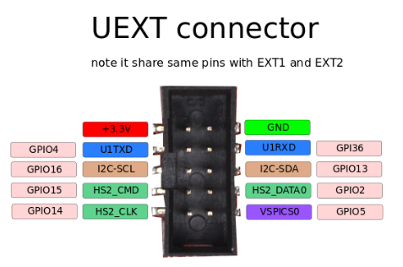

Olimex has developed number of MODULES with this connector. There are temperature, humidity, pressure, magnetic field, light sensors. Modules with LCDs, LED matrix, Relays, Bluetooth, Zigbee, WiFi, GSM, GPS, RFID, RTC, EKG, sensors and etc.

ESP32-P4-DevKit schematics:

ESP32-P4-DevKit latest schematic is on GitHub

SOFTWARE:

ESP32-P4-DevKit can be programmed with ESP-IDF versipon 5.4 or later.
You can learn how to install it here.

Revision History
Revision 1.0 December 2024

