Sensor array PCB for gas sensors

Objective:
Design a comprehensive gas-sensor PCB that: maintains proper thermal conditions; fits the enclosure; mounts easily and connects cleanly to power; provides a single serial output for the full board; and exposes the required per-sensor interfaces for an Arduino Mega MCU.
Reference - Using Sensor Fusion and Machine Learning to Create an AI Nose | Digi-Key Electronics

Controller
Arduino Mega 2560 (5 V, 16 analog inputs, 4 UARTs).
- All analog sensors are grouped and directly landed to Analog IO.
- ZE03/ZE08 connected to UARTs.

Sensor interfaces (prefer analog everywhere)

Analog to MCU (~A0…A12)
- MQ-series: MQ-2, MQ-4, MQ-6, MQ-7, MQ-131 Low, MQ-131 High, MQ-135, MQ-136 (H₂S), MQ-137
- MICS-6814 (3 channels: CO, NH₃, NO₂)
- SM4-NO₂ (analog)
- ZP07 VOC (analog)

I²C
- CJMCU-811

UART
- ZE03-SO₂ (compensated linearized digital data)
- ZE08-CH₂O (compensated linearized digital data)

~12 channels total (fits Mega’s 16 analogs).

Per-channel minimal conditioning:
At each MCU analog pin: 1 kΩ series + 100 nF to GND (RC) + (optional) 10 kΩ to GND (bleed).
This tames noise/ESD and costs almost nothing.

Simple digital
- DHT22 T/H sensor on a single GPIO (e.g., D2) with 4.7 kΩ pull-up to 5 V.

Power
- 5 V IN + polyfuse (3-5 A) + TVS diode: main 5 V plane.
- Create a 5V-HEAT branch via one ferrite bead to feed all heaters (MQ/MICS) and keep noise off logic.
- Bulk caps: 470 - 1000 µF near input; 220 µF near heater bank.
- Decoupling: 100 nF at every sensor header VCC and at Arduino 5 V pins.
- AREF: tie to 5 V, add 100 nF to GND at AREF pad.
Let’s keep the possibility to control heaters and add two N-MOSFETs (bank-level switching) with 100 Ω gate resistors + 10 k pulldowns.

Concrete pin map
Interface | Sensor | Target Gas / Parameter | Redundancy / Overlap
Analog A0 | MQ-2 | LPG, Smoke, H₂, CO | Partial overlap with MQ-6 (LPG)
Analog A1 | MQ-4 | Methane (CH₄) | Unique
Analog A2 | MQ-6 | LPG, Propane | Partial overlap with MQ-2
Analog A3 | MQ-8 | Hydrogen (H₂) | Unique
Analog A4 | MQ-131 (Low) | Ozone (O₃, low concentration) | Complementary with A5
Analog A5 | MQ-131 (High) | Ozone (O₃, high concentration) | Complementary with A4
Analog A6 | MQ-135 | Ammonia (NH3), sulfur (S), Benzene (C6H6)
Analog A7 | MQ-136 | Hydrogen sulfide (H₂S) | Unique
Analog A7 | MQ-137 | Ammonia
Analog A8 | ZP07 | VOCs | Overlaps with CJMCU-811 (TVOC)
Analog A9 | SM4-NO₂ | Nitrogen dioxide (NO₂) | Redundant with MICS-6814 NO₂
Analog A10 | MICS-6814 (CO) | Carbon monoxide (CO) | Unique
Analog A11 | MICS-6814 (NH₃) | Ammonia (NH₃) | Partially complement with MQ-137, MQ-135
Analog A12 | MICS-6814 (NO₂) | Nitrogen dioxide (NO₂) | Redundant with SM4-NO₂
UART1 | ZE03-SO₂ | Sulfur dioxide (SO₂) | Unique
UART2 | ZE08-CH₂O | Formaldehyde (CH₂O) | Unique
I2C | CJMCU-811 | eCO₂, TVOC | Overlaps with ZP07 VOC
Digital D2 | DHT22 | Temperature, Humidity | Unique

Analog sensors
- MQ-2 → 1 component
- MQ-4 → 1
- MQ-6 → 1
- MQ-8 → 1
- MQ-131 → 1 (Low & High are just two outputs from one sensor)
- MQ-136 → 1
- ZP07 → 1
- SM4-NO₂ → 1
- MICS-6814 → 1 (outputs multiple gases, but one component)
Analog total components: 9

UART Sensors
- ZE03-SO₂ → 1
- ZE08-CH₂O → 1
UART total components: 2

Digital / I2C Sensors
- CJMCU-811 → 1
- DHT22 → 1
Digital/I2C total components: 2

Total physical (separate) sensors
9 (analog) + 2 (UART) + 2 (digital/I2C) = 13 physical sensor components

Optionally:
D6 HEAT_BANK_1 (optional MOSFET gate)
D7 HEAT_BANK_2 (optional MOSFET gate)

Board layout
- Top: Arduino Mega headers, sensor headers around edges, RC filters next to MCU A-pins.
- Bottom: wide 5 V & GND pours; heater returns home to 5V-HEAT star point near ferrite.
- Analog runs short and away from heater loops and any fast edges.

Placement strategy with heating & airflow (symmetric 7+7+1)
Mechanical concept:
- Make the PCB symmetrical left/right with 7 sensor headers per side and 1 sensor more.
- Add a central vertical slot/window (e.g., 8-12 mm wide) to promote chimney airflow and reduce thermal pooling.
- Place the Arduino and power entry below the slot (or offset) to keep heat away from VOC/formaldehyde sensors.
Thermal & cross-sensitivity rules:
- Hot sensors outward: MQ heaters and MICS-6814 (has heater) go near board perimeter, spaced apart; put their headers so the sensing elements protrude off-board into free air (still maintaining symmetry and even sensor placement).
- Sensitive/low-ppm inward but not hot: ZE08-CH₂O (CH₂O), ZP07 VOC, SM4-NO₂ closer to the central slot, but not directly above power or the heater branch.
- Pair low/high O₃ (MQ-131) on opposite sides to minimize mutual heating and to sample different boundary layers.
- Stagger heights: board will be placed on standoffs or small brackets so warm plumes don’t wash over the most sensitive parts; keep at least 15-20 mm lateral spacing between different families.
- DHT22 on an edge away from the heater branch (upstream of airflow) to get meaningful ambient T/H for compensation.
- Shielding by placement, not cans: avoid metal shields unless required; not to trap heat, design the slot and spacing instead.
Example split (balanced 7/side):
- Left (7): MQ-2, MQ-6, MQ-131 Low, MICS-6814 (3ch header), ZE03-SO₂ (analog), DHT22
- Right (7): MQ-4, MQ-8, MQ-131 High, MQ-136, ZP07 VOC, SM4-NO₂, ZE08-CH₂O
(we can swap pairs to match your enclosure airflow; keep “hot” evenly distributed.)

Airflow direction:
- Since the robot has a known forward motion, we can orient the slot along the way to travel so fresh air replenishes both banks equally. Also parallel positioning is possible.
- Avoid placing vents/grilles that recirculate motor exhaust or battery heat into the sensor zone.

Connectors & service
- JST-XH (2.54 mm) (or locking MicroFit) 3-pin per sensor: 5V / G / SIG, clearly silkscreened.
- Test pads: 5V, GND, AREF, and one pad per analog net.
- Label every net SEN_<NAME> to keep bring-up painless.

TL;DR
- Arduino Mega 2560, all sensors in analog mode directly to A0-A13, DHT22 on D2, UART1: ZE03-SO₂, UART2: ZE08-CH₂O.
- One 5 V rail with polyfuse + TVS; a single ferrite bead creates a 5V-HEAT branch; bulk/decoupling caps only.
- Per-channel 1 k/100 nF RC into each analog pin (no op-amp/external ADC).
- Symmetric layout: 7 sensors left + 7 right, central airflow slot, hot parts at the perimeter, sensitive parts near the slot, DHT22 away from heaters.
- Two MOSFETs to switch heater banks, and spare UART pads for future digital modes.

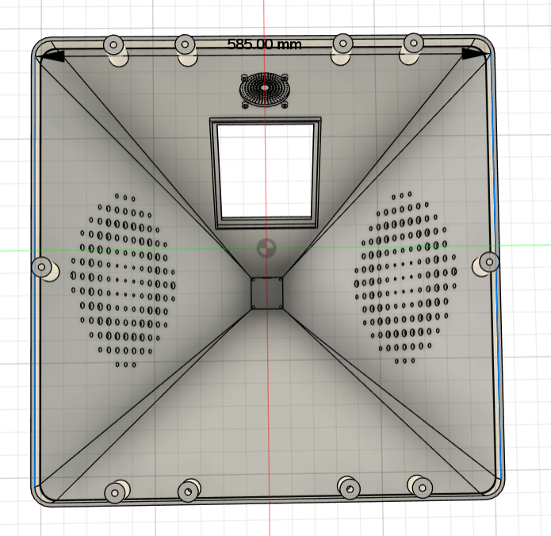 | 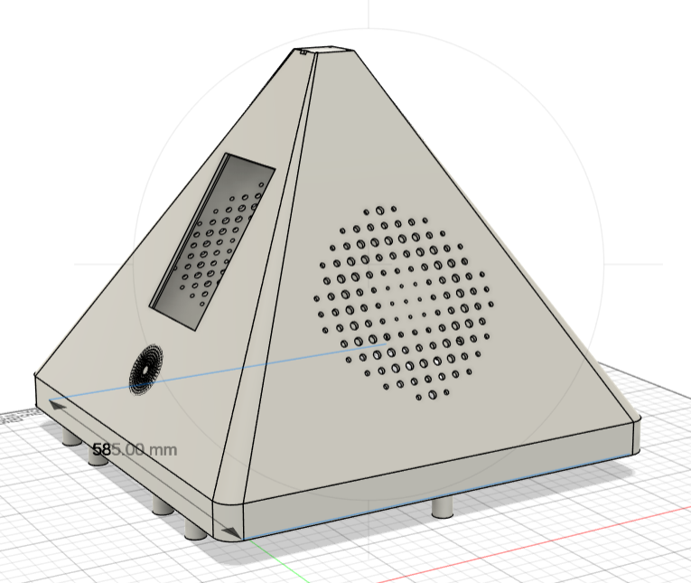
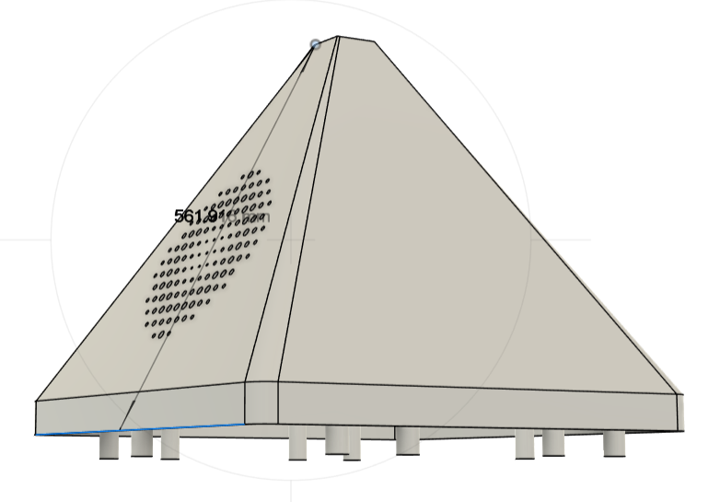 | 