AIRMAN  
Aeronautics  
Airman XB-70 Pro Flight Computer

Product Development Workflow

XB-70 Pro Flight controller main hardware components:

|  |  |  |  |
| --- | --- | --- | --- |
|  |  |  |  |
| STM32H747XIH6 |  | 32-bit Arm® Cortex®-M7 and 32-bit Arm® Cortex®-M4 480MHz |  |
| BMI360 |  | Programmable smart sensor combining accelerometer, gyroscope and fusion software. |  |
| BMM350 |  | 3-axis magnetic sensor with high data rate. |  |
| SHT41-AD1F-R2 | Sensirion_SHT4x-AD1F | 4 th Gen. Relative Humidity and Temperature Sensor |  |
| MIPI 3.5 Inch LCD |  | **3.5 Inch IPS Landscape Type High Resolution 640 \* 480 Mipi Interface IPS TFT Display** |  |

Project is divided into 4 milesones:

1. Connect and test all sensors and display to the main dev board and check real time performance.
2. Design and Deliver the PCB production file. Same time develop the GUI and other flight control logics on the dev boards.
3. Test and Debug the firmware on the prototyped PCB product.
4. Ground Test and debug the product.

Here is the hardware interconnection of the devices to main processor:

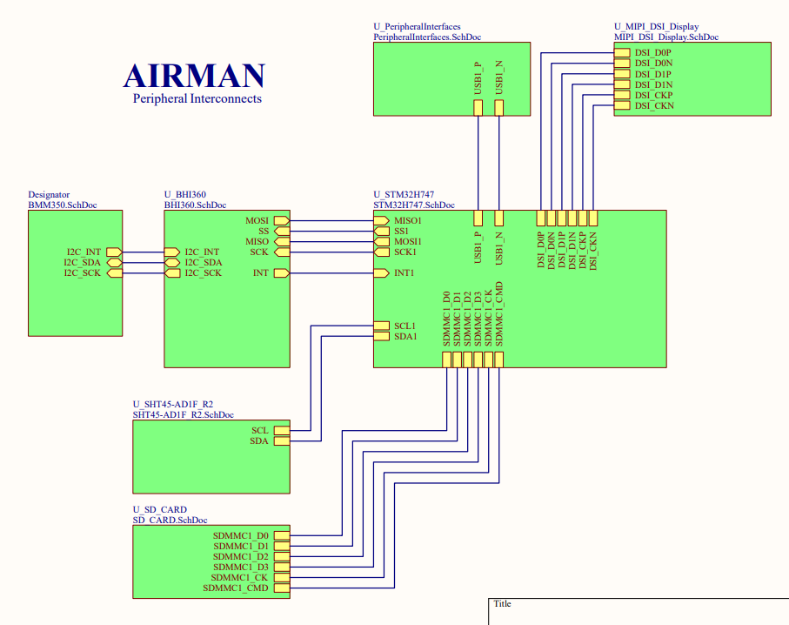

Timelines for each Milestones:

|  |  |  |
| --- | --- | --- |
| Milestones | Required Time |  |
| 1. Connect and test all sensors and display to the main dev board and check real time performance. | 12 days after dev boards arrival. |  |
| 1. Design and Deliver the PCB production file. Same time develop the GUI and other flight control logics on the dev boards. | 17 days. |  |
| 1. Test and Debug the firmware on the prototyped PCB product. | 12 days |  |
| 1. Ground Test and debug the product. | Part of after delivery work. |  |
|  |  |  |
|  |  |  |

My expected payment for the project is USD 3000. You can distribute the payments in milestones.