This Software Rebuild Phase 1 is part of the development of an invention intended to print custom images on a golf ball using an HP45 print cartridge. It is further intended to produce proof of concept images without the defects shown in the images shown below to make it suitable for a marketing campaign.

  

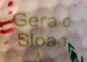 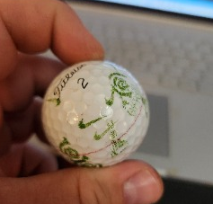 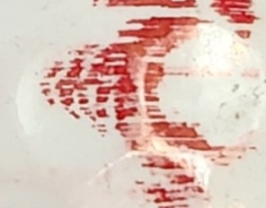

The Phase 1 Software Rebuild should implement fine-tuned software controls of an HP45 print cartridge such that it produces the attached images with a print quality resembling a scaled-down and monochromatic version of a given parent image as closely as reasonably possible. It should fit within a single sweep of a portion of the surface area of a standard golf ball. It will minimize misprints and errant ink marks. In consideration of the many factors involved in processing such an image, it preserves as much detail from the parent image as reasonably possible. The goal is to achieve the highest-quality print possible, with the consideration that changes outside of the scope of the Software Rebuild Phase 1 will be required in Software Rebuild Phase 2 to further improve print quality for the final marketing video.

We are using Windows as the OS. We only have one unit so the candidate needs to test it remotely. I attached the printed image of a 1/8th note, and you can see the cross-hatching.

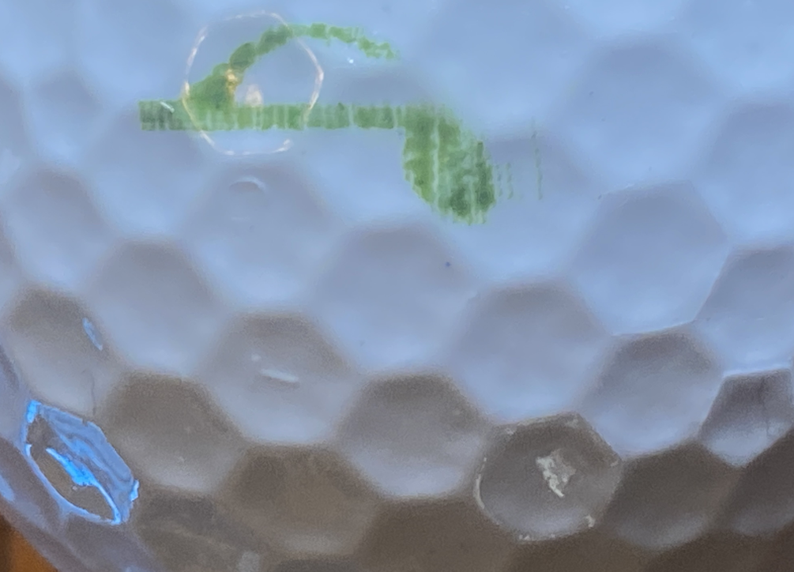 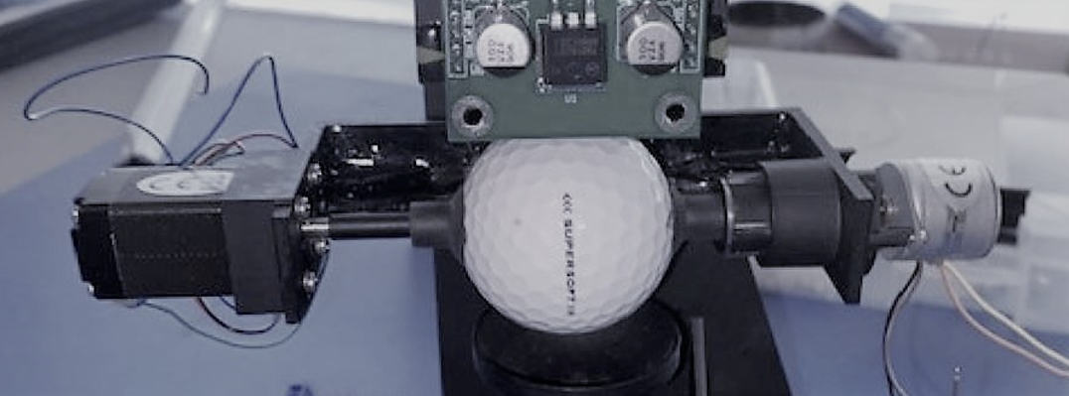

Note the ragged nature of the image/edges.

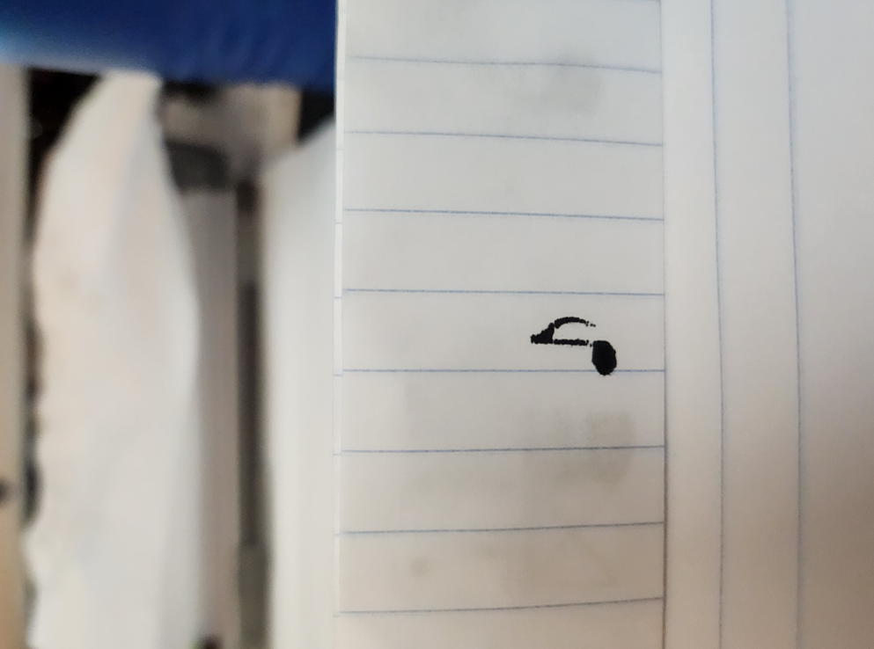

Here is a video of the concept model we did.

<https://vimeo.com/472313772>

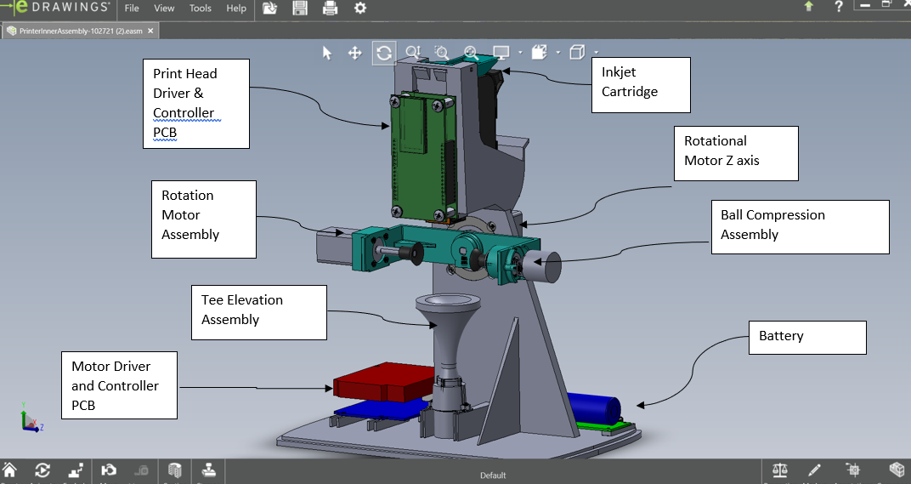

Internal Sub Assemblies

We have attached the current firmware and documents - teensy 3.1/3.2 on the printhead(controller schematic, driver schematic, BOM) and 4.1 on the bread board(instructions).

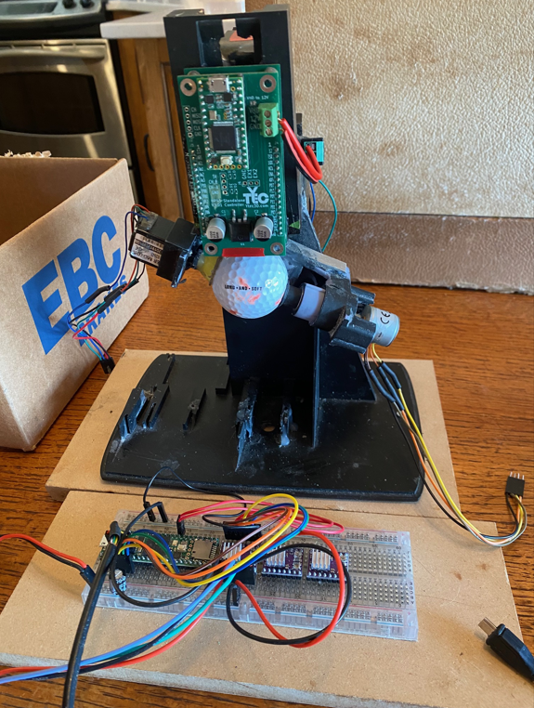

You can share milestones according to the follow tasks.

1 Get the printhead to print something on the ball, no motors, just the printhead

2.print something using the gimbal motor to rotate the ball clockwise and counterclockwise.

3. print something using the gimbal motor and the rotational motor.

4. Add in the clamping motor and print something

5. Add in the motor that raises and lowers the tee.