Absarulislam, Jibran

jga26

GosnioSQL314!

sql1.njit.edu

Users: User 1: dpn72 072

User 2: jga26 026

Clickable Link

<https://web.njit.edu/~jga26/download/z2.php?ucid=dpn72&account=072&amount=-47>

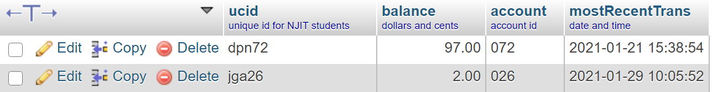

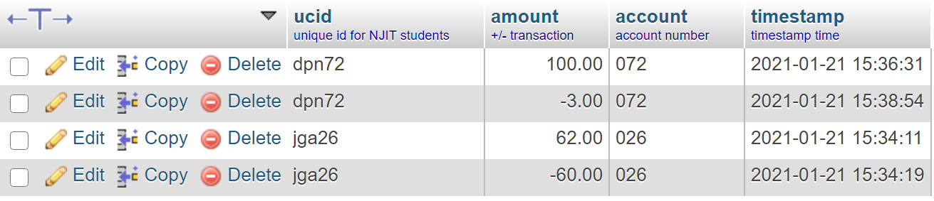Figure 1A. **accounts** table **before** doing transaction

Figure 1B. **transactions** table BEFORE doing transaction

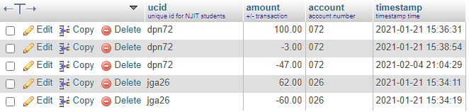

Figure 1C. **transactions** table **AFTER** doing transaction

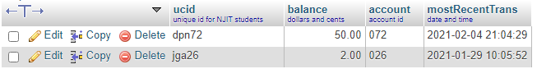

Figure 1D. **accounts** table **AFTER** doing transaction

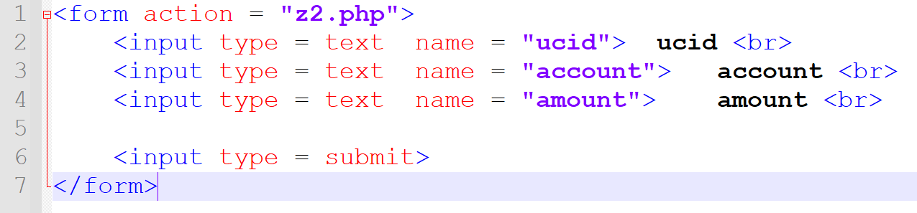

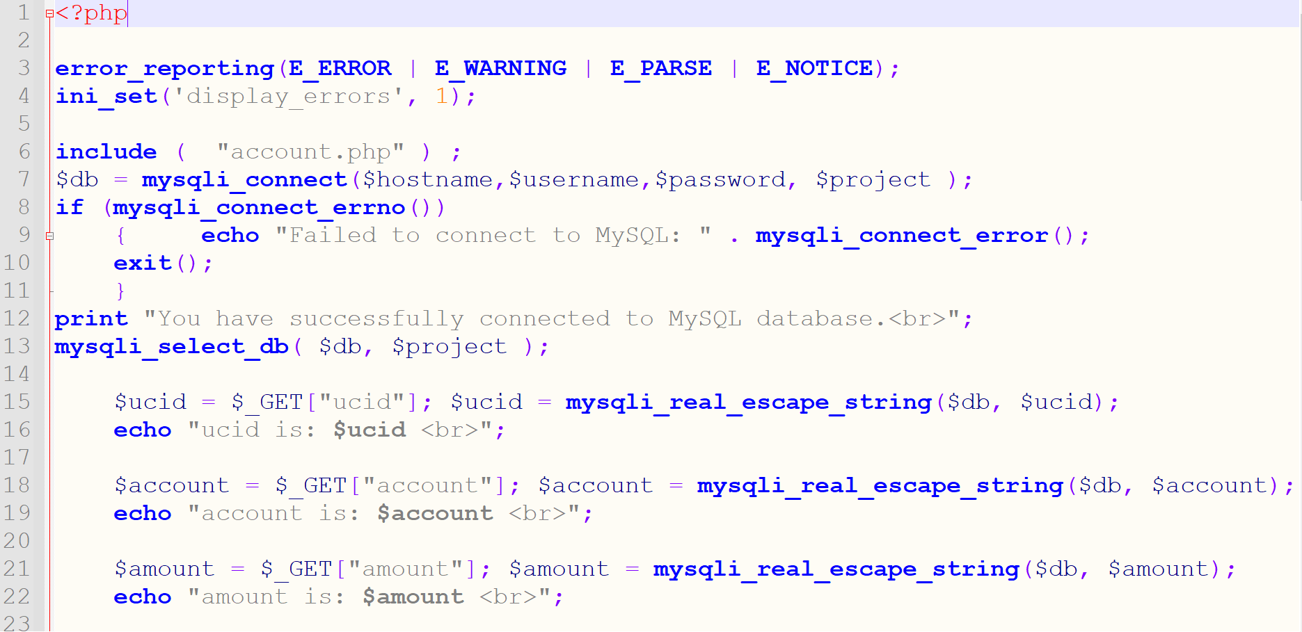**Figure 2. Code for HTML page**

**Figure 3a. Code for PHP page**

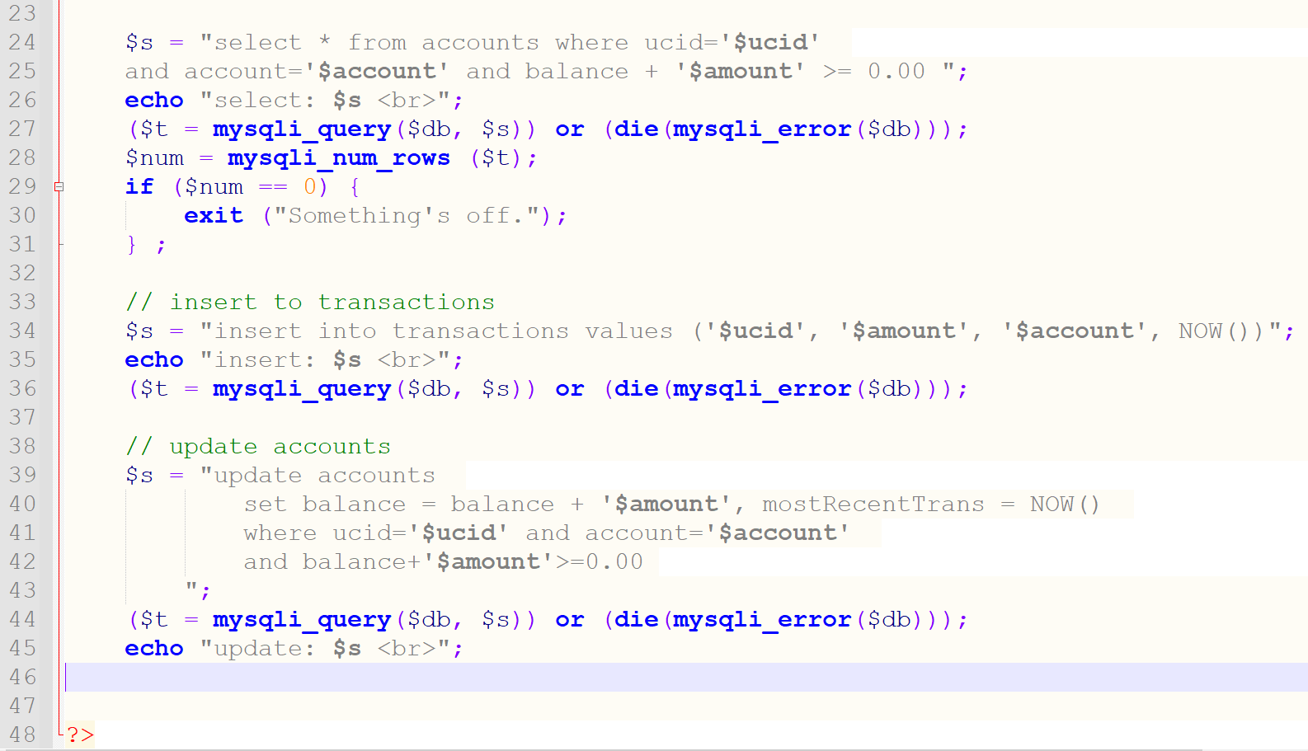

**Figure 3b. Code for PHP page (cont.)**