JAVA FALAFEL PROJECT LAB REPORT

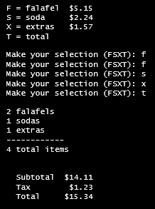
Name and Student ID: Jibran Akhter
Date project completed: 4/1/2024
Sample program execution
Platform (Mac, PC, Linux, etc.): Windows 11 PC
Development system (onlineGDB, NetBeans, Eclipse): onlineGDB

A falafel is a very popular Middle Eastern food. It is served as a sandwich stuffed in pita bread usually containing lettuce, tomatoes, and some round balls of fried chickpeas. The fried balls of chickpeas look like meatballs but are green on the inside and are very nutritious. This project is to simulate a fast food ordering program. Feel free to change the program to any type of restaurant.

OBJECTIVES
Modify an existing program to add additional features
Compute the number of each item sold and total sold
Calculate tax
Handle illegal input selections

PROJECT DEFINITION
Modify the program to do the following:
  - Add and process at least one item on the menu.
  - Create a counter for each type of item sold (Falafels, Sodas, Extras) and for the total of all items sold.
  - When the ‘T’ key is pressed for the total, display the count for each item, the count for the total number of items, the subtotal for all items, compute tax at 8.7%, display the amount of tax, and the final total for all items including tax.
  - Use a constant to define the tax rate.
  - Each display should contain two digits past the decimal point.
  - The program must process unexpected or illegal inputs. If the user enters a menu selection that is invalid, an error message must be displayed.

INPUT – PROCESS – OUTPUT TABLE
INPUTS | PROCESSING | OUTPUTS
Users orders of falafels, sodas, hummus and extras if needed. | Calculates total amounts of the users orders with necessary variables | Displays the total that includes tax.

TEST DATA TABLE
TEST DATA VALUES  Provide several examples of menu selections. Also test no selections when 'T' is entered. | EXPECTED RESULT  Computed values before the program is run | ACTUAL RESULT  Fill in the output displayed  by the program
2 Falafels  2 Sodas  2 Hummus  2 Falafels  1 Soda  1 Hummus  No order | Total = $24.74  Total = $17.97  You have to order something to get a total. | 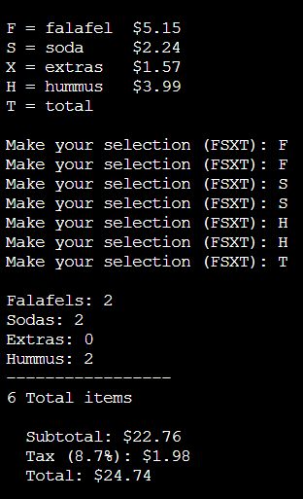  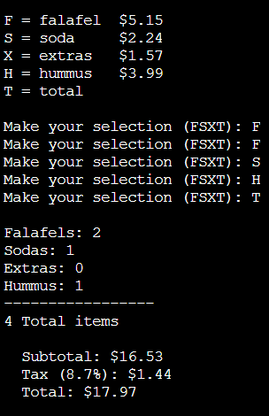  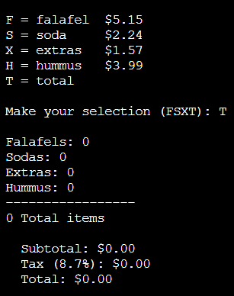

DISCUSSION
What did you do to develop the program? ("Followed the Directions" is not a complete description)

I wanted to replicate the appearance of a digital receipt for this program by incorporating elements like dashes and line gaps as suggested in the lab report's example. This approach enhances the readability and structure of the output, providing a clearer presentation of the order details for a more professional and organized appearance.

What problems did you have and how did you overcome the problems?

The main challenge was ensuring that the output appeared correctly formatted as a digital receipt, including the alignment of items and the inclusion of dashes. Integrating new functionalities, such as displaying counts for each item and calculating the total, required careful consideration of the existing code structure. To overcome these challenges, I carefully reviewed the provided lab report example and made adjustments to the code to match the desired formatting, such as adding dashes and line gaps. I approached the task methodically, breaking down each requirement into smaller steps and addressing them one by one. This helped ensure that the new features were seamlessly integrated into the existing codebase.

THREE SCREENSHOTS
Show screen shots for at least THREE sample purchases of the program execution. One screenshot must show what happens when the 'T' key is pressed with no items selected.

Capture only the portion of the screen that shows the calculator or program output. Do not capture the entire screen even though it may also contain the program output. If I need to zoom in on a screenshot, sometimes the image resolution is so poor that I am not able to read it. If this happens, I will ask that you resubmit your lab report. Refer to these instructions capturing screenshots and pasting them to the lab report

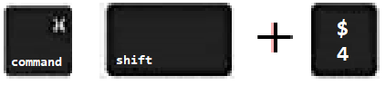
For the Mac
- hold down command + shift keys and press the 4 key
to get a screenshot of a selected area of the screen
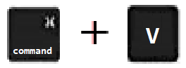
- Use the mouse or touchpad to select the desired area of the screen you want to save
- use command+V to paste into the lab report

For Windows
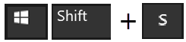
- use Microsoft's Snipping Tool by holding down the
Windows and Shift keys and tapping the ‘S’ key
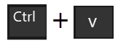
- Use the mouse or keypad to select the part of the screen you want to save
- use Ctrl+V to into the lab report.
Place your screenshots here

