JAVA PAYCHECK PROGRAM LAB ASSIGNMENT AND LAB REPORT
Sample program output
Name and Student ID: Jibran Akhter - 1073973
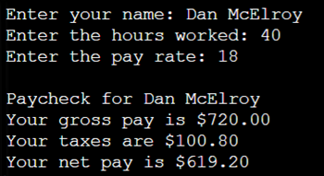
Date project completed: 2/25/2024
Platform (Mac, PC, Linux, etc.): Windows 11
Development system (onlineGDB, NetBeans, Eclipse, etc.): onlineGDB

OBJECTIVES
Use a development system to successfully run a Java program
Use console input to read data from the keyboard
Calculate regular and overtime pay using if…else statements
Use console output to display data to the monitor

PROJECT DESCRIPTION
Enter and run a program that does the following: 1) Read the number of hours and the pay rate, 2) compute the gross pay including overtime at time-and-a-half, 3) Compute taxes, 4) compute net pay, and 5) display the name, gross pay, taxes, and net pay with 2 digits past the decimal point.

INPUT – PROCESS – OUTPUT TABLE
INPUTS | PROCESSING | OUTPUTS
hours  payRate | Read hours from the keyboard into a double  Read payRate from the keyboard into a double  Determine regularHours (up to 40)  Determine overtimeHours1 (hours over 40)  Compute regPay, 1overtimeP1ay and 1grossPay  Compute taxes and netPay  Display name, 1grossPay, taxes and netPay | 1name  grossPay  taxes  netPay

TEST DATA TABLE
Use a calculator to compute the Expected Results
Fill in the Actual Results after you have run and tested your program. No screenshots.
TEST DATA VALUES | EXPECTED RESULTS  ?? are the computed values before the program is run | ACTUAL RESULTS  Fill in the output displayed  by the program
Hours = 39  PayRate = 20 | Your gross pay is 780.00  Your taxes are 132.60  Your net pay is 647.40 | The gross pay was 780.00  The taxes were 132.60  The net pay was 647.40
Hours = 40  PayRate = 20 | Your gross pay is 800.00  Your taxes are 136.00  Your net pay is 664.00 | The gross pay was 800.00  The taxes were 136.00  The net pay was 664.00
Hours = 41  PayRate = 20 | Your gross pay is 830.00  Your taxes are 141.10  Your net pay is 688.90 | The gross pay was 830.00  The taxes were 141.10  The net pay was 688.90

DISCUSSION
What did you do to develop the program? ("Followed the Directions" is not a complete description

I followed the instructions as per what was requested of me. First program of the class, it is understandable to copy and understand what is being programmed.

What problems did you have and how did you overcome the problems?

I had problems with the IDE (NetBeans) I was using. I was able to compile successfully. However, I was unable to run my program I have not fixed the issue yet but for now I was using onlineGDB as my editing platform for this lab assignment.

SCREENSHOTS
Capture only the portion of the screen that shows the calculator or program output. Do not capture the entire screen even though it may also contain the program output. If I need to zoom in on a screenshot, sometimes the image resolution is so poor that I am not able to read it. If this happens, I will ask that you resubmit your lab report. Refer to these instructions capturing screenshots and pasting them to the lab report

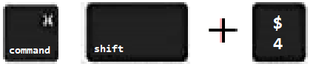
For the Mac
- hold down command + shift keys and press the 4 key
to get a screenshot of a selected area of the screen
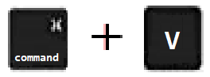
- Use the mouse or touchpad to select the desired area of the screen you want to save
- use command+V to paste into the lab report

For Windows

- use Microsoft's Snipping Tool by holding down the
Windows and Shift keys and tapping the ‘S’ key
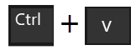
- Use the mouse or keypad to select the part of the screen you want to save
- use Ctrl+V to into the lab report.

Sample screenshots showing an onscreen calculator and program output for 40 hours at 18 per hour
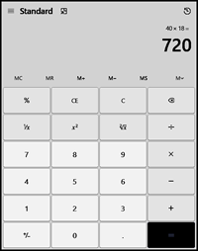 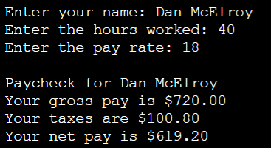

Paste five screenshots here

Screenshot #1 - On-screen calculator showing the result of 40 hours * pay rate of 20 without taxes

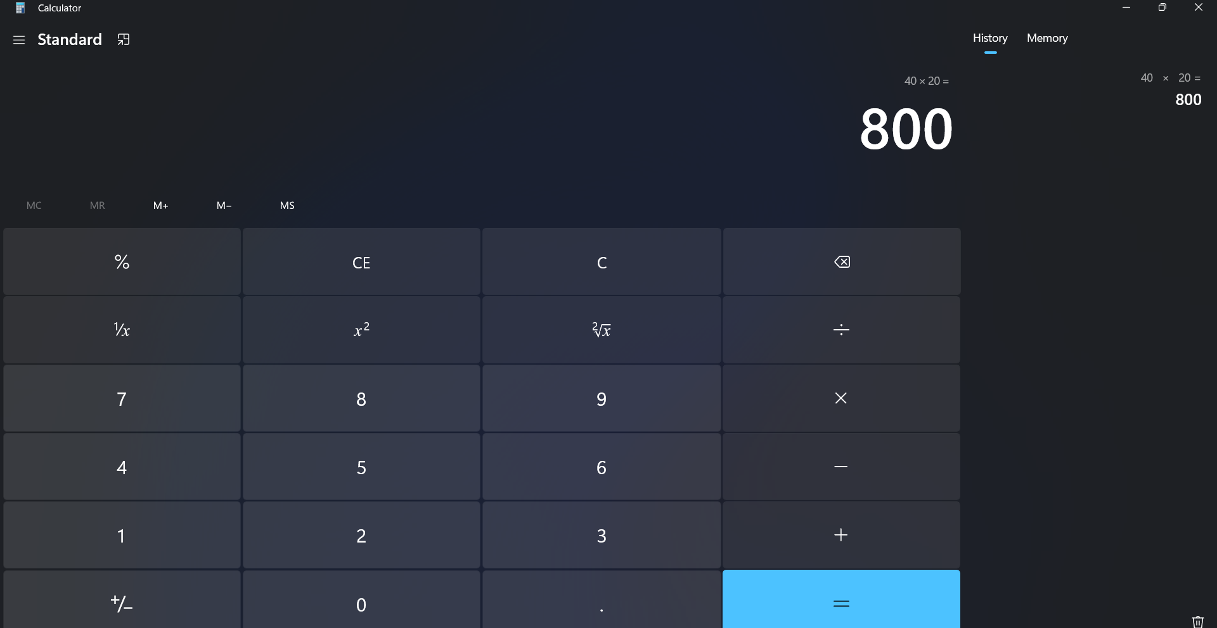

Screenshot #2 - On-screen calculator showing the result of just the taxes for 40 hours and pay rate of 20

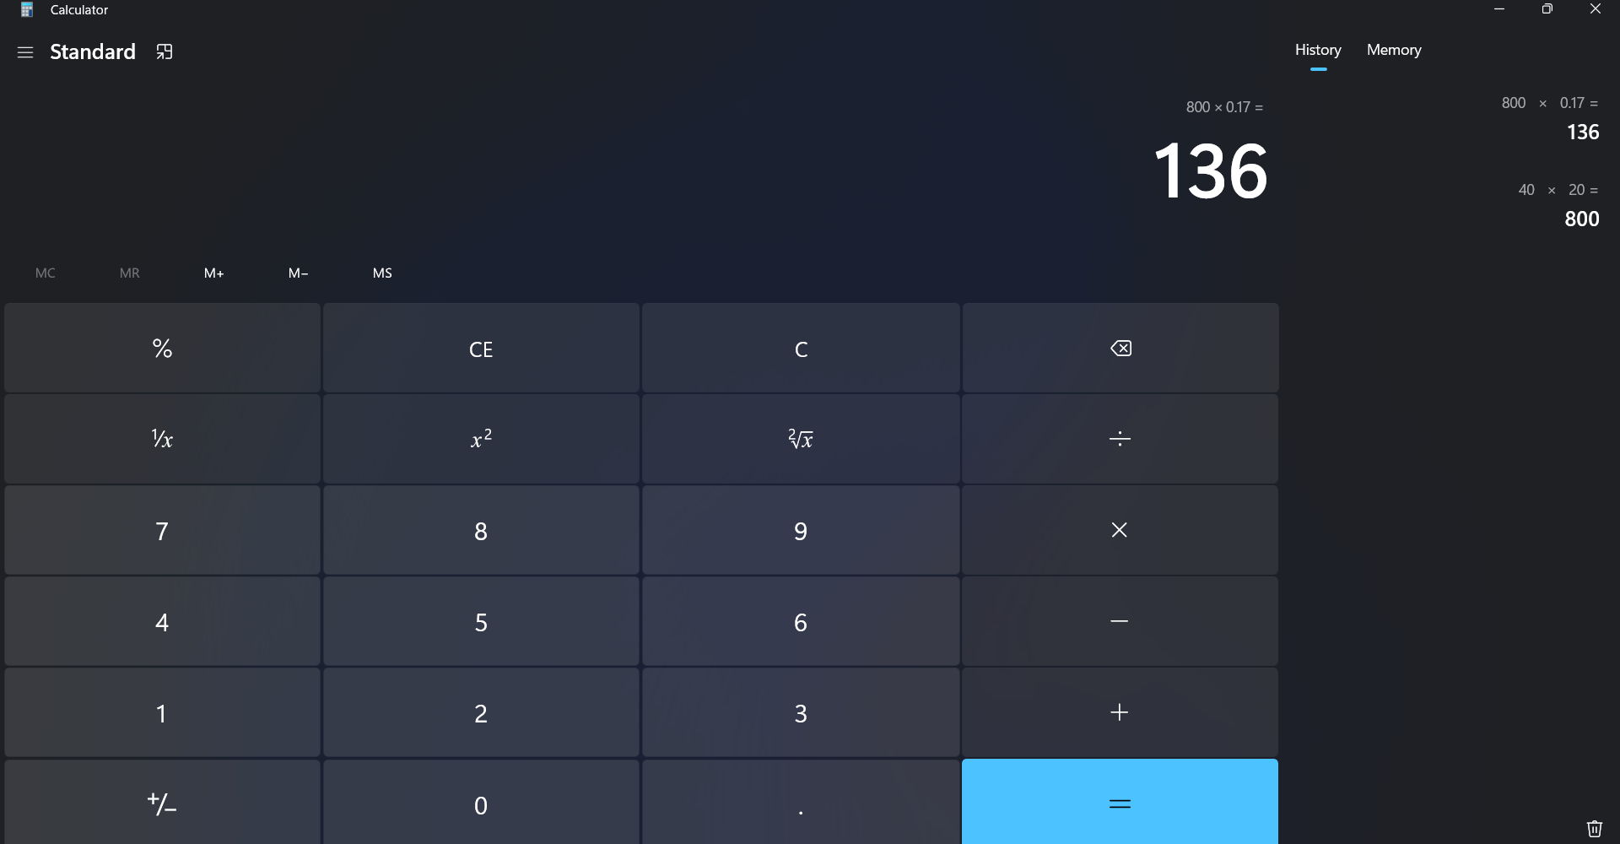

Screenshot #3 - Program output when the program is run with the hours worked less than 40

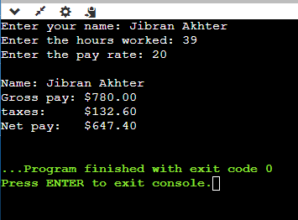

Screenshot #4 - Program output when the program is run with the hours worked equal to 40

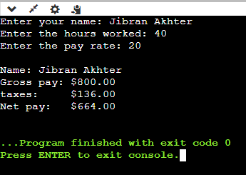

Screenshot #5 - Program output when the program is run with the hours worked greater than 40
