Java Polymorphism Lab Report
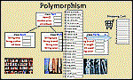
1) Enter your name, student ID, platform (Mac or PC) and date
Name and Student ID: Jibran Akhter - 1073973
Platform (Mac, PC, Linux, etc.): Windows 11 PC
Development System (NetBeans, Eclipse, etc.) onlineGDB
Date: 4/24/2024
PROJECT DESCRIPTION:
The Java Classes and Objects project has been updated to include polymorphism. Get the updated code
http://program-info.net/Java/Polymorphism/
**** YOU HAVE THREE THINGS TO UPLDATE FOR THIS PROJECT ****
UPDATE #1
Pants – add and test a class for Pants that is derived (a subclass of) Clothing. The Pants.java file that you need to create is going to be very similar to the Shirts.java file. The Pants class needs to have member fields for length and waist instead of size. Use the data type int for the length and waist.
UPDATE #2
The array that is used for the shopping cart only has room for 10 items. The shoppingCartCount is incremented each time an item is placed in the cart. It is your task to test to see if the cart is full before trying to place add any more items. If the cart is full, the display a message, "Your shopping cart is full". The cart is full if shoppngCartCount is equal to the length of the array for the shopping cart.
UPDATE #3
class Item has a getter and setter for inStock that can be used to read and update the inStock variable. It is your task to check to see if any items are available before placing them in the shopping cart and then subtract 1 from the inStock variable. If no items are available, then display a message, "Out of stock. Please try again later"
You will need to use the getInStock( ) and setInStock(newValue) with the selected item.
Use getInStock( ) to read the current value and setInStock(newValue) to update the inStock count of the selected item.
These Java files were created using the default package, meaning no package. It may be easiest when using NetBeans or Eclipse to create the BooksAndClothesPolymorphism project, use File/New to create an empty class for each file and then copy the contents of the file from the server into the file for your project.
DISCUSSION:
1) Complete the DISCUSSION section in English. It does not need to be long, but it needs to be complete.
1a) What did you do to develop the program?

In developing the program, I began by updating the `Pants` class to incorporate the length and waist as essential components. Next, I proceeded to modify the `BooksAndClothesPolymorphism` class to integrate the required updates. These updates included verifying the availability of the selected item before adding it to the shopping cart, adjusting the stock count by subtracting 1 when an item was added to the cart, and ensuring that appropriate messages were displayed in case of stock unavailability or a full shopping cart.
1b) What problems did you have and how did you overcome the problems?

Throughout the development process, I encountered a primary challenge related to accurately verifying the stock availability before allowing items to be added to the shopping cart. To overcome this, I carefully reviewed the code logic, making necessary adjustments to ensure the correct updating of stock counts and the display of relevant messages to users. Additionally, I faced minor issues concerning output formatting, which I resolved by carefully examining the code and adjusting formatting specifications where needed.
PROGRAM OUTPUT:
2) Provide screenshots showing correct operation of the program, including:
* input of an item number that is not in the list
* input of an illegal item number, such as alphabetic characters
* an item that is out of stock
* when the shopping cart is full
Refer to previous lab assignments to review how to save a screen shot to the lab report.
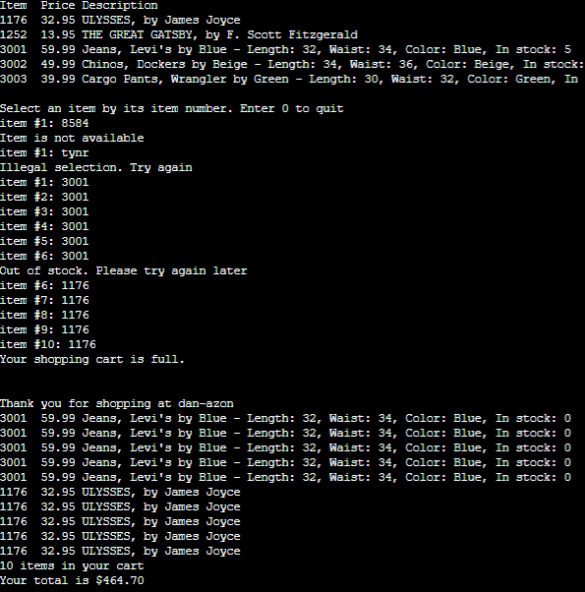
PROGRAM LISTING:
3a) Copy and paste the code for the file YOU created that has class Pants. Most likely the file Pants.java
public class Pants extends Clothing {
private int length;
private int waist;

// Constructor
public Pants(int itemID, String type, String brand, int length, int waist, String color, double price, int inStock) {
setItemID(itemID);
setType(type);
setBrand(brand);
setLength(length);
setWaist(waist);
setColor(color);
setPrice(price);
setInStock(inStock);
}

// Getters
public int getLength() {
return length;
}

public int getWaist() {
return waist;
}

// Setters
public void setLength(int length) {
this.length = length;
}

public void setWaist(int waist) {
this.waist = waist;
}

// Overriding toString method to include length and waist
@Override
public String toString() {
return String.format("%-4d %6.2f %s, %s by %s - Length: %d, Waist: %d, Color: %s, In stock: %d",
getItemID(), getPrice(), getType(), getBrand(), getColor(), getLength(), getWaist(), getColor(), getInStock());
}

}
3b) Copy and paste the code for the file that has both the public static void main and the Item[] array that includes objects of Books, Shirts and Pants. Most likely the file BooksAndClothesInheritance.java
This file should contain Pants objects added to the Item array as well as the three required updates listed in the project description.

import java.util.Scanner;
import java.util.InputMismatchException;

public class BooksAndClothesPolymorphism {
private static Item[] shoppingCart = new Item[10]; // contains items in user's shopping cart
private static int shoppingCartCount = 0; // number of total items in the cart

// define an array of books and pants
private static final Item[] ITEM_LIST = {
new Book(1176, "ULYSSES", "James Joyce", 1918, 32.95, 16),
new Book(1252, "THE GREAT GATSBY", "F. Scott Fitzgerald", 1925, 13.95, 30),
new Pants(3001, "Jeans", "Levi's", 32, 34, "Blue", 59.99, 5),
new Pants(3002, "Chinos", "Dockers", 34, 36, "Beige", 49.99, 15),
new Pants(3003, "Cargo Pants", "Wrangler", 30, 32, "Green", 39.99, 20)
};

public static void main(String[] args) {
// create the stdin object (to use the keyboard)
Scanner stdin = new Scanner(System.in);
int itemSelected = 0; // Item ID selected by user, 0 for not available
int itemIndex = 0; // selected index into array of items

// display items in the arrays using the toString method
System.out.printf("%-4.4s %6.6s %-11.11s\n", "Item", "Price", "Description");
for (Item item : ITEM_LIST) {
System.out.println(item);
}

System.out.println("\nSelect an item by its item number. Enter 0 to quit");
do {
try {
if (shoppingCartCount >= shoppingCart.length) {
System.out.println("Your shopping cart is full.");
break;
}

System.out.printf("item #%d: ", shoppingCartCount + 1);
itemSelected = stdin.nextInt(); // read line from keyboard
if (itemSelected == 0) {
continue; // exit the loop
}

// Search ITEM_LIST looking for the user's requested itemID
for (itemIndex = 0; itemIndex < ITEM_LIST.length; itemIndex++) {
if (itemSelected == ITEM_LIST[itemIndex].getItemID()) {
break; // it was found, itemIndex = position in the LIST
}
}

if (itemIndex == ITEM_LIST.length) { // reached the end and not found
System.out.println("Item is not available");
} else { // The item was found
if (ITEM_LIST[itemIndex].getInStock() <= 0) {
System.out.println("Out of stock. Please try again later");
} else {
shoppingCart[shoppingCartCount] = ITEM_LIST[itemIndex];
shoppingCartCount++; // keep track of items in the cart
ITEM_LIST[itemIndex].setInStock(ITEM_LIST[itemIndex].getInStock() - 1); // Decrement stock count
}
}
} catch (InputMismatchException | StringIndexOutOfBoundsException e) {
System.out.println("Illegal selection. Try again");
stdin.nextLine(); // clear input buffer
}
} while (itemSelected != 0); // loop until a '0' is entered

// display the shopping cart
System.out.println("\n\nThank you for shopping at dan-azon");
double total = 0;
for (int i = 0; i < shoppingCartCount; i++) {
System.out.println(shoppingCart[i]);
total += shoppingCart[i].getPrice();
}
System.out.println(shoppingCartCount + " items in your cart");
System.out.printf("Your total is $%.2f\n\n", total);
} // end of main()
} // end of class

