Module-8 Critical Thinking Assignment
Option-2: Part 2: Encoder-Decoder LSTM Sequence-to-Sequence Implementation

Jibran Gill
Colorado State University Global
CSC580 – Applying Machine Learning and Neural Networks - Capstone
Dr. Bingdong Lee

Table of Contents
Introduction 3
Seq- Seq Problem Definition 3
Example 4
Encoder Decoder Architecture 4
Flow Chart of Encoder-Decoder Neural Network Processing 5
Data Preparation and Verification 7
Mode Training and Convergence Behavior 8
Evaluation on Unseen Data 9
Qualitative Analysis of Prediction 10
Decoder Confidence Analysis 11
Output Artifacts 12
Conclusion & Improvement Opportunities 13
References 14
Appendix-A: Program Source Code 15
Appendix-B: Program Outputs 21
Terminal Output 21
Runtime Warnings and Information Messages 21
NumPy Future Warning 21
TensorFlow CPU Optimization Message 22
Plots for Decoder Confidence, Sequence prediction accuracy and Encoder-Decoder training loss and accuracy 22

Option-2: Distinguishing Cats and Dogs

Introduction
This section presents the implementation and experimental evaluation of an encoder-decoder sequence-to-sequence (seq2seq) neural network developed using the Keras deep learning library with a TensorFlow backend. The encoder–decoder architecture follows the sequence learning paradigm introduced by Sutskever, Vinyals, and Le (2014), in which a recurrent neural network encodes an input sequence into a fixed internal representation that is subsequently decoded into an output sequence. The purpose of this implementation is to demonstrate how encoder-decoder models learn temporal dependencies and generate variable-length outputs in a controlled, scalable setting.
The programming component complements the theoretical discussion in Part 1 by providing a concrete example of sequence-to-sequence learning using Long Short-Term Memory (LSTM) networks. A synthetic but nontrivial sequence transformation problem is used to verify that the model learns the intended mapping rather than relying on hard-coded logic.

Seq- Seq Problem Definition
The sequence-to-sequence task implemented in this project consists of transforming a fixed-length input sequence of integers into a shorter output sequence derived from the input. Each input sequence contains six randomly generated integer values, drawn from a predefined cardinality of 50 possible symbols. The integer value 0 is reserved exclusively as a start-of-sequence (SOS) and padding token and does not appear in the input data.
The target output sequence is constructed by selecting the first three elements of the input sequence and reversing their order. For example, an input sequence such as [13, 28, 18, 7, 9, 5] produces the target output [18, 28, 13]. Although simple for a human observer, this task requires the neural network to learn ordering, memory, and sequence transformation, making it well suited for validating encoder–decoder behavior (Sutskever et al., 2014).

Example
- Input: [13, 28, 18, 7, 9, 5]
- Target: [18, 28, 13]
This problem is intentionally simple yet effective for validating whether the encoder–decoder model has learned to:
- capture ordering and temporal relationships, and
- generate output sequences step-by-step rather than via direct indexing.

Encoder Decoder Architecture
The implemented model consists of two LSTM-based recurrent neural networks: an encoder and a decoder. The encoder processes the input sequence one timestep at a time and compresses the temporal information into its final hidden and cell states. These states serve as a learned representation of the input sequence and are passed directly to the decoder.
The decoder network is initialized using the encoder’s final states and generates the output sequence in an autoregressive manner. During training, the decoder receives a shifted version of the target sequence beginning with the start-of-sequence token, enabling it to learn conditional next-token prediction. During inference, the decoder generates the output sequence one element at a time without access to the true target values, relying solely on its previous predictions.
This approach closely follows the original sequence-to-sequence formulation for recurrent neural networks and mirrors the structure used in early neural machine translation systems (Sutskever et al., 2014; Bahdanau et al., 2014).
The model consists of two Long Short-Term Memory (LSTM) networks:
- Encoder Network
The encoder processes the input sequence one element at a time and compresses its information into internal hidden and cell states. These states act as a learned representation of the input sequence.
- Decoder Network
The decoder is initialized with the encoder’s final states and generates the output sequence autoregressively. At each time step, the decoder predicts the next output element and feeds it back as input for the next step.
During training, the decoder receives a shifted version of the target sequence that begins with a start-of-sequence token (0). During inference, the decoder generates outputs recursively without access to the true target values.

Flow Chart of Encoder-Decoder Neural Network Processing
A detailed flowchart was developed to depict the internal processing performed by the encoder–decoder LSTM neural network during both training and inference. Unlike a general program flow diagram, this flowchart focuses specifically on how data moves through the neural network layers and how sequence-to-sequence prediction is performed. The diagram illustrates the interaction between the encoder, decoder, hidden states, and recursive decoding mechanism that defines the encoder–decoder architecture.

During training, the encoder receives a one-hot encoded source sequence and processes it sequentially through an LSTM layer. As the input sequence is consumed, the encoder updates its hidden and cell states, which collectively capture temporal dependencies and contextual information from the entire input sequence. Once the final input timestep is processed, the encoder outputs its final hidden and cell states. These states form the learned representation of the input sequence and are passed directly to the decoder network.
The decoder is initialized using the encoder’s final hidden and cell states and receives a shifted version of the target sequence as input. At each decoder timestep, the LSTM generates an output vector and updates its internal states. A dense softmax layer transforms the LSTM output into a probability distribution over the output vocabulary. During training, the full target sequence is predicted in parallel using teacher forcing, allowing the network to learn conditional next-token probabilities efficiently.
During inference, the flowchart shows a different execution path. The encoder processes the source sequence once and outputs its final states. The decoder then operates recursively, beginning with a start-of-sequence token as input. At each timestep, the decoder predicts a single output token, updates its hidden and cell states, and feeds the predicted token back as input for the next timestep. This loop continues until the predefined output length is reached. The final predicted sequence is obtained by decoding the sequence of predicted probability distributions.
This flowchart explicitly highlights the distinction between training-time decoding (teacher forcing) and inference-time decoding (autoregressive generation), emphasizing how the same neural network components are reused under different execution modes.
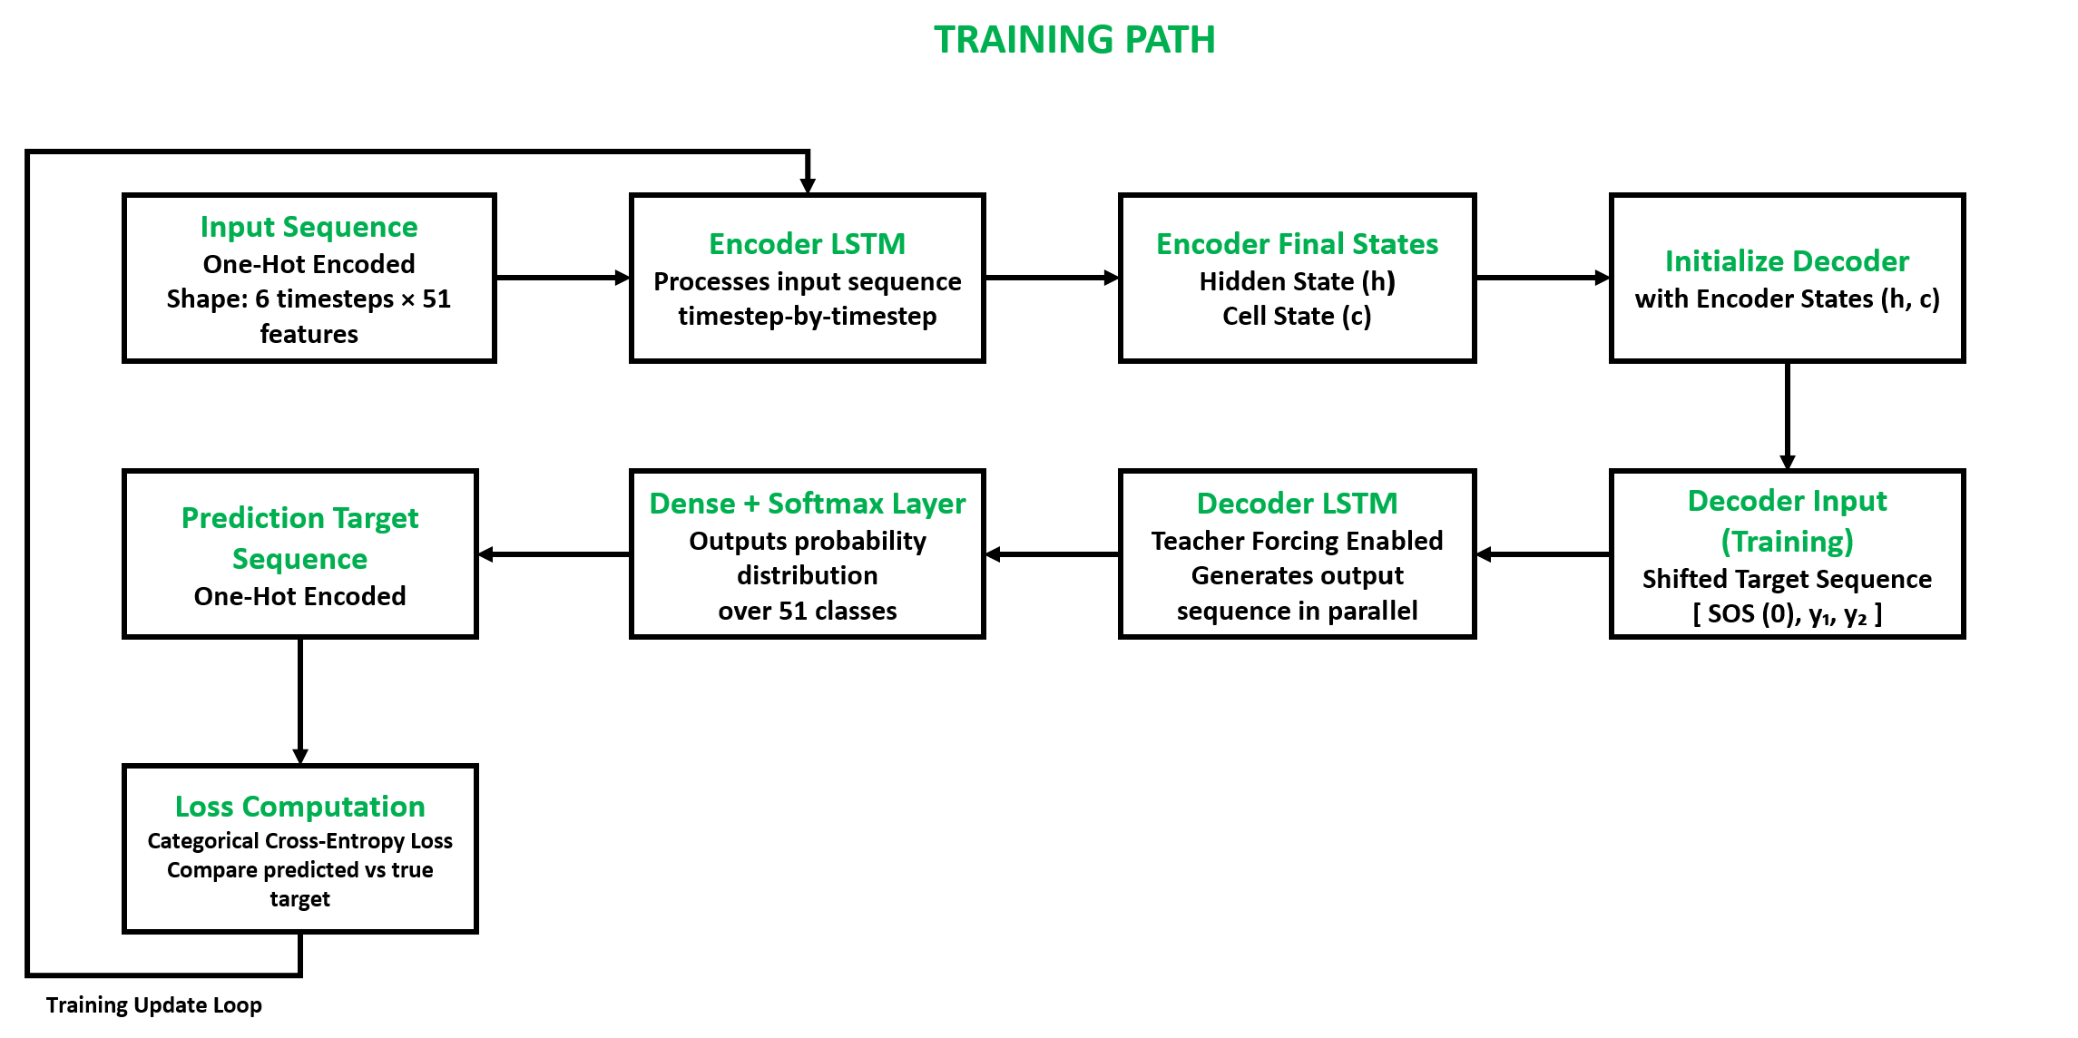
Figure-1: Neural Network Flowchart - Training Path
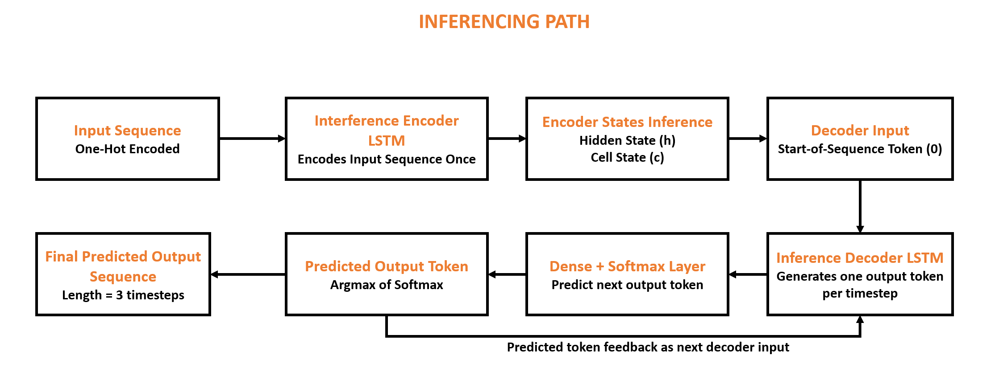
Figure-2: Neural Network Flowchart - Inferencing Path

Data Preparation and Verification
To support training and evaluation, a scalable data generation pipeline was implemented. Input sequences are generated randomly, corresponding target sequences are constructed deterministically, and all sequences are converted into one-hot encoded representations suitable for categorical prediction. An additional shifted target sequence is created to serve as decoder input during training, ensuring that the decoder learns proper temporal alignment.
The correctness of the dataset construction was verified by inspecting tensor shapes and decoding sample sequences prior to training. The printed shapes confirm that the encoder inputs, decoder inputs, and decoder outputs conform to the expected dimensions for sequence-to-sequence learning.
Figure-1: Verification of dataset structure and sample sequence decoding.

Mode Training and Convergence Behavior
The encoder–decoder model was trained using the Adam optimization algorithm with categorical cross-entropy loss. Training was conducted over multiple epochs using a sufficiently large synthetic dataset to ensure convergence. The training history demonstrates a consistent reduction in loss accompanied by an increase in accuracy, indicating that the model successfully learned the intended sequence transformation.
The observed training behavior aligns with expectations for sequence-to-sequence learning tasks, where convergence reflects the model’s ability to internalize ordering and dependency relationships rather than memorizing individual values.
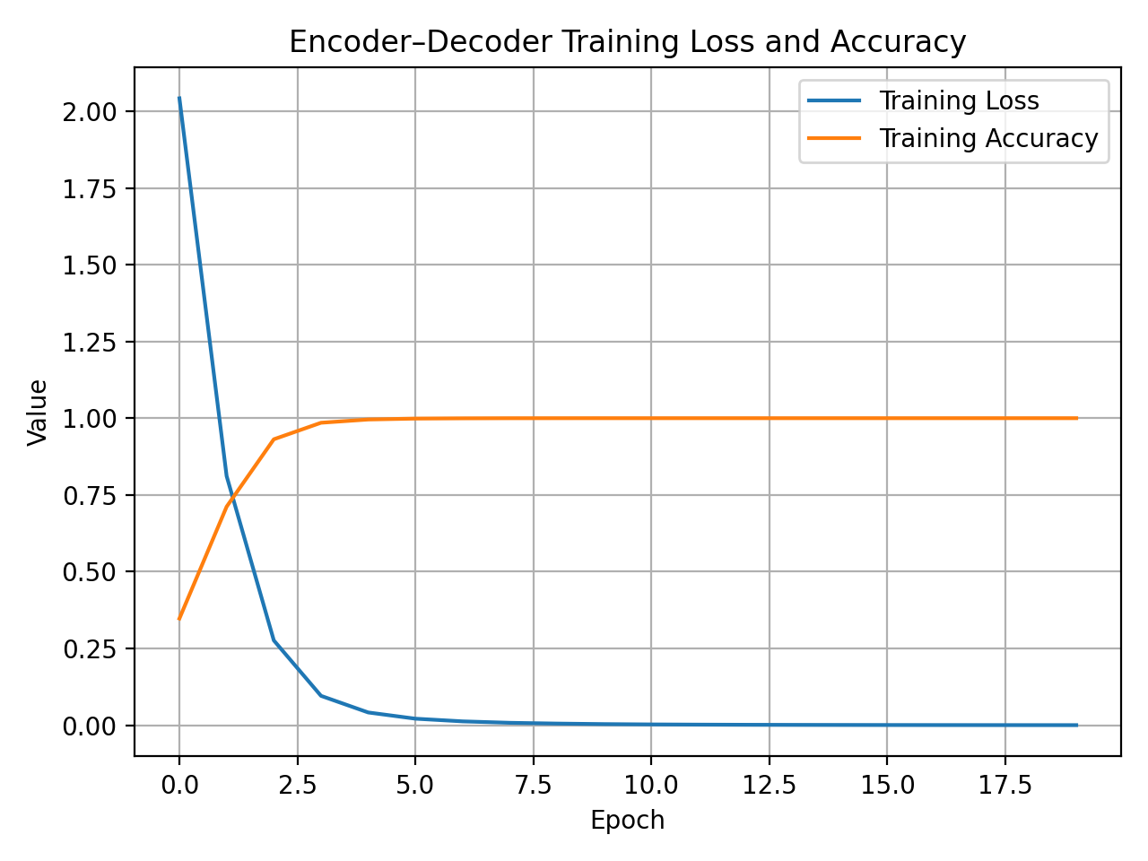
Figure-2: Training loss and accuracy across epochs.
A threshold sweep further illustrates this tradeoff. As the classification threshold increases, the proportion of predicted-positive samples that are actually cats increases significantly. High thresholds therefore improve confidence in positive predictions but reduce recall by excluding many true cat images. This behavior highlights the importance of threshold selection in practical classification systems.

Evaluation on Unseen Data
After training, the model was evaluated on 100 newly generated input sequences that were not included in the training data. For each evaluation sample, the encoder processed the input sequence once, and the decoder generated the target sequence recursively using the inference models. A prediction was considered correct only if the entire predicted sequence exactly matched the true target sequence.
The resulting evaluation accuracy demonstrates that the model generalizes effectively to unseen data and consistently performs the required sequence reversal task.
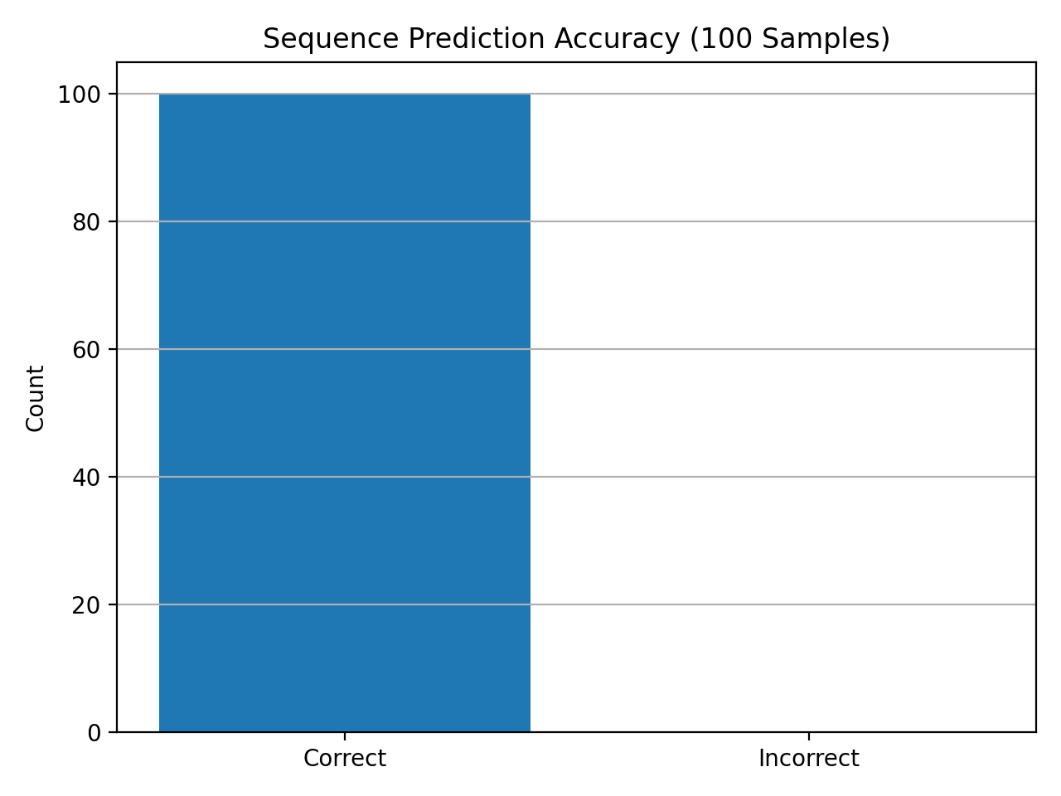
Figure-3: Correct versus incorrect predictions across 100 evaluation samples

Qualitative Analysis of Prediction
In addition to quantitative accuracy, qualitative inspection of decoded predictions provides insight into model behavior. Several sample predictions were printed, showing the decoded input sequence, the true target sequence, and the model’s predicted output. These examples confirm that the model generates the correct output ordering rather than relying on positional shortcuts or fixed mappings.
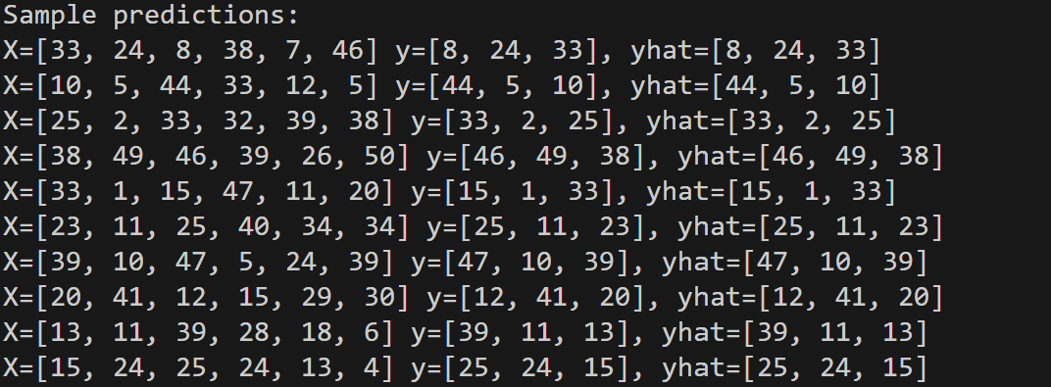
Figure-4: Sample decoded predictions from the encoder–decoder model

Decoder Confidence Analysis
To further analyze prediction behavior, the maximum softmax probability at each decoder timestep was plotted for a representative example. This visualization illustrates the model’s confidence as it generates each output token. High confidence values across all decoder steps indicate stable and consistent decoding behavior.
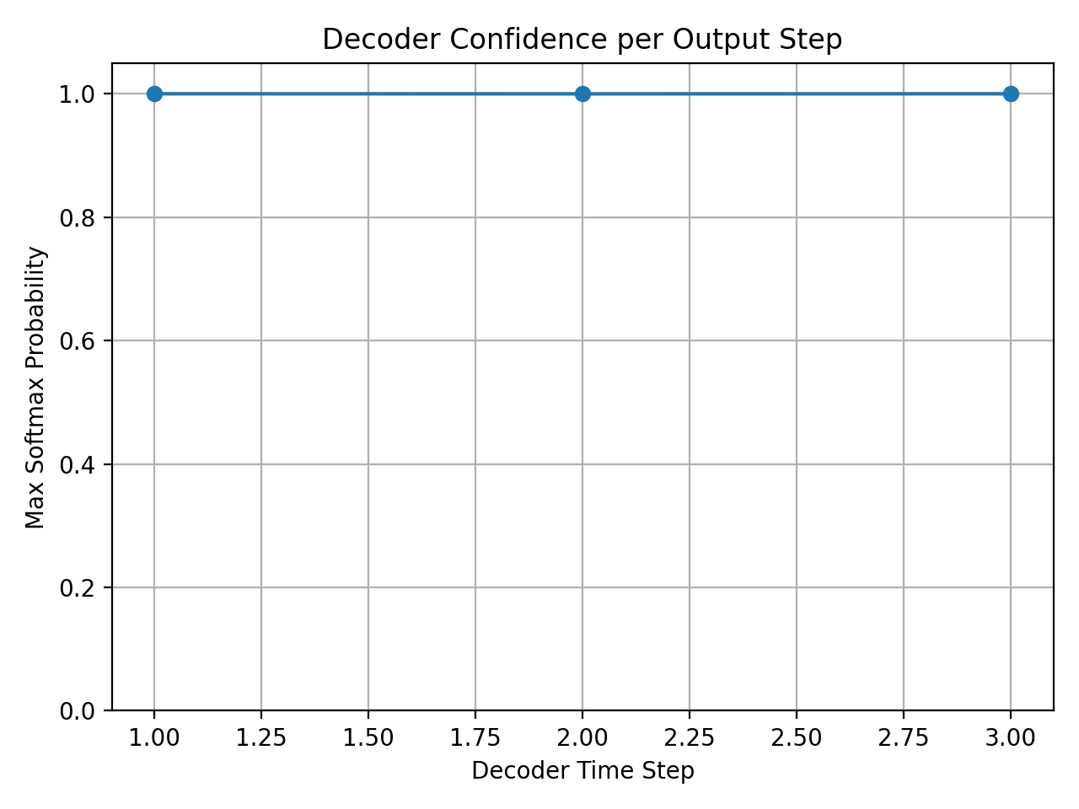
Figure-5: Decoder confidence per output timestep

Output Artifacts
The programming implementation produces a documented Python source file and an output text file containing runtime predictions and evaluation metrics. The output file provides a reproducible record of model performance and sample predictions, supporting the analysis presented in this section.
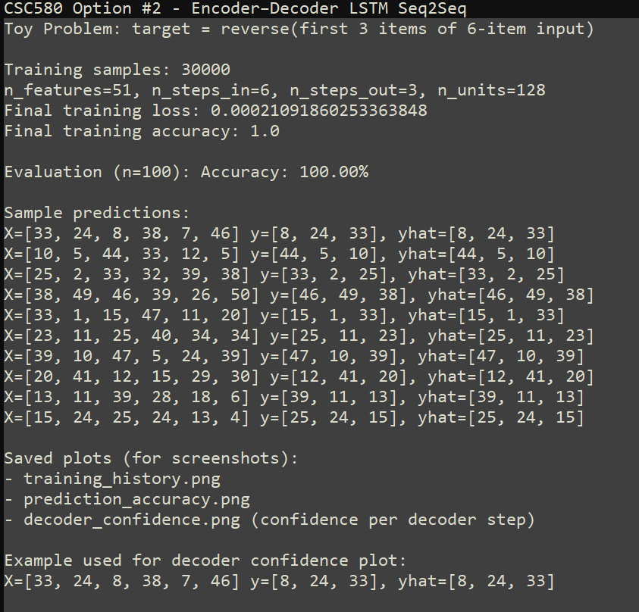
Figure-6: Runtime Output File

Conclusion & Improvement Opportunities
This programming implementation demonstrates the practical application of an encoder–decoder LSTM model to a sequence-to-sequence prediction problem. The results confirm that the model successfully learns to encode input sequences, preserve temporal relationships, and generate target sequences autoregressively. The experimental findings align with foundational sequence-to-sequence research and reinforce the suitability of encoder–decoder architectures for real-world sequence transformation tasks such as translation, speech recognition, and summarization (Sutskever et al., 2014).

References
- Bahdanau, D., Cho, K., & Bengio, Y. (2014). Neural machine translation by jointly learning to align and translate. arXiv preprint arXiv:1409.0473.
- Sutskever, I., Vinyals, O., & Le, Q. V. (2014). Sequence to sequence learning with neural networks. arXiv preprint arXiv:1409.3215.

Appendix-A: Program Source Code
"""
CSC580 Portfolio Project - Option #2
Encoder-Decoder LSTM for Sequence-to-Sequence Prediction using Keras/TensorFlow
Author: Jibran Gill
"""

import os
import random
import numpy as np
import matplotlib.pyplot as plt
from keras.utils import to_categorical
from keras.models import Model
from keras.layers import Input, LSTM, Dense

#Reproducibility
def set_seed(seed: int = 42) -> None:
"""Set seeds for reproducibility."""
random.seed(seed)
np.random.seed(seed)

#Encoder-Decoder Model Definition using Keras
def define_models(n_input: int, n_output: int, n_units: int):
"""
Define the encoder-decoder models in Keras.

Returns:
train_model: Used for training with [encoder_input, decoder_input] -> decoder_output
inf_encoder: Used to encode a source sequence for inference
inf_decoder: Used to decode the target sequence one step at a time for inference
"""
#Training Encoder
encoder_inputs = Input(shape=(None, n_input), name="encoder_inputs")
encoder = LSTM(n_units, return_state=True, name="encoder_lstm")
_, state_h, state_c = encoder(encoder_inputs)
encoder_states = [state_h, state_c]

#Training Decoder
decoder_inputs = Input(shape=(None, n_output), name="decoder_inputs")
decoder_lstm = LSTM(n_units, return_sequences=True, return_state=True, name="decoder_lstm")
decoder_outputs, _, _ = decoder_lstm(decoder_inputs, initial_state=encoder_states)
decoder_dense = Dense(n_output, activation="softmax", name="decoder_dense")
decoder_outputs = decoder_dense(decoder_outputs)
train_model = Model([encoder_inputs, decoder_inputs], decoder_outputs, name="train_model")

#Inference Encoder
inf_encoder = Model(encoder_inputs, encoder_states, name="inference_encoder")

#Inference Decoder
decoder_state_input_h = Input(shape=(n_units,), name="decoder_state_h")
decoder_state_input_c = Input(shape=(n_units,), name="decoder_state_c")
decoder_states_inputs = [decoder_state_input_h, decoder_state_input_c]

inf_decoder_outputs, out_h, out_c = decoder_lstm(
decoder_inputs,
initial_state=decoder_states_inputs
)
inf_decoder_states = [out_h, out_c]
inf_decoder_outputs = decoder_dense(inf_decoder_outputs)

inf_decoder = Model(
[decoder_inputs] + decoder_states_inputs,
[inf_decoder_outputs] + inf_decoder_states,
name="inference_decoder"
)

return train_model, inf_encoder, inf_decoder

#Scalable Sequence-to-Sequence Toy Problem
def generate_sequence(length: int, n_unique: int):
return [random.randint(1, n_unique - 1) for _ in range(length)]

def get_dataset(n_in: int, n_out: int, cardinality: int, n_samples: int):
X1, X2, y = [], [], []
for _ in range(n_samples):
source = generate_sequence(n_in, cardinality)

target = source[:n_out]
target.reverse()

target_in = [0] + target[:-1]

src_encoded = to_categorical([source], num_classes=cardinality)
tar_encoded = to_categorical([target], num_classes=cardinality)
tar_in_encoded = to_categorical([target_in], num_classes=cardinality)

X1.append(src_encoded)
X2.append(tar_in_encoded)
y.append(tar_encoded)

return np.array(X1), np.array(X2), np.array(y)

def one_hot_decode(encoded_seq):
return [int(np.argmax(vector)) for vector in encoded_seq]

#Inference: Predict a sequence step-by-step
def predict_sequence(infenc, infdec, source, n_steps: int, cardinality: int):
state = infenc.predict(source, verbose=0)

# Start-of-sequence token: one-hot for index 0
target_seq = np.zeros((1, 1, cardinality), dtype=np.float32)
target_seq[0, 0, 0] = 1.0

output_probs = []

for _ in range(n_steps):
yhat, h, c = infdec.predict([target_seq] + state, verbose=0)

output_probs.append(yhat[0, 0, :])

state = [h, c]
target_seq = yhat # feed prediction back in

return np.array(output_probs)

#Plotting helpers
def _metric_key(history_dict: dict, candidates: list[str]) -> str | None:
for k in candidates:
if k in history_dict:
return k
return None

def plot_training_history(history, filename="training_history.png"):
h = history.history
loss_key = _metric_key(h, ["loss"])
acc_key = _metric_key(h, ["accuracy", "acc"])

plt.figure()
if loss_key:
plt.plot(h[loss_key], label="Training Loss")
if acc_key:
plt.plot(h[acc_key], label="Training Accuracy")

plt.xlabel("Epoch")
plt.ylabel("Value")
plt.title("Encoder–Decoder Training Loss and Accuracy")
plt.legend()
plt.grid(True)
plt.tight_layout()
plt.savefig(filename, dpi=200)
plt.close()

def plot_prediction_accuracy(correct: int, total: int, filename="prediction_accuracy.png"):
incorrect = total - correct
plt.figure()
plt.bar(["Correct", "Incorrect"], [correct, incorrect])
plt.ylabel("Count")
plt.title(f"Sequence Prediction Accuracy ({total} Samples)")
plt.grid(axis="y")
plt.tight_layout()
plt.savefig(filename, dpi=200)
plt.close()

def plot_decoder_confidence(predicted_probs: np.ndarray, filename="decoder_confidence.png"):
confidences = predicted_probs.max(axis=1)
plt.figure()
plt.plot(range(1, len(confidences) + 1), confidences, marker="o")
plt.xlabel("Decoder Time Step")
plt.ylabel("Max Softmax Probability")
plt.title("Decoder Confidence per Output Step")
plt.ylim(0, 1.05)
plt.grid(True)
plt.tight_layout()
plt.savefig(filename, dpi=200)
plt.close()

#Main runner: Train, Evaluate, Print samples
def main():
set_seed(42)
# Configure problem
n_features = 50 + 1
n_steps_in = 6
n_steps_out = 3
n_units = 128

# Output artifacts (screenshots + text)
out_txt = "output_predictions.txt"
plot1 = "training_history.png"
plot2 = "prediction_accuracy.png"
plot3 = "decoder_confidence.png"

# Quick sanity check: dataset shapes (matches assignment expectation)
X1_check, X2_check, y_check = get_dataset(n_steps_in, n_steps_out, n_features, 1)
# Expect: (1, 1, 6, 51), (1, 1, 3, 51), (1, 1, 3, 51)
print(X1_check.shape, X2_check.shape, y_check.shape)
print("X1=%s, X2=%s, y=%s" % (
one_hot_decode(X1_check[0][0]),
one_hot_decode(X2_check[0][0]),
one_hot_decode(y_check[0][0])
))

#Training dataset
n_train = 30000
X1, X2, y = get_dataset(n_steps_in, n_steps_out, n_features, n_train)

# Keras expects (samples, timesteps, features); remove the extra singleton dimension
X1 = X1.squeeze(axis=1) # (n_train, 6, 51)
X2 = X2.squeeze(axis=1) # (n_train, 3, 51)
y = y.squeeze(axis=1) # (n_train, 3, 51)

# Define and compile models
train, infenc, infdec = define_models(n_features, n_features, n_units)
train.compile(optimizer="adam", loss="categorical_crossentropy", metrics=["accuracy"])

# Train
history = train.fit(
[X1, X2],
y,
epochs=20, #epocs can be bumped if accuracy is low
batch_size=64,
verbose=0
)

# Plot training history
plot_training_history(history, filename=plot1)

# Evaluate on 100 fresh samples
total, correct = 100, 0
sample_lines = []

# Store one example prediction probs for confidence plot
example_pred_probs = None
example_line = None

for i in range(total):
X1t, X2t, yt = get_dataset(n_steps_in, n_steps_out, n_features, 1)
X1t = X1t.squeeze(axis=1) # (1, 6, 51)
yt = yt.squeeze(axis=1) # (1, 3, 51)

pred_probs = predict_sequence(infenc, infdec, X1t, n_steps_out, n_features)

y_true = one_hot_decode(yt[0])
y_hat = one_hot_decode(pred_probs)

if np.array_equal(y_true, y_hat):
correct += 1

# Saving first 10 samples
if i < 10:
x_decoded = one_hot_decode(X1t[0])
line = f"X={x_decoded} y={y_true}, yhat={y_hat}"
sample_lines.append(line)

# Confidence Plot
if example_pred_probs is None:
example_pred_probs = pred_probs
example_line = line

accuracy = (correct / total) * 100.0

# Plot correct vs incorrect
plot_prediction_accuracy(correct, total, filename=plot2)

# Plot decoder confidence
if example_pred_probs is not None:
plot_decoder_confidence(example_pred_probs, filename=plot3)

hist = history.history
final_loss = hist.get("loss", [None])[-1]
final_acc = hist.get("accuracy", hist.get("acc", [None]))[-1]

with open(out_txt, "w", encoding="utf-8") as f:
f.write("CSC580 Option #2 - Encoder–Decoder LSTM Seq2Seq\n")
f.write("Toy Problem: target = reverse(first 3 items of 6-item input)\n\n")

f.write(f"Training samples: {n_train}\n")
f.write(f"n_features={n_features}, n_steps_in={n_steps_in}, n_steps_out={n_steps_out}, n_units={n_units}\n")
f.write(f"Final training loss: {final_loss}\n")
f.write(f"Final training accuracy: {final_acc}\n\n")

f.write(f"Evaluation (n={total}): Accuracy: {accuracy:.2f}%\n\n")

f.write("Sample predictions:\n")
for line in sample_lines:
f.write(line + "\n")

f.write("\nSaved plots (for screenshots):\n")
f.write(f"- {plot1}\n")
f.write(f"- {plot2}\n")
f.write(f"- {plot3} (confidence per decoder step)\n")

if example_line:
f.write("\nExample used for decoder confidence plot:\n")
f.write(example_line + "\n")

#Console output
print(f"\nAccuracy: {accuracy:.2f}%\n")
print("Sample predictions:")
for line in sample_lines:
print(line)

print("\nSaved artifacts:")
print(f"- {os.path.abspath(out_txt)}")
print(f"- {os.path.abspath(plot1)}")
print(f"- {os.path.abspath(plot2)}")
print(f"- {os.path.abspath(plot3)}")

if __name__ == "__main__":
main()

Appendix-B: Program Outputs

Terminal Output
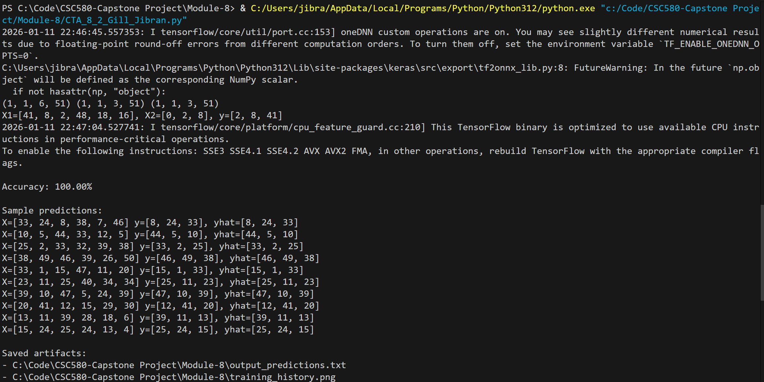

Runtime Warnings and Information Messages
During execution of the Python implementation, several runtime warnings and informational messages were displayed by underlying libraries. These messages are documented here for completeness and transparency. None of the messages affected the correctness, training behavior, or evaluation results of the encoder–decoder model.

NumPy Future Warning
A warning related to NumPy compatibility was observed during runtime:
FutureWarning: In the future np.object will be defined as the corresponding NumPy scalar.
This warning originates from internal Keras library code and reflects an upcoming deprecation in newer NumPy versions. The warning indicates that certain legacy aliases will change behavior in future releases. The current implementation does not directly use np.object, and this message does not impact model training, inference, or output generation. The warning can be safely ignored for the purposes of this assignment and is commonly encountered when using recent versions of NumPy with existing deep learning libraries.

TensorFlow CPU Optimization Message
An informational message related to CPU instruction usage was also displayed:
This TensorFlow binary is optimized to use available CPU instructions in performance-critical operations
This message indicates that the installed TensorFlow binary was compiled to support a standard set of CPU instructions and that additional hardware-specific optimizations (e.g., AVX, FMA) could be enabled by rebuilding TensorFlow from source. This message is informational only and does not indicate an error or performance issue that affects model correctness. The model executed successfully and produced correct results using the default TensorFlow installation.
Plots for Decoder Confidence, Sequence prediction accuracy and Encoder-Decoder training loss and accuracy

