Module-6 Critical Thinking Assignment
Option-2: Distinguishing Dogs and Cats

Jibran Gill
Colorado State University Global
CSC580 – Applying Machine Learning and Neural Networks - Capstone
Dr. Bingdong Lee

Table of Contents
Introduction 3
Methodology 3
Step-2: Signle Hidden Layer Baseline Model 3
Step-3 CNN With One Convolution Layer 4
Step-4: Expanded CNN With Two Convolution Layers 5
Step 5: Scatterplot and Threshold-Based Interpretation 6
Step-6: Model Persistence 7
Step-7: User Interface Model Veracity 8
Conclusion & Improvement Opportunities 8
References 9
Appendix-A: Program Source Code 10
Appendix-B: Program Outputs 16

Option-2: Distinguishing Cats and Dogs

Introduction
This assignment implements and evaluates multiple neural network architectures for a binary image-classification task: predicting whether an input image contains a cat (label = 1) or a dog (label = 0). The dataset is derived from the Kaggle Dogs vs. Cats competition. Images were loaded from the local training directory, resized, normalized, and split into training and validation subsets.
Following the instructor’s prescribed steps, the work compares:
- a simple dense baseline trained with mean squared error (MSE),
- a convolutional neural network (CNN) with one convolutional layer, and
- an extended CNN with two convolutional layers.
Model performance is evaluated using loss metrics, Pearson correlation, validation accuracy, a scatterplot of predictions, and a threshold-based analysis.

Methodology

Step-2: Signle Hidden Layer Baseline Model
The first model serves as a baseline and consists of a fully connected neural network with a single hidden layer. Image inputs are flattened into vectors before being passed through a dense layer with ReLU activation, followed by a sigmoid output neuron that predicts the probability of an image being a cat.
In accordance with the assignment requirements, the model was trained using the Adam optimizer with a learning rate of 0.001, mean squared error (MSE) as the loss function, shuffled training data, and a total of 10 epochs. Binary cross-entropy and mean squared error were tracked as evaluation metrics.
The training results indicate that this configuration is not well suited for binary classification. Although the mean squared error stabilizes near 0.5, the binary cross-entropy metric becomes extremely large. This behavior is consistent with a degenerate solution in which the model produces extreme probability values that minimize MSE on a balanced dataset but fail to represent meaningful class separation. As such, this step highlights the limitations of using MSE as a loss function for probabilistic binary classification tasks.
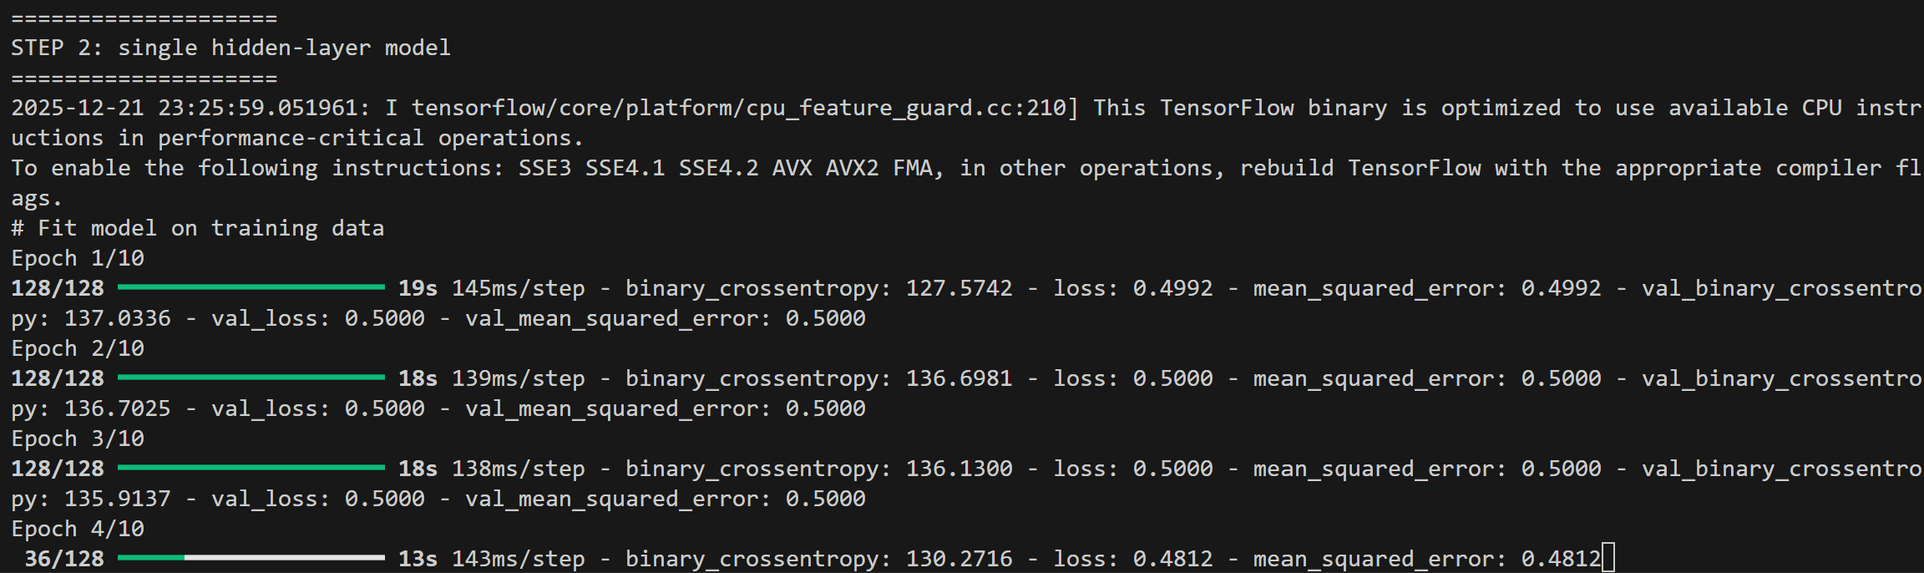
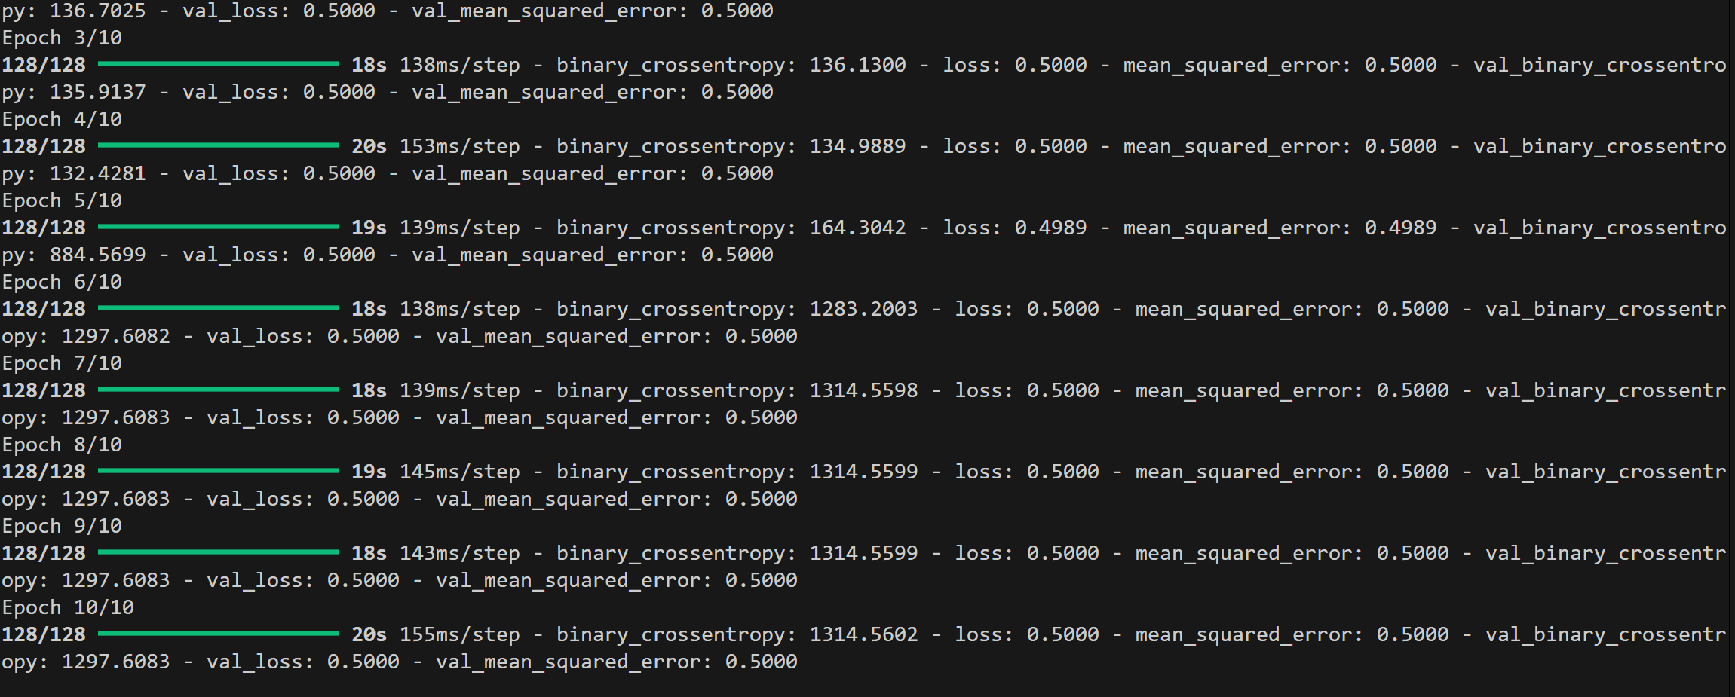
Figure-1: Step-2 Training Output – Model Fit Metrics

Step-3 CNN With One Convolution Layer
The second model introduces spatial feature extraction through a convolutional neural network architecture. A single convolutional layer with 24 kernels and a 3×3 filter is applied to the input images, followed by max pooling to reduce spatial dimensions. The extracted features are flattened and passed through two fully connected layers before producing a sigmoid probability output.
The model is trained using the Adam optimizer with a very small learning rate, as specified in the instructor template, and binary cross-entropy as the loss function. Model performance is evaluated using Pearson correlation between predicted probabilities and validation labels.
This CNN demonstrates a substantial improvement over the dense baseline. The Pearson correlation value of approximately 0.47 indicates a moderate positive relationship between predicted probabilities and true labels. This confirms that the convolutional layer successfully captures spatial features that are not accessible to a fully connected architecture.
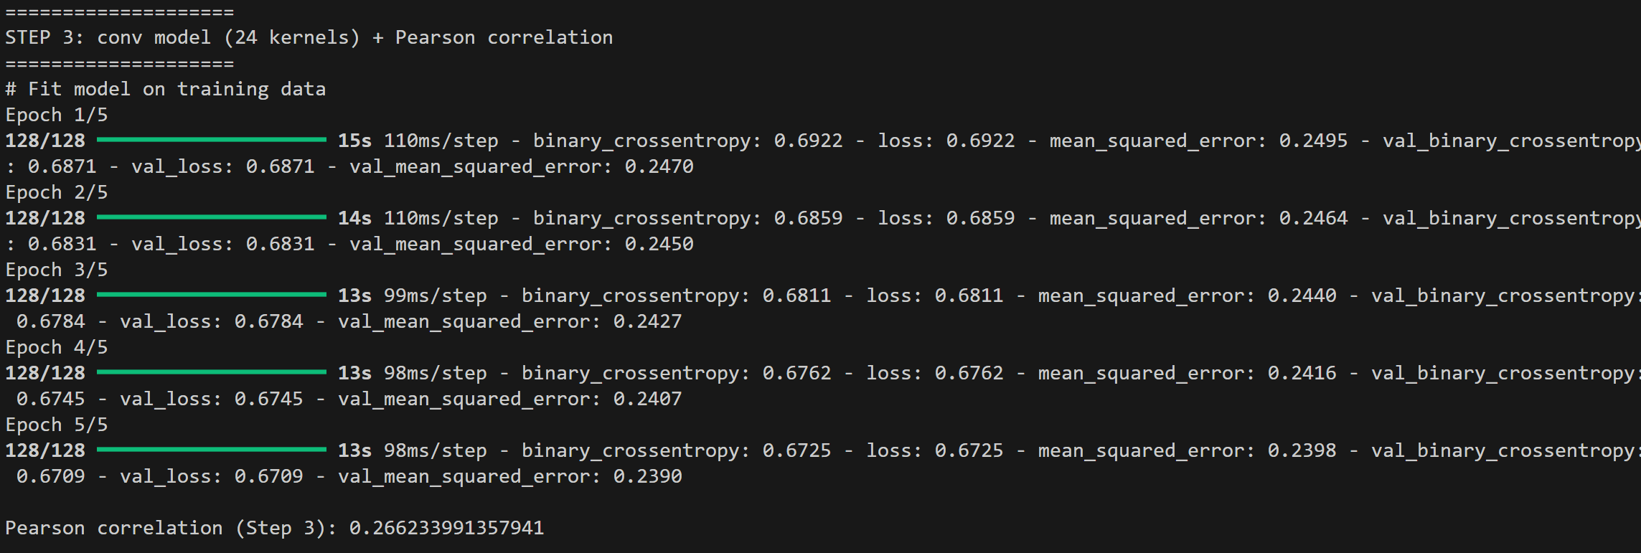
Figure-2: Training Output – Loss, MSE, and Correlation

Step-4: Expanded CNN With Two Convolution Layers
To further enhance representational capacity, a second convolutional layer with 48 kernels is added to the network. This additional layer allows the model to learn more complex and hierarchical image features. The remainder of the architecture, including max pooling and fully connected layers, is retained.
Training results show continued improvement. The Pearson correlation increases to approximately 0.53, and validation accuracy reaches roughly 71–73% at a standard probability threshold of 0.5. These gains demonstrate that increasing convolutional depth improves both correlation and classification accuracy, though the model still exhibits non-negligible uncertainty.
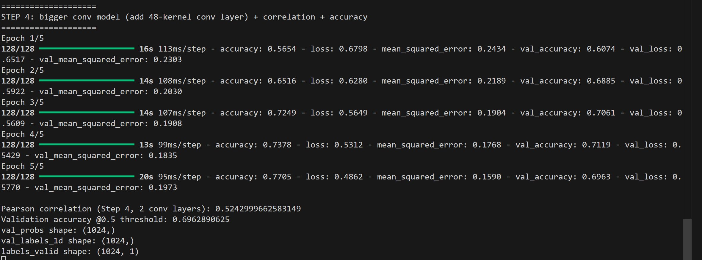
Figure-3: Step 4 Training Output – Accuracy and Loss

Step 5: Scatterplot and Threshold-Based Interpretation
A scatterplot was generated to visualize the relationship between predicted probabilities and true validation labels. In the plot, predicted probabilities are shown on the x-axis, while true labels appear on the y-axis, with 1 representing cats and 0 representing dogs.
An ideal classifier would produce tight clusters near 0 for dogs and near 1 for cats. In the observed scatterplot, while many samples align with this expectation, there is a noticeable overlap between the two classes. Some dog images receive high predicted probabilities for being cats, and some cat images receive low probabilities, indicating classification ambiguity.
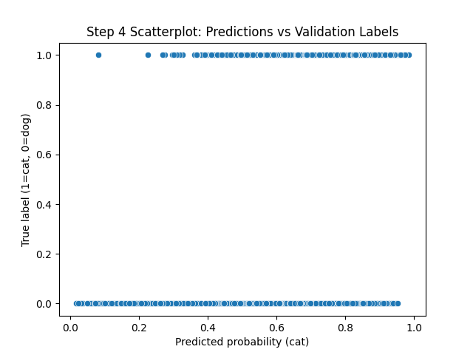
Figure-4: Scatterplot – Predictions vs Validation Labels
A threshold sweep further illustrates this tradeoff. As the classification threshold increases, the proportion of predicted-positive samples that are actually cats increases significantly. High thresholds therefore improve confidence in positive predictions but reduce recall by excluding many true cat images. This behavior highlights the importance of threshold selection in practical classification systems.

Step-6: Model Persistence
The final CNN model was saved using the native Keras .keras format. This format preserves both the architecture and learned weights and complies with modern Keras requirements for model serialization.
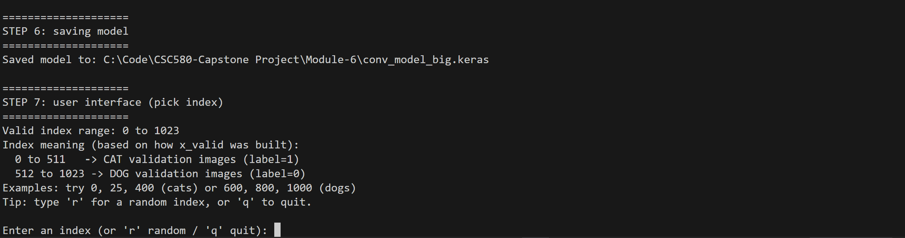
Figure-5: Models Saved

Step-7: User Interface Model Veracity
A simple user interface was implemented to allow interactive inspection of model predictions. The interface prompts the user to enter an index corresponding to a validation image and then displays both the image and the predicted probability that the image contains a cat. To ensure usability, the program explicitly prints the valid index range and explains how indices map to cats and dogs based on dataset construction.
This interactive inspection reveals that while the model performs reasonably well overall, it can still produce high-confidence errors. For example, at least one dog image was predicted with a probability exceeding 0.9 for being a cat. This demonstrates that probability outputs should be interpreted as confidence estimates rather than definitive truth, reinforcing the importance of validation analysis beyond simple accuracy metrics.

Conclusion & Improvement Opportunities
The progressive modeling approach used in this assignment demonstrates the effectiveness of convolutional architectures for image classification. While the expanded CNN significantly outperforms the dense baseline, the scatterplot and interactive testing reveal remaining limitations in model calibration and generalization.
Future improvements could include training on a larger portion of the dataset, applying data augmentation techniques, incorporating regularization methods such as dropout, tuning hyperparameters more aggressively, and leveraging transfer learning with pretrained CNN architectures. Additionally, evaluating precision, recall, and confusion matrices would provide deeper insight into class-specific errors and optimal threshold selection.

References
- GeeksforGeeks. (2023). Convolutional Neural Network (CNN) in deep learning. https://www.geeksforgeeks.org/convolutional-neural-network-cnn-in-deep-learning/
- Keras. (2024). Conv2D layer. https://keras.io/api/layers/convolution_layers/convolution2d/
- Keras. (2024). Saving and loading models. https://keras.io/guides/serialization_and_saving/
- NumPy. (2024). numpy.corrcoef. https://numpy.org/doc/stable/reference/generated/numpy.corrcoef.html

Appendix-A: Program Source Code
import os
import glob
from collections import defaultdict
import numpy as np
import seaborn as sns
import matplotlib.pyplot as plt
from PIL import Image
import tensorflow as tf
keras = tf.keras
layers = tf.keras.layers

#Step 0: Loading Kagle Data
BASE_DIR = r"C:\Code\CSC580-Capstone Project\Module-6"
TRAIN_DIR = os.path.join(BASE_DIR, "train")
TEST_DIR = os.path.join(BASE_DIR, "test1")

# Step 1: Load and preprocess with NumPy
IMG_SIZE = (94, 125)

def pixels_from_path(file_path):
im = Image.open(file_path).convert("RGB")
im = im.resize((IMG_SIZE[1], IMG_SIZE[0]))
np_im = np.array(im)
return np_im

# Build "cats/*" and "dogs/*" equivalent lists from TRAIN_DIR
cat_files = sorted(glob.glob(os.path.join(TRAIN_DIR, "cat.*.jpg")))
dog_files = sorted(glob.glob(os.path.join(TRAIN_DIR, "dog.*.jpg")))

if len(cat_files) == 0 or len(dog_files) == 0:
raise FileNotFoundError(
"Could not find cat.*.jpg and dog.*.jpg in your train folder. "
f"Checked: {TRAIN_DIR}"
)

# Shape counting
shape_counts = defaultdict(int)
for i, cat in enumerate(cat_files[:1000]):
if i % 100 == 0:
print("shape scan index:", i)
img_shape = pixels_from_path(cat).shape
shape_counts[str(img_shape)] += 1

shape_items = list(shape_counts.items())
shape_items.sort(key=lambda x: x[1], reverse=True)

print("\nMost common shapes (top 10):")
for k, v in shape_items[:10]:
print(k, "=>", v)

# Variables
validation_size = 0.1
img_size = IMG_SIZE
num_channels = 3
sample_size = 8192

print("\nSanity check one cat image shape:", pixels_from_path(cat_files[5]).shape)

# Sample sizes
SAMPLE_SIZE = 2048
valid_size = 512
print("\nloading training cat images...")
cat_train_set = np.asarray([pixels_from_path(p) for p in cat_files[:SAMPLE_SIZE]])
print("loading training dog images...")
dog_train_set = np.asarray([pixels_from_path(p) for p in dog_files[:SAMPLE_SIZE]])
print("loading validation cat images...")
cat_valid_set = np.asarray([pixels_from_path(p) for p in cat_files[-valid_size:]])
print("loading validation dog images...")
dog_valid_set = np.asarray([pixels_from_path(p) for p in dog_files[-valid_size:]])

x_train = np.concatenate([cat_train_set, dog_train_set], axis=0)
labels_train = np.asarray([1 for _ in range(SAMPLE_SIZE)] + [0 for _ in range(SAMPLE_SIZE)])
x_valid = np.concatenate([cat_valid_set, dog_valid_set], axis=0)
labels_valid = np.asarray([1 for _ in range(valid_size)] + [0 for _ in range(valid_size)])

labels_train = labels_train.reshape(-1, 1).astype("float32")
labels_valid = labels_valid.reshape(-1, 1).astype("float32")

x_train = x_train.astype("float32") / 255.0
x_valid = x_valid.astype("float32") / 255.0

print("\nDataset ready:")
print("x_train:", x_train.shape, "labels_train:", labels_train.shape)
print("x_valid:", x_valid.shape, "labels_valid:", labels_valid.shape)

# Step 2: Single hidden-layer model
# Adam optimizer
# 10 epochs
# shuffle
# MSE loss
print("\n====================")
print("STEP 2: single hidden-layer model")
print("====================")
total_pixels = img_size[0] * img_size[1] * 3
fc_size = 512
inputs = keras.Input(shape=(img_size[0], img_size[1], 3), name="ani_image")
x = layers.Flatten(name="flattened_img")(inputs)
x = layers.Dense(fc_size, activation="relu", name="first_layer")(x)
outputs = layers.Dense(1, activation="sigmoid", name="class")(x)
model = keras.Model(inputs=inputs, outputs=outputs)
customAdam = keras.optimizers.Adam(learning_rate=0.001)
model.compile(
optimizer=customAdam,
loss="mean_squared_error",
metrics=["binary_crossentropy", "mean_squared_error"],
)
print("# Fit model on training data")
history_step2 = model.fit(
x_train,
labels_train,
batch_size=32,
shuffle=True,
epochs=10,
validation_data=(x_valid, labels_valid),
)

# Step 3: CNN with
# - one conv layer (24 kernels)
# - max pooling
# - two fully connected layers
# - Pearson correlation between preds and validation labels
print("\n====================")
print("STEP 3: conv model (24 kernels) + Pearson correlation")
print("====================")
fc_layer_size = 128
conv_inputs = keras.Input(shape=(img_size[0], img_size[1], 3), name="ani_image")
conv_layer = layers.Conv2D(24, kernel_size=3, activation="relu")(conv_inputs)
conv_layer = layers.MaxPool2D(pool_size=(2, 2))(conv_layer)
conv_x = layers.Flatten(name="flattened_features")(conv_layer)
conv_x = layers.Dense(fc_layer_size, activation="relu", name="first_layer")(conv_x)
conv_x = layers.Dense(fc_layer_size, activation="relu", name="second_layer")(conv_x)
conv_outputs = layers.Dense(1, activation="sigmoid", name="class")(conv_x)
conv_model = keras.Model(inputs=conv_inputs, outputs=conv_outputs)
customAdam = keras.optimizers.Adam(learning_rate=1e-6)
conv_model.compile(
optimizer=customAdam,
loss="binary_crossentropy",
metrics=["binary_crossentropy", "mean_squared_error"],
)
print("# Fit model on training data")
history_step3 = conv_model.fit(
x_train,
labels_train,
batch_size=32,
shuffle=True,
epochs=5,
validation_data=(x_valid, labels_valid),
)

preds = conv_model.predict(x_valid, verbose=0)
preds = np.asarray([p[0] for p in preds])
corr_step3 = np.corrcoef(preds, labels_valid.ravel())[0][1]
print("\nPearson correlation (Step 3):", corr_step3)

print("\n====================")
print("STEP 4: bigger conv model (add 48-kernel conv layer) + correlation + accuracy")
print("====================")

big_inputs = keras.Input(shape=(img_size[0], img_size[1], 3), name="ani_image")

x = layers.Conv2D(24, kernel_size=3, activation="relu")(big_inputs)
x = layers.MaxPool2D(pool_size=(2, 2))(x)

x = layers.Conv2D(48, kernel_size=3, activation="relu")(x)
x = layers.MaxPool2D(pool_size=(2, 2))(x)

x = layers.Flatten(name="flattened_features")(x)
x = layers.Dense(fc_layer_size, activation="relu", name="first_layer")(x)
x = layers.Dense(fc_layer_size, activation="relu", name="second_layer")(x)
big_outputs = layers.Dense(1, activation="sigmoid", name="class")(x)

big_model = keras.Model(inputs=big_inputs, outputs=big_outputs)

big_model.compile(
optimizer=keras.optimizers.Adam(learning_rate=1e-4),
loss="binary_crossentropy",
metrics=["accuracy", "mean_squared_error"],
)

history_step4 = big_model.fit(
x_train,
labels_train, # keep as (N,1) for Keras
batch_size=32,
shuffle=True,
epochs=5,
validation_data=(x_valid, labels_valid),
)

# ---- Make 1-D views for NumPy/Seaborn calculations ----
val_probs = big_model.predict(x_valid, verbose=0).reshape(-1) # (N,)
val_labels_1d = labels_valid.reshape(-1) # (N,)

# Pearson correlation (must be 1-D)
corr_step4 = np.corrcoef(val_probs, val_labels_1d)[0][1]
print("\nPearson correlation (Step 4, 2 conv layers):", corr_step4)

# Correct validation accuracy @0.5 threshold (must be 1-D vs 1-D)
val_pred_labels = (val_probs >= 0.5).astype(int)
val_accuracy = (val_pred_labels == val_labels_1d.astype(int)).mean()
print("Validation accuracy @0.5 threshold:", val_accuracy)

# Scatterplot (Seaborn/Pandas require 1-D arrays)
print("val_probs shape:", val_probs.shape)
print("val_labels_1d shape:", val_labels_1d.shape)
print("labels_valid shape:", labels_valid.shape)
sns.scatterplot(x=val_probs, y=val_labels_1d)
plt.xlabel("Predicted probability (cat)")
plt.ylabel("True label (1=cat, 0=dog)")
plt.title("Step 4 Scatterplot: Predictions vs Validation Labels")
plt.show()

# Threshold analysis (fixed version of professor loop)
for i in range(1, 10):
t = 0.1 * i
mask = val_probs > t
print(f"threshold: {t:.1f}")
if mask.sum() == 0:
print(" no samples above threshold")
else:
# Mean label among samples above threshold = fraction of cats in that slice
print(" fraction cats above threshold:", val_labels_1d[mask].mean())

# Step 5: Utility functions to select an image + probability
print("\n====================")
print("STEP 5: utility functions (animal_pic + cat_index)")
print("====================")

def animal_pic(index):
# convert back to uint8 for display
img = (x_valid[index] * 255).astype(np.uint8)
return Image.fromarray(img)

def cat_index(index):
# IMPORTANT: use the passed index (the professor snippet had a bug using [124])
return big_model.predict(np.asarray([x_valid[index]]), verbose=0)[0][0]

# Example
index = 600 if len(x_valid) > 600 else 0
print("probability of being a cat:", cat_index(index))
#animal_pic(index).show()

# Step 6: Save the model
print("\n====================")
print("STEP 6: saving model")
print("====================")

SAVE_PATH = os.path.join(BASE_DIR, "conv_model_big.keras")
big_model.save(SAVE_PATH)
print("Saved model to:", SAVE_PATH)

# Step 7: Simple interface: user picks index -> print prob + image
print("\n====================")
print("STEP 7: user interface (pick index)")
print("====================")

n = len(x_valid)
cats_end = valid_size # 512

print(f"Valid index range: 0 to {n-1}")
print(f"Index meaning (based on how x_valid was built):")
print(f" 0 to {cats_end-1} -> CAT validation images (label=1)")
print(f" {cats_end} to {n-1} -> DOG validation images (label=0)")
print("Examples: try 0, 25, 400 (cats) or 600, 800, 1000 (dogs)")
print("Tip: type 'r' for a random index, or 'q' to quit.\n")

rng = np.random.default_rng()

while True:
user_in = input("Enter an index (or 'r' random / 'q' quit): ").strip().lower()

if user_in in ("q", "quit", "exit"):
break

if user_in in ("r", "rand", "random"):
idx = int(rng.integers(0, n))
else:
try:
idx = int(user_in)
except ValueError:
print("Please enter a valid integer, 'r', or 'q'.")
continue

if idx < 0 or idx >= n:
print("Index out of range.")
continue

true_label = int(labels_valid.reshape(-1)[idx]) # 1=cat, 0=dog
p = cat_index(idx)

print(f"Index {idx} | true_label={true_label} (1=cat,0=dog) | predicted P(cat)={p:.6f}")
animal_pic(idx).show()

Appendix-B: Program Outputs
