***AIRPORT_PROJECT***

*REGISTER '/home/jibran/piggybank-0.15.0.jar'*

We are registering the *piggybank* jar in order to use the CSVExcelStorage class.

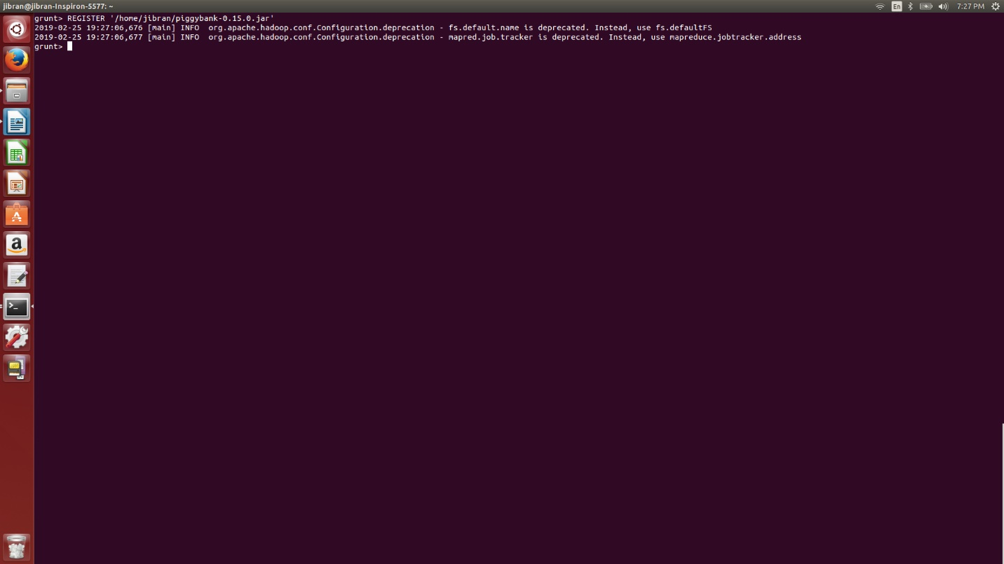

*A = load '/delayedFlights.csv' USING org.apache.pig.piggybank.storage.CSVExcelStorage(',','NO_MULTILINE','UNIX','SKIP_INPUT_HEADER');*

In relation **A**, we are loading the dataset using CSVExcelStorage

*B = foreach A generate (int)$1 as year, (int)$10 as flight_num, (chararray)$17 as origin,(chararray) $18 as dest*

In relation **B**, we are generating the columns that are

*C = filter B by dest is not null;*

In relation **C**, we are filtering the null values from the “dest” column.

*D = group C by dest;*

In relation **D**, we are grouping relation C by “dest.”

*E = foreach D generate group, COUNT(C.dest);*

In relation **E**, we are generating the grouped column and the count of each.

*F = order E by $1 DESC;*

*Result = LIMIT F 5;*

Relation **F** and **Result** is used to order and limit the result to top 5.

INPUT:

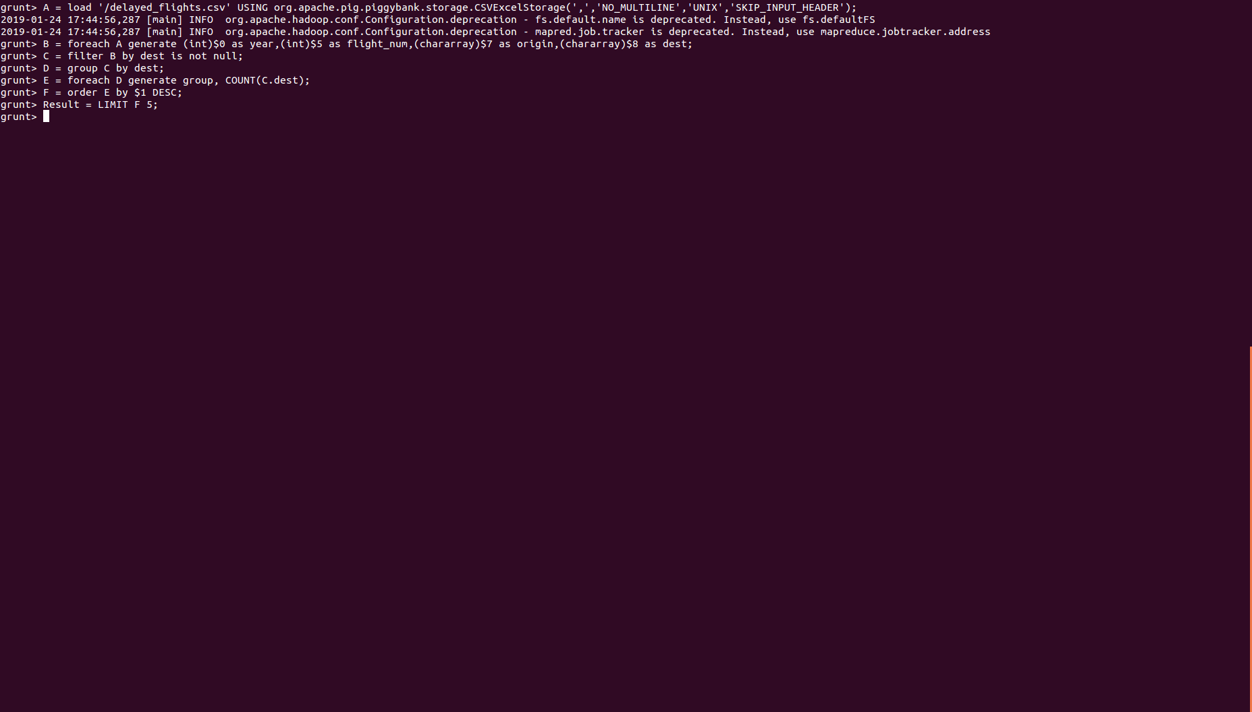

OUTPUT:

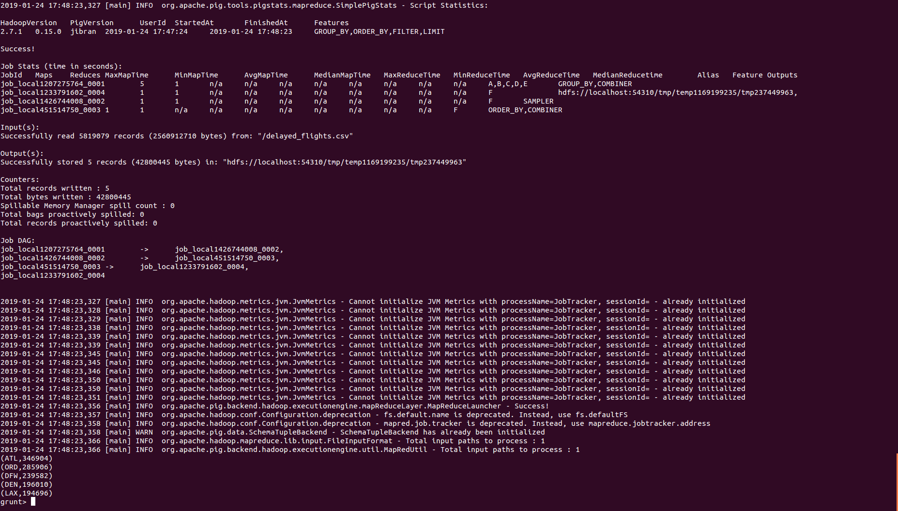

We will be using another table to find the city name and country as well.

*A1 = load '/airports.csv' USING org.apache.pig.piggybank.storage.CSVExcelStorage(',','NO_MULTILINE','UNIX','SKIP_INPUT_HEADER');*

In relation **A1**, we are loading another table to which we will look-up and find the city as well as the country

*A2 = foreach A1 generate (chararray)$0 as dest, (chararray)$2 as city, (chararray)$4 as country;*

In relation **A2**, we are generating dest, city, and country from the previous relation.

*joined_table = join Result by $0, A2 by dest;*

*dump joined_table;*

In relation **joined_table**, we are joining Result and A2 based on a common column, i.e., “dest”

INPUT:

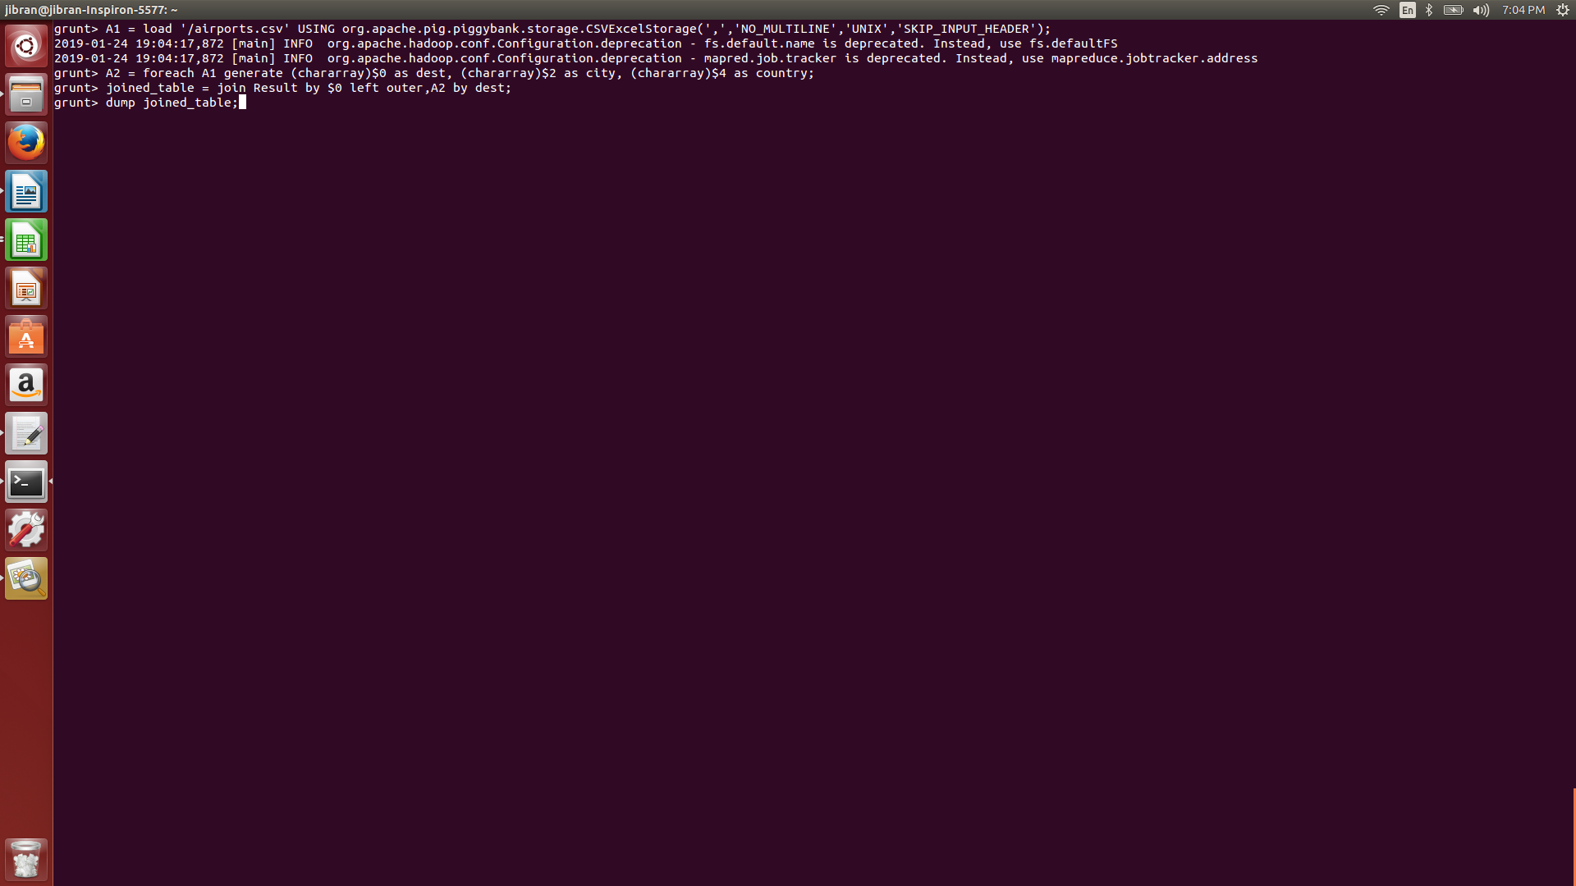

OUTPUT:

