|  |  |  |  |  |  |  |  |  |  |  |  |  |
| --- | --- | --- | --- | --- | --- | --- | --- | --- | --- | --- | --- | --- |
| **Software Requirement Specifications**  Volunteer Organizer with Management Entity  (VOWME)  Version: [0.01x]   |  |  | | --- | --- | | Project Code | VOWME | | Supervisor | Mr. Muhammad Shahzad | | Co Supervisor |  | |  |  | | Project Team | Jibran Tariq (14K- 3408) | | Submission Date |  | |

[Instructions]

* No section of template should be deleted. You can write ‘Not applicable’ if a section is not applicable to your project. But all sections must exist in the final document.
* All comments/examples mentioned in square brackets ([]) are in the template for explanation purposes and must be replaced / removed in final document.
* This’ Instruction’ section should also be removed in final document.
* MS-Word Reviewing feature must be used to get the document reviewed by supervisors or co-supervisors.

Document History

[Revision history will be maintained to keep a track of changes done by anyone in the document.]

|  |  |  |  |
| --- | --- | --- | --- |
| **Version** | **Name of Person** | **Date** | **Description of change** |
| 1.0 | Jibran Tariq |  | Initial Version |
|  |  |  |  |
|  |  |  |  |
|  |  |  |  |
|  |  |  |  |
|  |  |  |  |
|  |  |  |  |

Distribution List

[Following table will contain list of people whom the document will be distributed after every sign-off]

|  |  |  |
| --- | --- | --- |
| **Name** | **Role** | |
| Mr. Muhammad Shahzad | | Supervisor |
|  | | Co- Supervisor |
|  | |  |

Document Sign-Off

[Following table will contain sign-off details of document. Once the document is prepared and revised, this should be signed-off by the sign-off authority.

Any subsequent changes in the document after the first sign-off should again get a formal sign-off by the authorities.]

|  |  |  |
| --- | --- | --- |
| **Version** | **Sign-off Authority** | **Sign-off Date** |
| 1.0 | Mr. Muhammad Shahzad |  |
| 1.0 | FYP Committee |  |
|  |  |  |
|  |  |  |
|  |  |  |
|  |  |  |
|  |  |  |

**Table of Contents**

1. Introduction 10

1.1. Purpose of Document 10

1.2. Intended Audience 10

1.4 Document Convention 10

2. Overall System Description 11

2.1. Project Background 11

2.2. Project Scope 11

2.2.1. Features 11

2.3. Not in Scope 12

2.4. Project Objectives 12

2.5. Stakeholders 12

2.6. Operating Environment 12

2.7. System Constraints 12

2.8. Assumptions & Dependencies 13

3. External Interface Requirements 14

14

3.1. Hardware Interfaces 15

3.2. Software Interfaces 15

3.3. Communications Interfaces 15

4. Functional Requirements 17

4.1. Functional Hierarchy 17

4.2. Use Cases 17

4.2.1. Events Management 17

4.2.2. Time Management 18

4.2.3. Members Management 20

4.2.4. Reports Management 21

4.2.5. Reports Management 22

5. Non-functional Requirements 23

5.1. Performance Requirements 23

5.1.1. Application Response Time 23

5.1.2. Dynamic Page Update 23

5.1.3. File Compression 24

5.1.4. Third-Party Code Libraries and Frameworks 24

5.1.5. Serve Scaled Images 24

5.2. Safety Requirements 24

5.2.1. Source Code Documentation/Source Code Availability 24

5.2.2. Android Version Support 24

5.3. Security Requirements 25

5.3.1. Website Cache Process 25

5.3.2. Password Encryption 25

5.3.3. Malicious Input Protection 25

5.4. User Documentation 25

6. References 26

7. Appendices 27

1. Introduction

* 1. Purpose of Document

The purpose of this document is to describe the functionality of the Volunteer Organizer with Management Entity for Final Year Project of Master in Software Project Management.

* 1. Intended Audience

The intended audience for this SRS includes all the stakeholders in the Volunteer Organizer with Management Entity project. The document will be used by TCF Rahbar Team as the specification from which to implement the working program code. The document will be used by Mr. Muhammad Shahzad of the Supervisor as a statement of what functionality will be delivered during the project. The document will be used as a deliverable for the academic portion of the Final Year Project of Master program of Software Project Management and graded for its quality.

Team will be working with the society for TCF Rahbar Team, Cup of Kindness Team on the various campaigns organized by them. The campaigns are designed to "facilitate current issues around city”. The campaign consists of three sections containing lists of local organizations, area volunteers and other information that would be helpful to those in running campaigns profession. Team will be developing and modifying the way of registration online campaigns in accordance with the requirements outlined in this document.

[Note that this document assumes general knowledge about the purpose of the Volunteer Organizer with Management Entity project. The following text describes the overall purpose and long term goals of the project.]

**1.3 Abbreviations**

[Describe the abbreviations use this document.]

* 1. Document Convention

The abbreviation TBD has been used to represent the phrase To Be Determined.

1. Overall System Description
   1. Project Background

People like to bring a positive change to the society, and they do that by volunteering for various projects and causes. For some, the act offers a chance to give something back to the community or make a difference to the lives of people around them – for others, it provides an opportunity to develop new skills or gain experience or knowledge that they didn’t have before.

It is important for us to encourage, support and engage people into voluntary activities. The support shouldn’t just be there because it’s for good causes but it is another step towards a better society. People who have a purpose outside of their everyday working role are more motivated, healthier and happier. So, volunteering for good causes is a great act whichever way you look at it.

* 1. Project Scope

The project is based on mobile as well as web application, which will develop to work on the Android platform and Server-side language.

The mobile interface will start from the register page where volunteer must provide basic details or can allow fetch information from 3rd party application like Facebook. After registration, system track volunteer’s location and based on location, system redirects to screen where list of registered campaign will be shown with characteristics like durations, location and short description and title of campaign. Complete details with register button should display when volunteer touches on the specific campaign. Volunteer can register into campaign by providing express interest on the specific campaign. System must generate notification to organizer. System will notify registered volunteer when new volunteer will get enroll in same campaign. Volunteer can send joining invitation request to peer volunteer with 120 characters note. Volunteer can accept or reject invitation request. System should provide details of peer volunteer to another volunteer when invitation request is accepted. Volunteer can provide feedback about campaign and volunteer for future actions.

The web application must utilize for creating campaigns, approval volunteer into campaign and monitor volunteer’s activities like invitation request to another volunteer. Organizer can change details of campaigns and invites peoples for campaigns.

* + 1. Features

Following are important features of the VowMe.

* **Provide location based Campaigns.**

System will provide campaigns based on volunteer’s location within range of 100 miles.

* **Notification of new registered volunteers.**

System will notify registered volunteers about new comers in campaigns.

* **Link peer volunteer within campaigns.**

Volunteer will able to send notification to another volunteer after registration in campaigns.

* **Follow up on campaigns.**

Organizer will monitor and send notification to volunteers about the activities and ask feedback on activities

* **Feedback about volunteers and campaigns.**

Volunteers will allow to provide feedback on activity of campaigns as well as about co-volunteers.

* **Send invitations to peoples.**

Organizer will able to send invitations to people via emails or Facebook.

* **Track Volunteer Hour**

Volunteers will able to track/manage volunteer hours to show their company.

* 1. Not in Scope

The stakeholders request some improvements which are completely out of the scope of what this team can do in the time frame allotted. These features are captured in this document as a reference to future development teams, as some of them are large enough to be a project themselves.

* Power failure backup for the dedicated server
* Verification of Volunteer Information.
* List current campaigns which are being used or being executed within city or area
  1. Project Objectives

This project will provide a way for volunteers to find registered volunteer campaign within their area, communicate more easily with other volunteers who are registered within same volunteer campaign. It will record/track volunteer hours of volunteers and will allow volunteers to provide feedback about campaigns and peers. Also, the application will provide a way for organizers to create the volunteer campaign, maintains volunteer’s basic information and send notifications related to campaign.

* 1. Stakeholders

[This section will describe stakeholders of the system. This will include different business user classes that are expected to interact with system and similarly the technical people who are going to be involved in software development/management]

* 1. Operating Environment

[Describe the environment in which the software will operate, including the hardware platform, operating system, network environment and other software components or applications with which it must coexist.]

* 1. System Constraints

[Describe the constraints imposed on the system by the external environment. External environment may be caused by the stakeholders, business conditions, technical issues, academic requirements etc and may include the following:

* Software constraints
* Hardware constraints
* Cultural constraints (includes language etc.)
* Legal constraints
* Environmental constraints (e.g., the environment where the software will be installed, It could be a noisy environment, which may require that there is no sound event in the project).
* User constraints (e.g., the project is developed for children, so it may be required that the project has more graphic controls rather than textual controls).
* Off the shelf components that might be used in the project may have their constraints that are consequently transferred to the project.]
  1. Assumptions & Dependencies

[This section will identify:

* Any assumptions taken regarding the system or environment
* Any dependency of system on any external factor.]

1. External Interface Requirements

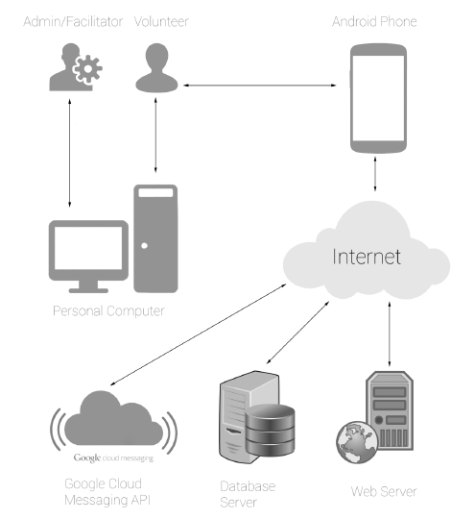

* 1. Hardware Interfaces



* 1. Software Interfaces

[Describe the connections between this system and other external software components (identified by name and version), including databases, operating systems, tools, libraries, and integrated commercial components. Identify and describe the purpose of the data items or messages exchanged among the software components. Describe the services needed and the nature of the inter-component communications. Identify data that will be shared across software components. ]

* 1. Communications Interfaces

.]

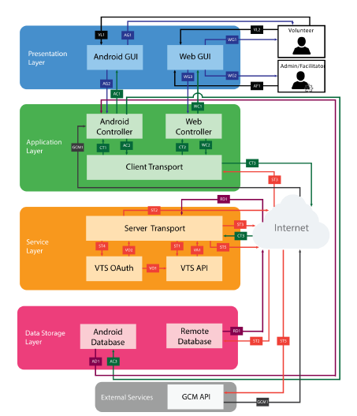

1. Functional Requirements
   1. Functional Hierarchy

[This section will give a big picture of overall system functionality. The main modules/features of system and their sub-functions will be described here in the form of a functional hierarchy so that, before getting into the use case, audience could grab the idea of overall system functions.]

* 1. Use Cases
     1. Events Management

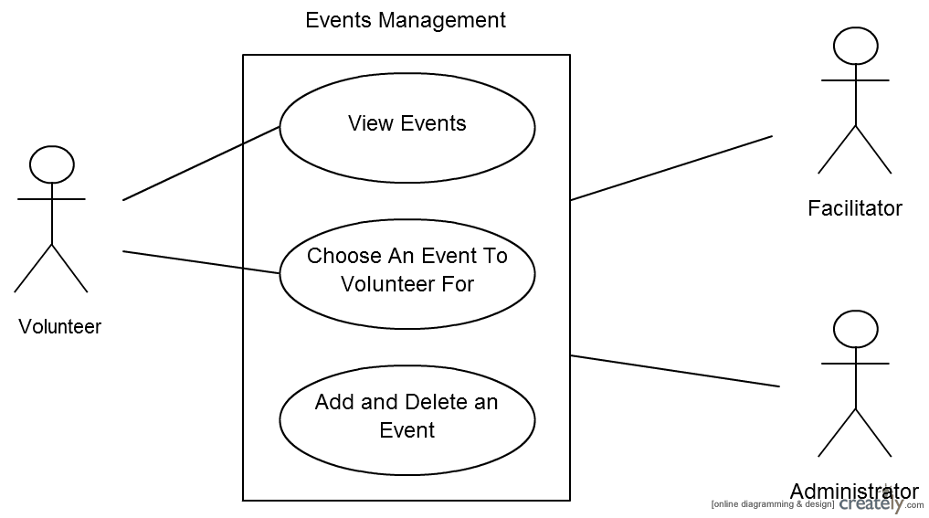

|  |  |  |  |  |  |
| --- | --- | --- | --- | --- | --- |
| **<Use case Id: name>** | | | | | |
| **Use case Id:** | | | Write use case reference number. | | |
| **Actors:**  <List of actors (external agents), indicating who initiated the use case> | | | | | |
| **Feature:** <Feature from which the use case is driven> | | | | | |
| **Pre-condition:** | | <List the assumptions required before this Use Case can be executed. > | | | |
| **Scenarios** | | | | | |
| **Step#** | **Action** | | | | **Software Reaction** |
| **1.** | Numbered actions of the actors | | | | Numbered description of system responses |
| **2.** |  | | | |  |
|  |  | | | |  |
| **Alternate Scenarios:** Write additional, optional, branching or iterative steps. Refer to specific action number to ensure understandability. | | | | | |
| **1a:**    **2a:** | | | | | |
| **Post Conditions** | | | | | |
| **Step#** | **Description** | | | | |
|  | Sequentially list conditions expected at the completion of the use case. | | | | |
|  |  | | | | |
|  |  | | | | |
| **Use Case Cross referenced** | | | | <Related use cases, which use or are used by this use case> | |

* + 1. Time Management

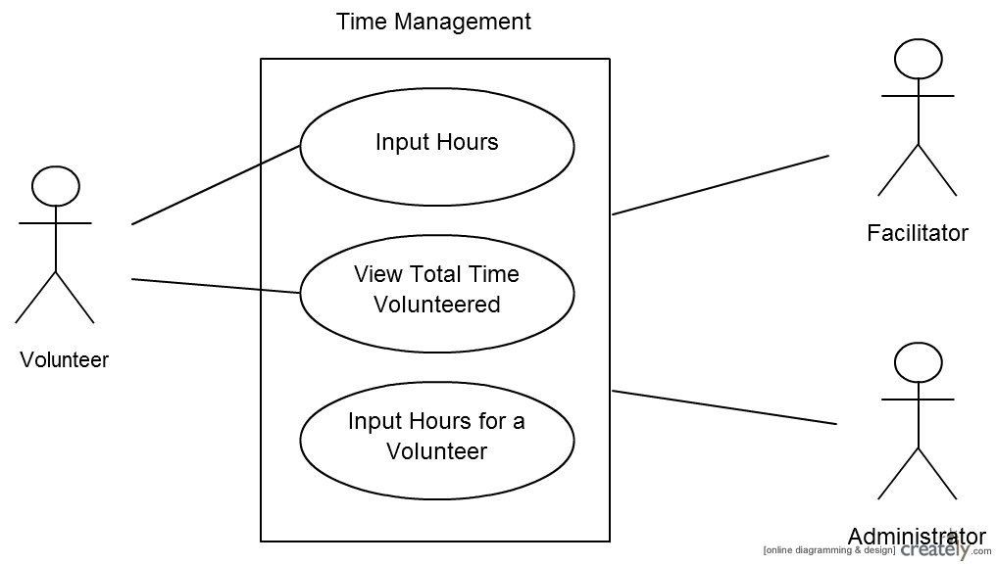

|  |  |  |  |  |  |
| --- | --- | --- | --- | --- | --- |
| **<Use case Id: name>** | | | | | |
| **Use case Id:** | | | Write use case reference number. | | |
| **Actors:**  <List of actors (external agents), indicating who initiated the use case> | | | | | |
| **Feature:** <Feature from which the use case is driven> | | | | | |
| **Pre-condition:** | | <List the assumptions required before this Use Case can be executed. > | | | |
| **Scenarios** | | | | | |
| **Step#** | **Action** | | | | **Software Reaction** |
| **1.** | Numbered actions of the actors | | | | Numbered description of system responses |
| **2.** |  | | | |  |
|  |  | | | |  |
| **Alternate Scenarios:** Write additional, optional, branching or iterative steps. Refer to specific action number to ensure understandability. | | | | | |
| **1a:**    **2a:** | | | | | |
| **Post Conditions** | | | | | |
| **Step#** | **Description** | | | | |
|  | Sequentially list conditions expected at the completion of the use case. | | | | |
|  |  | | | | |
|  |  | | | | |
| **Use Case Cross referenced** | | | | <Related use cases, which use or are used by this use case> | |
|  | | | |  | |

* + 1. Members Management

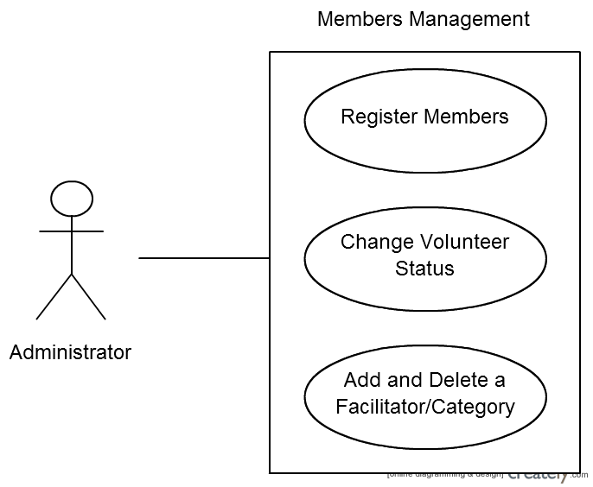

|  |  |  |  |  |  |
| --- | --- | --- | --- | --- | --- |
| **<Use case Id: name>** | | | | | |
| **Use case Id:** | | | Write use case reference number. | | |
| **Actors:**  <List of actors (external agents), indicating who initiated the use case> | | | | | |
| **Feature:** <Feature from which the use case is driven> | | | | | |
| **Pre-condition:** | | <List the assumptions required before this Use Case can be executed. > | | | |
| **Scenarios** | | | | | |
| **Step#** | **Action** | | | | **Software Reaction** |
| **1.** | Numbered actions of the actors | | | | Numbered description of system responses |
| **2.** |  | | | |  |
|  |  | | | |  |
| **Alternate Scenarios:** Write additional, optional, branching or iterative steps. Refer to specific action number to ensure understandability. | | | | | |
| **1a:**    **2a:** | | | | | |
| **Post Conditions** | | | | | |
| **Step#** | **Description** | | | | |
|  | Sequentially list conditions expected at the completion of the use case. | | | | |
|  |  | | | | |
|  |  | | | | |
| **Use Case Cross referenced** | | | | <Related use cases, which use or are used by this use case> | |
|  | | | |  | |

* + 1. Reports Management

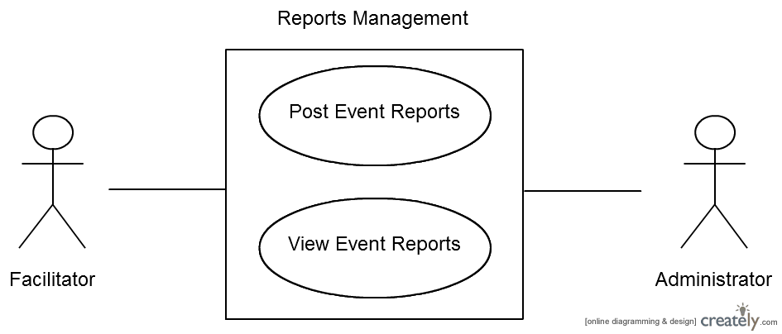

|  |  |  |  |  |  |
| --- | --- | --- | --- | --- | --- |
| **<Use case Id: name>** | | | | | |
| **Use case Id:** | | | Write use case reference number. | | |
| **Actors:**  <List of actors (external agents), indicating who initiated the use case> | | | | | |
| **Feature:** <Feature from which the use case is driven> | | | | | |
| **Pre-condition:** | | <List the assumptions required before this Use Case can be executed. > | | | |
| **Scenarios** | | | | | |
| **Step#** | **Action** | | | | **Software Reaction** |
| **1.** | Numbered actions of the actors | | | | Numbered description of system responses |
| **2.** |  | | | |  |
|  |  | | | |  |
| **Alternate Scenarios:** Write additional, optional, branching or iterative steps. Refer to specific action number to ensure understandability. | | | | | |
| **1a:**    **2a:** | | | | | |
| **Post Conditions** | | | | | |
| **Step#** | **Description** | | | | |
|  | Sequentially list conditions expected at the completion of the use case. | | | | |
|  |  | | | | |
|  |  | | | | |
| **Use Case Cross referenced** | | | | <Related use cases, which use or are used by this use case> | |
|  | | | |  | |

* + 1. Reports Management

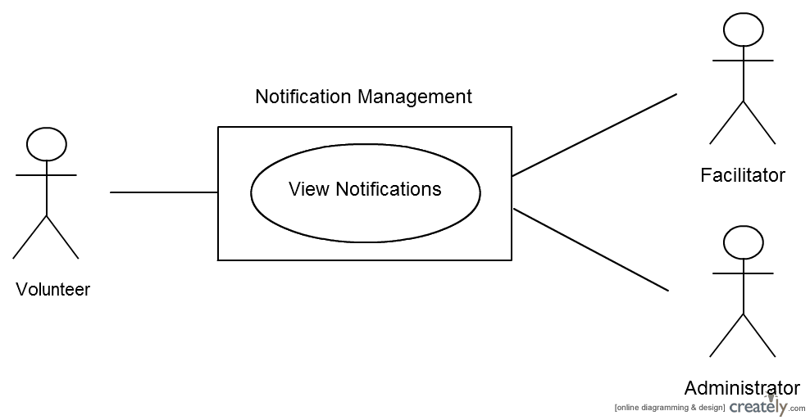

|  |  |  |  |  |  |
| --- | --- | --- | --- | --- | --- |
| **<Use case Id: name>** | | | | | |
| **Use case Id:** | | | Write use case reference number. | | |
| **Actors:**  <List of actors (external agents), indicating who initiated the use case> | | | | | |
| **Feature:** <Feature from which the use case is driven> | | | | | |
| **Pre-condition:** | | <List the assumptions required before this Use Case can be executed. > | | | |
| **Scenarios** | | | | | |
| **Step#** | **Action** | | | | **Software Reaction** |
| **1.** | Numbered actions of the actors | | | | Numbered description of system responses |
| **2.** |  | | | |  |
|  |  | | | |  |
| **Alternate Scenarios:** Write additional, optional, branching or iterative steps. Refer to specific action number to ensure understandability. | | | | | |
| **1a:**    **2a:** | | | | | |
| **Post Conditions** | | | | | |
| **Step#** | **Description** | | | | |
|  | Sequentially list conditions expected at the completion of the use case. | | | | |
|  |  | | | | |
|  |  | | | | |
| **Use Case Cross referenced** | | | | <Related use cases, which use or are used by this use case> | |

1. Non-functional Requirements
   1. Performance Requirements

This section discusses the performance requirements for this project. The main concerns regarding the performance of the product are based on primarily the availability and the responsiveness. The product is expected to offer a continuous and smooth experience to the user.

* + 1. Application Response Time
       1. **Description**: The response time between the user interaction and the result must be less than 8 seconds on the site and on the Android application
       2. **Constraints**: Internet connections and hardware capacity of devices.
       3. **Standards**: None
       4. **Priority**: 3-Moderate
    2. Dynamic Page Update
       1. **Description**: Only the necessary parts of the web page will be updated when the user interacts instead of completely reloading the page.
       2. **Constraints**: JavaScript may not be enabled by default on Web browsers
       3. **Standards**: AJAX standards.
       4. **Priority**: 3-Moderate
    3. File Compression
       1. **Description**: The JavaScript and CSS files will be compressed to reduce the size of the file. The size of JPEG images should be less than 3 MB.
       2. **Constraints**: None
       3. **Standards**: None
       4. **Priority**: 4-Low
    4. Third-Party Code Libraries and Frameworks
       1. **Description:** JavaScript and CSS libraries will be directly accessible from the Caching Servers, thereby improving access time in remote locations.
       2. **Constraints**: Not all third-party libraries offer Cache URLs
       3. **Standards**: None
       4. **Priority**: 4-Low
    5. Serve Scaled Images
       1. **Description:** Images on different scales will be used in different scenarios. That is, thumbnails, full-screen images.
       2. **Constraints**: None
       3. **Standards**: None
       4. **Priority**: 4-Low
  1. Safety Requirements

This section discusses the requirements safety requirements needed to maintain the security of the system and control the privacy of information.

* + 1. Source Code Documentation/Source Code Availability
       1. **Description:** The source code must be well documented with comments and details about the feature. The code will help anyone who wants to develop this product in the future.
       2. **Constraints**: All the documentations shall be in English.
       3. **Standards**: None
       4. **Priority**: 3-Moderate
    2. Android Version Support
       1. **Description:** The mobile version of the system will be based on Android. The application supports a minimum API level of 16, which corresponds to version 4.1.2 (Jelly Bean).
       2. **Constraints**: All the documentations shall be in English.
       3. **Standards**: The Android device supports Android version 4.1.2 or higher.
       4. **Priority**: 4-Low
  1. Security Requirements

This section discusses the requirements security and privacy requirements needed to maintain the security of the system and control the privacy of information.

* + 1. Website Cache Process
       1. **Description:** The age of the web site cache will be limited to 7 days.
       2. **Constraints**: None
       3. **Standards**: HTTP cache control standards
       4. **Priority**: 4-Low
    2. Password Encryption
       1. **Description:** All user passwords must be encrypted in the MySQL database.
       2. **Constraints**: None
       3. **Standards**: MD5 hash function
       4. **Priority**: 1-Critical
    3. Malicious Input Protection
       1. **Description:** All user passwords must be encrypted in the MySQL database.
       2. **Constraints**: None
       3. **Standards**: MD5 hash function
       4. **Priority**: 1-Critical
  1. User Documentation

[List the user documentation components that will be delivered along with the software, such as user manuals, online help, context-sensitive help and tutorials.]

1. References

[This section should provide a complete list of all documents referenced at specific point in time. Each document should be identified by title, report number (if applicable), date, and publishing organization. Specify the sources from which the references can be obtained. (This section is like the bibliography in a published book).]

1. Appendices

[This section should include supporting detail that would be too distracting to include in the main body of the document.]