Lab #6

Deploying a Private AI Model with Ollama and OpenWebUI

Week #12/13

NACT-262 Fundamentals of System Administration

2025-2026 Fall Semester

Submitted by Jibreal Id-deen

Due by November 23, 2025

Professor Mark Jeremy

Table Of Contents
Objective 6
Network DIAGRAM 7
Procedure 9
Questions and Answers 53
Observations 54

Table of Figures
Figure 1 - Type "Rufus" on google url 9
Figure 2 - Download it 9
Figure 3 - type "ubuntu Server" on google url to download 10
Figure 4 - Download it 10
Figure 5 - Use Ubuntu Server to start booting on the USB 11
Figure 6 - Install Ubuntu Server on PC2 12
Figure 7 - install OpenSSH Server 12
Figure 8 - type the required command to update the Ubuntu Server system 13
Figure 9 - type the required command to install ollama on Ubuntu Server 13
Figure 10 – Downloading 13
Figure 11 - Reboot the Ubuntu Server system 13
Figure 12 - After rebooting, type the requiredcommand to start the ollama service 13
Figure 13 - type the required command to enable ollama service 13
Figure 14 - type the required command to pull the AI model from olamma 14
Figure 15 - Pulling 14
Figure 16 - Make sure to see the "Success" word after pulling the AI model from ollama 14
Figure 17 - type the required command to run the AI model, mistral 14
Figure 18 - Mistral AI mode now 14
Figure 19 - Type the required command to 'watch’ AI mistral 14
Figure 20 - Make sure ollama service is running to respond while you make sure to watch the memory raise up 15
Figure 21 - Type the required command to install docker 15
Figure 22 - Type the required command to start the docker service 15
Figure 23 - Type the required command to enable the docker service 15
Figure 24 - Type the required command to run the container of the docker 16
Figure 25 - Type the required command to allow ufw 8080 to be on 16
Figure 26 - Type the required command to reload the firewall 16
Figure 27 - Type the required command to check the firewall status 16
Figure 28 - Type the DHCP IP Address on the google url 17
Figure 29 - The showcase of the openwebui 17
Figure 30 - Create Admin Account 18
Figure 31 - Click "Admin" panel 19
Figure 32 - Click Settings then connections, and change the API connections 20
Figure 33 - Change the host url 21
Figure 34 - Make sure to use the localhost as the url 22
Figure 35 - Save it 22
Figure 36 - Successfully API settings updated 23
Figure 37 - Add User 23
Figure 38 - Create an standard account 24
Figure 39 - Click "Groups" 25
Figure 40 - Create Group 25
Figure 41 - Describe the group 26
Figure 42 - Make sure to work on the permissions for the standard account to have some permissions and not 27
Figure 43 - Save it 28
Figure 44 - Click "Test-Player" to drag to the group 28
Figure 45 - Successfully added the standard account to the group 29
Figure 46 - Make sure to check the ubuntu's IP Address 29
Figure 47 - Type the required command to change the Ubuntu Server's IP Address 29
Figure 48 - Set the required configuration manually to change the IP Address 30
Figure 49 - Type the required command to apply the netplan to confirm changes 30
Figure 50 - Make sure to reboot the ubuntu server 31
Figure 51 - Check the Ubuntu Server's IP Address again 31
Figure 52 - Make sure to start the container of the docker once again 31
Figure 53 - Type the static IP Address on the Google url 31
Figure 54 - Sign the openwenUI account 32
Figure 55 - Successfully logged in 32
Figure 56 - Type "ollama.ai" website on the google url 32
Figure 57 - Click "Models" on Ollama website 33
Figure 58 - Type the command to run the another AI model 33
Figure 59 - Type the command to run the llama 33
Figure 60 - Type the command to run phi4 34
Figure 61 - Test the three AI models to see how fast they respond 35

Lab #6 – Deploying a Private AI Model with Ollama and OpenWebUI

Objective
Set up a private AI chat stack on your LAN by installing Ubuntu + Ollama with OpenWebUI on PC2 (RTX GPU), then secure it (static IP, firewall, authentication) and verify it works by pulling multiple models and comparing their responses.

Network DIAGRAM
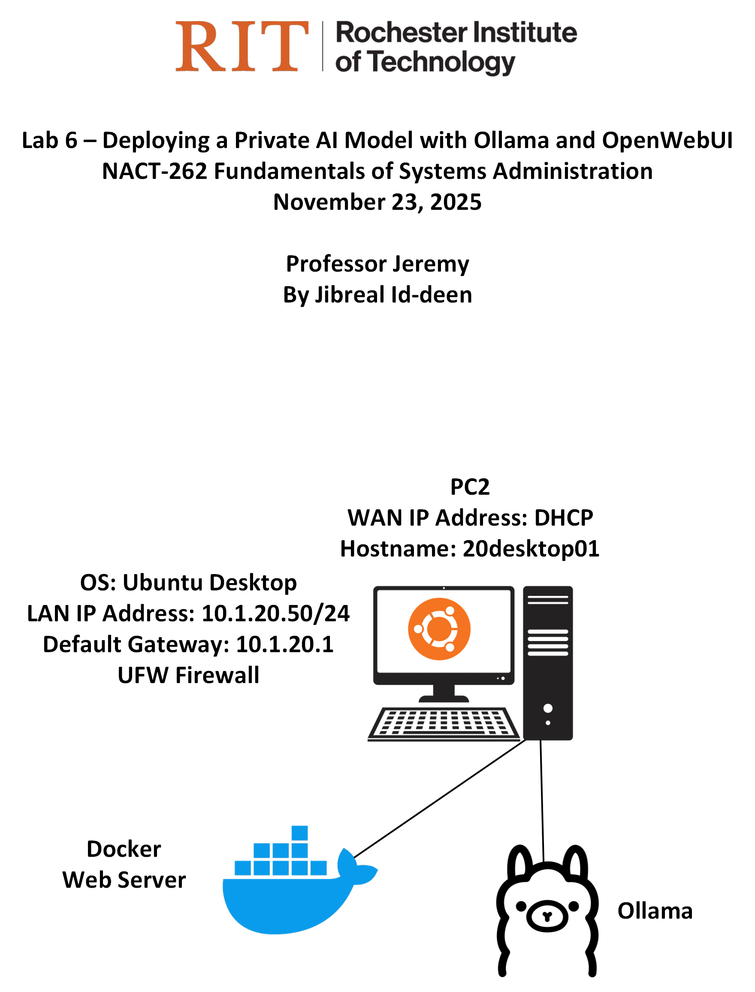

Hostname | Ai01
Virtual Machine or Physical? | Physical
Operating System | Ubuntu Server 24.04 LTS
RAM size | 16GB
HD size | 1TB
Ethernet #1 IP Address (if none – remove line) | 10.1.20.60
Ethernet Gateway IP Address (if none – remove line) | 10.1.20.1
Primary DNS IP Address (if none – remove line) | 8.8.8.8
Network Services (if none – remove line) | Ollama, OpenWebUI, SSH

Procedure

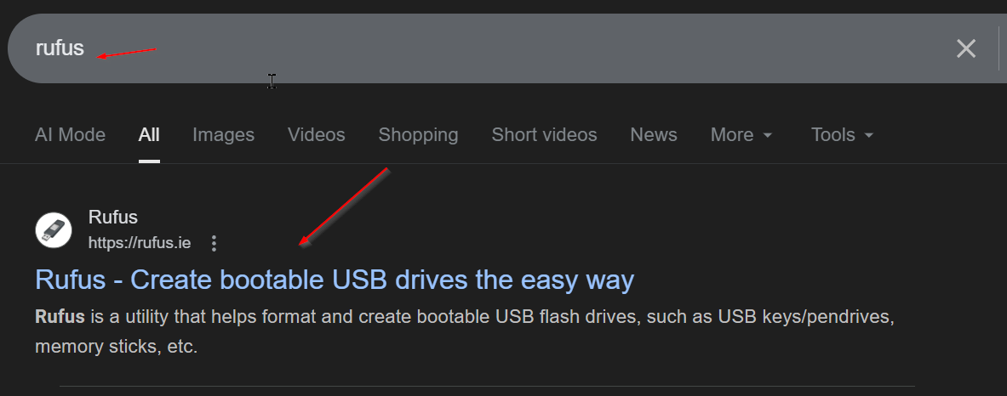
Figure 1 - Type "Rufus" on google url

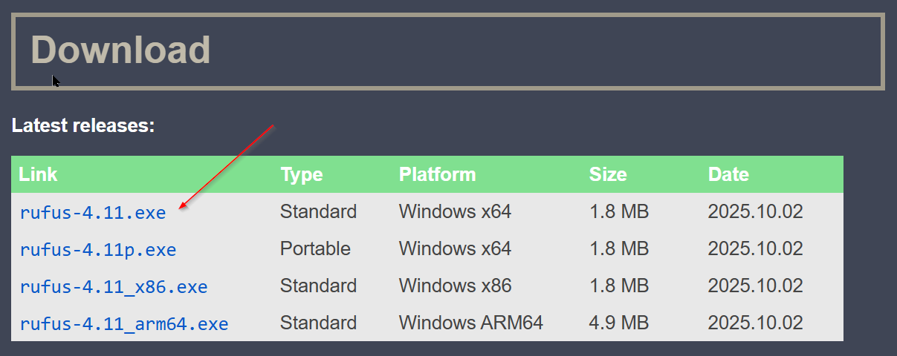
Figure 2 - Download it

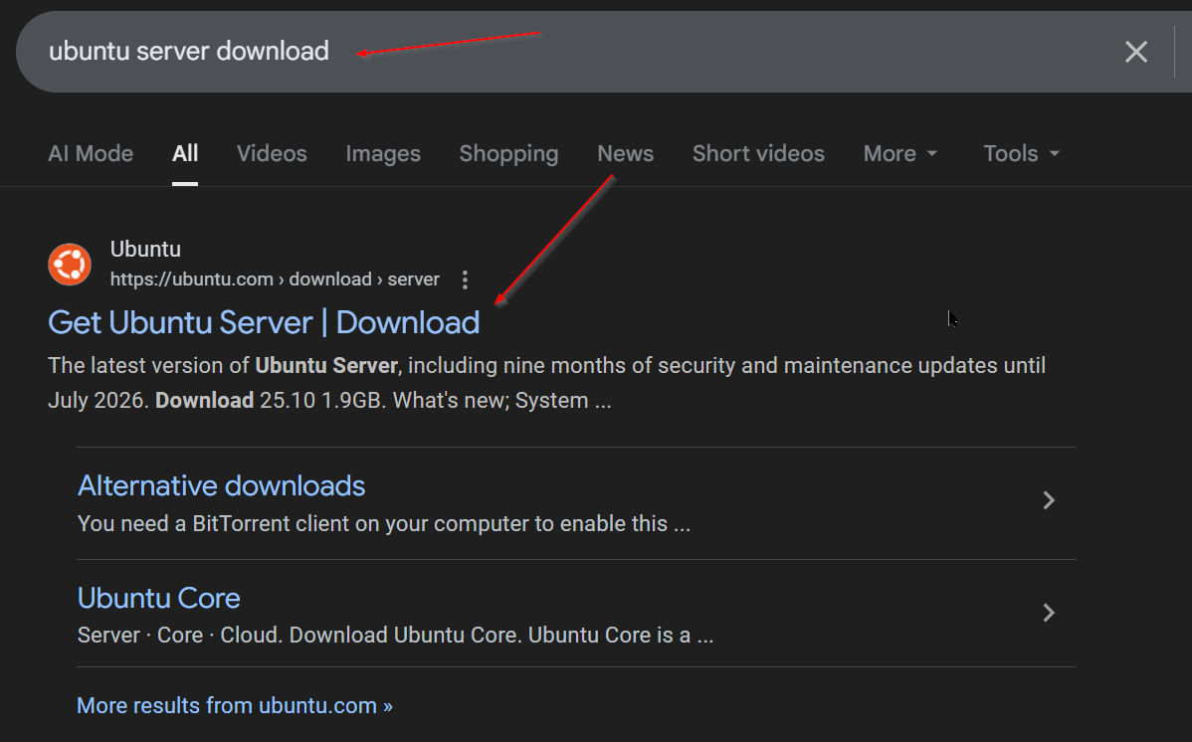
Figure 3 - type "ubuntu Server" on google url to download

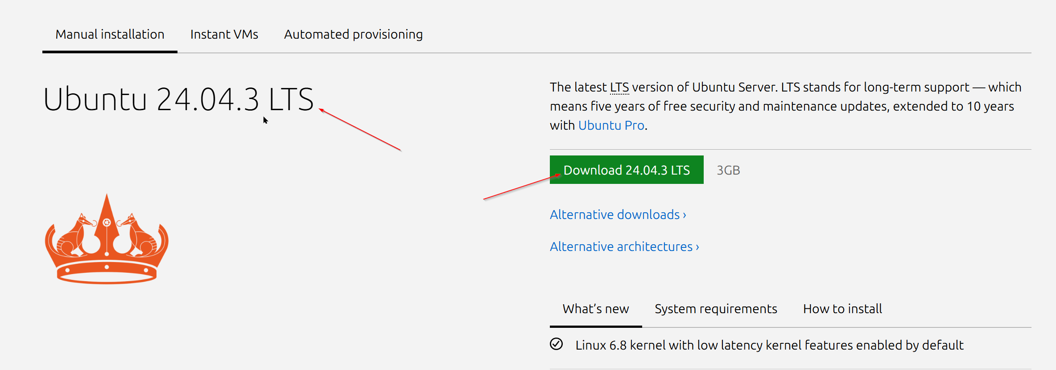
Figure 4 - Download it

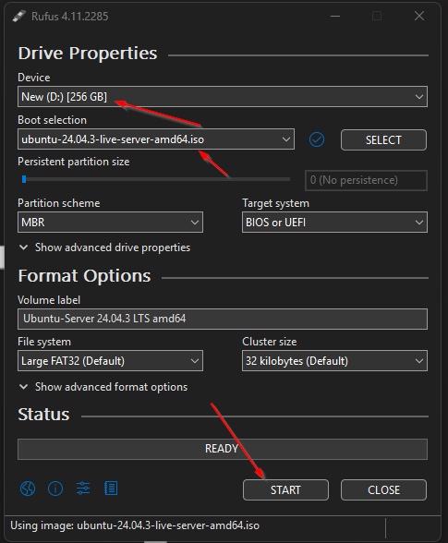
Figure 5 - Use Ubuntu Server to start booting on the USB

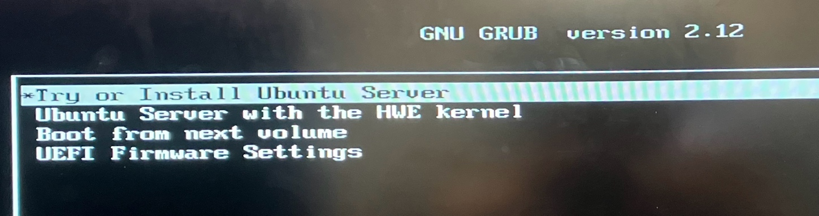
Figure 6 - Install Ubuntu Server on PC2

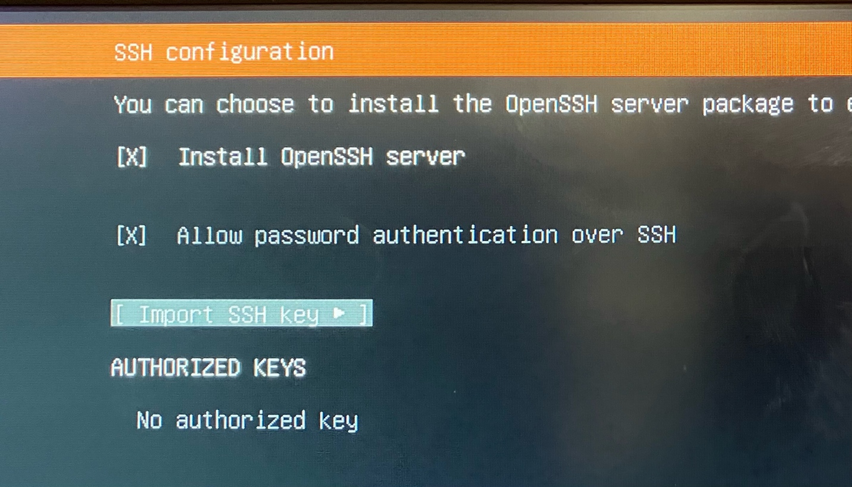
Figure 7 - install OpenSSH Server

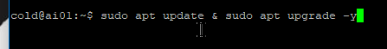
Figure 8 - type the required command to update the Ubuntu Server system

Figure 9 - type the required command to install ollama on Ubuntu Server

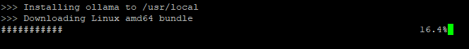
Figure 10 – Downloading

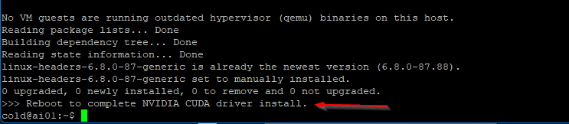
Figure 11 - Reboot the Ubuntu Server system

Figure 12 - After rebooting, type the requiredcommand to start the ollama service

Figure 13 - type the required command to enable ollama service

Figure 14 - type the required command to pull the AI model from olamma

Figure 15 - Pulling

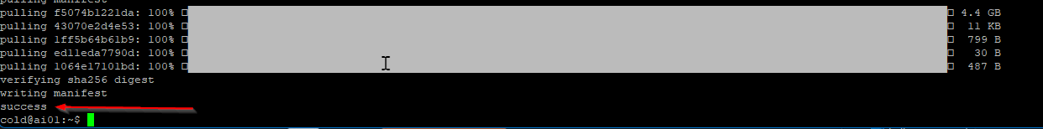
Figure 16 - Make sure to see the "Success" word after pulling the AI model from ollama

Figure 17 - type the required command to run the AI model, mistral

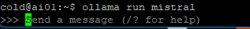
Figure 18 - Mistral AI mode now

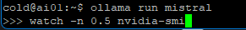
Figure 19 - Type the required command to 'watch’ AI mistral

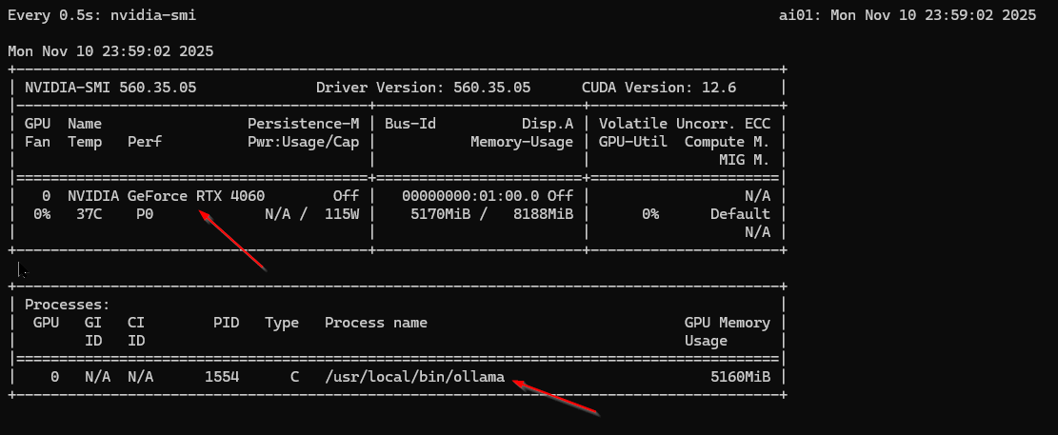
Figure 20 - Make sure ollama service is running to respond while you make sure to watch the memory raise up

Figure 21 - Type the required command to install docker

Figure 22 - Type the required command to start the docker service

Figure 23 - Type the required command to enable the docker service

Figure 24 - Type the required command to run the container of the docker

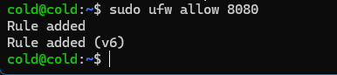
Figure 25 - Type the required command to allow ufw 8080 to be on

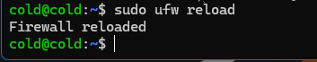
Figure 26 - Type the required command to reload the firewall

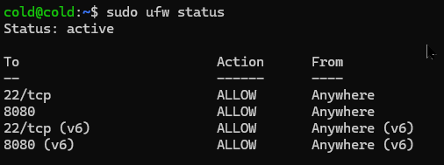
Figure 27 - Type the required command to check the firewall status

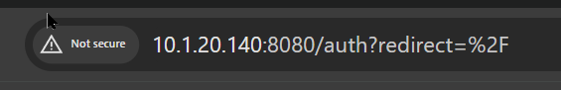
Figure 28 - Type the DHCP IP Address on the google url

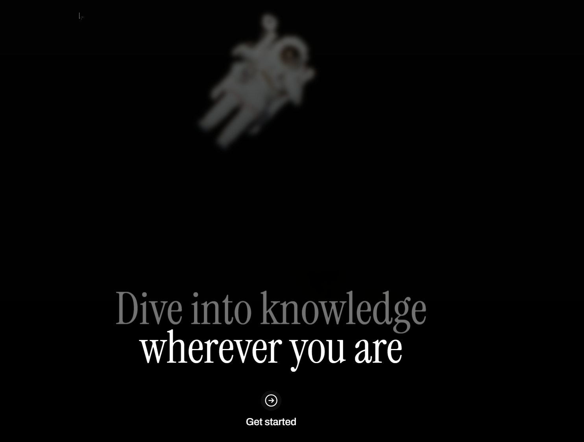
Figure 29 - The showcase of the openwebui

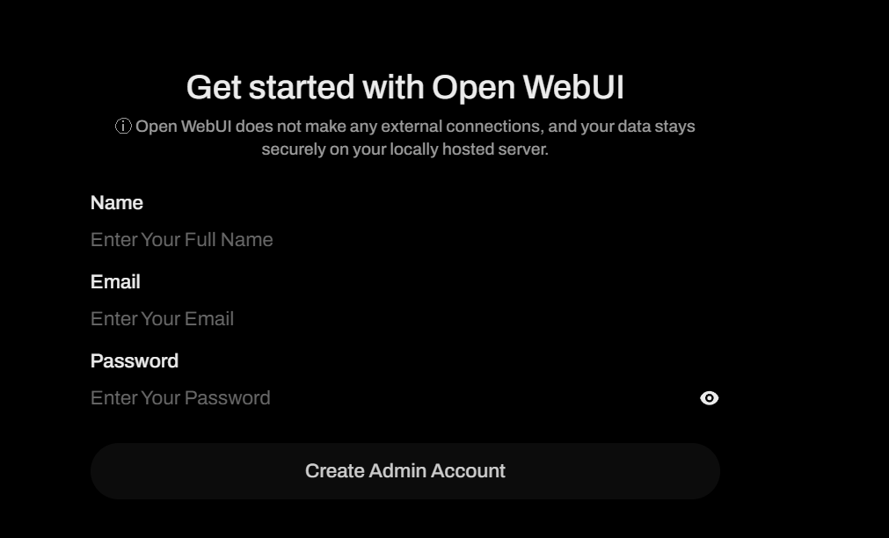
Figure 30 - Create Admin Account
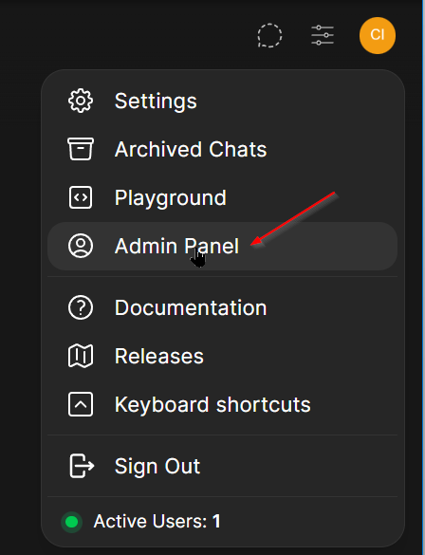
Figure 31 - Click "Admin" panel

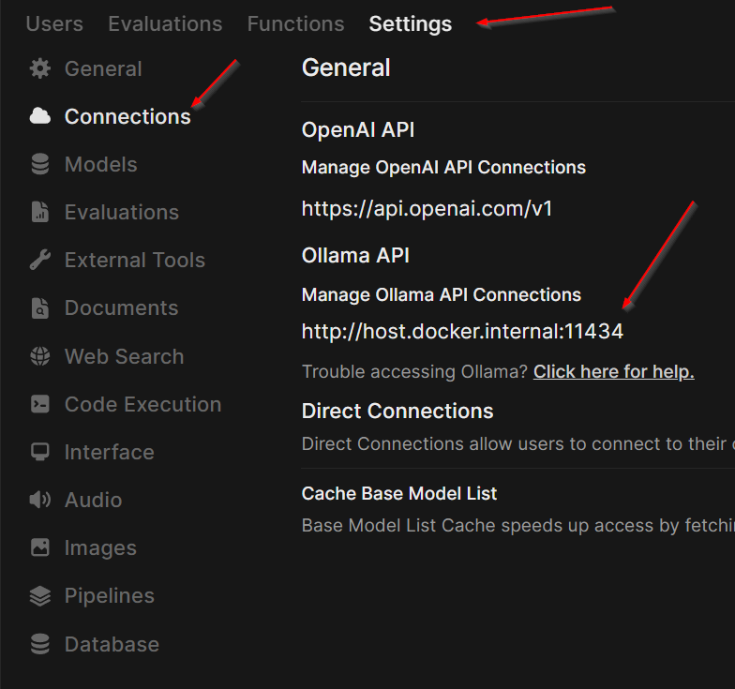
Figure 32 - Click Settings then connections, and change the API connections

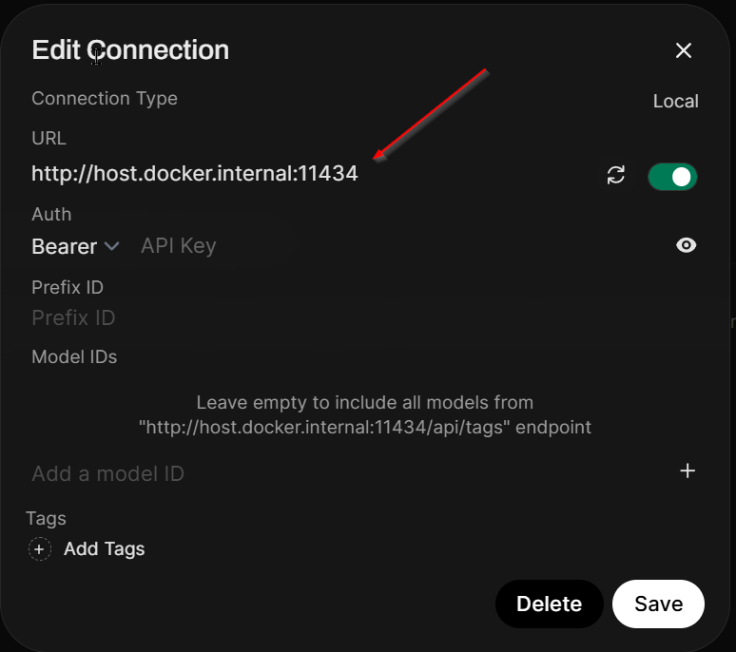
Figure 33 - Change the host url

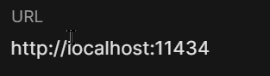
Figure 34 - Make sure to use the localhost as the url

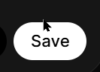
Figure 35 - Save it

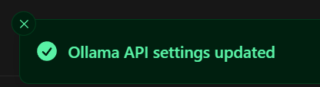
Figure 36 - Successfully API settings updated

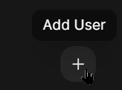
Figure 37 - Add User

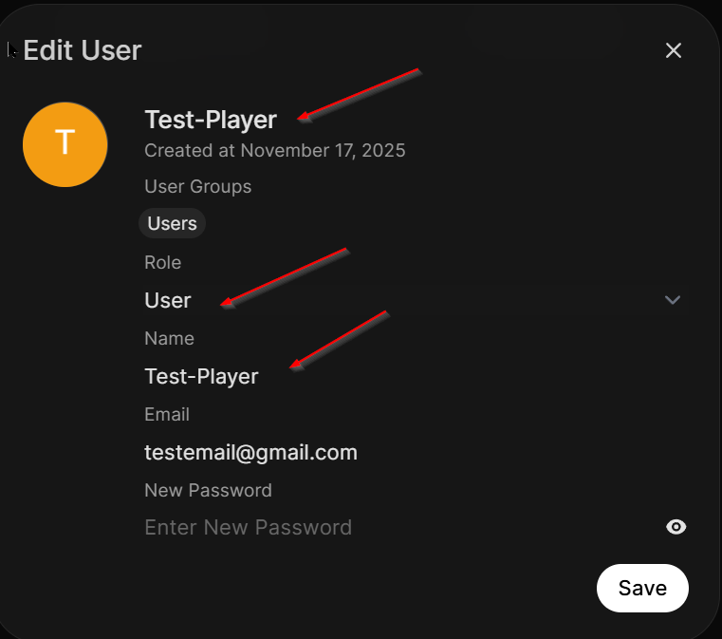
Figure 38 - Create an standard account

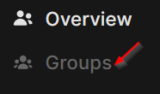
Figure 39 - Click "Groups"

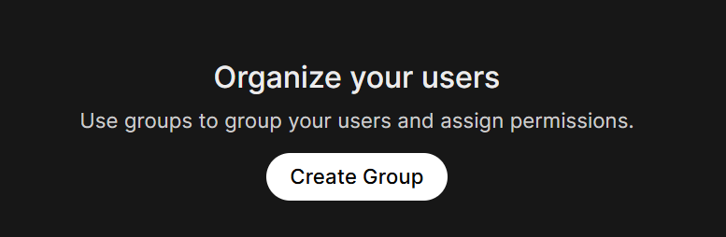
Figure 40 - Create Group

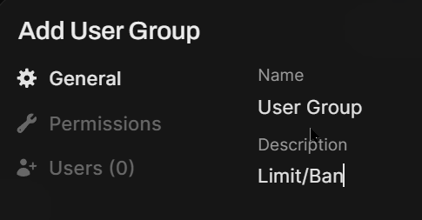
Figure 41 - Describe the group

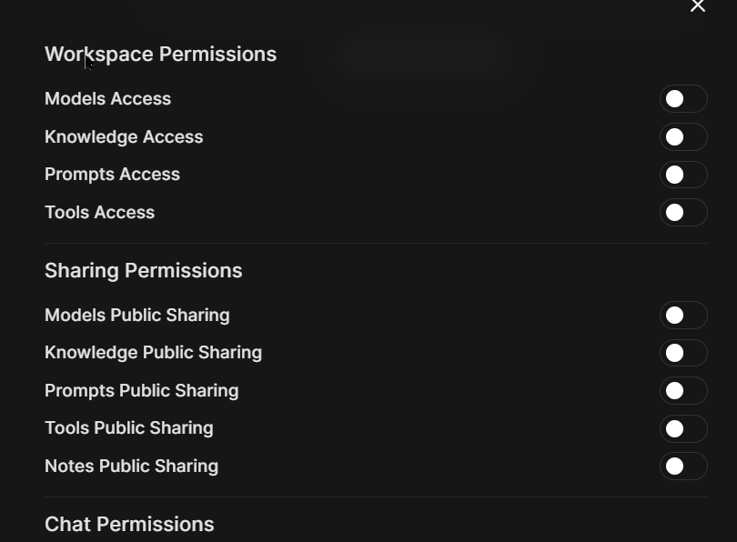
Figure 42 - Make sure to work on the permissions for the standard account to have some permissions and not


Figure 43 - Save it

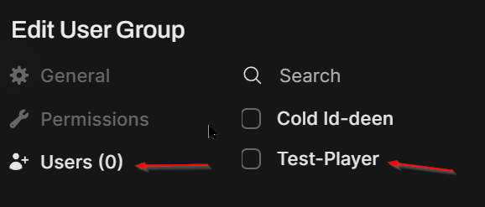
Figure 44 - Click "Test-Player" to drag to the group

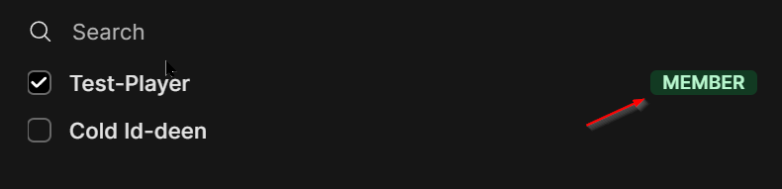
Figure 45 - Successfully added the standard account to the group

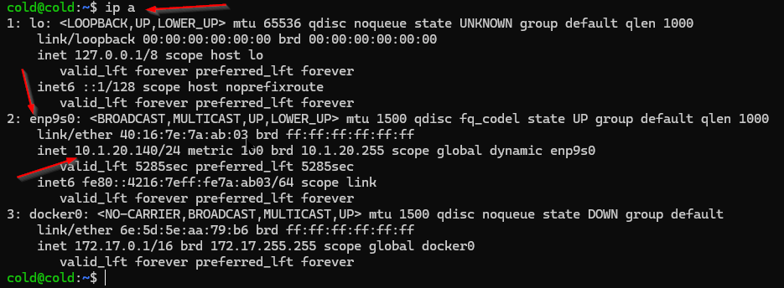
Figure 46 - Make sure to check the ubuntu's IP Address

Figure 47 - Type the required command to change the Ubuntu Server's IP Address

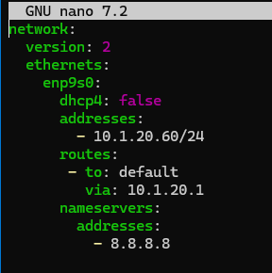
Figure 48 - Set the required configuration manually to change the IP Address

Figure 49 - Type the required command to apply the netplan to confirm changes


Figure 50 - Make sure to reboot the ubuntu server

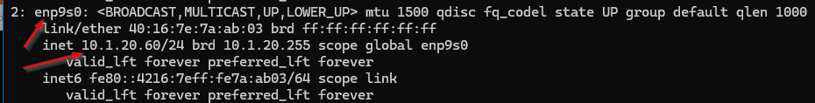
Figure 51 - Check the Ubuntu Server's IP Address again

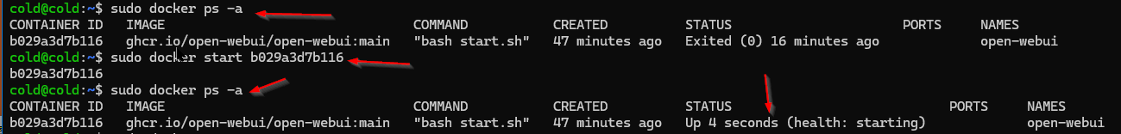
Figure 52 - Make sure to start the container of the docker once again

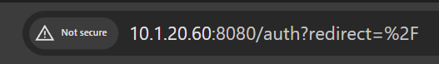
Figure 53 - Type the static IP Address on the Google url

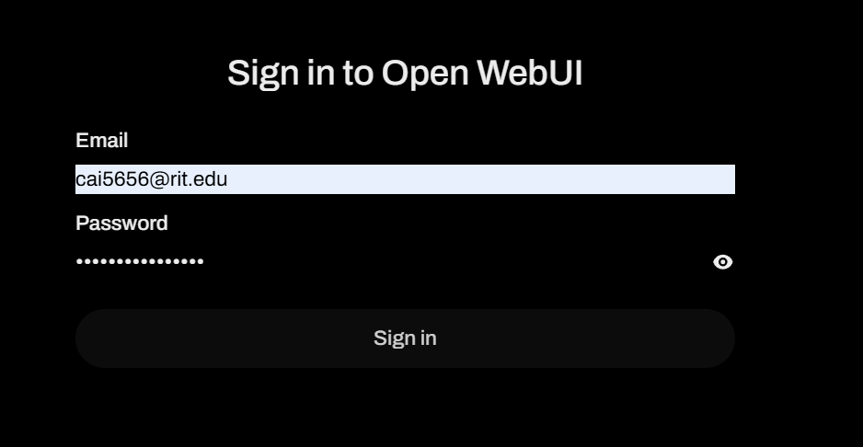
Figure 54 - Sign the openwenUI account

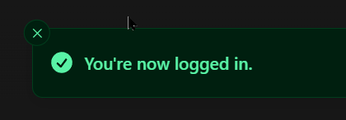
Figure 55 - Successfully logged in


Figure 56 - Type "ollama.ai" website on the google url

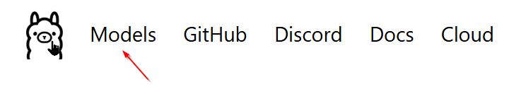
Figure 57 - Click "Models" on Ollama website

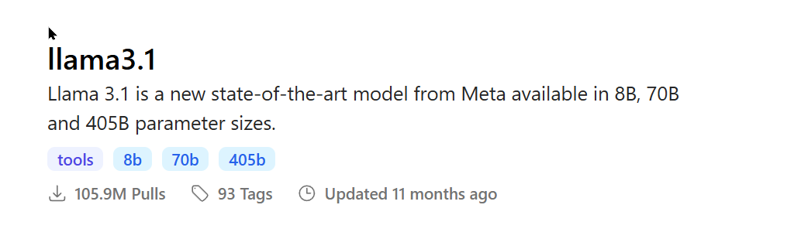
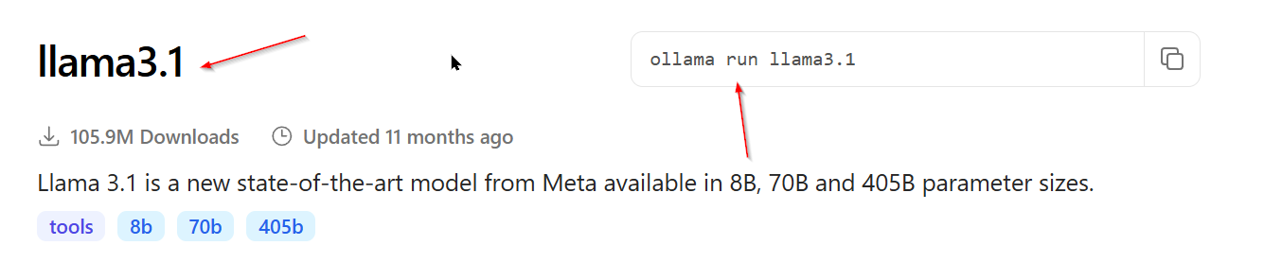
Figure 58 - Type the command to run the another AI model

Figure 59 - Type the command to run the llama

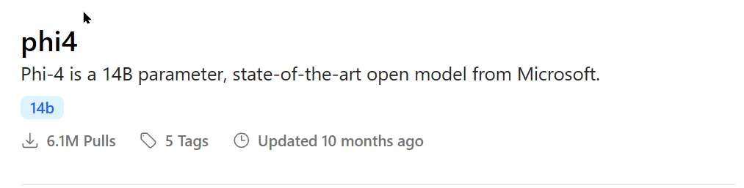

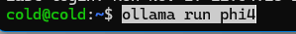
Figure 60 - Type the command to run phi4

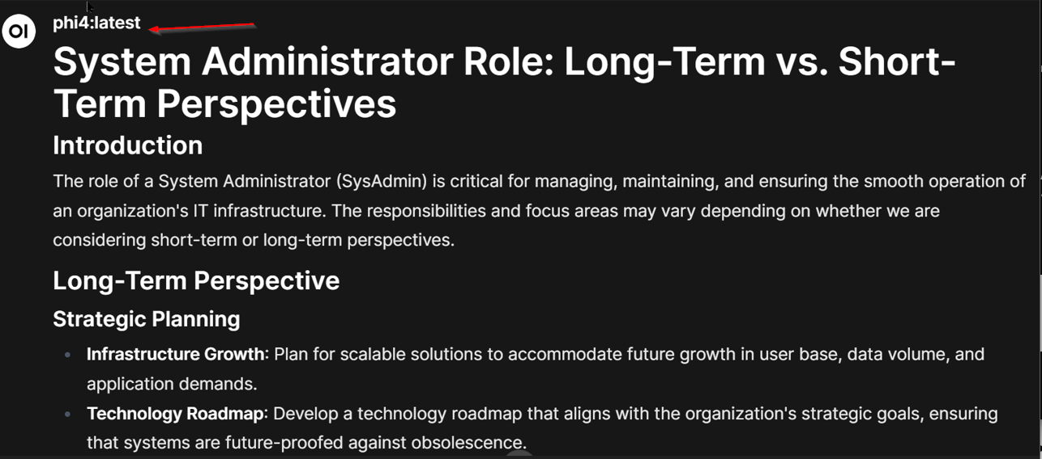

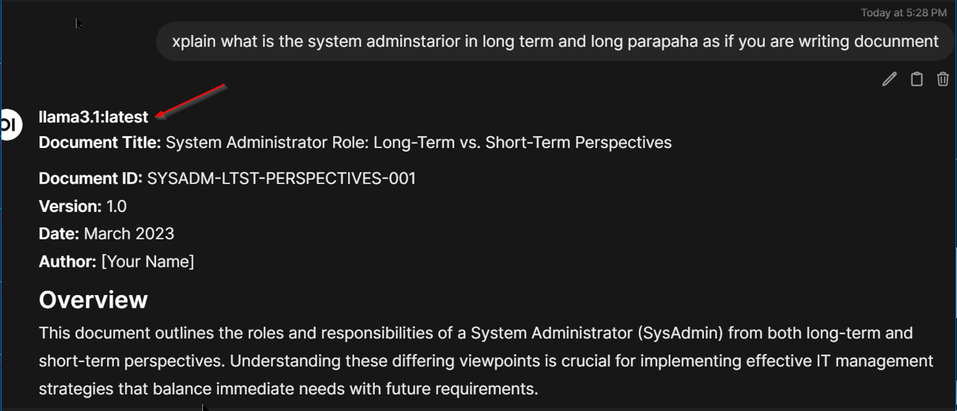

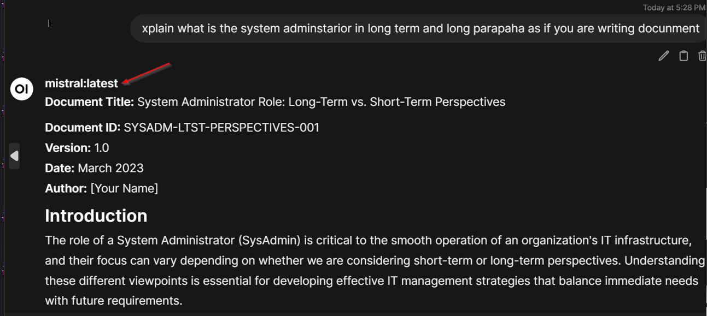
Figure 61 - Test the three AI models to see how fast they respond

Questions and Answers
- What are the benefits of running a private AI model?
- You keep data on your own network, so privacy is strong. Latency is low and cost is predictable. You can customize models and work offline.
- How would you secure this service in a production environment?
- Use HTTPS, strong login, and a firewall. Put it on its own VLAN or behind a VPN. Keep the OS, Docker, and models updated, and log access.
- What are the limitations of local LLMs compared to cloud-based ones?
- Big models may be too heavy for your GPU. Quality and features can be lower than top cloud models. Scaling to many users is harder and you must maintain everything.

Observations
It was easy to understand, so it made things easier, and I learned that blocking ads can be easier thing to do when you use PI!

