CS446100 Software Engineering Homework 1 (Group Exercise)

(Notes) Two or three students should work as a team to finish question 1, while the whole group (6 to 7 students) should work as a team to finish question 2.
（註）第1題若為6人的組別，請以2、2、2人為一組作答，若7人的組別則以2、2、3人為一組作答;第2題請以整個小組為一組作答。檔案上傳的格式請參照第1題最後的說明，可將第2題的答案文件放入相同的壓縮檔中。
_______________________________________________________
- (50%) Develop a grade system (GradeSystemProject.doc) using the myAgile method described in the myAgile.pptx file:
Please pair your group members off in this exercise.
If the number of your group members is seven, please also separate into three little groups.

What you need to do (refer to GradeSystemProject.doc):
- Use Eclipse to develop the Java code which is readable including the source code, header, and pseudo-code. (1. Notice that the data structure of aGradeSystem cannot be LinkedList and you can create new functions except顯示成績(Show the grade), 顯示排名(show the rank), 顯示平均(Show the average), 更新配分(update weights) and 離開選單(exit)
- Use JUnit to develop two unit test codes for each method and at least two integration test codes. (also need headers)
- Use eUML2 to get the UML class diagram automatically.

What you need to hand in:
- (35%) The whole Eclipse project (including grade system source code, header, pseudo-code, test code, .ucd file generated from eUML2)
- (10%) Relevant documents (including user manual, acceptance test cases, architecture design and a picture)
- (5%) A file recording the time you spend on the following items for each method. (Unit: hour) [excel file]
  - Unit test cases planning (test code header writing)
  - Unit test coding (test code writing)
  - Pseudo-coding, tracing to debug, and header writing
  - Source coding
  - Unit-testing (including integration).

Pack all of the above files into a single .zip file:
<StudentID>_<StudentID>.zip or <StudentID>_<StudentID>_<StudentID>.zip
- <Eclipse project folder>
- Documents.doc
- Time.xlsx

For details, please refer to the myAgile.ppt and GradeSystemProject.doc files.
For your information, please refer to the JUnit.ppt and eUML2.doc files.

- (50%) Case Studies
The full paper is available at: http://www.msr-waypoint.com/en-us/groups/ese/fp17288-bhat.pdf

In this section we discuss two case studies performed at Microsoft Corporation using TDD. These studies were performed in two different divisions inside Microsoft, Windows and MSN respectively. For the sake of convenience we call the projects, A (Windows division) and B (MSN division) respectively. After reading the case studies in the next page, please answer the following questions.
- (20%) Please describe Test-Driven Development (TDD), which is also called Test-First Development and Waterfall development model briefly. Compare the differences between these two development models and explain which model is better in the following case studies.
- (15%) Is TDD applicable for every situation of developing software system? Please explain your idea briefly.
- (15%) Please imagine that you are developing a project with your teammates. This project will use Test-Driven Development (TDD) to develop. Explain your methods of using test-driven development, and what considerations you should make. Make sure that your answer includes the following things:
- Describe the system you are trying to develop briefly
- The hypotheses for the functionality of the system
- The plan/design for developing the system using TDD

Each group should hand in this part as <group_number>.pdf

CASE STUDY A
This case study was performed in the Windows networking team. The context factors for project A are presented in Table 1. The context factors indicate the size of the development team involved (6 developers – not including testers/program managers) and their experience levels. Project A consisted of an experienced set of people in terms of the program manager’s expertise, domain and language expertise. The project was developed using C/C++ with all developers located in Redmond, USA.
Table 1: Project A – Context Factors
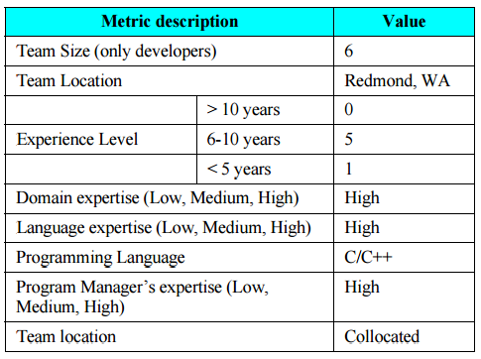
The overall product metrics for the developed system are shown in Table 2. The product measures are derived from the product itself and broadly discuss the size and test effort involved in the project. Project A though not large is a non-trivial project that has a 79% block coverage based on the unit-test effort alone. This coverage is exclusive of the coverage attained by the test teams. The overall development time also for the two projects in presented in man months.
Table 2: Project A - Product Measures
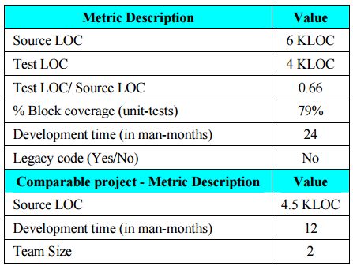
From the outcome measures perspective as shown in Table 3 we observe that there is greater defect density (greater than two and a half times) for the project that did not employ TDD. Though estimates from managers put the increase in development time for the TDD project was in the order of 25-35%. From our first case study, project A we can hence observe a significant improvement in quality of the system developed using TDD. Alternatively there is a 25-35% increase in the overall development time for the team employing TDD.
Table 3: Project A- Outcome Measures
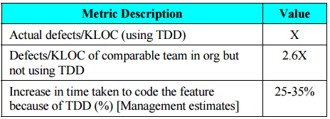
CASE STUDY B
This case study was conducted on a web services application in the MSN division at Microsoft. The related context factors are shown in Table 4. The project during its development lifecycle involved between 5 and 8 developers. The personnel involved in project B were less experienced than the personnel involved in project A in terms of program managers expertise, domain and language expertise. The development team was collocated in Redmond, USA.
Table 4: Project B – Context Factors
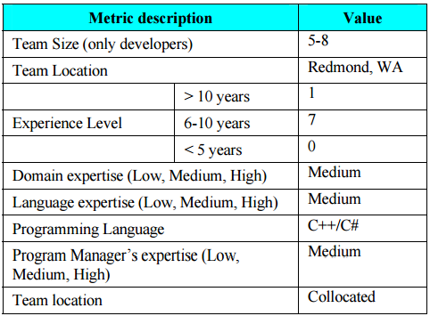
The product measures indicate the size of the projects and overall test effort, and the development time in man months. The ratio of the lines of code between source and test is high (0.89). The block coverage is also higher than project A at 88% from the unit testing effort alone.

Table 5: Project B - Product Measures
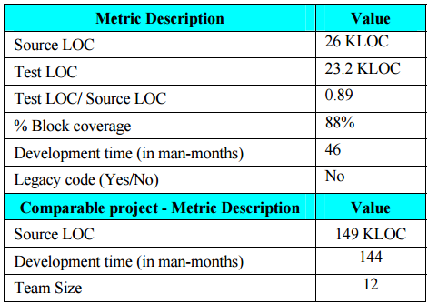
For project B the outcome measures shown in Table 6 indicate that there is a 4.2 times increase in the quality of code developed using TDD compared to a project using a non-TDD approach in the same organizational hierarchy. Additionally the project developed using TDD took 15% more time than the non-TDD project.
Table 6: Project B- Outcome Measures
