TECHNIQUE REPORT

**Approach to AI**

referringCNN

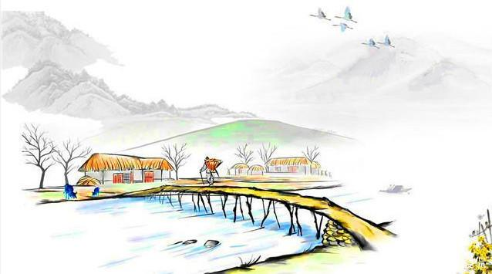

*The meaning of life is to give life a meaning …*

INDEX

0 OVERVIEW 1

0.0 Current Work 1

0.0.1 Mission today 1

0.1 How to Make AI Distinguish Difficulty Levels 2

0.2 global working flow 2

0.2.1 Image splitting 2

0.2.2 Data sampling 2

0.2.3 Converting data to LDB 2

0.2.4 Computing data mean 2

0.2.5 Training 3

0.2.6 Classifier 3

0.2.7 Generative Adversarial Networks 3

0.2.8 most important concepts and objects 3

0.2.9 Depending Libraries 3

0.3 Loss functions 3

0.4 Blob 3

0.4.1 3

0.4.2 Main data members 3

0.5 Layer 4

0.5.1 Data flow process 4

0.5.2 Main data members 4

0.6 Net 4

0.6.1 Main data members 4

0.6.2 Important member functions 4

0.7 Solver 4

0.8 Main Processing Flow 5

0.8.1 Steps to generate personal dataset 5

1 PRELIMINARIES 6

2 DATA 7

2.0 The Process of Data Management 7

2.0.1 The format of training data 7

2.0.2 Data preparation tools 7

3 CODES IMPLEMENTATION 8

3.0 The Architecture of referringCNN 8

3.0.1 Displaying the Debuging Information 8

3.0.2 Some Macros 8

3.1 Main Working Flow 8

3.2 Reusable Classes 8

3.2.1 CInit 8

4 GUI 9

4.0 Parameters 9

4.0.1 net config 9

4.1 ini 9

4.2 Message Manager 9

4.2.1 progress bar 9

4.3 Working Thread 9

4.3.1 Job 10

4.3.2 Job parameters 10

4.4 Debug 10

4.4.1 10

5 ARTIFICIAL NEURAL NETWORK 11

5.0 Toeplitz Matrix 11

6 EXPERIMENTS 12

6.0 The Architecture of Testing Flow 12

6.1 Database Creating and Converting 12

6.1.1 将图片集生成为训练用数据库 12

6.2 Testcases 12

6.2.1 Tiny testcase 12

6.2.2 mnist 12

REFERENCES 14

# OVERVIEW

Fix some of the filter weights of classical CNN with classical convolution kernels such as sobel, kirch etc.

Short term targets:

* 实现参考学习的轻量级平台
* 支持脚本进行网络参数匹配
* 测试平台在mnist上的训练速度和分类性能

Long range targets:

Network that can distinguish difficulty levels, easy cases will be trained lightly while difficult cases will be thoutoughly exhausted trained in the network structure.

## Current Work

未来3个月目标：

运行实例，改善实例的load流程，优化实例的输出

level-training algorithm:

* in each level the training algorithm is at different stage with different strategy
* example: dark image vs bright image lead to different next processing stage

增加模板类 头文件：hybrid_conv_layer.h，实现：hybrid_conv_layer.hpp。

### Mission today

构造 tiny testcase 调试网络的构造流程

构建一个简单的深度网络进行测试

Tiny testcase - mnist

## How to Make AI Distinguish Difficulty Levels

## global working flow

### Image splitting

### Data sampling

### Converting data to LDB

### Computing data mean

### Training

fineTune ( )

### Classifier

### Generative Adversarial Networks

### most important concepts and objects

### Depending Libraries

## Loss functions

## Blob

### 

### Main data members

## Layer

### Data flow process

。

### Main data members

## Net

### Main data members

### Important member functions

初

## Solver

## Main Processing Flow

### Steps to generate personal dataset

# PRELIMINARIES

# DATA

The classical flow of machine learning including the following steps:

1. Data source gathering
2. Row data processing
3. Feature fetching
4. Data classification
5. Model training
6. Model verification
7. Model testing
8. Prediction and classification

## The Process of Data Management

### The format of training data

### Data preparation tools

# CODES IMPLEMENTATION

## The Architecture of referringCNN

### Displaying the Debuging Information

### Some Macros

## Main Working Flow

## Reusable Classes

### CInit

# GUI

## Parameters

### net config

## ini

## Message Manager

### progress bar

## Working Thread

### Job

### Job parameters

## Debug

### 

# ARTIFICIAL NEURAL NETWORK

## Toeplitz Matrix

# EXPERIMENTS

## The Architecture of Testing Flow

## Database Creating and Converting

### 将图片集生成为训练用数据库

## Testcases

### Tiny testcase

### mnist