**MJava文法范式对应的抽象语法树结构**

* Goal-> MainClass *{* ClassDeclaration *}* EOF

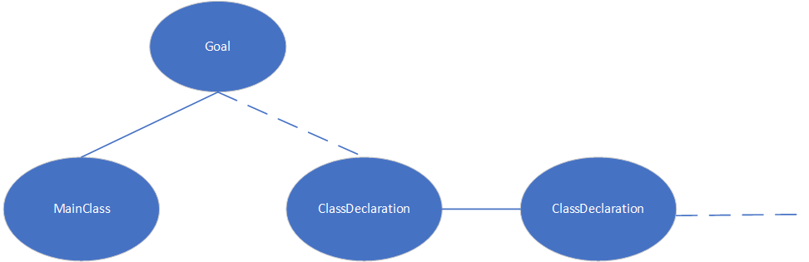

* MainClass->**"class"** Identifier **"{"** **"public"** **"static"** **"void"** **"main"** **"("** **"String"** **"["** **"]"** Identifier **")"** **"{"** Statement **"}"** **"}"**

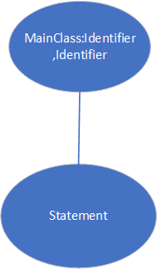

* ClassDeclaration->**"class"** Identifier *[* **"extends"** Identifier *]* **"{"** *{* VarDeclaration *}* *{* MethodDeclaration *}* **"}"**

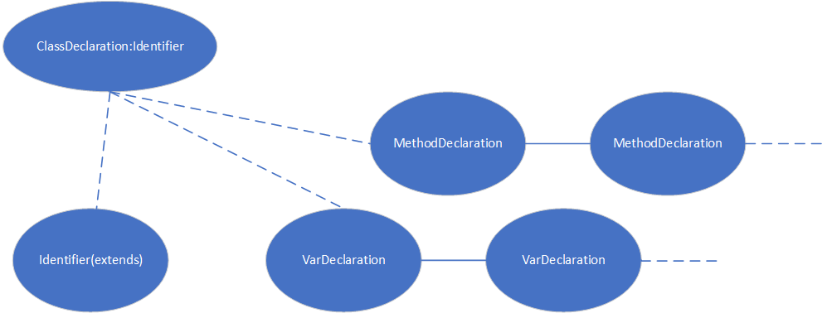

* VarDeclaration ->TypeIdentifier **";"**

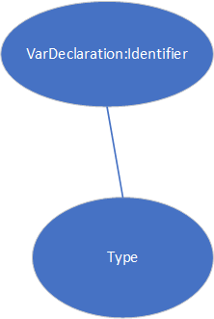

* MethodDeclaration->**"public"** Type Identifier **"("** *[* Type Identifier *{* **","** Type Identifier *}* *]* **")"** **"{"** *{* VarDeclaration *}* *{* Statement *}* **"return"** Expression **";"** **"}"**

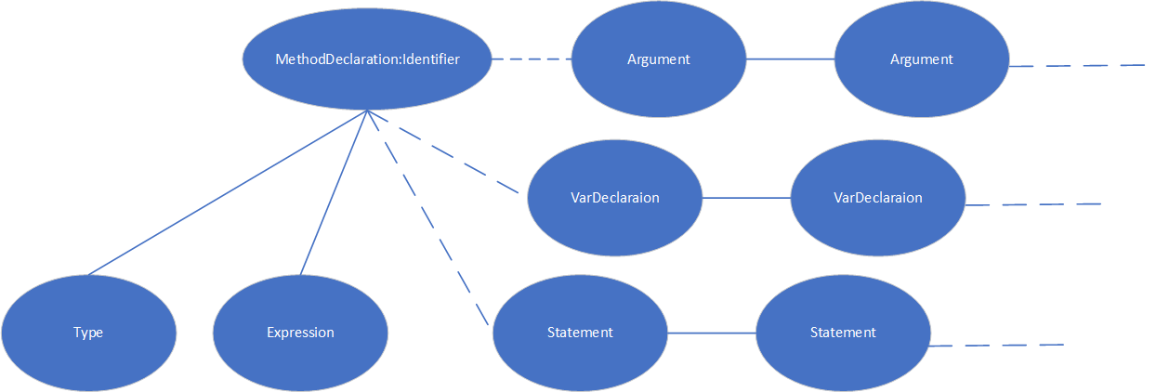

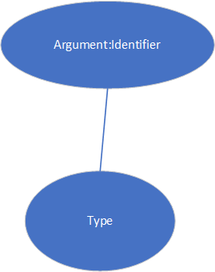

* Type->**"int"** **"["** **"]"***|***"boolean"***|***"int"***|* Identifier

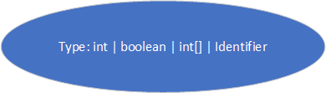

* Statement->**"{"** *{* Statement *}* **"}"**

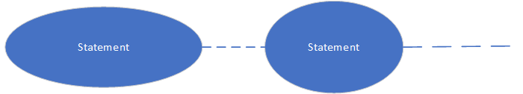

* Statement->**"if"** **"("** Expression **")"** Statement **"else"** Statement

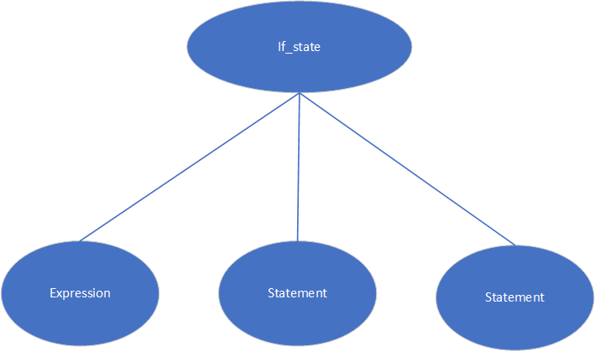

* Statement->**"while"** **"("** Expression **")"** Statement

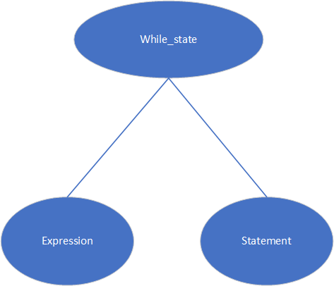

* Statement->**"System.out.println"** **"("** Expression **")"** **";"**

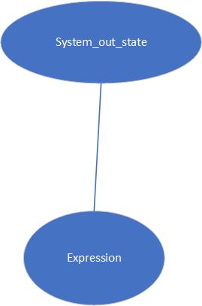

* Statement-> Identifier **"="** Expression **";"**
* Statement-> Identifier **"["** Expression **"]"** **"="** Expression **";"**

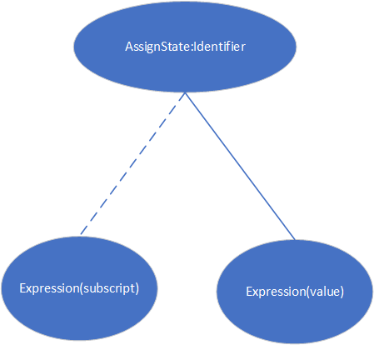

* Expression-> Expression *(* "&&" | "<" | "+" | "-" | "*" *)* Expression

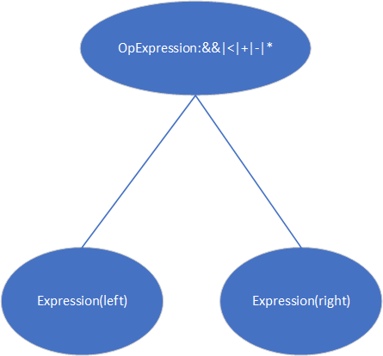

* Expression-> Expression **"["** Expression **"]"**

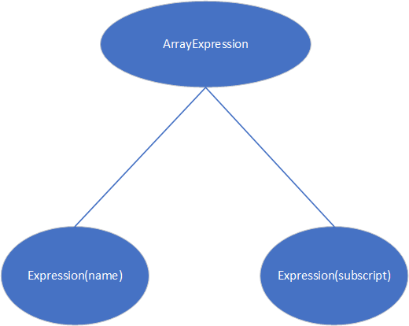

* Expression-> Expression **"."** **"length"**

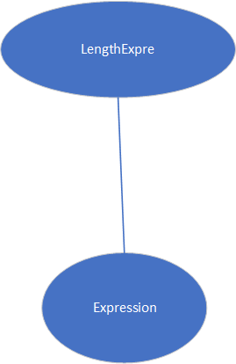

* Expression-> Expression **"."** Identifier **"("** *[* Expression *{* **","** Expression *}* *]* **")"**

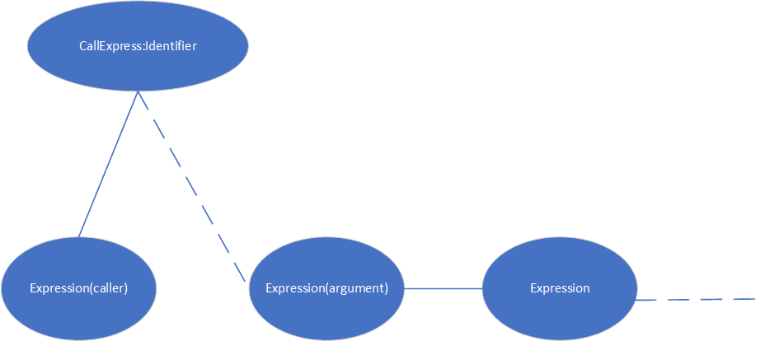

* Expression-> IntegerLiteral *|***"true"***|***"false"***|* Identifier *|***"this"**

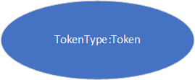

* Expression->**"new"** **"int"** **"["** Expression **"]"**

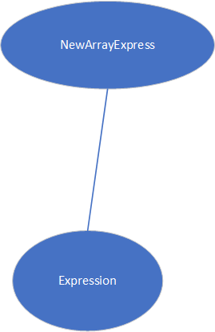

* Expression->**"new"** Identifier "(" ")"

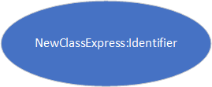

* Expression-> **"!"** Expression

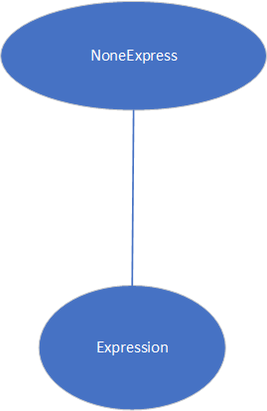

* Expression->**"("** Expression **")"**

