1. What is SQL?

* Structured Query Language

1. How to create table and insert data using SQL?

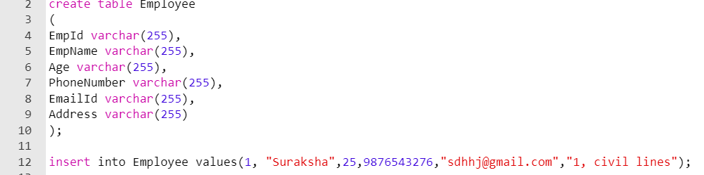

1. How to retrieve all data from Employee table?

* Using select
* 
* Output: 

1. How to take count (number of employess from table)?

* Using select count
* select count(*) from Employee;

1. How to retrieve particular employee whose name is Pratik

Using where

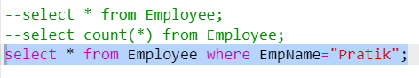

Output : 

1. How to select employee whose name is pratik and age is 32

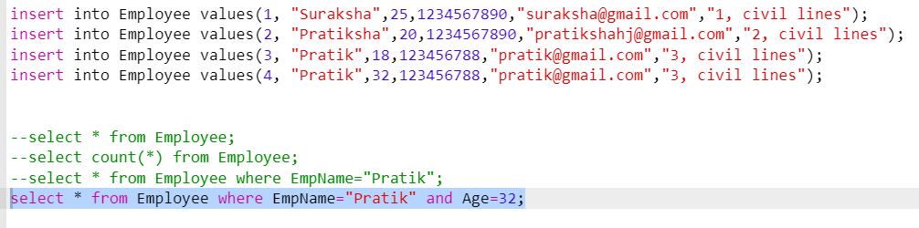

Output: 

1. How to select employee whose age is greater than 20

* Using ‘>’ operator
* select * from Employee where Age>20;

1. Can user add same data in table using insert into?

* Yes. It can add same data. To avoid duplication, you need to fetch data using Distinct keyword as show below
* When you use

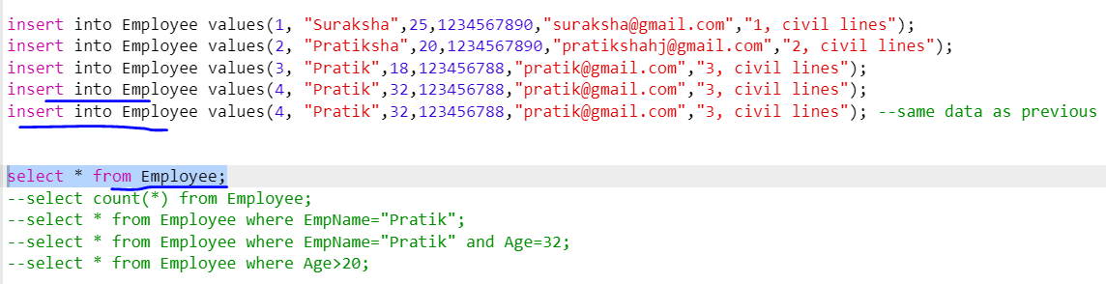

Output : 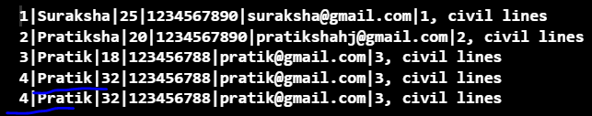

* When you use distinct keyword to differentiate then
* 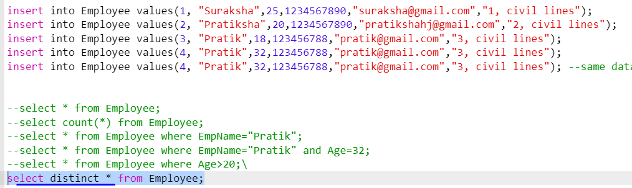

Output: 

1. Now count the unique employees in the table

* 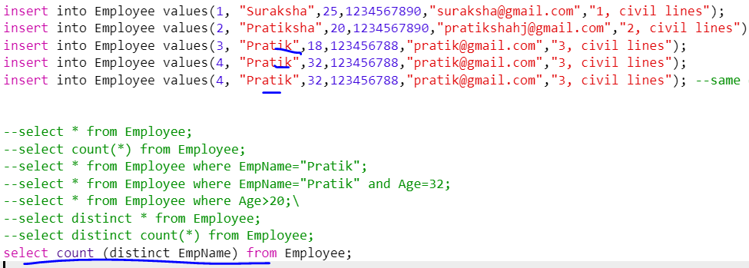
* Output: 

1. What is ORDER BY, AND/OR/NOT with Select query?

* We use ORDERBY keyword when we need to get data in ascending or descending order
* 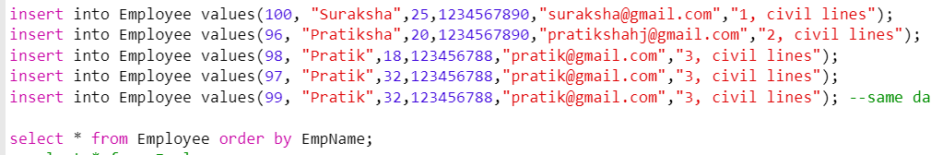
* 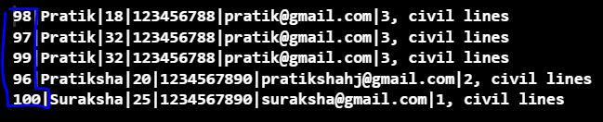
* To fetch data in descending order, you need to write below query:
* select * from Employee order by EmpName DESC;
* If you are writing ‘select * from Employee order by EmpName, Age’ then it will arrange in ascending order with EmpName and not by age

1. How to use AND operator and OR operator

* select * from Employee where age >30 **and** EmpId>2
* select * from Employee where age >30 **or** EmpId>2
* AND & OR operator together

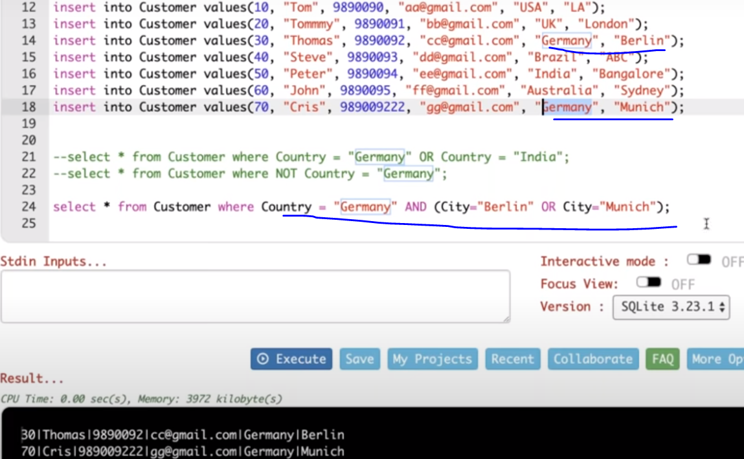

1. How to use NOT operator?

* select * from Employee **NOT** where age =30;

1. What is LIKE, NULL and NOT NULL in query?