Eric Peterson & Olujide Jacobs

Engineering 102 Report

Problem Statement & Objective

The main objective of this project is to build a Matlab code that will be able to calculate the amount of heat loss and adiabatic temperature rise for the total hydration process of fresh concrete. Adiabatic temperature means no heat loss. The program also should be able to plot the graph of current temperature vs. time, heat flux vs. time, adiabatic temperature vs. time and adiabatic temperature rise vs. time, respectively. To begin this project, the Matlab code has to be built based on the additional information given and the data also in the excel sheet. We divided separate parts of this project so as to make it easier to finish. We were able to develop our coding based on what the instructor explained in class and also did some other calculations before completing the code. The diagram below shows how the hydration process is measured.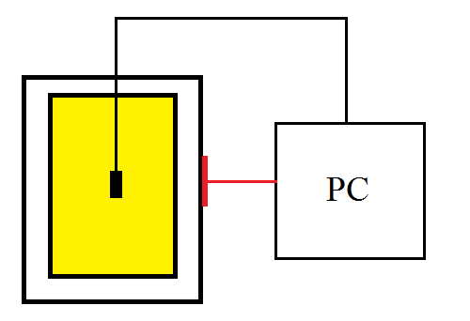

Diagram showing the instrument used to measure the heat during the hydration process

Detailed Discussion

As was previously mentioned, the goal of the project was to build a Matlab program to calculate the adiabatic temperature rise of the entire concrete hydration process based on the data given. The specific heat of concrete and the total weight of the concrete are given in the project info page, this will be essential to calculating the adiabatic temperature rise later in the project.

The first step to calculating the desired adiabatic temperature rise is to import the data from the given excel file into Matlab using the ‘xlsread’ command and typing the name of the excel file in as a string. Once this step is complete, we separated the data tables from the excel file into individual vectors and define them as they are labeled in excel. This was also the time when we defined other predetermined variables such as the mass of the concrete and the specific heat.

 The next step was to plot the graphs Temperature V.S. Time (figure 1.1), and Heat Flux V.S. Time (figure 1.2) using the plot function. We gave each graph a particular color to define which graph was which to avoid confusion. Other features were also added such as titles, grid, x-labels, and y-labels.

FIGURE 1.2

FIGURE 1.1

The third step of the project was to calculate the Heat Lost which was done using a “for end” loop, defining heat before the loop in the script file. Heat is set equal to zero before the loop because it must be redefined inside the loop. The i is defined on the first line of the for/end loop as “1: length (HF)”, HF being the variable defined previously, that is heat flux. The statement 1: length (HF) simply means the loop will continue to reapply itself from 1 to however long the vector HF turns out to be. The heat is then calculated by using the function given in our code; this is when we redefine the variable for heat. Heat can me calculated as $mc∆T$. The adiabetic temperature is then calculated from the previous heat calculation in the loop. This is then the end of the loop and the loop starts over from the beginning except from i=2, then 3 and so on. Once the heat loss and adiabatic temperature are calculated we can then graph the adiabatic temperature V.S. time (figure 1.3) by using the plot function.

FIGURE 1.2

The adiabatic temperature rise is found by simply subtracting the adiabatic temperature by the minimum adiabatic temperature for each point. By getting the minimum value of the adiabatic temperature, we were able to get the change in heat for every single time through the hydration process. This is then graphed in our fourth and final figure, (figure 1.4) also using the plot function.

FIGURE 1.3

FIGURE 1.4

Conclusion and future plans

In total, there are four graphs for the whole hydration process, representing different heat measurements and duration. We were able to generate a matlab code that will calculate the overall heat loss and adiabatic temperature rise for the hydration process of fresh concrete. In the setup diagram, a thermocouple was used to measure the temperature of the concrete at every duration because it is a more accurate instrument for measuring temperature than the thermometer. In future, building a Matlab code for a problem similar to this will be easier because of our knowledge of coding in Matlab and also a similar problem has been treated.