Agent Installation and Configuration
  - Hermes Agent on Linux • Installation, troubleshooting, Ollama configuration, and functional verification

1. Purpose and environment
This section documents the installation and configuration of Hermes Agent in the Linux environment used for the CYFI 725 final project. It records the commands entered, installation errors, troubleshooting, setup selections, and the final command-line test. The screenshots are retained as evidence of the observed workflow.
Component | Recorded configuration
Host environment | Linux; terminal prompt identifies student@tsurugi10
Agent | Hermes Agent; final welcome screen reports v0.23.1 (2026.9.24)
Installation troubleshooting | Commit d923a5e, described in the source report as corresponding to v0.22.2
Model provider | Custom (Direct API), configured for an Ollama-compatible endpoint
Selected model | qwen3.8:27b (as displayed in the model list)
API compatibility | Auto-detect
Context length | Left blank for automatic detection
Display name | Ollama
Reasoning effort | Medium
Terminal backend | Local
Gateway / messaging | Gateway installation declined; messaging setup skipped

2. Installation and troubleshooting

Step 1 — Update the Linux system
The installation began by refreshing the package index and upgrading installed packages. The terminal requested the student account password for elevated privileges. Command: sudo apt update && sudo apt upgrade -y
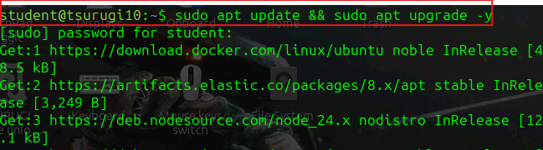
Figure 1. Linux package update and upgrade command.

Step 2 — Run the Hermes installer
The initial installation command was run as the regular user: curl -fsSL https://hermes-agent.nousresearch.com/install.sh | bash. The installation did not complete successfully.
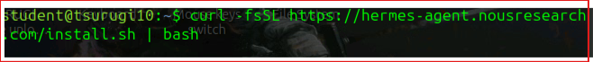
Figure 2. Initial Hermes installer command.
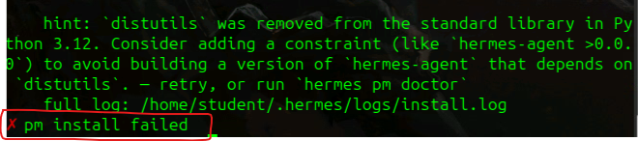
Figure 3. Installer failure, including the Python distutils-related message and “pm install failed”.

Step 3 — Retry with a specified commit
Following the installation error, the team attempted a specific commit described in the source as v0.22.2. The commands were: curl -fsSL https://hermes-agent.nousresearch.com/install.sh -o /tmp/hermes-install.sh; bash /tmp/hermes-install.sh --commit d923a5e. The report then records SETUPTOOLS_USE_DISTUTILS=local followed by bash /tmp/hermes-install.sh as a setuptools troubleshooting attempt. These are documented as separate shell commands; the source does not independently prove that the environment variable remained set for the subsequent command.
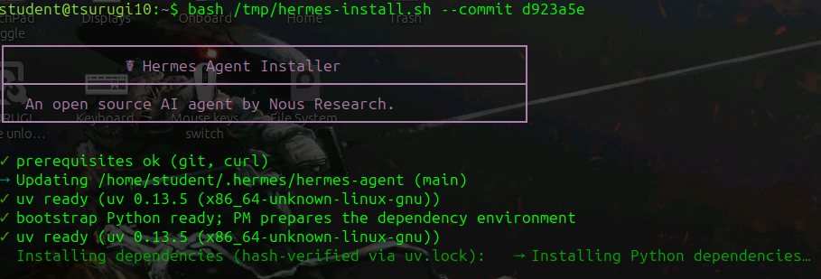
Figure 4. Installer retry using commit d923a5e.
Figure 5. Download of the installer script and commit-specific execution.
Figure 6. Setuptools troubleshooting command and installer rerun.

3. Initial setup selections

Step 4 — Begin interactive setup
After the installer proceeded, the interactive prompts were completed. The team selected Yes to review import options and then Quick Setup.
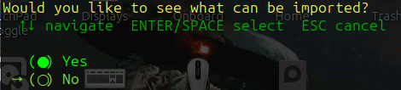
Figure 7. Import-options prompt with Yes selected.
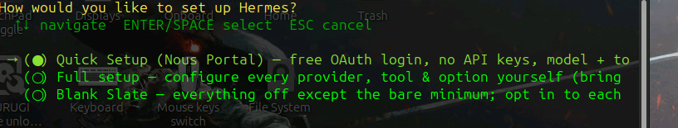
Figure 8. Quick Setup selection.

Step 5 — Configure runtime and optional services
The local terminal backend was retained. Messaging-platform setup was skipped, gateway installation was declined, and the optional usage-sharing prompt was answered No thanks.
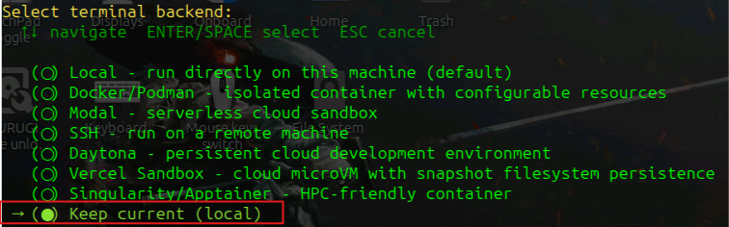
Figure 9. Local terminal backend retained.
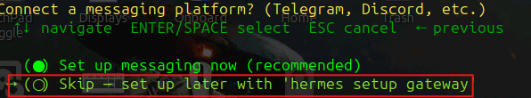
Figure 10. Messaging setup skipped.
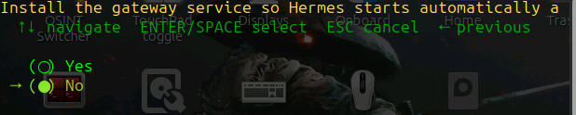
Figure 11. Gateway service installation declined.
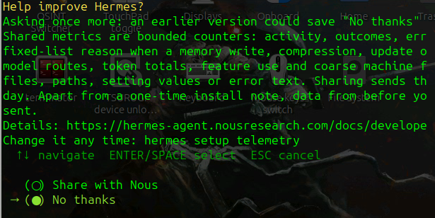
Figure 12. Optional Hermes telemetry sharing declined.

4. Language model provider configuration

Step 6 — Select the provider
When Hermes reported that no inference provider was configured, the team chose to set one up and selected Custom (Direct API) for the Ollama-compatible service.
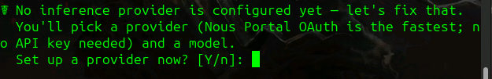
Figure 13. Provider setup prompt.
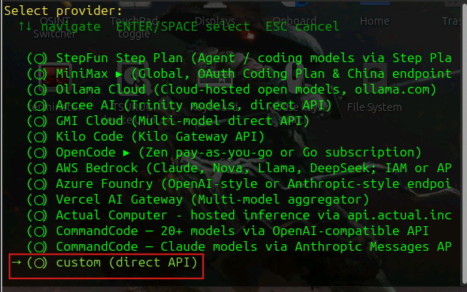
Figure 14. Custom (Direct API) provider selection.

Step 7 — Enter the API endpoint
The source report records the API base URL as http://136.160.215.236:11434/v1. The setup next prompted for an API key. The key itself is not included in this report.
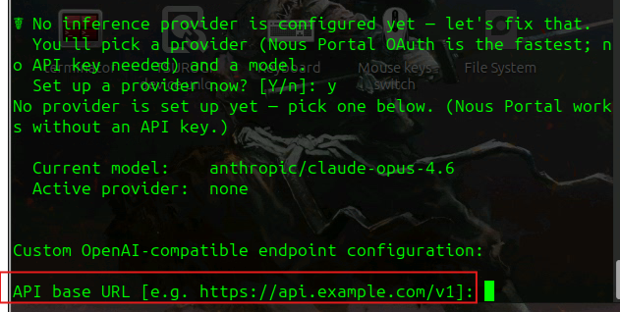
Figure 15. Custom OpenAI-compatible API base URL prompt.

Step 8 — Select compatibility and model
The API compatibility mode was set to 1 (Auto-detect). The available-model list included qwen3.8:27b, which the team identified as its selected model.
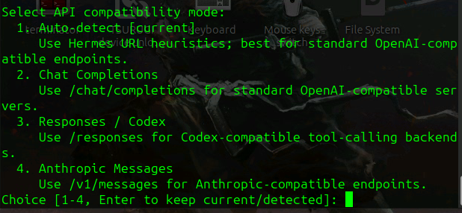
Figure 16. Auto-detect API compatibility selection.
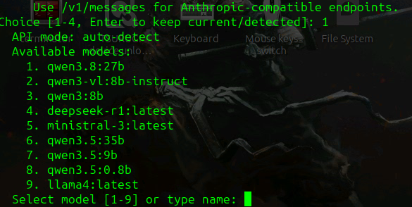
Figure 17. Available model list including qwen3.8:27b.

Step 9 — Complete model settings
The context-length field was left blank to use auto-detection. The display name was set to Ollama, and the reasoning effort was set to Medium.
Figure 18. Context-length and display-name configuration.
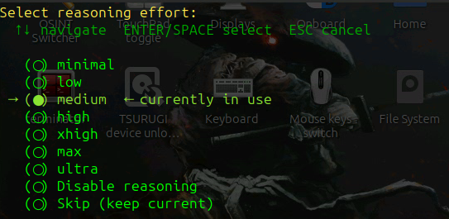
Figure 19. Medium reasoning-effort selection.

5. Functional verification

Step 10 — Launch and test Hermes
Hermes displayed its welcome screen. The team tested the installation by asking for the present working directory with pwd. The first test returned an error stating that provider auto had no endpoint configured, so the request was not sent.
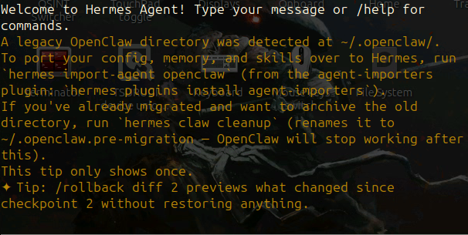
Figure 20. Hermes welcome screen after setup.
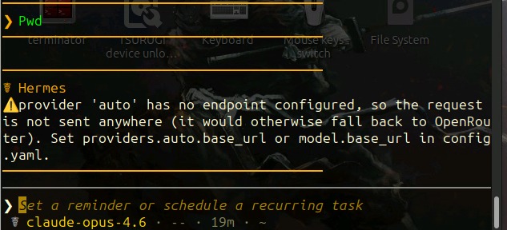
Figure 21. Initial pwd test and provider endpoint error.

Step 11 — Restart and retest
The session was closed and Hermes was launched again. The subsequent screen showed Hermes Agent v0.23.1, model qwen3.8:27b, and provider CUSTOM. The pwd test then returned /home/student, demonstrating that the agent could execute a basic terminal command in the recorded session.
Figure 22. Hermes relaunched from the Linux terminal.
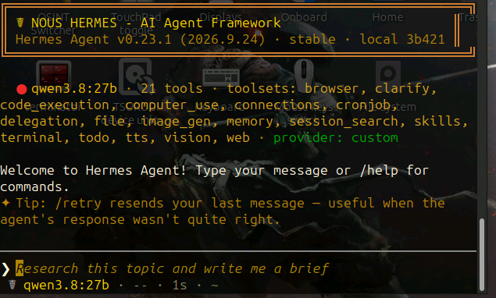
Figure 23. Hermes welcome screen after restart, showing agent version and selected model.
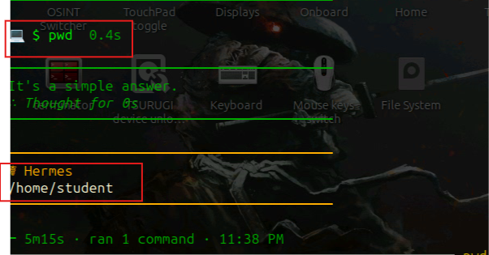
Figure 24. Successful pwd response showing /home/student.

6. Results and limitations
The documented workflow shows an initial installation failure, a commit-specific retry and setuptools troubleshooting, interactive configuration of a custom Ollama-compatible model endpoint, and an unsuccessful first functional test. After restarting Hermes, the working-directory command succeeded and returned /home/student.
Version reporting requires care: the source associates commit d923a5e with v0.22.2, while the later Hermes welcome screen reports v0.23.1. This report preserves both observations rather than assuming they refer to the same installed build. The screenshots demonstrate basic command execution, but do not independently establish network isolation, the complete permissions inventory, or a comprehensive audit of file changes and tool calls.

7. Evidence handling and reproducibility
For the final project repository, retain the installation commands, sanitized configuration information, version output, and screenshots in environment/. Do not publish API keys, access tokens, or other credentials. The screenshots in this report document the actions visible during setup; additional command logs and configuration records would be needed to establish a complete, reproducible audit trail.

