CART ABANDONMENT ANALYSIS

Phase 1: Data Understanding

1.Project Overview

This project analyses the data of cart abandonment by customers. The main goal is to find the main reasons of cart abandonment and to reduce it by taking neccessery measures.

2.Dataset summary

  - Columns- 12
  - Rows- 5000
The data spans abandonment reasons, device types, browsers, operating systems, cart size, cart value, coupon usage, and returning customer behaviour.

Phase 2: Data Audit and Cleaning

3.Data Analysis using Python

Data preparation and cleaning was performed by using python.

Data loading: Imported dataset using pandas.

Data exploration: Used df.info() for data structure analysis.

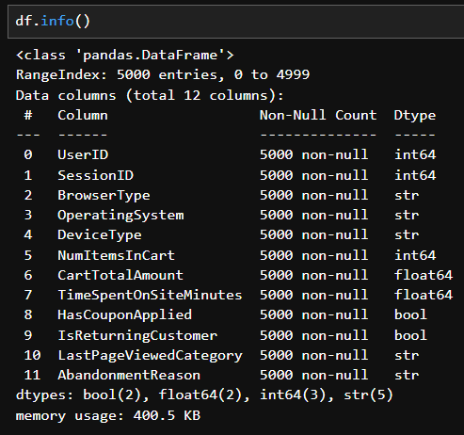

Then i checked the Abandonment reasons. In the abandonment reasons i found about 70% of cart abandonment because of various reasons and 30% of no abandonment. So i decided to find the reasons for abandonment, so i removed the 30% of no abandonment from the dataset and analyse the rest.

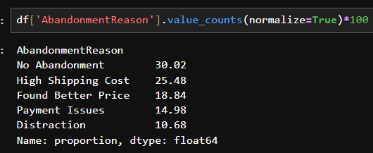

Data Transformation: Created new column named abandonment.

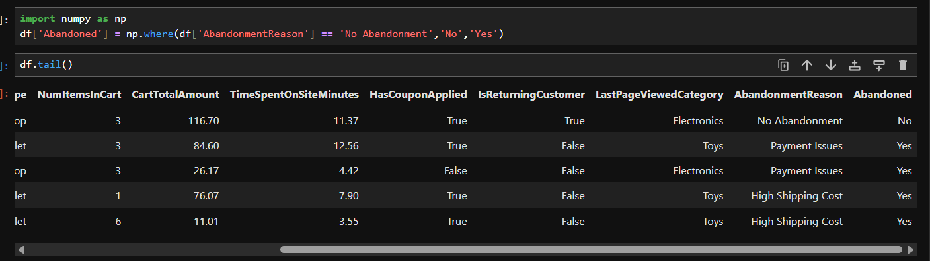
Then i removed the rows with abandonment as “No” to get the data of abandonment carts by customers.

Created column cartsize to categorise NumItemsInCart.

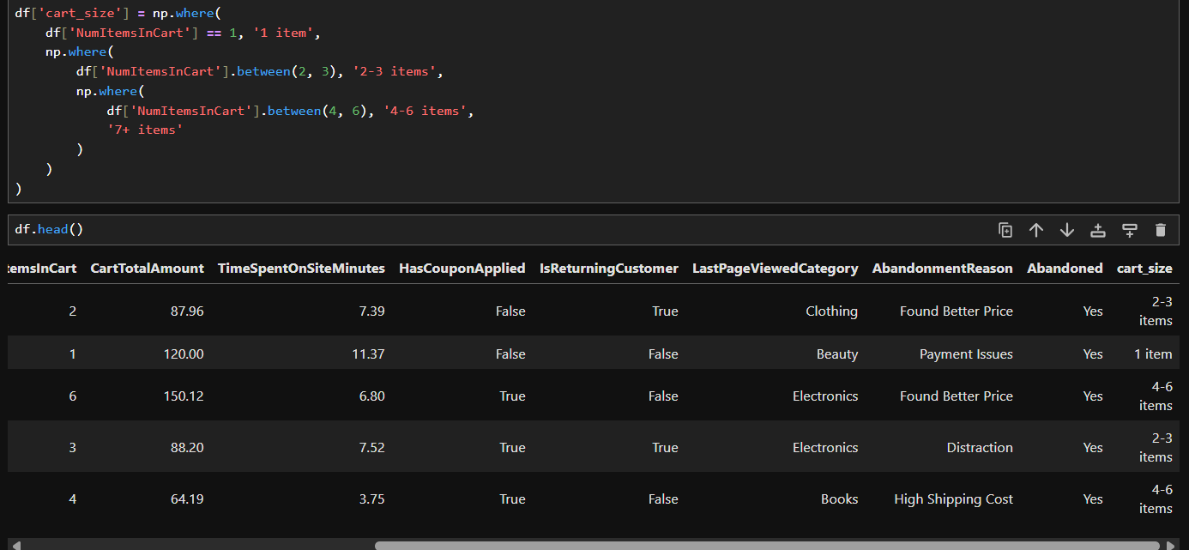

Created column CartAmount to categorise CartTotalAmount.

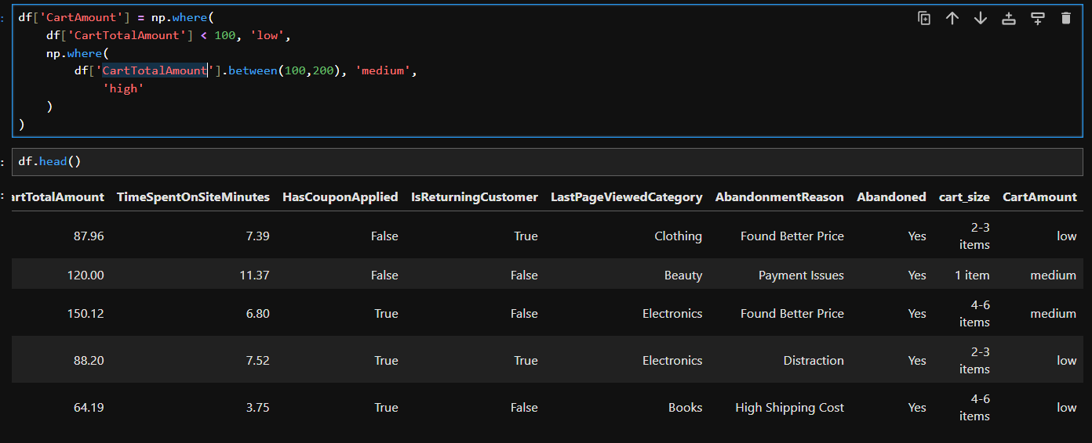

Database integration: Connected python script to MS SQL and loaded cleaned dataset into the database for SQL analysis.

Phase 2: Exploratory Data Analysis

4.Data Analysis using SQL

1.Abandonment Size: Found how many carts has been abandoned.

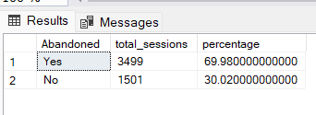

2. Device Type vs Abandonment:

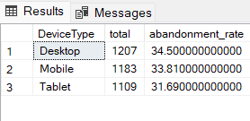

3. Browser Type vs Abandonment:

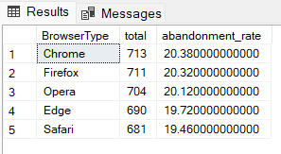

4. Operating System vs Abandonment:

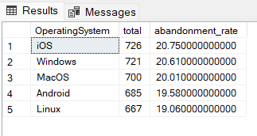

5. Cart size vs Abandonment:

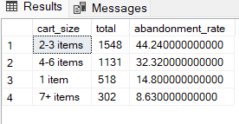

6. Cart Amount vs Abandonment:

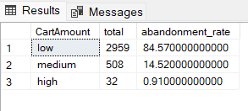

7. Return vs Abandonment:

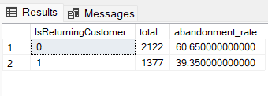

8. Coupon Applied vs Abandonment:

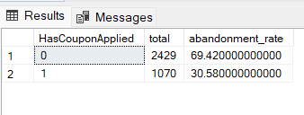

Phase 3: Visualisation

5.Dashboard in Tableau

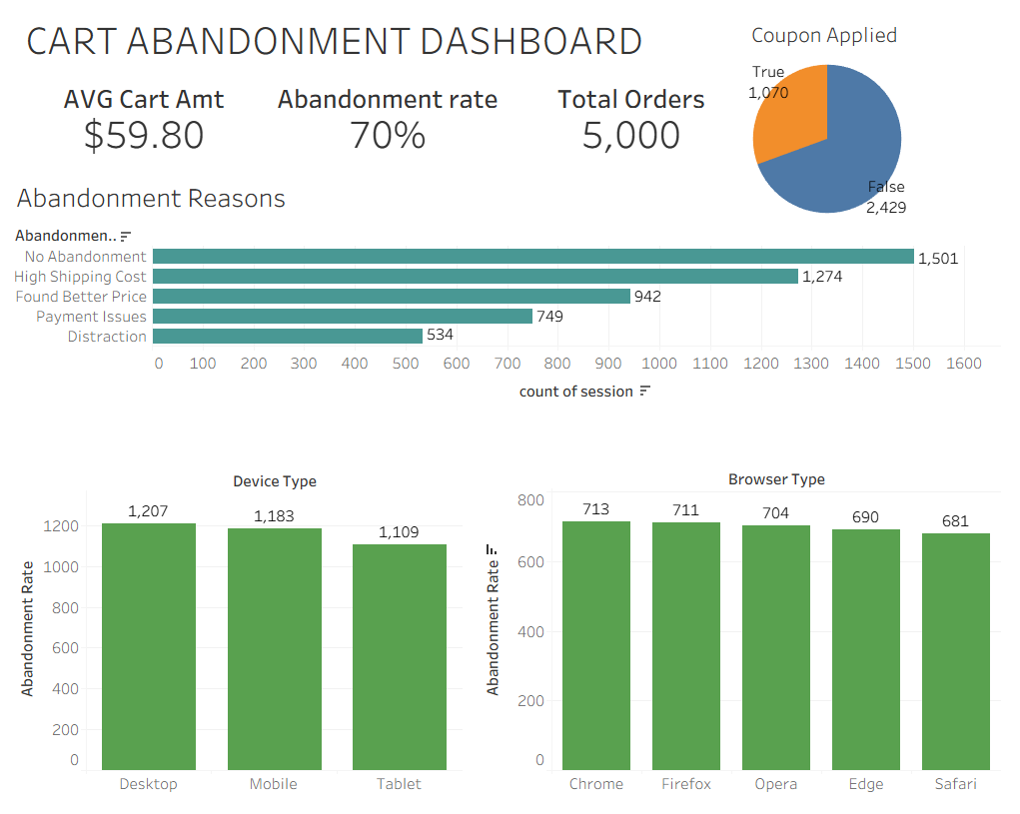

6. Business Recommendations

1.Shipping Cost: First fix the shipping cost. High shipping cost lead to 36% of abandonment. Be transparent about shipping costs earlier on the product page not just at checkout. Introduce a free shipping over the purchase of $75 since average cart i $59.80.

2.Price Sensitivity: Found Better Price is the second leading reason for abandonments(18.84%). Implement dynamic discounts and price matching warranty for price sensitive products.

3.Payment Issue: Payment Issues caused 14.98% of abandonments, this is a technical problem so it can be fixed. Limit payment options focus on popular payment options used by customer.

4.Coupon Usage: Coupon usage is low among abandoners, Only 31% of abandoned cart users had applied a coupon, most abandoners weren't even using a discount.

5.New Customers: New customers abandon more than returning customers. Consider giving first purchase incentives like ‘Get free shipping on your first order’ to build trust and convert new visitors.

