SALES DATA ANALYSIS

1.Project Overview

This project analyses sales from 2023 to 2025 of a store across various products. The main goal is to analyse the sales performance done by the store on these years and find a way to boost the sales in the future.

2.Dataset summary

  - Columns- 16
  - Rows- 1486
  - Data consist of sales of from the year 2023 to 2025 with unit price, quantity sold, regions, salespersons etc...

3.Data Analysis using Python

Data preparation and cleaning was performed by using python.

Data loading: Imported dataset using pandas.

Data exploration: Used df.info() for data structure analysis.

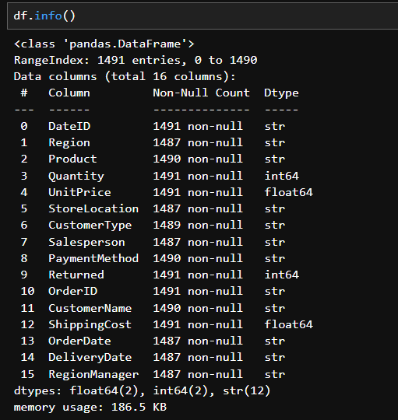

Data cleaning and processing: Changed data types of DateID, OrderDate, DeliveryDate. Then found some missing values. Since the 50% of data in a each row was missing, those rows were removed completely. If those values were assumed and filled, it could affect the final output in analysis.

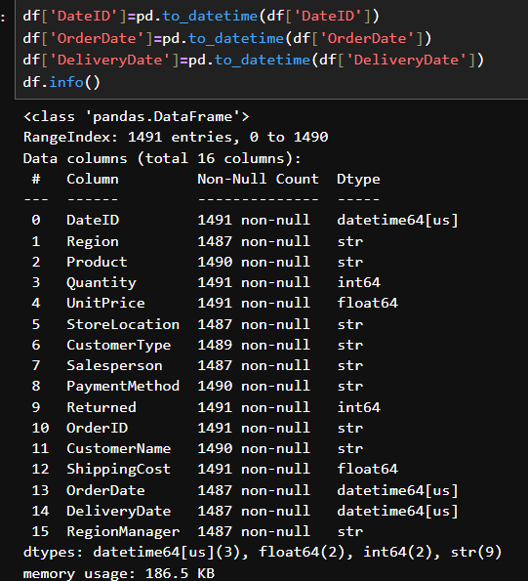
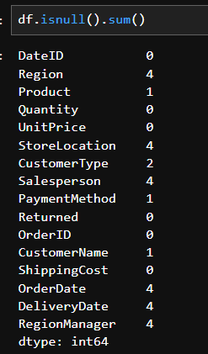

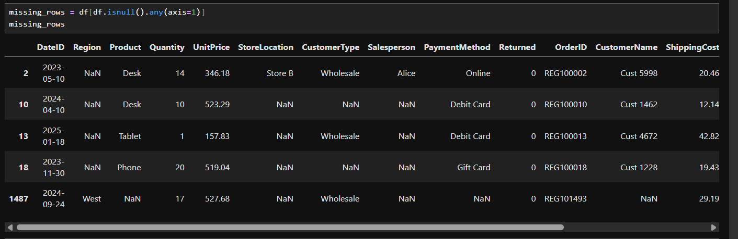

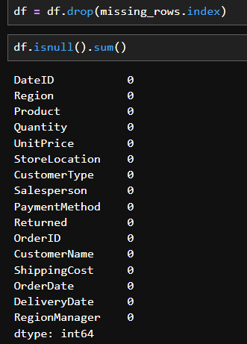

Found total sales by multiplying unit price with quantity sold. Then found profit by subtracting shipping cost from sales.

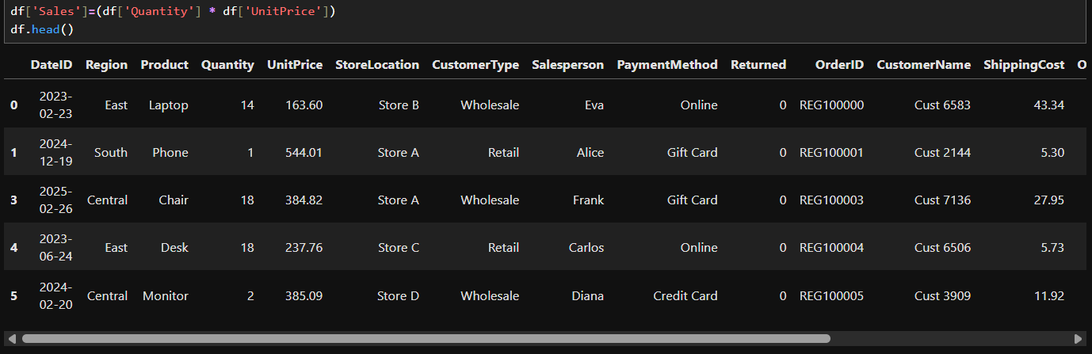

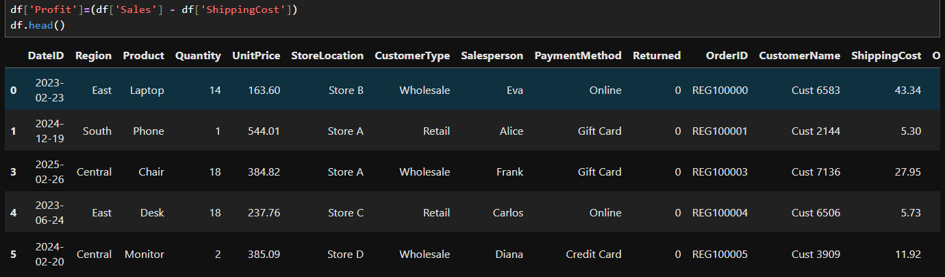
Database integration: Connected python script to MS SQL and loaded cleaned dataset into the database for SQL analysis.

4.Data Analysis using SQL

Structured analysis in MS SQL was used to answer business questions:

1. Regional sales and profit: Calculated total sales and profit created by each regions. The north region has the highest performance.

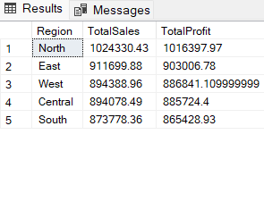

2. Top products: Found top products which created high sales. Laptop, Tablet and Printer holds the top 3 highest sales.

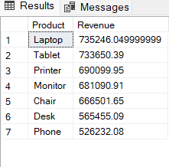

3. Employee performance: Evaluated which salesperson creates more profit. Alice sold highest quantity but Bob made higher profit than Alice by selling less quantity than Alice. It’s may be because Bob sold high priced products than Alice.

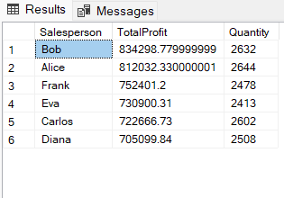

4. Customer type sales: Calculated which customer type created more sales and profit. Retail customers made more than Wholesale but there isn’t much difference in sales and profit between them.

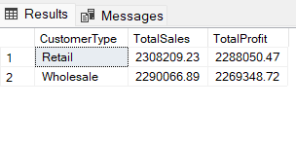

5. Product return: Calculated the number of return of products by customers. Laptop has the highest return among the products.

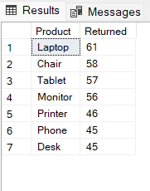

6. Popular and most profitable payment method: Found the most used payment method used by the customers to buy our products. Online payment method is the most used payment method. The next most used is by cash.

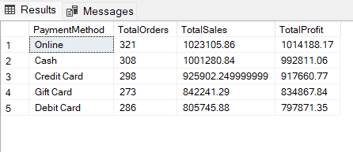

7. Store orders: Calculated which store has the highest average order value. Store D has the highest average order value among the 4 stores.

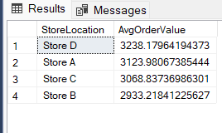

8. Regional Delivery Time: Found the regional average deliver time. The central and south regions take less time in delivery than west, east and north regions.

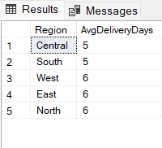

9. Management performance: Calculated which regional managers oversee the most profitable region. Ryan oversees the most profitable region which is the north region.

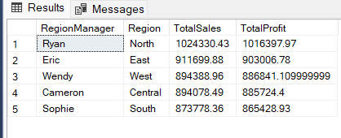

5. Dashboard in Power BI

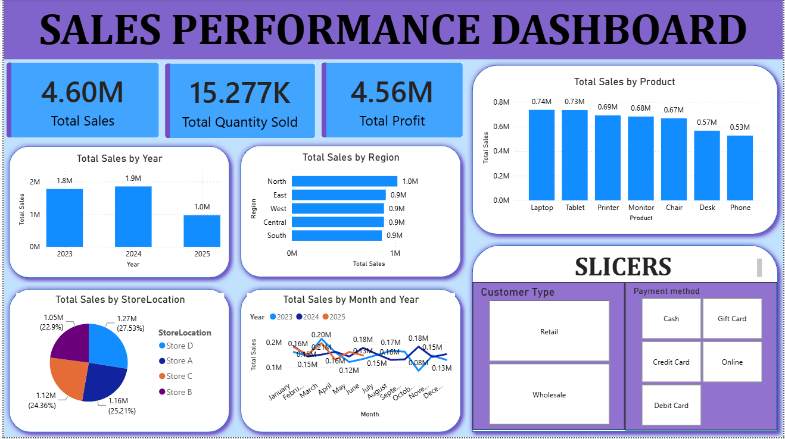

6. Business Recommendations

1. Regional strategy: The North region leads in sales and profit managed by Ryan.
Study what's working in the North, is it the management, sales team or product mix. Implement those practices in underperforming regions. Also investigate why the west, east, and north regions have longer delivery times despite north being the top performer.

2. Product return: Laptops are the top seller but also the no.1 returned product.
Investigate the cause of laptop returns, is it product defects, customer mismatch expectation or delivery damage. A return rate silently kills the profit. Consider adding better product descriptions, open box delivery, or improving customer support to reduce laptop returns. Tablets and Printers have strong sales with lower returns.

3. Salesperson incentives: Rethink the commission structure.
Alice sold the highest quantity but Bob generated more profit by selling fewer, higher priced items.
If the commission structure is purely on quantity sold based, it may be rewarding the wrong person. Shift incentives toward profit based commissions rather than quantity sold. Use Bob's strategy in training understanding which products have higher margins and attracting customers toward them is a high value skill. Alice may benefit from selling premium products.

4. Payment methods: Online payment is the most popular method followed by cash.
Invest in a secure online payment method. Consider adding Buy Now Pay Later options to increase average order value. Also don't avoid cash handling, a portion of the customers still relies on it.

5. Store performance: Learn from Store D.
Store D has the highest average order value and sales among all four stores. Analyse what Store D does differently store layout, staff training, or selling techniques.

6. Delivery time: A Hidden Competitive Advantage.
Central and South regions deliver faster than North, East, and West.
Faster delivery impacts customer satisfaction and reduces return rates. Prioritise reducing delivery times in the slower regions. Consider partnering with regional logistics providers or study the reasons for fast delivery from Central and South.

