# 广西大学行健文理学院

## 课程设计

课题题目： 超市信息管理系统

学 部： 理工学部

专 业： 计算机科学类

班 级： 计科173

学 号： 1738940341

姓 名： 杨启玢

指导老师： 甘秋铃

2018年 12月 20日

1. **系统功能分析与设计（给出模块图及分析说明）**

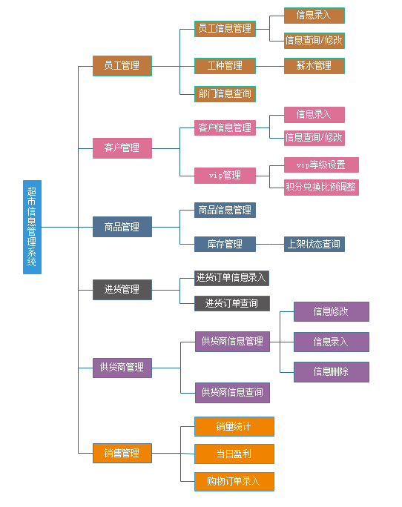

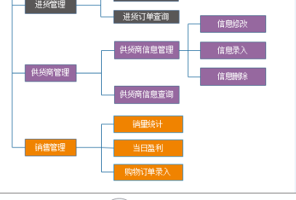

**系统需求分析**

能够实现员工信息的管理，修改查询，工种的管理，

能够实现部门管理，部门信息修改、查询，部门领导人指派

顾客的基本信息的添加、删除、修改以及查询

Vip管理，等级，积分兑换

商品管理，商品的查询，入库，销售。

进货管理，进货信息的查询

供货管理。供货商信息的管理，

销售管理。销量的统计，盈利统计，购物订单的录入

餐桌的基本信息的添加、删除、修改以及查询

对于点菜信息的添加、删除、修改以及查询

**具体功能模块设计：**

**一、点菜管理模块**： **（杨启玢）**

-- 销量管理

-- 订单录入

-- 销量统计

-- 销量统计排行

-- 盈利管理

-- 查询盈利

-- 盈利排行

-- 供货商管理

-- 供货商信息管理

-- 信息修改

-- 信息录入

-- 信息删除

-- 供货商信息查询

**二．数据库设计（全局E-R图及各表）**

**1、每个同学的课程设计报告中要提交全局E-R图，**

**2、自己子系统的局部E-R图，**

**3、自己子系统用到的表结构**

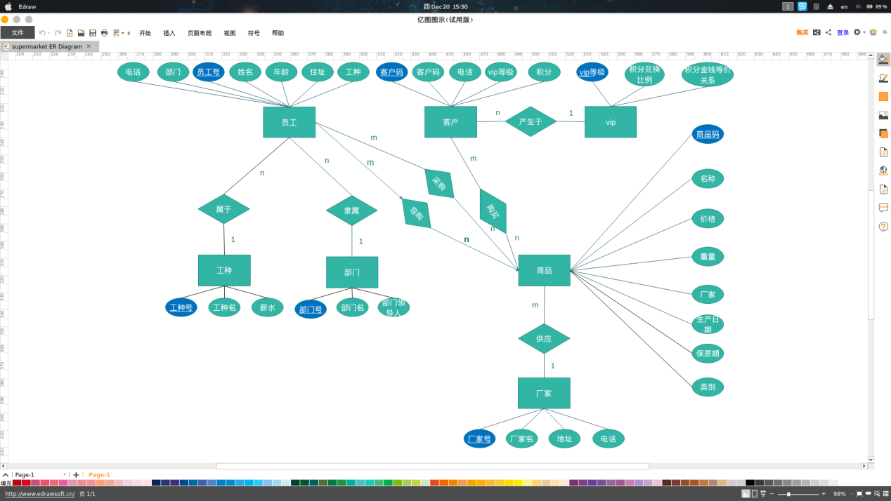

**商品属性**

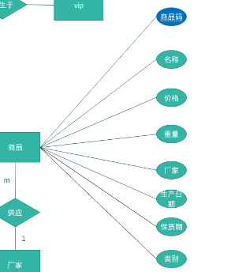

**厂家属性**

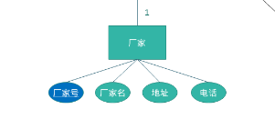

**厂家表**

|  |  |  |  |  |  |
| --- | --- | --- | --- | --- | --- |
| 厂家表 | | | | | |
| **主外码** | **属性名** | **数据类型** | **空否** | **取值范围** | **备注** |
| 主码 | manuNum | char(10) | N |  | 厂家号 |
|  | manuName | char(30) | N |  | 厂家名 |
|  | manuLoc | char(100) | N |  | 厂家地址 |
|  | manuTel | char(11) | N |  | 联系电话 |

**商品表**

|  |  |  |  |  |  |
| --- | --- | --- | --- | --- | --- |
| 商品表 | | | | | |
| **主外码** | **属性名** | **数据类型** | **空否** | **取值范围** | **备注** |
| 主码 | proNum | char(20) | N |  | 商品号 |
|  | proName | char(30) | N |  | 商品名 |
|  | value | float(10) | N | X>=0 | 单价 |
|  | weight | float(10) | N | X>=0 | 重量 |
| 外码 | manuNum | char(10) | N |  | 厂家号 |
|  | prodate | date | N |  | 生产日期 |
|  | deadTime | date | N |  | 保质期 |
|  | proRemain | int | N | X>=0 | 库存量 |

**购物表**

|  |  |  |  |  |  |
| --- | --- | --- | --- | --- | --- |
| 购物表 | | | | | |
| **主外码** | **属性名** | **数据类型** | **空否** | **取值范围** | **备注** |
| 主外码 | billNum | char(10) |  |  | 购物单号 |
| proNum | char(20) | N |  | 商品号 |
|  | number | int | N | x>0 | 数量 |
|  | price | float | N | x>0 | 总价 |
|  | shopDate | date | N |  | 消费日期 |

**进货表**

|  |  |  |  |  |  |
| --- | --- | --- | --- | --- | --- |
| 进货表 | | | | | |
| **主外码** | **属性名** | **数据类型** | **空否** | **取值范围** | **备注** |
| 主外码 | proNum | char(20) | N |  | 商品号 |
|  | emNum | char(11) | N |  | 采购员工号 |
|  | Cargoprice | float(10) | N | x>0 | 进货价 |
|  | number | int | N | x>0 | 数量 |
|  | manuNum | char(10) | N |  | 厂家号 |
|  | CargoDate | date | N |  | 采购日期 |

1. **系统实现**

**代码附在这个部分**

建立商品表：

create table Product(

proNum char(20),

constraint ProP primary key(proNum),

proName char(30) not null,

value float(10) not null,

constraint ProC0 check (value>=0),

weight char(10) not null,

-- constraint ProC1 check (weight >0),

manuNum char(10) not null,

prodate date not null,

deadTime date not null,

proRemain int not null,

constraint ProC2 check (proRemain>=0)

);

插入商品：

insert Product(proNum,proName,value,weight,manuNum,prodate,deadTime,proRemain,type)

values('P1','康帅傅泡面','5','200g','M01','2018-11-11','2019-11-11','50','食品'),

('P2','农夫三拳绿茶','4','500ml','M02','2018-10-10','2019-10-10','60','饮料'),

('P3','哇哈哈AD钙奶','3','200ml','M03','2018-10-11','2019-10-11','100','饮料'),

('P4','小宝护肤品','20','150ml','M04','2018-11-18','2020-11-18','30','母婴'),

('P5','恰宝矿泉水','2','500ml','M05','2018-12-13','2020-12-13','100','饮料');

创建进货表：

create table Purchase(

cbillNum char(10) not null,

constraint PUCPk primary key(cbillNum),

proNum char(20),

constraint PCFk foreign key(proNum) references Product(proNum),

emNum char(11),

constraint PCFk1 foreign key(emNum) references Employee(emNum),

Cargoprice float(10) not null,

constraint PurCk check(Cargoprice>0),

number int not null,

constraint PurCk1 check(number>0),

manuNum char(10) not null,

GargoDate date not null

);

插入数据到进货表：

insert Purchase(cbillNum,proNum,emNum,Cargoprice,number,manuNum,GargoDate)

values('1','P1','A01','3.5','50','M01','2018-12-15'),

('2','P2','A01','2.5','60','M02','2018-12-15'),

('3','P3','A01','2','100','M03','2018-12-15'),

('4','P4','A01','15','30','M04','2018-12-15'),

('5','P5','A01','1.1','100','M05','2018-12-15');

创建厂家表：

create table Manu(

manuNum char(10) not null,

constraint ManuPk primary key(manuNum),

manuName char(30) not null,

manuLoc char (100) not null,

manuTel char(11) not null

);

插入数据到厂家表中：

insert into Manu(manuNum,manuName,manuLoc,manuTel)

values('M01','康帅傅','北京路号','788415558'),

('M02','农夫三拳','南京路号','023-8845652'),

('M03','哇哈哈','东京路号','8008208820'),

('M04','小宝','中山路号','17788789454'),

('M05','恰宝','南山区号','4008884933');

创建购物表：

create table Shopping(

billNum char(10) not null,

proNum char (20) not null,

constraint ShopFk foreign key(proNum) references Product(proNum),

constraint ShopPk primary key(billNum,proNum),

number int not null,

constraint ShopCk check(number>0),

price float not null,

constraint ShopCk1 check (price >0),

shopDate date not null

);

插入数据

insert Shopping(billNum,proNum,number,price,shopDate)

values('S01','p1','2','10','2018-12-15'),

('S02','p3','1','3','2018-12-15'),

('S03','p5','3','6','2018-12-15'),

('S04','p2','5','20','2018-12-15');

-- 销量管理

-- 订单录入

insert Shopping(billNum,proNum,number,price,shopDate)

values('S01','p1','2','10','2018-12-15'),

('S02','p3','1','3','2018-12-15'),

('S03','p5','3','6','2018-12-15'),

('S04','p2','5','20','2018-12-15');

-- 销量统计

select Product.proNum,proName,counts

from Product,

(select Shopping.proNum,sum(number) counts

from Shopping

group by proNum) AS PRO

where PRO.proNum=Product.proNum;

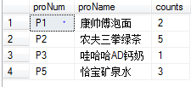

-- 销量统计排行

-- 全局

-- 降序

select Product.proNum,proName,counts

from Product,

(select Shopping.proNum,sum(number) counts

from Shopping

group by proNum) AS PRO

where PRO.proNum=Product.proNum

order by counts Desc;

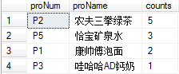

-- 升序

select Product.proNum,proName,counts

from Product,

(select Shopping.proNum,sum(number) counts

from Shopping

group by proNum) AS PRO

where PRO.proNum=Product.proNum

order by counts ASC;

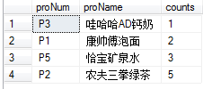

-- 当日/指定日期销量统计

-- 降序

select Product.proNum,proName,counts

from Product,

(select Shopping.proNum,sum(number) counts

from Shopping

where shopDate='2018-12-15'

group by proNum) AS PRO

where PRO.proNum=Product.proNum

order by counts Desc;

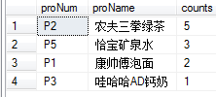

-- 升序

select Product.proNum,proName,counts

from Product,

(select Shopping.proNum,sum(number) counts

from Shopping

where shopDate='2018-12-15'

group by proNum) AS PRO

where PRO.proNum=Product.proNum

order by counts ASC;

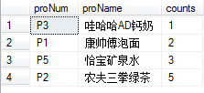

-- 指定日期段

select Product.proNum,proName,counts

from Product,

(select Shopping.proNum,sum(number) counts

from Shopping

where shopDate<='2018-12-15' and shopDate>='2018-12-13'

group by proNum) AS PRO

where PRO.proNum=Product.proNum

order by counts Desc;

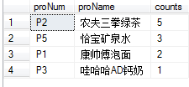

-- 指定商品统计销量

-- 升序

select Product.proNum,proName,counts

from Product,

(select Shopping.proNum,sum(number) counts

from Shopping

group by proNum) AS PRO

where PRO.proNum=Product.proNum and PRO.proNum='P2'

order by counts ASC;



-- 指定商品统计销量(比较)

-- 升序

select Product.proNum,proName,counts

from Product,

(select Shopping.proNum,sum(number) counts

from Shopping

group by proNum) AS PRO

where PRO.proNum=Product.proNum and Product.proNum in ('P1','P2')

order by counts DESC;



-- 盈利管理

-- 全局

select Product.proNum,proName,profitSum

from Product,

(select Shopping.proNum,sum(Shopping.number*price- Purchase.Cargoprice*Shopping.number) profitSum

from Shopping,Purchase

where Shopping.proNum=Purchase.proNum

group by Shopping.proNum) AS PRO

where PRO.proNum=Product.proNum

order by profitSum;

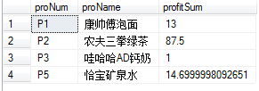

-- 指定日期/段(当日也适用)

select Product.proNum,proName,profitSum

from Product,

(select Shopping.proNum,sum(Shopping.number*price- Purchase.Cargoprice*Shopping.number) profitSum

from Shopping,Purchase

where Shopping.proNum=Purchase.proNum and shopDate<='2018-12-15' and shopDate>'2018-12-13'

group by Shopping.proNum) AS PRO

where PRO.proNum=Product.proNum

order by profitSum;

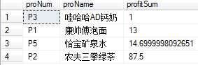

-- 供货商管理

-- 供货商信息管理

-- 信息修改

update Manu

set ManuTel='17774809112'

where manuNum='M05'

-- 信息录入

insert into Manu(manuNum,manuName,manuLoc,manuTel)

values('M01','康帅傅','北京路号','788415558'),

('M02','农夫三拳','南京路号','023-8845652'),

('M03','哇哈哈','东京路号','8008208820'),

('M04','小宝','中山路号','17788789454'),

('M05','恰宝','南山区号','4008884933');

-- 信息删除

delete

from Manu

where manuNum='Mo1';

-- 供货商信息查询

-- 仅本表内查询

select *

from Manu;

-- 查询指定商家的信息

select *

from Manu

where manuName='康帅傅';

-- 链表查询

-- 查询商品的供应商

select Product.proNum,Product.proName,Manu.manuName

from Manu,Product

where Manu.manuNum=Product.manuNum;

-- 查询指定商品的供应商

select Product.proNum,Product.proName,Manu.manuName

from Manu,Product

where Manu.manuNum=Product.manuNum and Product.proName='恰宝矿泉水';

-- 查询指定供货商所供应的商品

select Product.proNum,Product.proName,manuName

from Product,Manu

where Product.manuNum=Manu.manuNum and Product.manuNum='M03';

-- 查询当前盈亏

select Manu.manuNum,Manu.manuName,profitSUM

from Manu,

(select Purchase.manuNum,sum(Shopping.price*Shopping.number-Purchase.Cargoprice * Purchase.number) profitSUM

from Purchase,Shopping

where Purchase.proNum=Shopping.proNum

group by manuNum) AS PRO

where Manu.manuNum=PRO.manuNum;

-- 查询与所有供应商的交易总额

select Manu.manuNum,Manu.manuName,purSUM

from Manu,

(select manuNum,sum(Cargoprice * number) purSUM

from Purchase

group by manuNum) AS PRO

where Manu.manuNum=PRO.manuNum;

**四 .小结（心得体会）**

通过这次的课程设计，对数据库的设计过程有了进一步的认识，而且要想建好一个数据库，首先就要对自己要设计的对象深度了解，其间的各个流程都要把握好。这次我们小组结合课本知识，理论联系实际，完成了这次数据库的设计，使我们受益匪浅。

**五 开发工具和参考文献**

萨师煊，王珊.数据库系统概论（第4版）.北京：高等教育出版社，2005年.