**购物系统功能进度**

组员：邓焰心 1738940308

何媛媛1738940305

章耀中1738940339

` 杨启玢1738940341

**1.功能结构图**

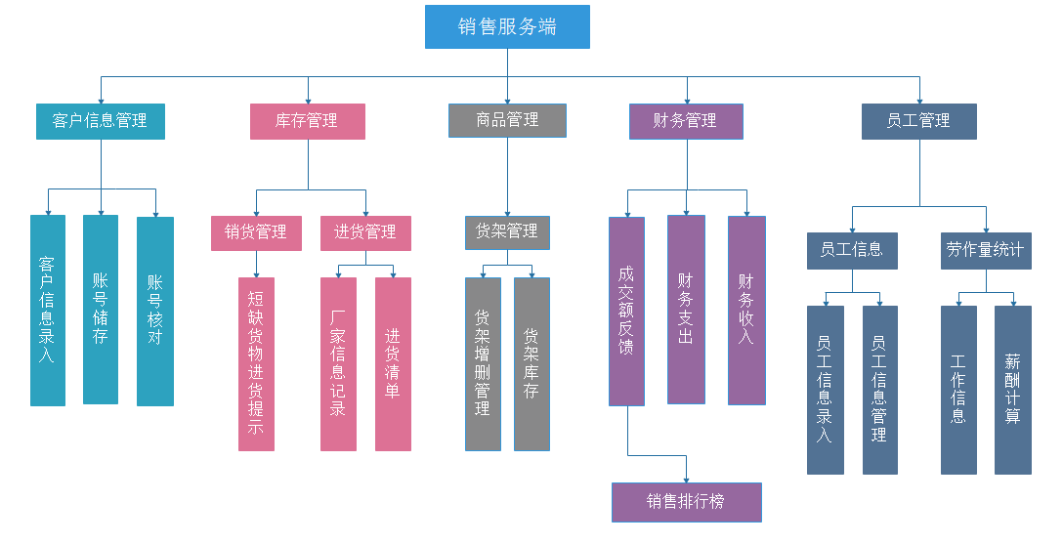

**2.数据库建表表格**

|  |  |  |  |  |  |  |  |  |  |  |  |  |  |  |  |  |  |  |  |  |  |  |  |  |
| --- | --- | --- | --- | --- | --- | --- | --- | --- | --- | --- | --- | --- | --- | --- | --- | --- | --- | --- | --- | --- | --- | --- | --- | --- |
| 员工表 | | | | | | | | | | | | | | | | | | | | | | | | |
| **主外码** | | | **属性名** | | | | | | | **数据类型** | | | | | **空否** | | | | | **取值范围** | | | | **备注** |
| 主码 | | | emNum | | | | | | | char（11） | | | | | 否 | | | | |  | | | | 员工号 |
|  | | | name | | | | | | | char（8） | | | | | 否 | | | | |  | | | | 姓名 |
|  | | | sex | | | | | | | char(２） | | | | | Ｎ | | | | |  | | | | 性别 |
|  | | | location | | | | | | | char(100） | | | | | Y | | | | |  | | | | 地址 |
|  | | | age | | | | | | | int | | | | | N | | | | | 18<=x<=50 | | | | 年龄 |
| 外码 | | | depNum | | | | | | | char(10) | | | | | Y | | | | |  | | | | 部门号 |
| 外码 | | | jobNum | | | | | | | char(10) | | | | | Y | | | | |  | | | | 工种号 |
| 部门表 | | | | | | | | | | | | | | | | | | | | | | | | |
| **主外码** | **属性名** | | | | | | | **数据类型** | | | | | **空否** | | | | | **取值范围** | | | | **备注** | | |
| 主码 | depNum | | | | | | | char(10) | | | | | N | | | | |  | | | | 部门号 | | |
|  | depName | | | | | | | char（20） | | | | | N | | | | |  | | | | 部门名称 | | |
| 外码 | depLeader | | | | | | | char(10) | | | | | N | | | | |  | | | | 部长员工号 | | |
| 工种表 | | | | | | | | | | | | | | | | | | | | | | | | |
| **主外码** | | | | | **属性名** | | | | **数据类型** | | | | | **空否** | | | | | **取值范围** | | | | **备注** | |
| 主码 | | | | | jobNum | | | | char(10) | | | | | N | | | | |  | | | | 工种号 | |
|  | | | | | jobName | | | | char(10) | | | | | N | | | | |  | | | | 工种名 | |
|  | | | | | salary | | | | float(10) | | | | | N | | | | | X>=0 | | | | 薪水 | |
| 商品类 | | | | | | | | | | | | | | | | | | | | | | | | |
| **主外码** | | | | **属性名** | | **数据类型** | | | | | **空否** | | | | | **取值范围** | | | | | **备注** | | | |
| 外码 | | | | proNum | | char(20) | | | | | N | | | | |  | | | | | 商品号 | | | |
|  | | | | type | | char(20) | | | | | N | | | | |  | | | | | 商品类 | | | |
|  | | | | emNum | |  | | | | |  | | | | |  | | | | | 导购员工号 | | | |
| 商品表 | | | | | | | | | | | | | | | | | | | | | | | | |
| **主外码** | | **属性名** | | | | | **数据类型** | | | | | **空否** | | | | | **取值范围** | | | | | **备注** | | |
| 主码 | | proNum | | | | | char(20) | | | | | N | | | | |  | | | | | 商品号 | | |
|  | | proName | | | | | char(30) | | | | | N | | | | |  | | | | | 商品名 | | |
|  | | value | | | | | folat(10) | | | | | N | | | | | X>=0 | | | | | 价格 | | |
|  | | weight | | | | | folat(10) | | | | | N | | | | | X>=0 | | | | | 重量 | | |
| 外码 | | manuNum | | | | | char(10) | | | | | N | | | | |  | | | | | 厂家号 | | |
|  | | prodate | | | | | date | | | | | N | | | | |  | | | | | 生产日期 | | |
|  | | deadTime | | | | | date | | | | | N | | | | | X>=0 | | | | | 保质期 | | |

create database supmarket;

create table Employee(

emNum char(11),

constraint ENP primary key(emNum),

name char(8) not null,

sex char(2) not null,

location char(100),

age int not null,

constraint ENC check (age >= 18 and age <= 50),

depNum char(10),

constraint ENF foreign key(depNum) references Department(depNum),

jobNum char(10),

constraint ENFJ foreign key(jobNum) references JobKind(jobNum)

);

create table Department(

depNum char(10),

constraint DEPP primary key(depNum),

depName char(20) not null,

depLeader char(11) not null,

constraint DEPF foreign key(depLeader) references Employee(emNum)

);

create table JobKind(

jobNum char(10),

constraint JOBP primary key(jobNum),

jobName char(10) not null,

salary float(10) not null,

constraint JobC check(salary>=0)

);

create table Product(

proNum char(20),

constraint ProP primary key(proNum),

proName char(30) not null,

value float(10) not null,

constraint ProC0 check (value>=0),

weight float(10) not null,

constraint ProC1 check (weight >0),

manuNum char(10) not null,

prodate date not null,

deadTime date not null

);

create table ProType(

proNum char(20) not null,

constraint PROTFkey foreign key(proNum) references Product(proNum),

emNum char(11) not null,

constraint PROTFkey1 foreign key(emNum) references Employee(emNum)

)