CHAPTER I

* 1. **Introduction to Hotel Management System**

One of the most important sectors for the economic growth of the country is the Tourism sector, where no doubt the good facilities, good behaviour and a good management play a major role for their attraction. Hotels, Lodges, Resorts etc.., being the important for the guest during their stay, management should have the proper manpower and equipment to provide a better service.

“Hotel” can simply, be defined as a place where a bonafide traveler can receive food and shelter, provided he/she is in a position to pay for it and is in a fit condition to be received. So, in general terms, Hotel Management System is expertise in management, leading to the prosperity and profit for the hotel.

The term Hotel Management System includes the management of each and every aspect related to the Hotel for the attraction, smoothness of handling things, and proper management. Especially the Reservations, Registration, Account, Services, Payment modes, Extra activities should be handled and maintained carefully and in an effective way so as to satisfy the guest as well as to check there is no leakage of profit to the hotel. The better the service, more the attraction and more the profit not only to the Hotel but also indirectly to the nation.

* + 1. **Front Office**

The front office in a hotel is the department responsible for the sale of hotel rooms through systematic methods of reservations followed by registrations and assigning rooms to customers. ‘Sale’ here means the use of rooms at a price. It has a complementary role of image-building which is the first and last point of contact of every guest. Hence, the front office in a hotel holds prime importance in view of the basic of business of a hotel i.e. to sell rooms.

The term “Hotel Reception” is interchangeably used with Front Office.

* + 1. **Stock Department**

Stock department is an internal department of the Hotel where the stocks of the things required for the Hotel are handled. The purchased stocks of the things required for the Hotel are handled. The purchased stocks are entered and are transferred to the respective departments according to the demand. A good database program is required to manage the things in stock.

1.2 **Introduction to the HOTELIER (Software)**

HOTELIER is a stand-alone multi-user technology based software using full graphical user interface and is meant for managing the guest, room, and stock property of the hotel. HOTELIER improves the business performance of a hotel by compressing the time and improving the quality of hotel’s guest service and related business processes like reservation, check-in, check-out, receiving and sending message, making phone calls, and stock handling process with full graphical interface.

* 1. **Goal and Objectives of HOTELIER**

The main objective of HOTELIER is to make Management System much simpler and more effective in order to meet the effective and the satisfaction levels of customers.

The goal of this project is to introduce the efficient consistent and computerize Hotel Management System to the society of Hotels and let them get the opportunity to use the most happening technology to prosper their business and themselves.

Apart from this, HOTELIER aims to provide the advance security, thus protecting the confidentiality of all information stored in the system and limiting the access control.

* 1. **Processes in HOTELIER**

HOTELIER is made to use by different staff at different department. Primarily, it functions the usability in Front Office Department.

In the software, the concept of giving permission to use is handled according to the entered at the time login. So, all the functions related to the department will be seen to the user.

The primary functions of Front Office are as follows:

Room Booking

If any message for a room reservation arrives then receptionist will up the Reservation form. All the necessary information like number and type of rooms to reserve, the arrival date – time, and number of days to stay, etc. are filled up.

Each new Reservation form generates a unique Reservation Folio ID for him which can be referred when guest arrived to the Hotel.

Guest Registration

Whenever a guest arrives in the Hotel, the first task of the Receptionist is to enter the guest’s information filled up in the Registration form. If guest had already booked then the data filled previously during reservation will be updated automatically in the respective fields through the Reservation Folio ID. During registration, room(s) is/are allotted to the guest. The Selection of rooms available can be viewed graphically through the Show Room Menu.

During registration, all the details of guest like Name, Address, Passport No., Visa No. etc. are stored so that the details can be retrieved during and even after he leaves the Hotel.

Handling message and telephone calls

If some message is dropped for particular guest while he is out, primarily it is stored in computer and the relayed to the concerning party. The advantage for storing the message in the computer is that the message can be viewed or relayed at any time in case of loss of message.

If a guest makes a telephone call from the Hotel, he should be accordingly charged. So the details of “telephone” form.

Cash Bill Entry

Different services from different departments can be used by the guests. Since the software is primarily limited to Reception, the bills of the services used are not directly updated through the networking system from the concerned department but entered through the receptionist according to the bill from the concerned departments signed by guest.

Check-in / Check- out query

The necessary information like the list of guest checking in today can be viewed or printed through Search Criteria so that necessary arrangement can be done in time as requested by the guest or other department.

Guest Info

The details of the guest staying at the Hotel or the history of guest who had stayed previously can be viewed through the Search Criteria.

Room Details

Room can be viewed whether they are occupied or not with and additional details of the rooms if clicked on them.

Guest Monitoring

The reasons for monitoring guest is to make Management System more effective and to meet the satisfaction levels of customers, whereby staff that will help the guest when arrived to pack in luggage will be assigned. This is done through the Guest Booking Registration tab, whereby the Receptionist will assign a staff through the drop down box.

* 1. Technical Requirements

The minimum requirements for HOTELIER are:

Hardware:

* PC with Pentium IV Processor (1.70 MHz) or latest
* 3GiB of RAM or more
* Color Monitor (Preferably)
* Hard Disk with at least 5GiB of free space

Software:

* Windows 7 operating system with Java SE 8.0 or later provider
  1. Introduction to Database Management System (DBMS)

A database system is essentially nothing more than a computerize record-keeping system. It is repository for collection of computerized data files. The user of system will be given facilities to perform a variety of operation data record such as:

* Inserting new data into existing files
* Retrieving data from existing files
* Updating data in the existing files
* Deleting data from the existing files

The collection of inter-related data referred to as the database contains information about one particular enterprise. The primary goal of DBMS is to provide in environment that is both convenient and efficient to use in retrieving and storing database information. The management of data involves both the definition of structures for the storage of information and the provision of information stored, despite system crashes or attempt at unauthorized access.

The advantage of computerized database are:

* It avoids the replication of the same data in many places in full based systems
* Consistency of data is avoided
* Fast accessing of data
* Multiple user access the data at the same time
* It provides security of data by giving privileges to access the database to the user according to their records.
  + 1. Normalization of Data

Normalization is the process of organizing data in the database. This includes creating tables and establishing the relationships between those tables according to the rules designed both to protect the data and to make the database more flexible by eliminating two factors: redundancy and dependency.

There are some benefits of normalization.

* Faster sorting and index creating because tables are narrower
* More clustered indices are allowed because there are no tables
* Narrower indices per table, helping INSERT, UPDATE, and DELETE performance
* Fewer nulls and less redundant data, increasing database compactness
  1. introduction to Software/Language used

For my project I have used the following software:

1. Java programming language (Java SE 8.0)
2. Netbeans IDE 8.0
3. SQLite3 (Structured Query Language)

1.7.1 Java Programming Langauge (Java SE 8.0)

Java programming language is an OOP platform independence programming language. OOP means Object Oriented Programming is a methodology that studies the evolution of object and how to implement it. Platform Independence means program written one once machine (OS like Windows) can run on different machine without changing any code written earlier, this is done with the help of Java Virtual Machine (JVM).

1.7.2 Netbeans IDE 8.0

Netbeans IDE is rapid application development software, which can be used to develop application programs for a variety of purposes. This is the fastest and easiest way to create application for all machines whether you are an experienced profession or brand new to Java programming. Netbeans provides you with a complete set of tools to simplify rapid application development.

There are two areas in Netbeans IDE which are:

* Code area and
* Design area.

Design area- is a visual part of Netbeans IDE used to create the graphical user interface (GUI). Rather than writing numerous lines of code to describe the appearance and the location of interface elements, you simply add re-built objects into place on screen.

Code area- is an area where you write event for your object placed in Design area.

1.7.3 SQLite3(Structured Query Language)

SQLite is a software library that implements a self-contained, serverless, zero-configuration, transactional SQL database engine. SQLite is one of the fastest-growing database engines around, but that's growth in terms of popularity, not anything to do with its size. The source code for SQLite is in the public domain.

Whether you are using SQLite3 database or other relational database, good database design is the key stone to create a database that does what you want it to do efficiently, accurately and effectively.

Steps in designing a database

This topic provides reference information about these basic steps in designing a database.

* Determine the purpose of your database.
* Determine the tables you need in database.
* Determine the fields you need in the tables.
* Identify the fields with unique values in each record.
* Determine the relationships between the tables.
* Refine your design
* Enter data and create other database objects

CHAPTER II

REQUIREMENT STUDY AND FEASIBILITY ANALYSIS

This sections deals about the feasibility of HOTELIER in context of manual system.

2.1 **Problems with manual Hotel Management System**

It is important to keep pace with time the increasing competition in the market and to stand on the present environment of the modern world.

The various drawbacks of manually handling the operations in the hotel are:-

* Though paper work acts as the basis for any activities by now-a-days this is considered as slower way of performing compared to the computerized system.
* Searching records of individual guest takes time.
* Record of guest and payment record can be inconsistent.
* The system is unreliable and inaccurate.
* Uneconomical due to large number of manpower, stationeries, and time investment.
* To find the info and the current balance of the guest manually is burdensome.
* Manually receipt making is not efficient when the party is large.
* Retrieving information like reports and queries is very time consuming and almost impossible practicably if time has to be considered.

2.2 Requirement of Hotelier

After the analysis on the problems associated with manual system of the hotel management, it is understood that the proper system for maintaining the information of the guest and retrieving the information, personal accounts, payment bill and the stock management is required. So, in order to overcome those problems, a system was needed to develop which would help to fulfill the following requirements of the hotel management system.

* Storing the information f the guest in the computerized database.
* Generating receipt and other balance records.
* Accessing information of the guest.
* Updating the guest account according to the service used by him.
* Making queries to know about the guests checking-in, checking-out, room occupancy, services available.
* Generating bills at the time of check-out.
* Knowing the foreign currency exchange rate for converting the currencies.
* Managing the stocks at the Stock Department.

2.3 Feasibility analysis of HOTELIER

2.3.1 Technical feasibility

Technical, the HOTELIER will sound as the system uses the renowned database system SQLite3 as a backened database. Apart from that SQLite3 also has features for data integrity checking which ensures that the database is always in correct state. The SQLite3 also ensures the data consistency. For the front end we will be using NetBeans which is very efficient, easy and reliable visual rapid application development tool. NetNeans provides the capability to develop the database application with ease and reliability. With its user-friendly environment we can create equally friendly database applications. It also provides the facility for data validation in the front and to ensure the correctness of the database.

2.3.2 Economic Feasibility

Economically, the HOTELIER is also feasible, there is almost no expenses incurred in developing the system. There will be no expenses incurred in using this software as they are freely provided to use in the laboratory.

Whereas from the users point of view, the technical requirements worthless in compare to the effectiveness and efficiency HOTELIER provides for the Hotel management record keeping and manipulation.

CHAPTER III

SYSTEM DESIGN

* 1. DFD Analysis

Data flow diagram (DFD) is a method used to illustrate the flow of data in a system. It is one of the most important modeling tools used by system designers to understand the system. As information moves through software, it is modified by a series of transformation. A data flow diagram (DFD) is a graphical technique that depicts information flow and the transforms that are applied as data move from input to output. The DFD provides the mechanism or functional modeling as well as information flow modeling.

The illustration of DFD is show below:

* 1. ER Analysis

The entity-relationship (ER) modeling i.e. based on the perception of a real world that consists of a set of basic objects called entities and of relationships among these objects the objects have their other attributes and once object is differentiated from the other by their attributes.

An entity is a thing or an object in a real world that is distinguishable from all other objects and a relationship is an association of two or more entities.

Two entities can be related to one another in the following ways.

* One to One

An entity in one entity can be associated as most one entity in the other entity set.

* One to May

An entity in one entity set can be associated to any number of entities in the other entity set. However, the entities in 2nd entity set are associated with only an entity in use 1st entity set.

* Many to One

Any number of entities in one entity set can be associated to only entity in the other entity set. However , the entity in 2nd entity set can be associated with any number of entities in the first entity set.

* Many to Many

An entity in one set can be associated with any number of entities in the other entity set and vice versa.

ER-DIAGRAM

Main Window

Login

Close

Gallery

Gallery al

Login Window

Search Criteria

Staff Info

All Rooms

Login

No

Yes

Front Offce

Guest Registration

House Status

Gallery

Close Application

Log Out

Stop

* 1. **Identification of major Inputs and Outputs of the HOTELIER**

Since the HOTELIER normally deals with guests the Major inputs involved are:

This is displayed in four (4) Modules

1st Module. Room Booking Registration involves information like…

Room Reservation

The necessary information like name of Guest, Date of Arrival, Days to stay, Departure Date , Departure time, Type of Room, Reservation type, etc are the inputs of Room reservation. All of this information is stored in a single table named “Guest_records”

Guest Information

After the arrival of Guest, the information stored in two tables, namely guest registration and room-detail. The room number allocated to the guest is set as occupied in the table and room detail and other information are stored in Guest Registration Table.

Payment mode

According to service used, the details are stored in Payment table. Information like mode of payment, release date, air pickup, bank name, and discount are stored.

Company Information

The necessary information about guest job is stored in company_info table. Information like company name, company address, department and country are stored.

Contact Information

Information like country guest address, phone, mobile and fax number are gathered and stored in Contact_info.

2nd Module. Search Criteria

Information entered in Room Booking Registration is display here for ease of the user. This helps user to quickly search for guest records and to update existing records.

Print

This button automatically generate report about Guest Information and print it in any format. It improves the quality of HOTELIER

3th Module. Staff Information

To assign staff for particular guest then the staff must have been registered in the database. This helps to insert new staff and information like picture, name, country, etc are stored in one table called staff_records.

4th Module. House Status

This helps to quickly check for available room and user can also add new room if instructed.

Show Gallery

This Menu opens a window that has pictures room available in the Hotel and gallery. This helps for better service and presentation.

Print

It is applicable to Print button in 2nd model, is just that it deals with Rooms

CHAPTER IV

IMPLIMENTATION OF HOTELIER

4.1 **Introduction**

The project Hotelier was implemented using the software Java Programming language and SQLite3 the implementation phase was further divided into three phases.

* System implementation phase.
* Database implementation phase.
* Front – end implementation phase.

4.1.1 System Implementation phase

In the system implementation phase, conceptual model of the database as designed with the help of (DFD, ER). The structure of the table was designed and the relations between tables were defined. The output of this phase was a well-defined table structure and clearly defined and relation between those tables. Also the integrity rules were also defined in the phase.

4.1.2 Database implementation phase

In the database implementation phase, the normalized tabled were built and implemented in the database, in this phase we clearly defined the primary key and maintained relationships between tables.

4.1.3 Front End Implementation Phase

In this phase, front –end for the application was developed. The front-end was developed in Java programming language. For accessing the database made in SQLite, I have used one important Driver/connector the sqlite-jdbc -5.1.32 downloaded from sqlite.com website.

Sqlite-jdbc-5.1.32 driver allows the java to access the database (SQLite) through programming.

4.2 Database Structure of the Hotelier

Name of the database for the Hotelier is “hotel_manager”.

All the tables are not necessarily related, since the system does not require. The database contains the following:

House_status

Guest_records

Employee_records

|  |  |
| --- | --- |
| EmployeeId | Varchar |
| Name | Varchar |
| Address | Varchar |
| Phone | Varchar |
| Email | Varchar |

|  |  |
| --- | --- |
| Id |  |
| Title | Mobile |
| Name | |  | | --- | | **Phone** | |
| Address | Fax |
| Country | Identity_card |
| No_of_room | Identity_no |
| Room_type |  |
| Arrival_date |  |
| Arrival_time |  |
| Departure_date |  |
| Departure_time |  |
| Reservation_type |  |
| Night_use |  |
| No_of_adult |  |
| No_of_child |  |
| Email |  |

|  |
| --- |
| Unit_room |
| Room_Avail |
| Room_Type |
| Status |
| Availability |
| Remarks |

|  |  |
| --- | --- |
| city | Varchar |
| gender | Varchar |
| image | Blob |

Room:

|  |
| --- |
| Room_id |
| All_room |
| Available_room |
| Status |

Login :

|  |
| --- |
| Username |
| password |

4.3 **Control Used**

The JfieldText:

The Jtextfield control is the primary mechanism for displaying and entering text and is one of the most common elements of the windows user interface. The Jtextfield control is a small text editor that provides all the basic text-editing facilities: inserting and selecting text, scrolling the text if it doesn’t fit in the control’s area, and even exchanging text with other applications through the Clipboard.

The textbox is an extremely versatile data entry tool that can be used for entering a single line of text, such as number or, password, or for entering simple text files.

Basic properties

JTextArea

This property determines whether the Textbox control will hold a single line or multiple line of text. By default, the control holds a line of text. To change this behavior, set the Multi line property to true.

MaxLength

This property determines the number of characters the jTextField control will accept. Its default value is zero, which means the text may be of any length, up to the controls capacity limit. To restrict the number of characters the user can type , set the value of this property accordingly.

JComboBox Control

The Combo Box controls present lists of choices from which the user can select one or more. It contains multiple items but occupies less space on the screen. The real advantage of Combo Box Control is that user can enter new information I the Combo Box, rather than being forced to select only the items listed.

JDatePicker

Java date use plug-in called JdatePicker.jar which can be added to library folder and called from the action button. JDatePicker is use to select date graphically and set it in its text field.

4.4 **Module of the System**

Beyond the process in HOTELIER listed above, there are also additional modules that can be used by front officer.

The additional modules are:

Report

In the report creation the used of Jasper report and ireport helped to create advance and graphical report which also can print a document. The kind of document that was made to print is guest contact information amd House status in which the manager use to contact the guest. So one can easily view the guest contact info in a printed copy or save the document for future use.

4.5 **Technical aspect of implementation phase**

Approach taken for the study and development of the project

For the implementation of the project overall planning was done from the beginning of the project. The listed above show the plan, which is a standard life circle model for data intensive systems. Different stages involved the completion of the project is as follows:

Requirement analysis and problem definition

In this phase major information for the project was collected from the different Hotels accessible to me. The result was a list of documents and information divided into functional and non-functional, which are mandatory and optional.

Feasibility Analysis

In this feasibility analysis, information required was studied. System objective and scope were defined and system requirement was listed. Technical requirements like hardware and software were also listed.

DFD-ER Analysis

After determining the requirement, DFD (Data Flow Diagram) and ER (Entity Relationship) model has to be produced. This will help in analysis and later system development.

System Design Phase

In this phase logical database was design in SQLite3.

User Interface Prototyping

This is a user interface prototyping phase. In this I designed frames in paper and tried to make it as user friendly as possible.

User Interface Implementation

In this phase front end of the system was developed using the rapid application tool NetBeans IDE 8.0

Coding Phase

In this phase the coding of the system was done using the language called Java Programming language v8.

System Integration and Testing

In this phase I invited the various people and allow them to run program and according to their comment I reviewed my program, and tried to make more user friendly and more efficient.

**Final Report Presentation**

This report is being prepared in this phase.

CHAPTER V

CONCLUSION AND RECOMMENDATIONS

5.1 **Conclusions**

First of all, it has been a great importance doing this project. Starting for the simple record, search module, I have reached the end of project. As I have used prototype models to develop my system, I have learnt that I must make a good system design before implement the design.

However, I can say that the project has been a success but there are still some factors due to which there is doubt whether I have met the expectation level of performance. It may be because of the lack of technical expertise the project has not turned out the way, it was expected of. There are still assumptions have to be made like database dumped in annual basis to implement the system real life. With some more time the system can be made function properly. The necessary background work has been done on the system. So a little more effect will most probably make the project implementable.

5.2 **Recommendations**

The project was done in the partial fulfillment of the 2nd Year 2nd Semester Project Course of Computer Science, Gateway ICT Polytechnic and not as the authority governing the polytechnic or any other initiation has sanctioned that. Apart from this regular suggestions and comments of my supervisor were helpful for me to complete this project.

Important of all, I really think should be concentrated upon is in the system design phase and detail study of the system. I reviewed the design phase various time on the data available to me according to the suggestion of my instructor. Design phase leads the project that is reliable or, not small mistake is design phase gives the big problem in the implementation phase. So, I think the system design phase needs very keen attention and the systems properly checked before proceeding any further. And another area to be concentrated is the front-end implementation; from-end design leads the easiness of the project towards handling. During the design I should contact with the general user (which I couldn’t do due to lack of such personals).

**APPENDIX**

Programming codes

}//GEN-LAST:event_Clear_btn4ActionPerformed

private void Clear_btn5ActionPerformed(java.awt.event.ActionEvent evt) {//GEN-FIRST:event_Clear_btn5ActionPerformed

try {

String sql = "insert into guest_records(Title,Name,Address,Country,No_of_room,Room_Type,Arrival_date,Arrival_time,Departure_date,Departure_time,Reservation_type,Night_use,No_of_adult,No_of_child,Email,Phone,Mobile,Fax,Identity_Card,Identity_no,Nationality,Gender,VIP_Status,Mode,Release_date,Bank_name,term,company_name,Department,company_address,city,Room_No,Staff,Card_name,Air_Pickup) values(?,?,?,?,?,?,?,?,?,?,?,?,?,?,?,?,?,?,?,?,?,?,?,?,?,?,?,?,?,?,?,?,?,?,?)";

pst = con.prepareStatement(sql);

pst.setString(1, (String) combo_name.getSelectedItem());

pst.setString(2, field_name.getText());

pst.setString(3, text_add.getText());

pst.setString(4, (String) combo_country.getSelectedItem());

pst.setString(5, field_room.getText());

pst.setString(6, (String) combo_room.getSelectedItem());

pst.setString(7, ((JTextField) field_arrival.getDateEditor().getUiComponent()).getText());

pst.setString(8, Arrival_time.getText());

pst.setString(9, ((JTextField) departure_date.getDateEditor().getUiComponent()).getText());

pst.setString(10, departure_time.getText());

pst.setString(11, (String) combo_type.getSelectedItem());

pst.setString(12, field_night.getText());

pst.setString(13, field_adult.getText());

pst.setString(14, field_child.getText());

pst.setString(15, field_mail.getText());

pst.setString(16, field_phone.getText());

pst.setString(17, field_mobile.getText());

pst.setString(18, field_fax.getText());

**ACRONYMES USED**

DFD - Data Flow Diagram

ER – Entity Relation

DBMS – Database Management System

SQL – Structured Query Language

LIST OF FIGURES

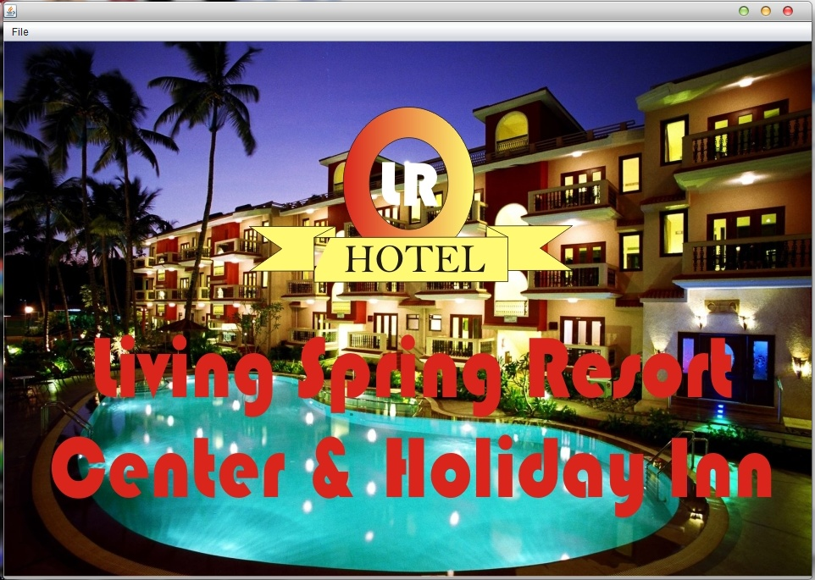

Splash Screen

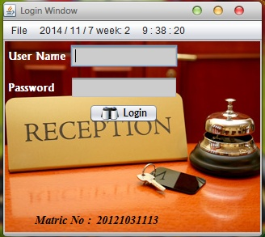

Login Window

Front Office

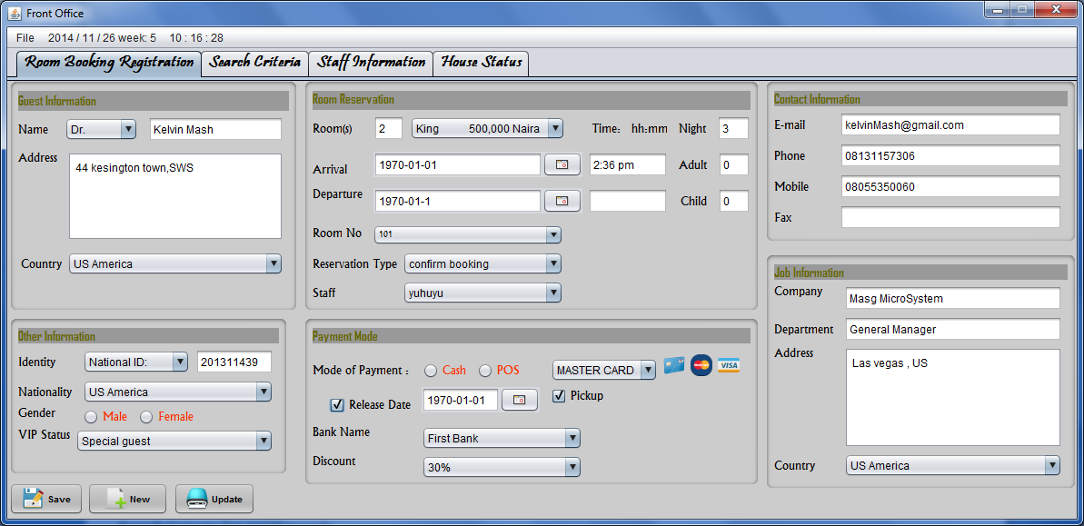

Room Booking Tab

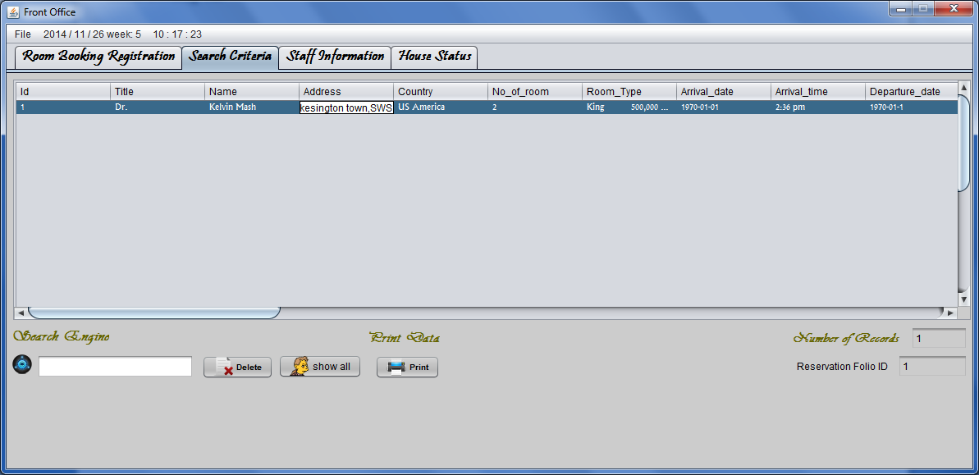

Guest Info Report

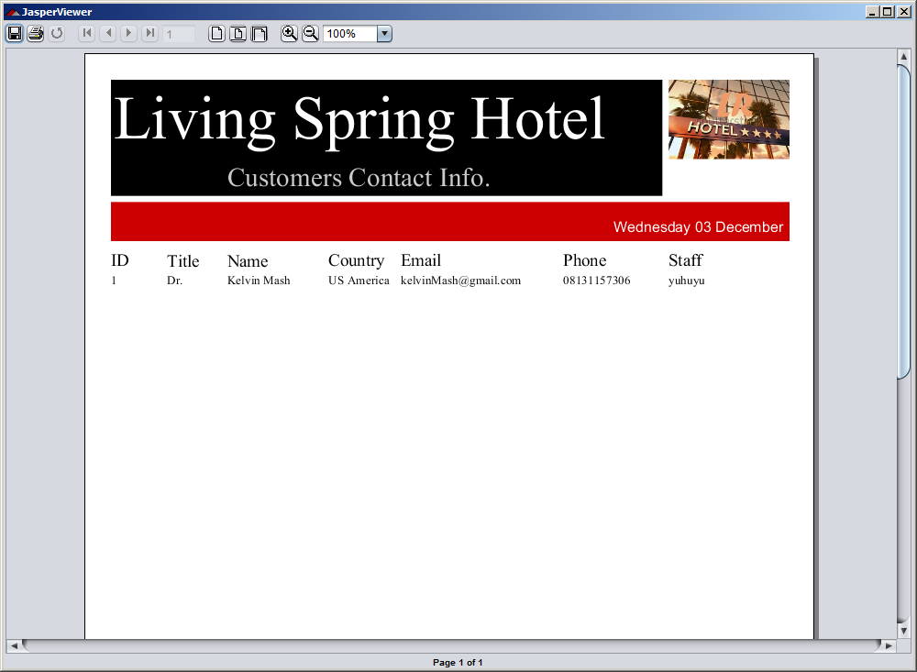

Search Criteria for guest records

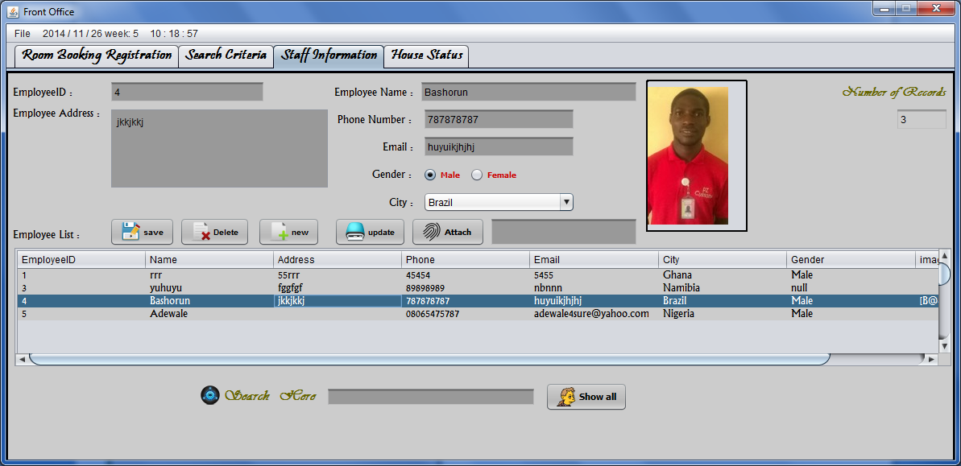

Staff Information

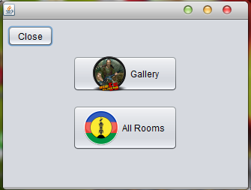

View Gallery

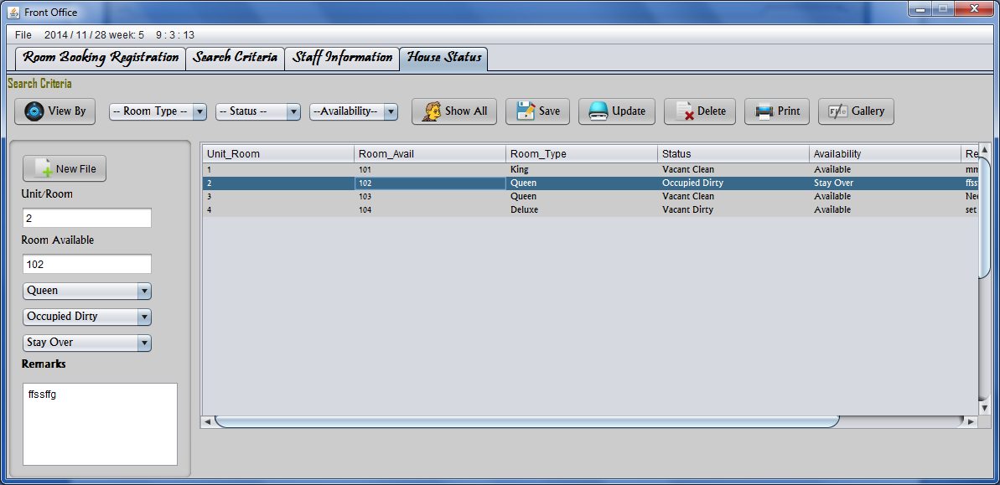

House Status

Hous Status Report

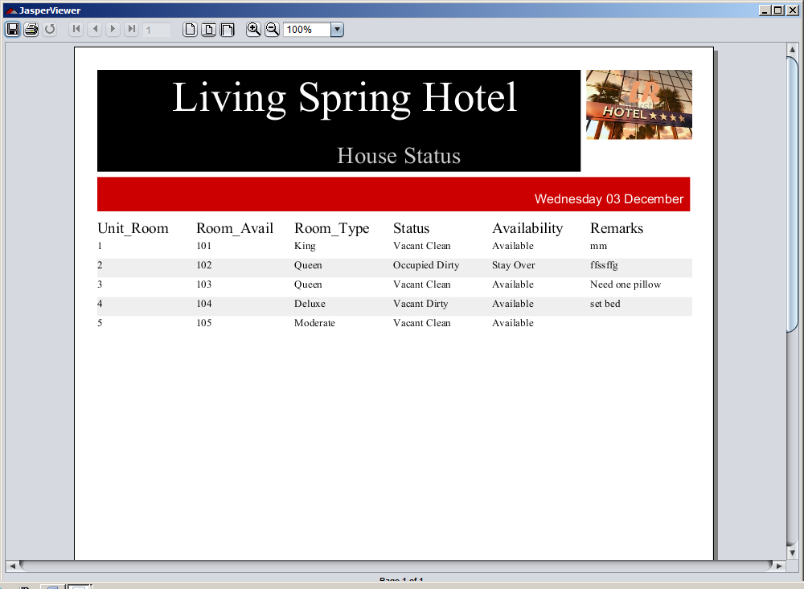

COST ESTIMATED

|  |  |  |
| --- | --- | --- |
| S.No | Particulars | Total |
| 1 | Man Power (5*8*500) | 20,000 |
| 2 | Empty CD (3*100) | 3,00 |
| 3 | Report | 8,000 |
| 4 | Miscellaneous | 4,000 |
|  | Total | 32,300 |

REFERENCES

Introducing JavaFX 2.0, by Nandini Ramani:

<http://medianetwork.oracle.com/video/player/1191127359001>

Chris Oliver's weblog: <http://blogs.oracle.com/chrisoliver/entry/f3>

JavaFX Roadmap: <http://javafx.com/roadmap/>

OpenJDK Discussion About JavaFX, by Richard Bair: <http://fxexperience.com/2011/10/openjdkdiscussion>

Java on Wikipedia: <http://en.wikipedia.org/wiki/Java>

Richard Bair Java Client Architect, Stephen Chin( @steveonjava).

Peter Pilgrim (@peter_pilgrim)

<http://www.nighthacking.com>