Hadoop2.6安装配置

架构目标

master 192.168.10.96 namenode
slave1 192.168.10.97 datanode
slave2 192.168.10.98 datanode
一个namenode节点两个datanode节点
在hosts文件中配置：
vi /etc/hosts
127.0.0.1 localhost
192.168.10.96 master
192.168.10.97 slave1
192.168.10.98 slave2
hostname文件的修改：
vi /etc/hostname
在master中就改为master就行了，如果在slave1中就改为slave1。

好了我们现在开始安装软件吧。
Jdk的安装不讲了.. 直接安装hadoop2.6 吧

下载安装hadoop2.6
下载：hadoop2.6.0
wget http://www.apache.org/dyn/closer.cgi/hadoop/common/hadoop-2.6.0/hadoop-2.6.0.tar.gz
解压：
tar xzvf hadoop-2.6.0.tar.gz -C /usr/local/hadoop/
得先有hadoop这个目录 mkdir /usr/local/hadoop/
在 /etc/profile 中配置hadoop的环境变量
export HADOOP_HOME=/usr/local/hadoop/hadoop-2.6.0
export PATH=$PATH:$HADOOP_HOME/bin:$HADOOP_HOME/sbin
export JAVA_LIBRARY_PATH=${HADOOP_HOME}/lib/native
/*这个环境变量还没配完等等再来配*/
source /etc/profile #使刚刚配的路径生效
现在试试 hadoop ersion 吧看看效果
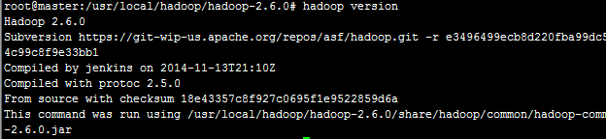
看到这至少说明能用了，虽然说什么都还没有配吧！！！

hadoop的各类配置文件
我都被这些配置文件搞晕了..........
记住hadoop1.x和hadoop2.x有很大的区别，刚开始我就是用1.x去配2.x，我就傻眼了....所以找教程也去找2.x的吧相识度高点...

Hadoop-env.sh文件的配置
修改JAVA_HOME值（export JAVA_HOME=/usr/lib/jvm/jdk1.8.0_51）
我的jdk是解压在/usr/lib/jvm/jdk1.8.0_51这下面，自己看情况而定吧。

hadoop-env.sh文件的配置
添加：export JAVA_HOME=/usr/lib/jvm/jdk1.8.0_51

Slaves文件的配置
slaves （这个文件里面保存所有slave节点）


core-site.xml文件的配置
<configuration>
<property>
<name>fs.defaultFS</name>
<value>hdfs://master:8020</value>
</property>
<property>
<name>io.file.buffer.size</name>
<value>131072</value>
</property>
<property>
<name>hadoop.tmp.dir</name>
<value>file:/home/aboutyun/tmp</value>
<description>Abase for other temporary directories.</description>
</property>
</configuration>
这个东西带我去研究研究看看到底怎么配置吧...

hdfs-site.xml文件的配置
<configuration>
<property>
<name>dfs.namenode.secondary.http-address</name>
<value>master:9001</value>
</property>
<property>
<name>dfs.namenode.name.dir</name>
<value>file:/home/hadoopWork/dfs/name</value>
</property>
<property>
<name>dfs.datanode.data.dir</name>
<value>file:/home/hadoopWork/dfs/data</value>
</property>
<property>
<name>dfs.replication</name>
<value>3</value>
</property>
<property>
<name>dfs.webhdfs.enabled</name>
<value>true</value>
</property>
</configuration>
标红的我知道有啥用处，其他的我就不知道了
Dfs.namenode.name.dir 是namenode节点存放文件的地方
Dfs.datanode.data.dir 是datanode节点存放文件的地方
Dfs.replication 是副本数就是你在集群中一个文件块备份的多少。。别设置的太大了
hdfs-site.xml文件设置就先这样吧

mapred-site.xml文件的配置
<configuration>
<property>
<name>maprep.job.tracker</name>
<value>master:9001</value>
</property>
<property>
<name>mapreduce.framework.name</name>
<value>yarn</value>
</property>
<property>
<name>mapreduce.jobhistory.address</name>
<value>master:10020</value>
</property>
<property>
<name>mapreduce.jobhistory.webapp.address</name>
<value>master:19888</value>
</property>
</configuration>
先就这样吧不怎么理解。..

yarn-site.xml文件设置
<configuration>
<property>
<name>yarn.nodemanager.aux-services</name>
<value>mapreduce_shuffle</value>
</property>
<property>
<name>yarn.nodemanager.aux-services.mapreduce.shuffle.class</name>
<value>org.apache.hadoop.mapred.ShuffleHandler</value>
</property>
<property>
<name>yarn.resourcemanager.address</name>
<value>master:8032</value>
</property>
<property>
<name>yarn.resourcemanager.scheduler.address</name>
<value>master:8030</value>
</property>
<property>
<name>yarn.resourcemanager.resource-tracker.address</name>
<value>master:8031</value>
</property>
<property>
<name>yarn.resourcemanager.admin.address</name>
<value>master:8033</value>
</property>
<property>
<name>yarn.resourcemanager.webapp.address</name>
<value>master:8088</value>
</property>
</configuration>
先不管了。。。。。

四、SSH无密码登陆
没装ssh就先装ssh
apt-get install openssh-server
Ssh免登录的原理：就是我把工钥放到里面，然后本台机器就可以ssh无密码登录了。如果想彼此无密码登录，那么就需要把彼此的工钥（*.pub）放到authorized_keys里面
具体步骤如下：
第一步：产生密钥
ssh-keygen -t dsa -P '' -f ~/.ssh/id_dsa
第二部：导入authorized_keys
cat ~/.ssh/id_dsa.pub >> ~/.ssh/authorized_keys
第二部导入的目的是为了无密码等，这样输入如下命令：
ssh localhost
进入master的.ssh目录
scp authorized_keys slave1:~/.ssh/authorized_keys
这个scp挺好玩的
进入slave1的.ssh目录
ssh-keygen -t dsa -P '' -f ~/.ssh/id_dsa
cat ~/.ssh/id_dsa.pub >> ~/.ssh/authorized_keys
scp authorized_keys slave2:~/.ssh/authorized_keys
把最后生成的authorized放到每台机器上就可以实现任意两台电脑无密钥登录了..
这个很好玩的。。。

将master上的配置文件配发到slave上（你要是有时间也可以自己再配几遍也行）
scp $HADOOP_HOME/etc/hadoop/* slave1:/usr/local/hadoop/hadoop-2.6.0/etc/hadoop/
scp $HADOOP_HOME/etc/hadoop/* slave2:/usr/local/hadoop/hadoop-2.6.0/etc/hadoop/
scp /etc/hosts slave1:/etc/hosts
scp /etc/hosts slave2:/etc/hosts
Profile文件也可以的，但是hostname就不要了，小心这一点...

启动测试

启动hadoop
格式化namenode节点
hdfs namenode -format
启动start-dfs.sh
./start-dfs.sh
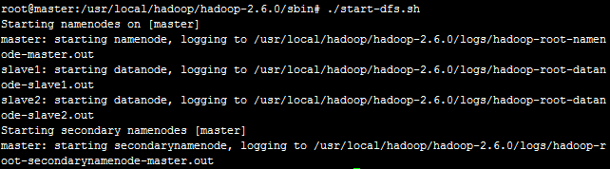
在用jps命令看看master吧
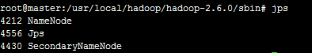
看看slave的jps有啥吧
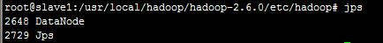
好了接下来启动 ./start-yarn.sh
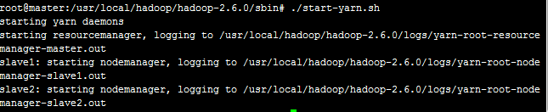
再看看master的jps多了啥吧
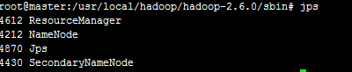
Yarn是用来管理的可以看见多了ResourceManager
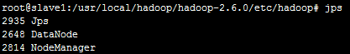
这是slave上的jps看见没多了NodeManager这个守护进程...
基本就成功了...哈哈..

web界面验证

1.hadoop管理
浏览器中输入：http://192.168.10.96:8088
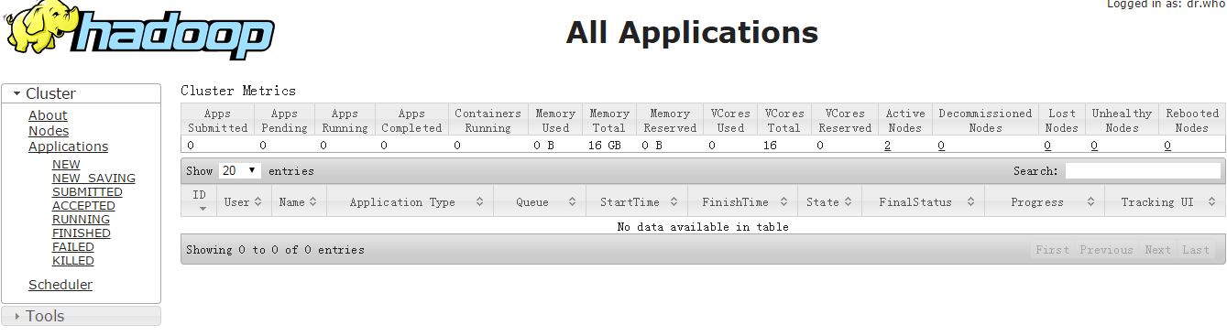
有东西哦，你就随便看看吧
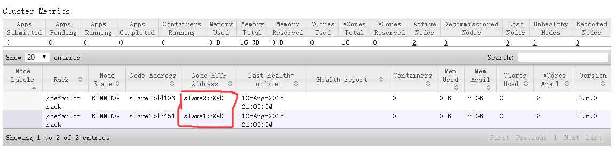
看见我们的data节点了没
<property>
<name>yarn.resourcemanager.webapp.address</name>
<value>master:8088</value>
</property>
貌似和这个有点关系

查看HDFS集群状态
地址：http://master:50070/
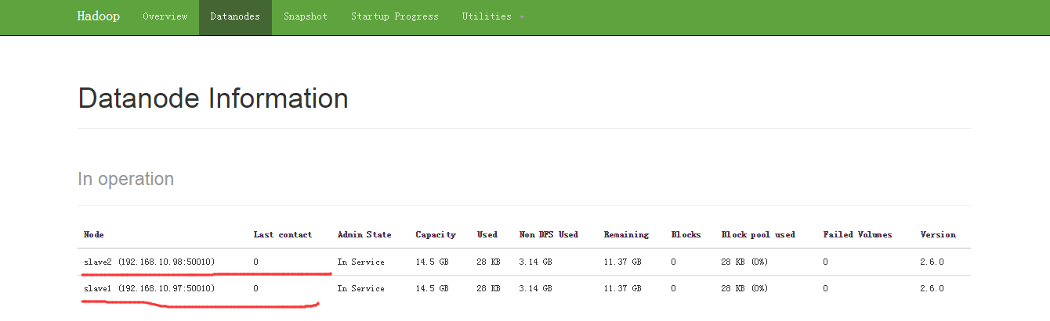
界面还是相当好看的...
组件 ：HDFS
节点 ：NameNode
默认端口：50070
配置 ：dfs.namenode.http-address
用途说明：http服务的端口

。。。。。。。。。。。。。。。。。。。。。。。。。。。。。。。。。。。。。。。。。。。。。。。。。。。。。。。。。。。。。。。。。。。。。。。。。。。。。。。

运行自带例子
在hdfs文件系统中创建几个目录：
hdfs dfs -mkdir -p /test/input
hdfs dfs -mkdir -p /test/output
cp README.txt readme.txt 用readme.txt作为测试数据
上传readme.txt到hdfs文件系统中
hdfs dfs -put readme.txt /test/input
执行
root@master:/usr/local/hadoop/hadoop-2.6.0# 15/08/11 09:05:26 INFO client.RMProxy: Connecting to ResourceManager at master/192.168.10.96:8032
15/08/11 09:05:29 INFO input.FileInputFormat: Total input paths to process : 1
15/08/11 09:05:30 INFO mapreduce.JobSubmitter: number of splits:1
15/08/11 09:05:30 INFO mapreduce.JobSubmitter: Submitting tokens for job: job_1439255104001_0001
15/08/11 09:05:31 INFO impl.YarnClientImpl: Submitted application application_1439255104001_0001
15/08/11 09:05:32 INFO mapreduce.Job: The url to track the job: http://master:8088/proxy/application_1439255104001_0001/
15/08/11 09:05:32 INFO mapreduce.Job: Running job: job_1439255104001_0001
15/08/11 09:05:46 INFO mapreduce.Job: Job job_1439255104001_0001 running in uber mode : false
15/08/11 09:05:46 INFO mapreduce.Job: map 0% reduce 0%
15/08/11 09:05:58 INFO mapreduce.Job: map 100% reduce 0%
15/08/11 09:06:08 INFO mapreduce.Job: map 100% reduce 100%
15/08/11 09:06:10 INFO mapreduce.Job: Job job_1439255104001_0001 completed successfully
15/08/11 09:06:10 INFO mapreduce.Job: Counters: 49
File System Counters
FILE: Number of bytes read=1836
FILE: Number of bytes written=215083
FILE: Number of read operations=0
FILE: Number of large read operations=0
FILE: Number of write operations=0
HDFS: Number of bytes read=1471
HDFS: Number of bytes written=1306
HDFS: Number of read operations=6
HDFS: Number of large read operations=0
HDFS: Number of write operations=2
Job Counters
Launched map tasks=1
Launched reduce tasks=1
Data-local map tasks=1
Total time spent by all maps in occupied slots (ms)=8841
Total time spent by all reduces in occupied slots (ms)=6371
Total time spent by all map tasks (ms)=8841
Total time spent by all reduce tasks (ms)=6371
Total vcore-seconds taken by all map tasks=8841
Total vcore-seconds taken by all reduce tasks=6371
Total megabyte-seconds taken by all map tasks=9053184
Total megabyte-seconds taken by all reduce tasks=6523904
Map-Reduce Framework
Map input records=31
Map output records=179
Map output bytes=2055
Map output materialized bytes=1836
Input split bytes=105
Combine input records=179
Combine output records=131
Reduce input groups=131
Reduce shuffle bytes=1836
Reduce input records=131
Reduce output records=131
Spilled Records=262
Shuffled Maps =1
Failed Shuffles=0
Merged Map outputs=1
GC time elapsed (ms)=269
CPU time spent (ms)=2800
Physical memory (bytes) snapshot=428421120
Virtual memory (bytes) snapshot=3795288064
Total committed heap usage (bytes)=283639808
Shuffle Errors
BAD_ID=0
CONNECTION=0
IO_ERROR=0
WRONG_LENGTH=0
WRONG_MAP=0
WRONG_REDUCE=0
File Input Format Counters
Bytes Read=1366
File Output Format Counters
Bytes Written=1306

这就有结果了，来看看输出的是啥吧
root@master:/usr/local/hadoop/hadoop-2.6.0#
(BIS), 1
(ECCN) 1
(TSU) 1
(see 1
5D002.C.1, 1
740.13) 1
<http://www.wassenaar.org/> 1
Administration 1
Apache 1
BEFORE 1
BIS 1
Bureau 1
Commerce, 1
Commodity 1
Control 1
Core 1
Department 1
ENC 1
Exception 1
Export 2
For 1
Foundation 1
Government 1
Hadoop 1
Hadoop, 1
Industry 1
Jetty 1
License 1
Number 1
Regulations, 1
SSL 1
Section 1
Security 1
See 1
Software 2
Technology 1
The 4
This 1
U.S. 1
Unrestricted 1
about 1
algorithms. 1
and 6
and/or 1
another 1
any 1
as 1
asymmetric 1
at: 2
both 1
by 1
check 1
classified 1
code 1
code. 1
concerning 1
country 1
country's 1
country, 1
cryptographic 3
currently 1
details 1
distribution 2
eligible 1
encryption 3
exception 1
export 1
following 1
for 3
form 1
from 1
functions 1
has 1
have 1
http://hadoop.apache.org/core/ 1
http://wiki.apache.org/hadoop/ 1
if 1
import, 2
in 1
included 1
includes 2
information 2
information. 1
is 1
it 1
latest 1
laws, 1
libraries 1
makes 1
manner 1
may 1
more 2
mortbay.org. 1
object 1
of 5
on 2
or 2
our 2
performing 1
permitted. 1
please 2
policies 1
possession, 2
project 1
provides 1
re-export 2
regulations 1
reside 1
restrictions 1
security 1
see 1
software 2
software, 2
software. 2
software: 1
source 1
the 8
this 3
to 2
under 1
use, 2
uses 1
using 2
visit 1
website 1
which 2
wiki, 1
with 1
written 1
you 1
your 1

好吧就这样了！！！！

有问题看看这吧：http://www.aboutyun.com/forum.php?mod=viewthread&tid=7728

